Supporting information
for:

Hydrothermal synthesis and characterization of the eulytite phase of bismuth germanium oxide powders

by

Timothy J. Boyle, Eric Sivonxay, Pin Yan,

Mark A. Rodriguez, Bernadette A. Hernandez-Sanchez,

Nelson S. Bell, Andrew Velazquez, Bryan Kaehr,

Marlene Bencomo, James J. M. Griego, Patrick Doty

S1. PXRD of non-optimized E-BGO samples.
◊
∆
◊
◊
◊
◊

Figure S1. Powder XRD Patterns of E-BGO Produced and listed as (Condition/Phase): (a) E-BGO simulated pattern, (b) E-BGO (PDF 00-034-0416), (c) E-BGO isolated with (Bi₂(O)₂(OH)(NO₃) (◊, PDF 04-012-5737))²⁰ and (d) GeO₂ (∆, PDF 00-035-0729).

The calculated spectrum Figure S1a for E-BGO was found to be consistent with E-BGO powder isolated in the process discussed in the Experimental section (Figure S1b). Several other products were also identified in the earlier, less successful attempts, including Bi₄(Ge_{2.87}O_{11.6}) (PDF 01-074-9425), Bi_{3.64}(Ge₃O_{11.4}) (PDF 01-074-9426), Bi₂Ge₃O₉ (PDF 00-043-0216), Bi₂(GeO₅) (PDF 00-036-0289). In addition, several contaminants were also noted for the un-optimized syntheses including Bi₆(O)₆(OH)₃(NO₃)₃•1.5H₂O²⁰ [PDF 04-012-5737 - referred to as Bi₂(O)₂(OH)(NO₃); Figure 1c] and GeO₂ (PDF 00-035-0729; Figure 1d). The Bi contaminant was removed by the addition of a 10% excess of GeO₂ starting materials and any residual GeO₂ was easily removed with successive washes with water.

S2.1. VT-PXRD of non-optimized E-BGO
Figure S2. VT-PXRD of E-BGO (20 – 30 2θ range): (a) Bi-contaminated sample and (b) optimized E-BGO.
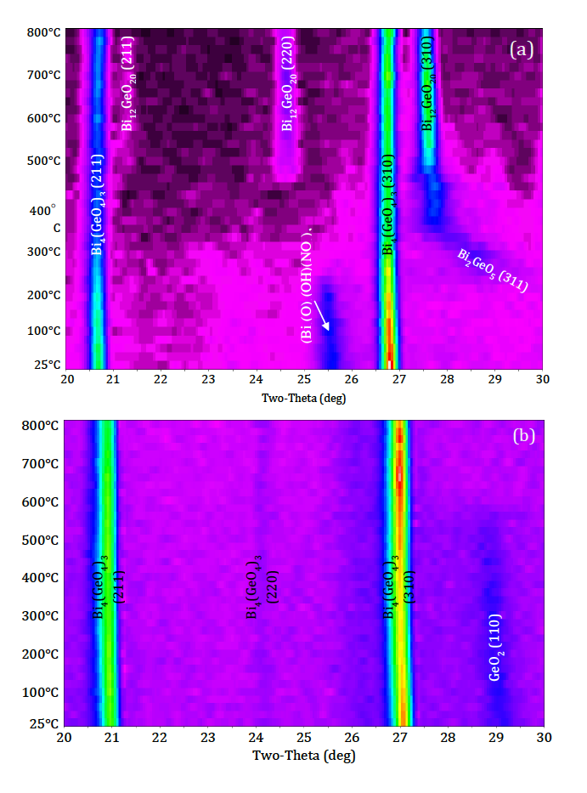
In some instances, thermal processing of the powders led to increased phase separation of what was originally relatively pure material. VT-PXRD experiments were therefore undertaken to explore this phenomenon while elucidating the various phase changes that occurred during thermal processing. Two samples were analyzed and are shown in Figure 5a (Bi-containing contaminant E-BGO; Figure S1c) and Figure S2 (optimized E-BGO with GeO₂ contaminant; Figure S1d). The initial sample investigated (note: this is a sample generated prior to optimization of the E-BGO) revealed a PXRD pattern that was E-BGO with the presence of two forms of bismuth oxide nitrate hydroxide contaminant, (Bi₂(O)₂(OH)(NO₃); PDF 04-012-5737)²⁰ and (Bi₃(NO₃)₃(O)₂(OH)₂; PDF 04-013-4109). These impurities are not unexpected with the stoichiometric synthesis originally used and the fact that these phases can be prepared hydrothermally at 190 ºC for 24 hours from ''Bi(NO₃)₃•5 H₂O'' and ''H₂O''. Two different atmospheres (air or N₂) were employed to determine how they would impact phase formation during the heat treatment cycle. For both samples, the major E-BGO component could be observed throughout the heat treatment, but the behavior of the sample’s impurities revealed some interesting results. Careful evaluation of the VT-PXRD scans reveal that changes occur as the room temperature sample was heated (under flowing UHP N₂). The Bi₂(O)₂(OH)(NO₃)²⁰ phase decomposes at about 220 ºC. This is quickly followed by the formation of a nano-grained (broad peak) by-product, which has been tentatively identified as a high-Bi containing intermediate (i.e., aurivillius: PDF 04-011-0087). The presence of excess Bi as a result of the decomposition of the Bi₂(O)₂(OH)(NO₃),²⁰ appears to drive a reaction of this Bi-rich phase with the eulytite phase. This results in the degradation of the E-BGO fraction and the growth of a Bi-rich sillenite phase (PDF entry 00-034-0096). The same sample heated under an air atmosphere showed nearly identical behavior. Therefore, alternative syntheses were necessary to optimize the E-BGO route and minimize Bi contaminant, which led to the use of excess GeO₂ (vide infra). As shown above, the VT-PXRD experiments reveal the importance of developing pure materials, as both Bi- or Ge-rich BGO samples can fail or degrade thermally.

