Supplementary Mateiral
The redox ability of photogenerated electrons and holes, which is closely correlated with the band position of semiconductor, is an important factor in affecting the photocatalytic activity of catalyst. Therefore, we calculated the band potential of ZHS and P25 based on the literature reported. The result is shown in Table SI and Fig. S1. The band potential of ZHS and TiO₂ is -0.19 and -0.29 eV. Considering that the potential of O₂/•O²⁻ is about -0.046 eV vs SHE. Both the photogenerated electrons on TiO₂ and ZHS can reduce O₂ to •O²⁻ species.
TABLE SI. Absolute electronegativity, estimated Band Gap, energy Levels of calculated conduction band edge, and valence band at the point of zero charge for TiO₂ and SnZn(OH)₆.
Semiconductor oxides | Absolute  electronegativity (X) (eV) | Calculated conduction band position (eV) | Calculated valance band position (eV) | Estimated  energy band  gap, E_{g} (eV)
TiO₂ | 5.81 | -0.29 | 2.91 | 3.20
ZHS | 6.408 | -0.19 | 4.12 | 4.31
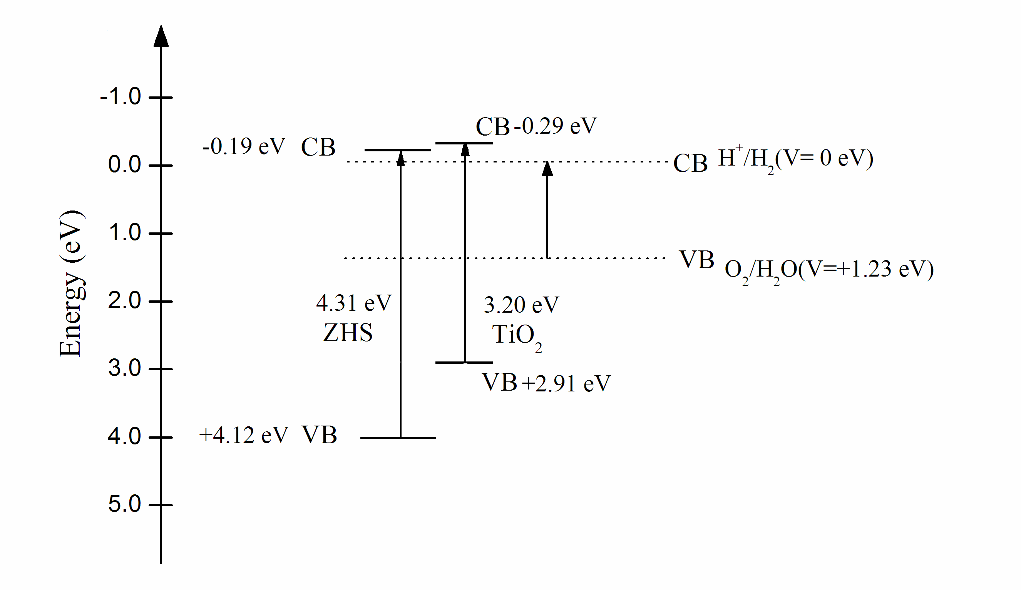
FIG. S1. Relationship between energy band gap of semiconductor and redox potentials of water splitting.

It is also found that RhB degradation over Ag/AgCl/ZHS with different Ag/AgCl contents all fits the pseudo-first-order kinetics. The linear plot of -ln(C/C₀) versus irradiation time t is shown in Fig. S2. It can be seen that S3 exhibited higher photocatalytic degradation rates than other two samples. The pseudo-first-order constant is also summarized in Fig. S2.
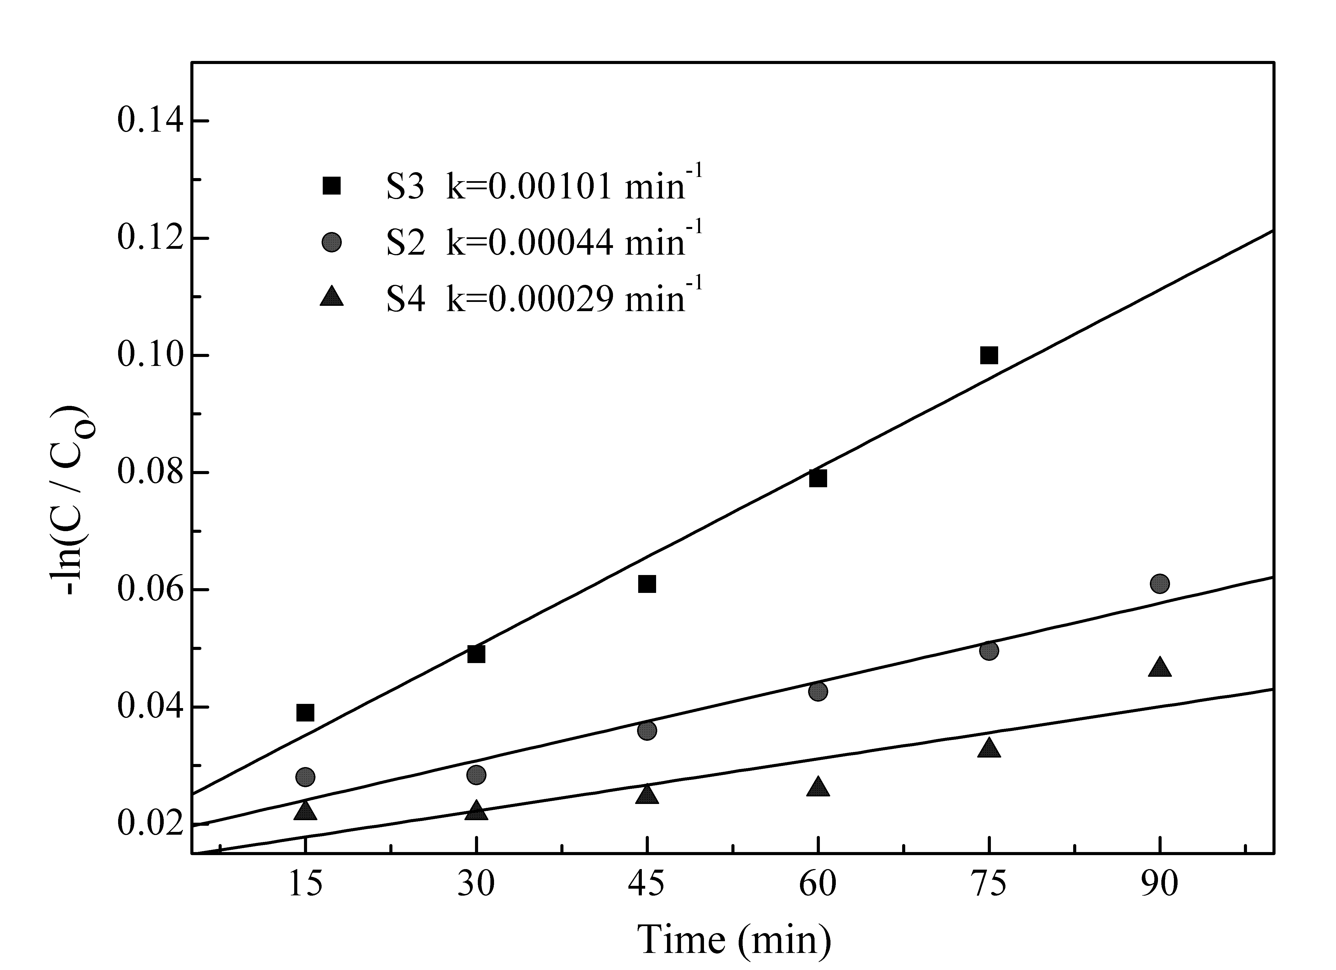
FIG. S2. Kinetic fit for the degradation of RhB with S3, S2 and S4 under visible light.

