Fig. 1
(a)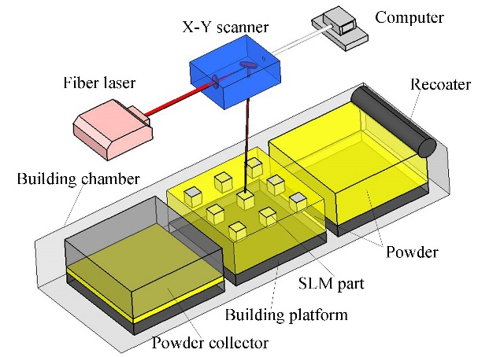 (b)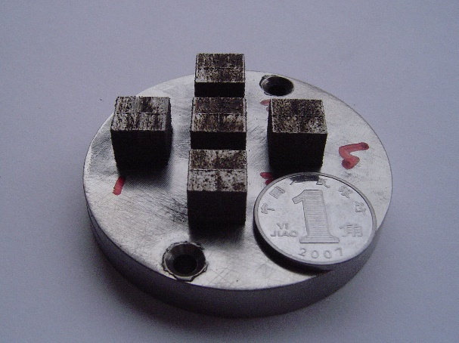

Fig. 1 (a) Schematic of selective laser melting process and (b) photograph of processed parts.

Fig. 2
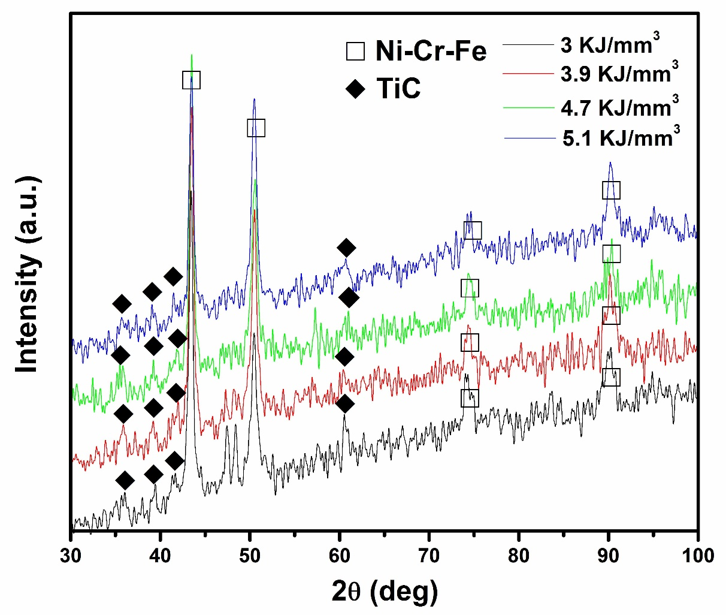
Fig. 2 XRD spectra of SLM-processed parts at different laser energy densities.

Fig. 3
(a)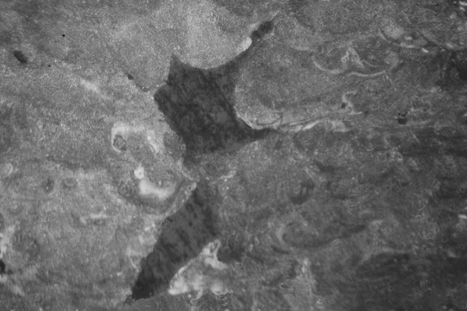 (b)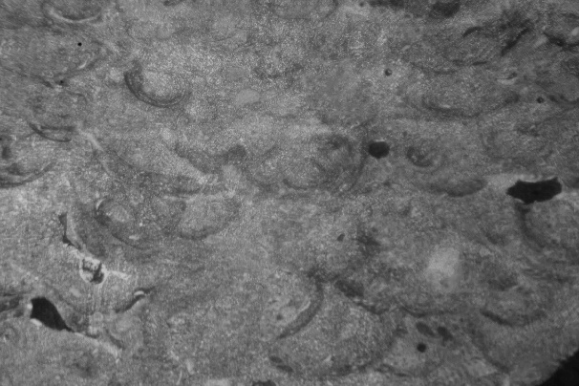
100μm
100μm
Pore chains
Interlayer micropores
(c)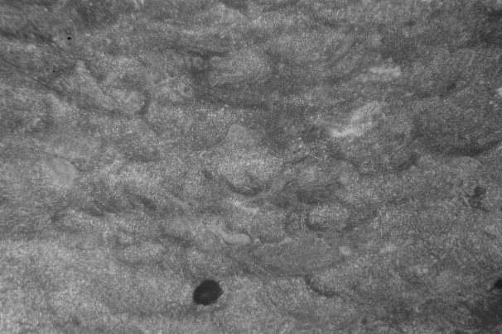 (d)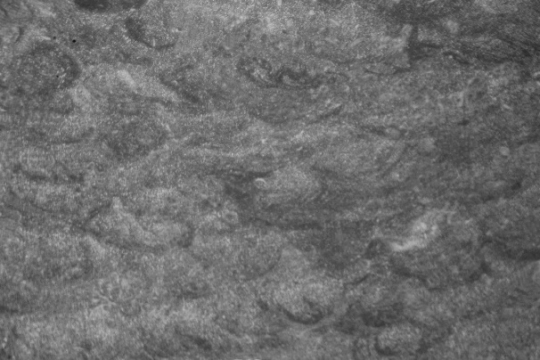
100μm
100μm
Fig. 3 Optical microscopy images showing interlayer microstructures of SLM-processed parts under different SLM conditions: (a) 3 KJ/mm³; (b) 3.9 KJ/mm³; (c) 4.7 KJ/mm³; (d) 5.1 KJ/mm³.

Fig. 4
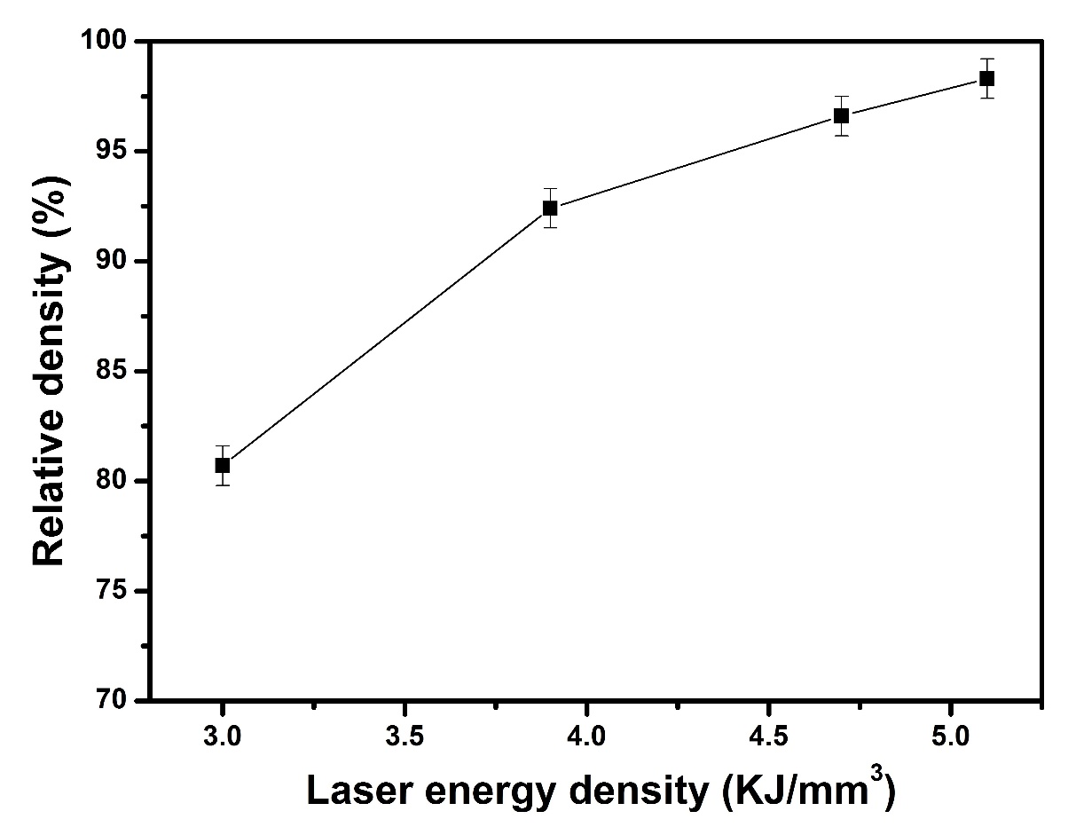
Fig. 4 Effect of laser energy density on densification response of SLM-processed parts.

Fig. 5
(a)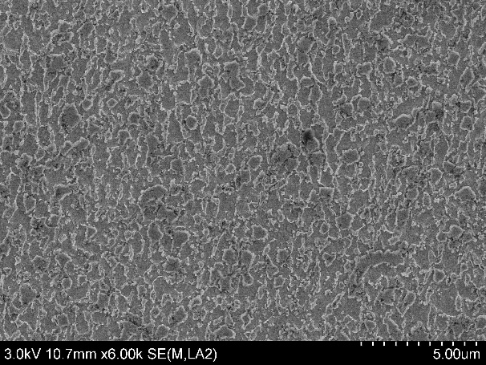 (b)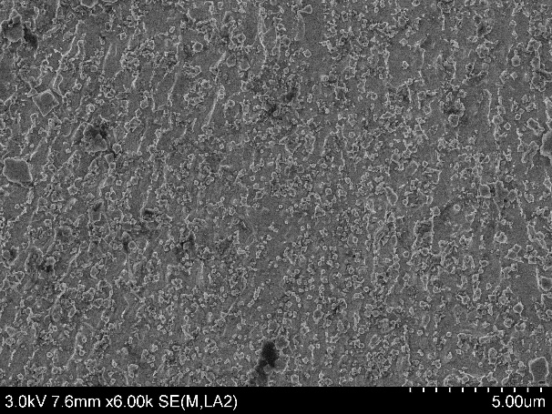
(c)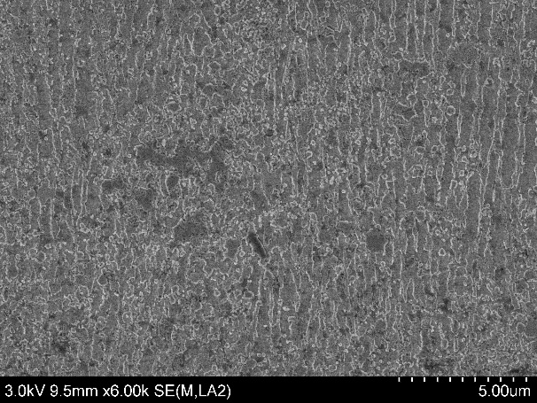 (d)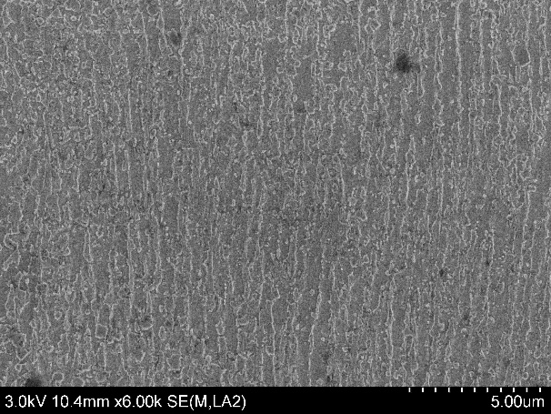
Fig. 5 SEM images showing typical microstructures on the etched vertical-sections of SLM-processed parts at different laser energy densities: (a) 3 KJ/mm³; (b) 3.9 KJ/mm³; (c) 4.7 KJ/mm³; (d) 5.1 KJ/mm³.

Fig. 6
(a)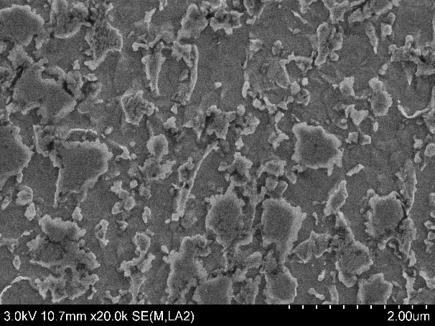 (b)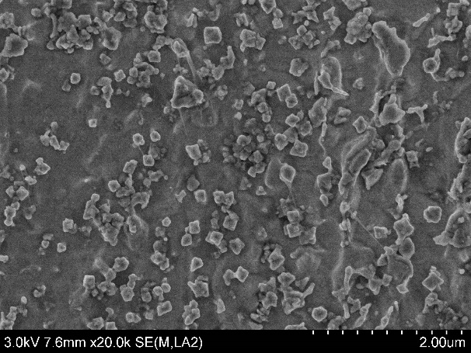
(c)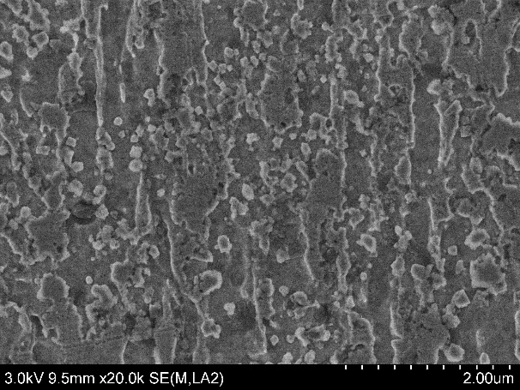 (d)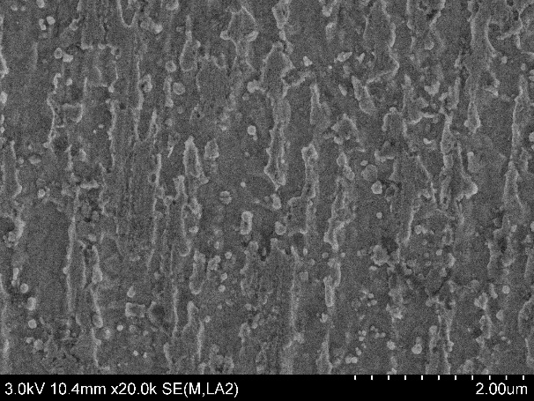
Fig. 6 High-magnification SEM images showing characteristic microstructures in SLM-processed parts in (a) Fig. 5a; (b) Fig. 5b; (c) Fig. 5c; (d) Fig. 5d.

Fig. 7
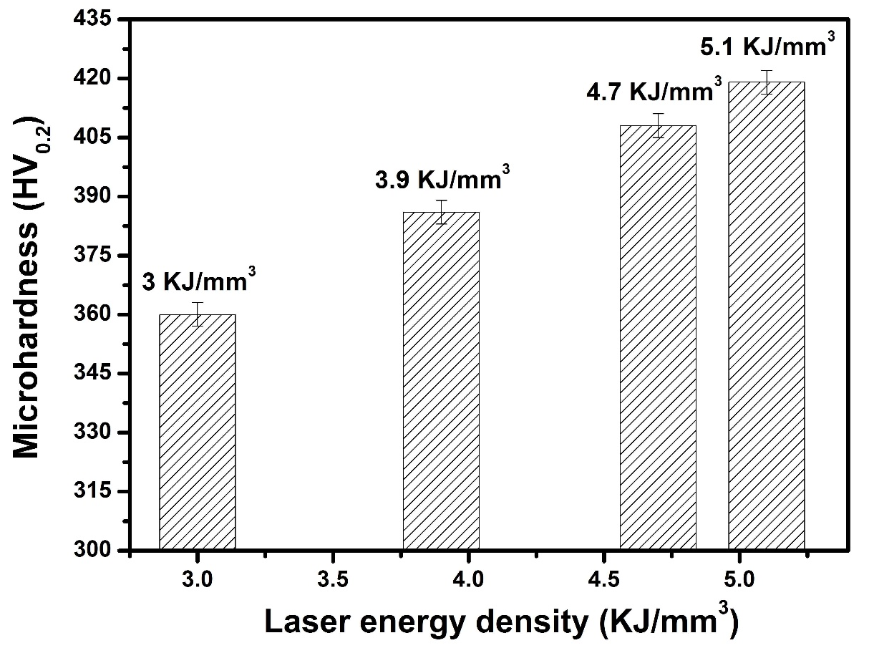
Fig. 7 Microhardness of SLM-processed parts under various SLM processing conditions.

Fig. 8
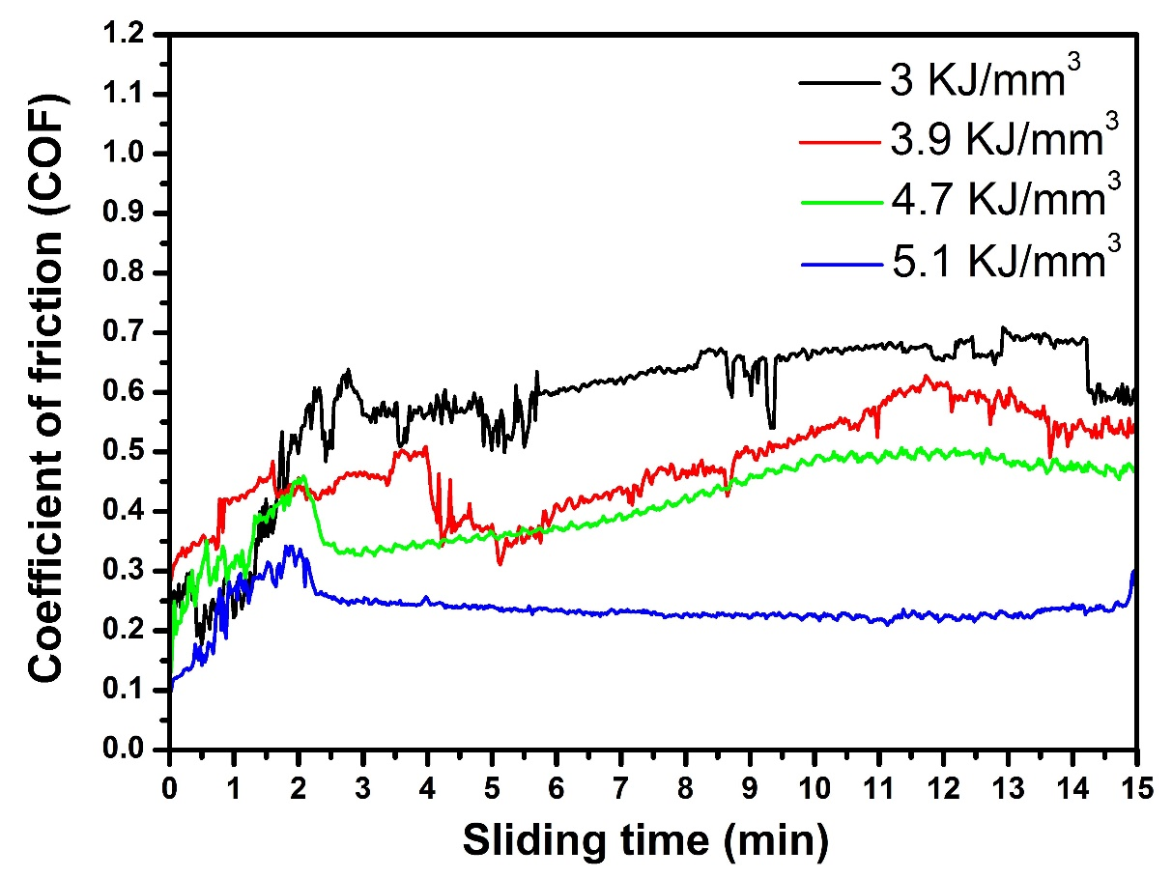
Fig. 8 Effect of laser energy density on COFs of SLM-processed parts.

Fig. 9
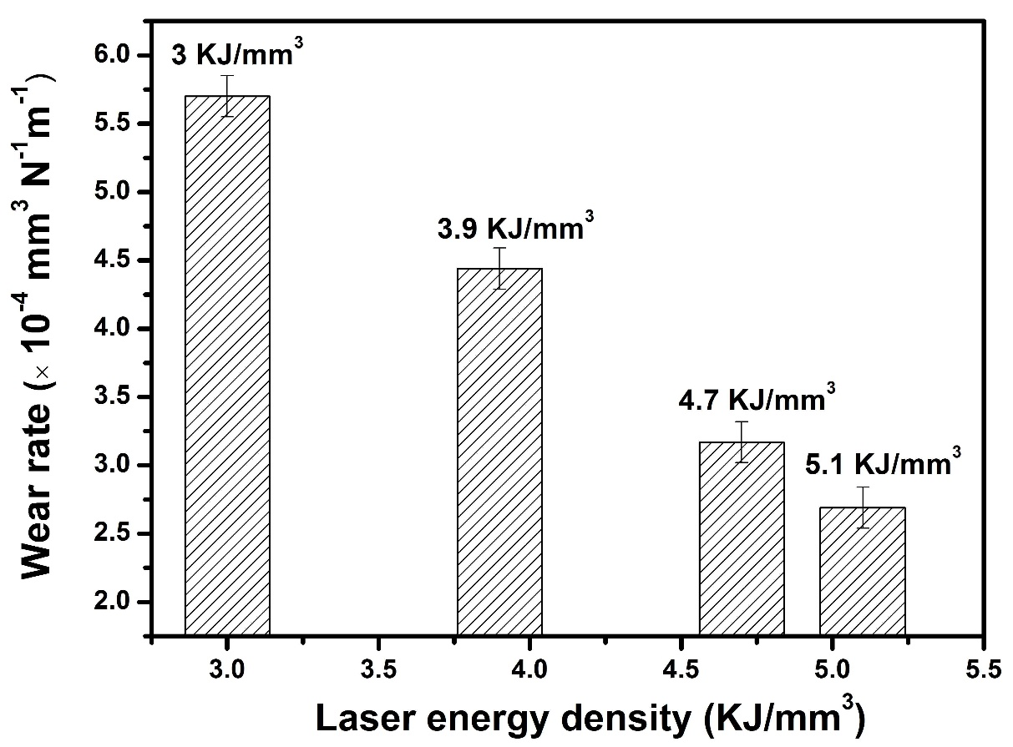
Fig. 9 Wear rates of SLM-processed parts using different processing parameters.

Fig. 10
(a)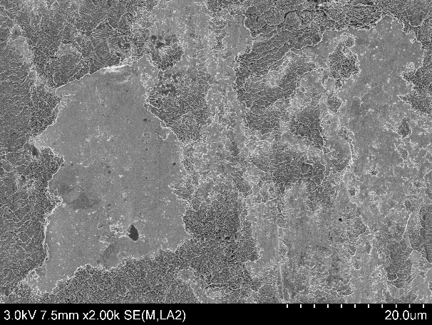 (b)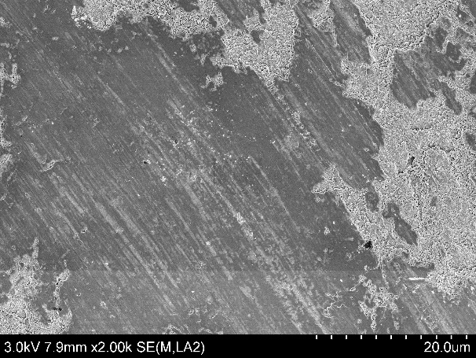
(c)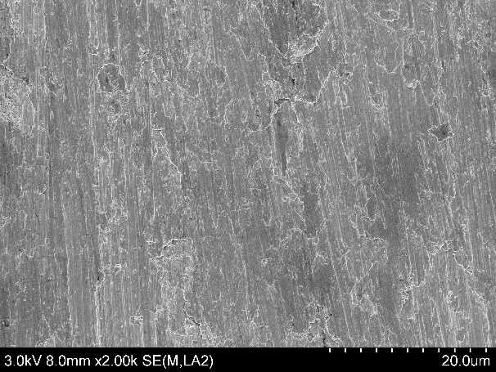 (d)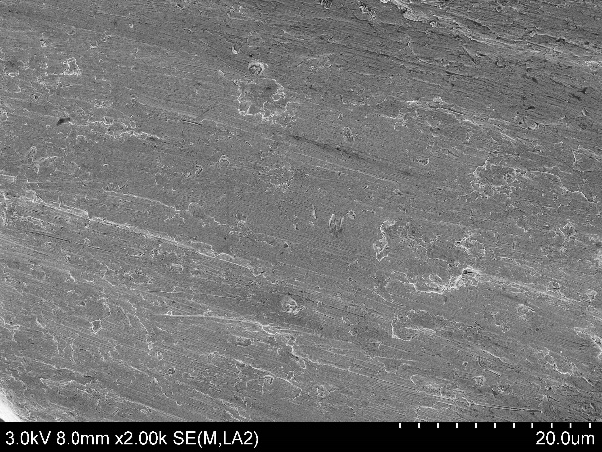
Fig. 10 SEM images showing worn surface morphologies on SLM-processed parts under various laser energy densities: (a) 3 KJ/mm³; (b) 3.9 KJ/mm³; (c) 4.7 KJ/mm³; (d) 5.1 KJ/mm³.

Fig. 11
(a)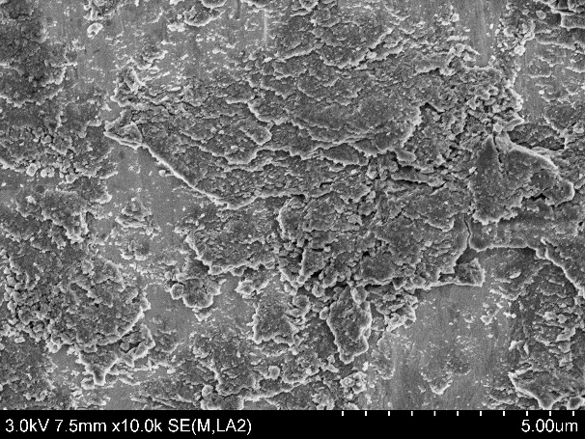 (b)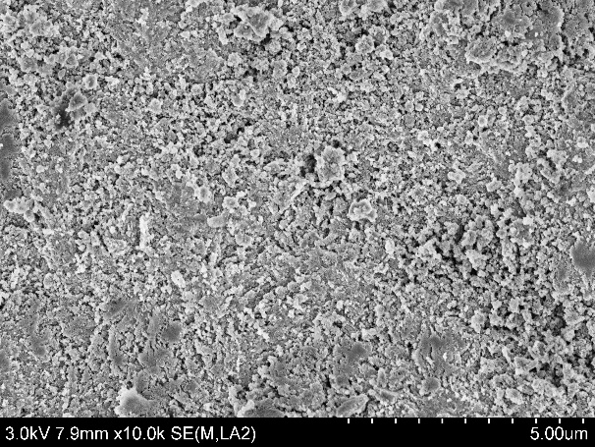
(c)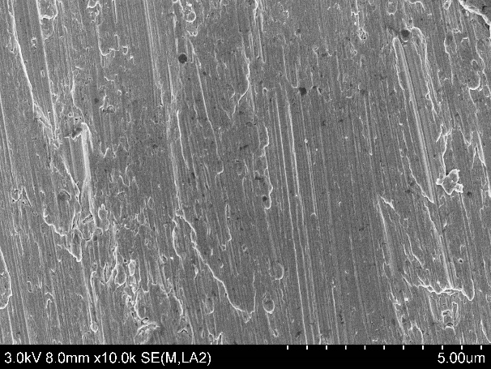 (d)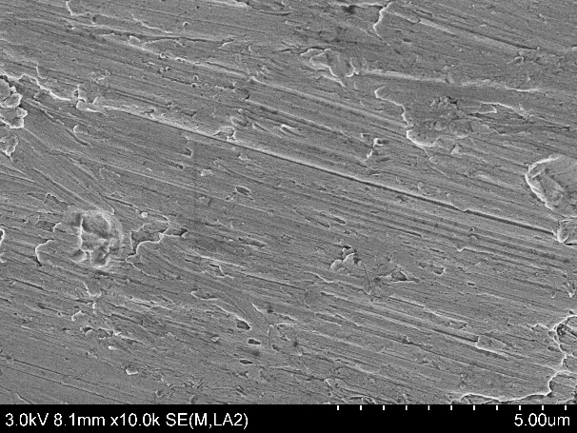
Fig. 11 High-magnification SEM images showing characteristic worn surface morphologies in SLM-processed parts in (a) Fig. 10a; (b) Fig. 10b; (c) Fig. 10c; (d) Fig. 10d.

