Supporting Materials

- Strain rate sensitivity (SRS) and activation volume
$σ=k⋅{\overset{˙}{ε}}^{m}$ (1)
$\text{ln}σ=\text{ln}k+m⋅\text{ln \{}\overset{˙}{ε}$ (2)
When we have two loading rates, i.e. ${\overset{˙}{ε}}_{1}$ and ${\overset{˙}{ε}}_{2}$, and the corresponding fracture strengths, $σ_{1}$ and $σ_{2}$, can be given in the following equations.
${\text{ln}σ_{1}=\text{ln}k+m⋅\text{ln \{}\overset{˙}{ε}}_{1}$ (3)
${\text{ln}σ_{2}=\text{ln}k+m⋅\text{ln \{}\overset{˙}{ε}}_{2}$ (4)
To cancel out k, Eq (3) minus Eq (4), we obtain,
$\text{ln}\frac{σ_{1}}{σ_{2}}=m⋅\text{ln}\frac{{\overset{˙}{ε}}_{1}}{{\overset{˙}{ε}}_{2}}$ (5)
To find out the maximal SRS, we use ${\overset{˙}{ε}}_{1}={\text{10}}^{−3}$ s⁻¹, $σ_{1}=\text{356 MPa}$,
${\overset{˙}{ε}}_{2}=\text{892}$ s⁻¹, $σ_{2}=8\text{64}\text{ MPa}$,
m_{max}=$\frac{\text{ln}\frac{σ_{2}}{σ_{1}}}{\text{ln}\frac{{\overset{˙}{ε}}_{2}}{{\overset{˙}{ε}}_{1}}}$=$\frac{\text{ln}\frac{\text{864}}{\text{356}}}{\text{ln}\frac{\text{892}}{{\text{10}}^{−3}}}$=0.06,
To find out the minimal SRS, we use ${\overset{˙}{ε}}_{1}={\text{10}}^{−3}$ s⁻¹, $σ_{1}=5\text{79}\text{ MPa}$,
${\overset{˙}{ε}}_{2}=\text{996}$ s⁻¹, $σ_{2}=\text{768 MPa}$,
m_{min}=$\frac{ln\frac{\text{768}}{\text{579}}}{\text{ln}\frac{\text{996}}{{\text{10}}^{−3}}}$=0.02,
Thus, the measured SRS ranges within 0.02~0.06.
The activation volume (v*) of plastic deformation is inherently related to the strain rate sensitivity^{S1} by
$v^{}=\frac{\sqrt{\text{3 }}⋅k⋅T}{σ⋅m}$ (6)

Here k is the Boltzmann constant (1.38×10⁻²³ m² kg s⁻²k⁻¹), T is absolute temperature, and $σ$ and m are respectively applied stress and SRS.
Here we take σ=864 MPa and m=0.06 to calculate the activation volume of plastic deformation at dynamic loading
$v^{}=\frac{\sqrt{\text{3 }}⋅1\text{.}\text{38}⋅{\text{10}}^{−\text{23}}⋅\text{293}}{8\text{64}⋅{\text{10}}^{6}⋅0\text{.}\text{06}}$=0.135 nm³ =2~3 b³ (︱b︱=0.38 nm for plane spacing in Figure 4 of our manuscript).
The activation volume under quasi-static loading is calculated as follows:

=0.994nm³=18 b³.

Here=356 MPa (we take the maximum compressive strength under quasi-static loading) and m=0.02 (we take m=0.02 in order to roughly estimate the maximum activation volume).
- Evaluation of fracture energy dissipation for dynamic/quasi-static compression.
For the quasi-statically compressed sample, the original sample geometry is 2mm x 2mm x 4mm. Upon fracture, the sample was roughly split into two parts with two fracture surfaces. The two fracture surface areas were estimated to be the total of 16mm²(2mm x 4mm x 2).
For the dynamic case, the pristine geometry is 3mm x 3mm x 3mm. The average fragment size is approximately 0.154mm. Here we treat each fragment as an ideal cube. Thus, the created surface area can be estimated to be the total of
$${}^{{\left(\frac{\text{3mm}}{0\text{.}\text{154mm}}\right)}^{3}∗6∗{\left(0\text{.}\text{154}\text{mm}\right)}^{2}−6∗{\left(3\text{mm}\right)}^{2}=\text{998}{\text{mm}}^{2}}$$

Fig. S1. Schematic illustration of dynamic compression process, for simplicity, each irregular-shaped fragment is treated as an idea cube.

Here we introduce k (J/mm²) as the fracture energy and assume it to be a constant. When we consider the volume effect (sample geometry), we can further obtain the fracture energy dissipation per unit volume, as follows.
For the quasi-static case, the fracture energy dissipation per unit volume is 16mm² k/2mm x 2mm x 4mm=1 J/mm³.
For the dynamic one, the fracture energy dissipation per unit volume is 998mm² k/3mm x 3mm x 3mm=37 J/mm³. Thus, the ratio of energy dissipations of dynamic fracture to that of the quasi-static fracture is 37.

- Fractograph observation of dynamic compression nacre along cross section
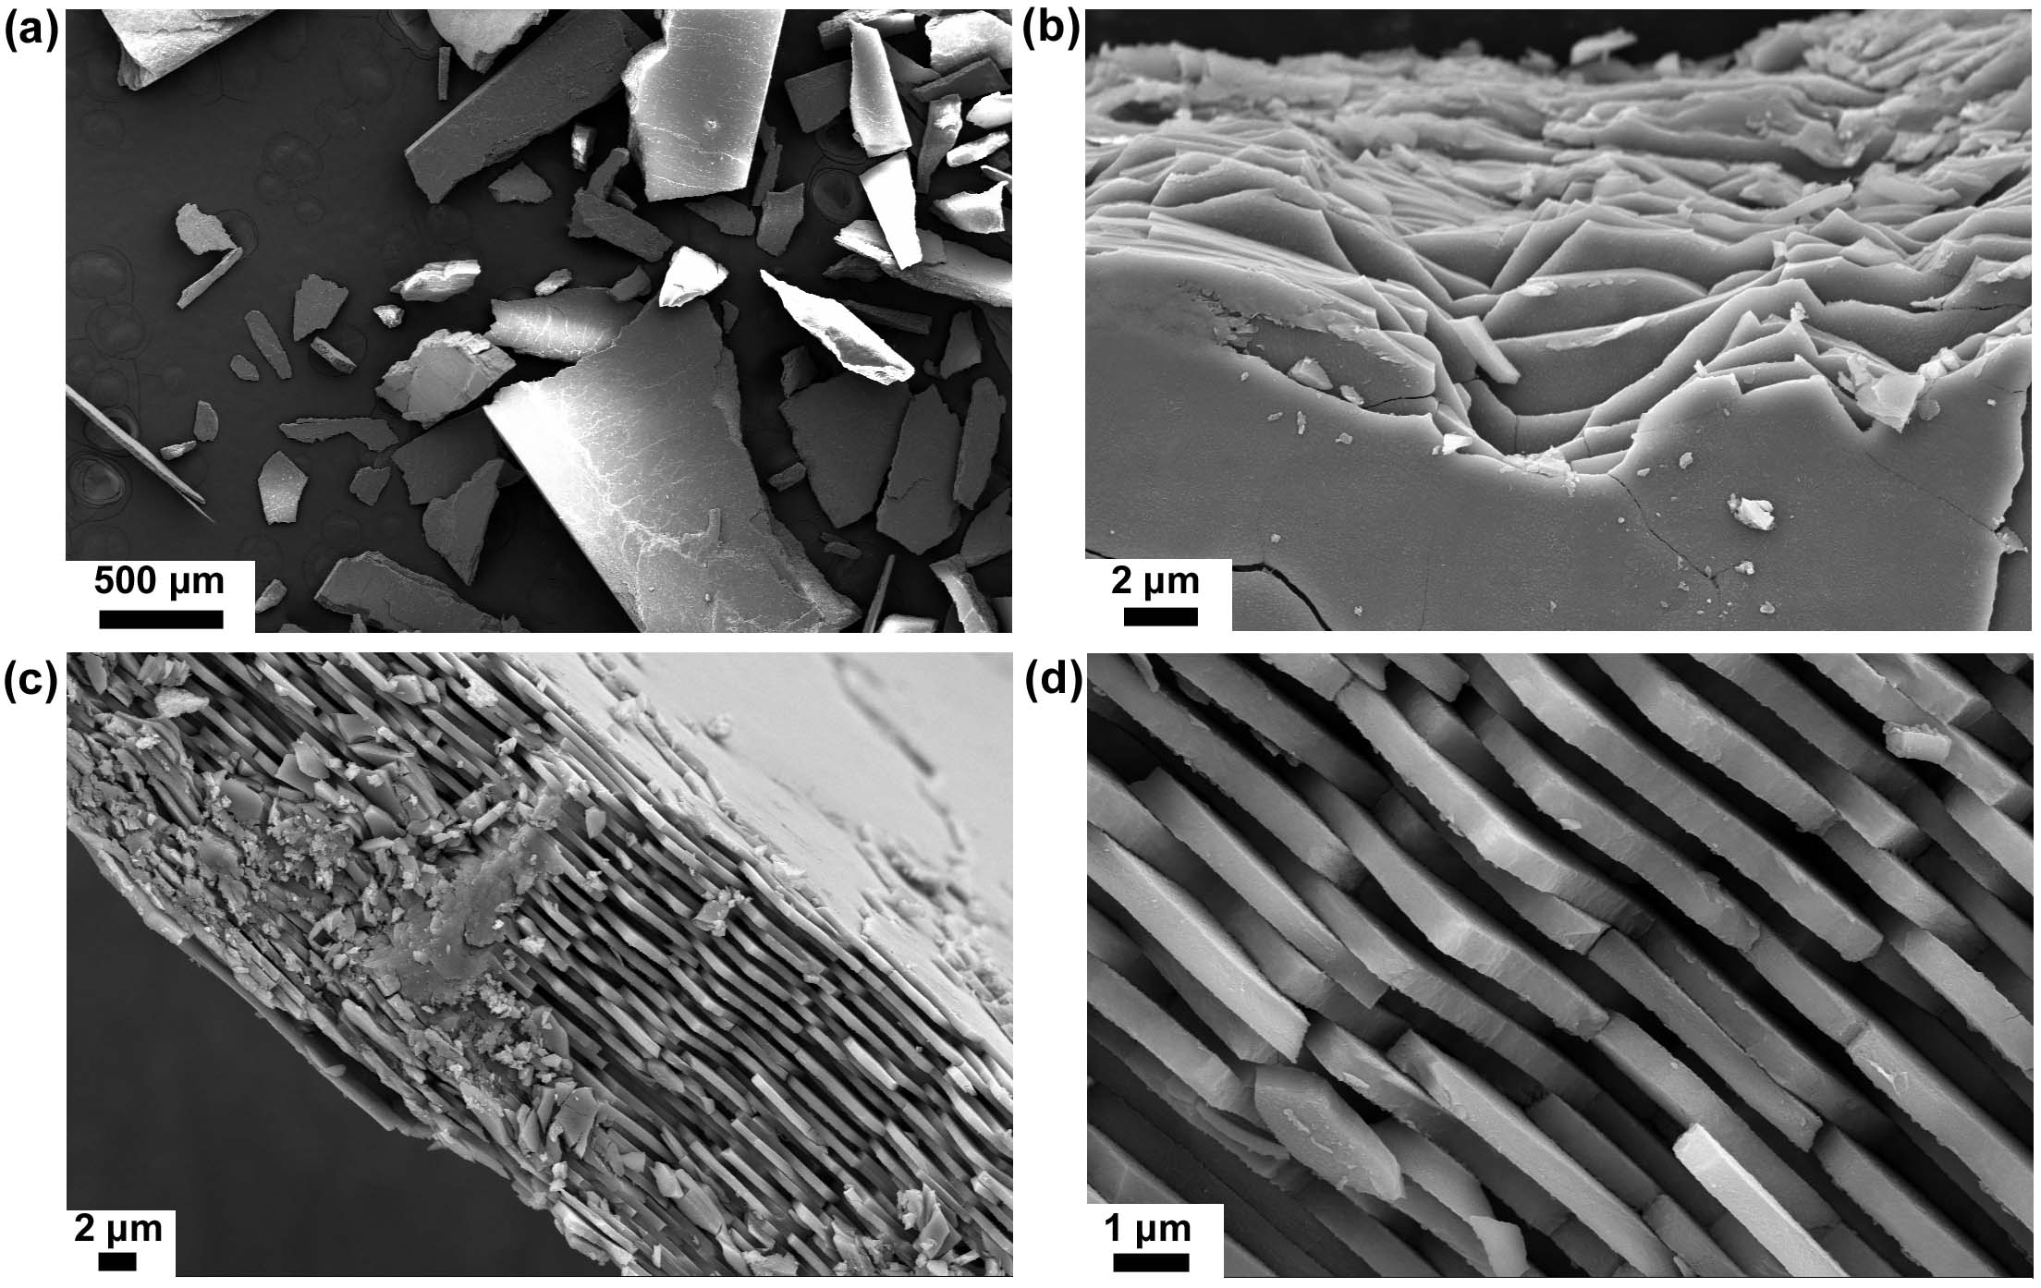
Fig. S2. Fractography observation in the dynamically-compressed nacre along cross section. (a) The fragment size distribution is typically in the range of submillimeter. (b) The fracture surface viewed from c-axis shows that crack propagates, to a large extent, along the biopolymer interface. (c) Microscopic observation on the cross section confirms the interface-dominated crack failure. (d) A close-up examination shows that the aragonite platelets remain comparatively intact.

- Schematic illustrations of crack propagation when loading from c-axis and cross section, respectively.
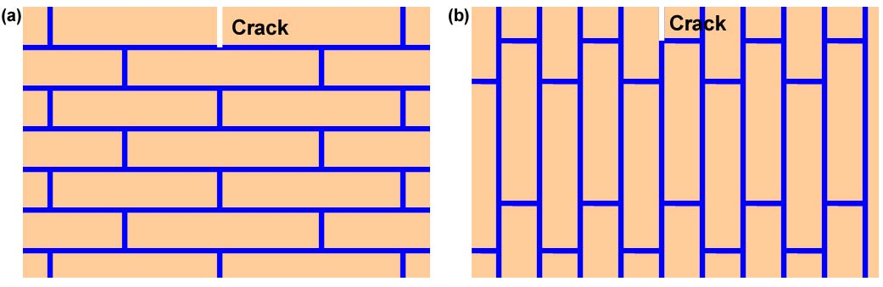
Fig. S3. Effect of loading direction on the potential crack path. (a) When loading along nacre’s c-axis, the geometrically staggered aragonite platelets posts a critical crack extension resistance. (b) Comparatively, the biopolymer interface favors the crack propagation (stress release) while loading direction is along nacre’s cross section.

