Synergistic Effect of Binary Ligands on Nucleation and Growth /Size Effect of Nanocrystals; Studies on Reusability of the Solvent
Chandan H. R, Saravanan V, Ranjith Krishna Pai and Geetha R Balakrishna*
Centre for Nano and Material Sciences, Jain Global Campus, Jain University, Bangalore Rural -562112, India
Table 1: Comparison of nOD and ODE properties
Solvent | Heat Capacity | Viscosity | Boiling Point | Melting point
n-octadecane (nOD) | 1.712  J/gK | Solid at STP | 317° C | 26° C-30° C
1-Octadecene (ODE) | ------ | 0.00432pa s | 179°C at 15mm Hg(lit) or 315°C | 15°C

Table 2. Analysis of peak area for the second time recovered nOD in GCMS report
 | Peak |  | R.T. |  | Height |  | Area |  | Pct Max |  | Pct Total
1 |  | 5.039 |  | 141631 |  | 7194923 |  | 0.37 |  | 0.352
2 |  | 5.207 |  | 1726227 |  | 72820164 |  | 3.72 |  | 3.763
3 |  | 5.401 |  | 27651894 |  | 1.95E+09 |  | 100 |  | 95.604
4 |  | 6.013 |  | 130646 |  | 3626153 |  | 0.19 |  | 0.147
5 |  | 6.601 |  | 37832 |  | 475498 |  | 0.02 |  | 0.114
Table 3. Analysis of peak area for the recovered ODE in GCMS report  Peak |  | R.T. |  | Height |  | Area |  | Pct Max |  | Pct Total
1 |  | 3.24 |  | 193212 |  | 13709450 |  | 1.06 |  | 0.490
2 |  | 3.855 |  | 3521469 |  | 77663689 |  | 3.45 |  | 2.348
3 |  | 4.815 |  | 3411369 |  | 73641668 |  | 3.19 |  | 2.05
4 |  | 5.087 |  | 2506878 |  | 1.68E+08 |  | 7.47 |  | 4.209
5 |  | 5.359 |  | 28962523 |  | 2.25E+09 |  | 100 |  | 66.004
6 |  | 5.584 |  | 9944371 |  | 2.69E+08 |  | 11.96 |  | 12.108
7 |  | 7.03 |  | 985826 |  | 28408357 |  | 1.26 |  | 4.51
8 |  | 7.653 |  | 555330 |  | 17514819 |  | 0.78 |  | 3.021
9 |  | 8.301 |  | 1406140 |  | 32428267 |  | 4.21 |  | 5.26

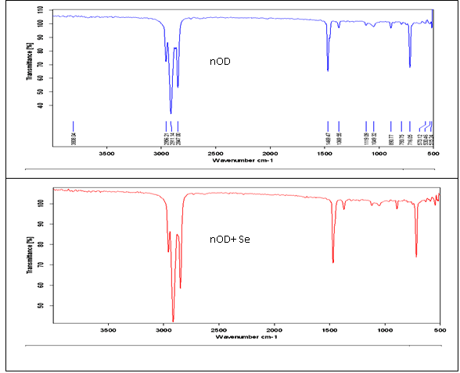
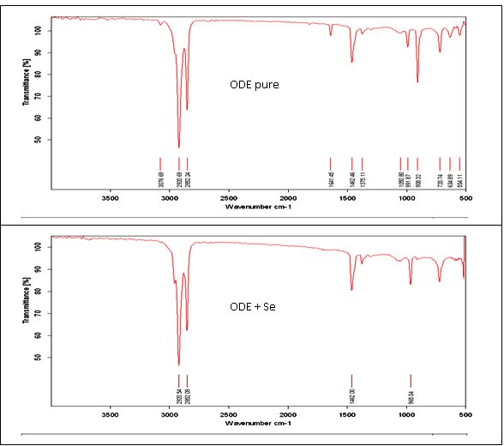
Figure 1 ATR IR spectra depicting the reaction of the solvent ODE with Se (resulting in a loss of double bond characteristics) unlike the nOD solvent

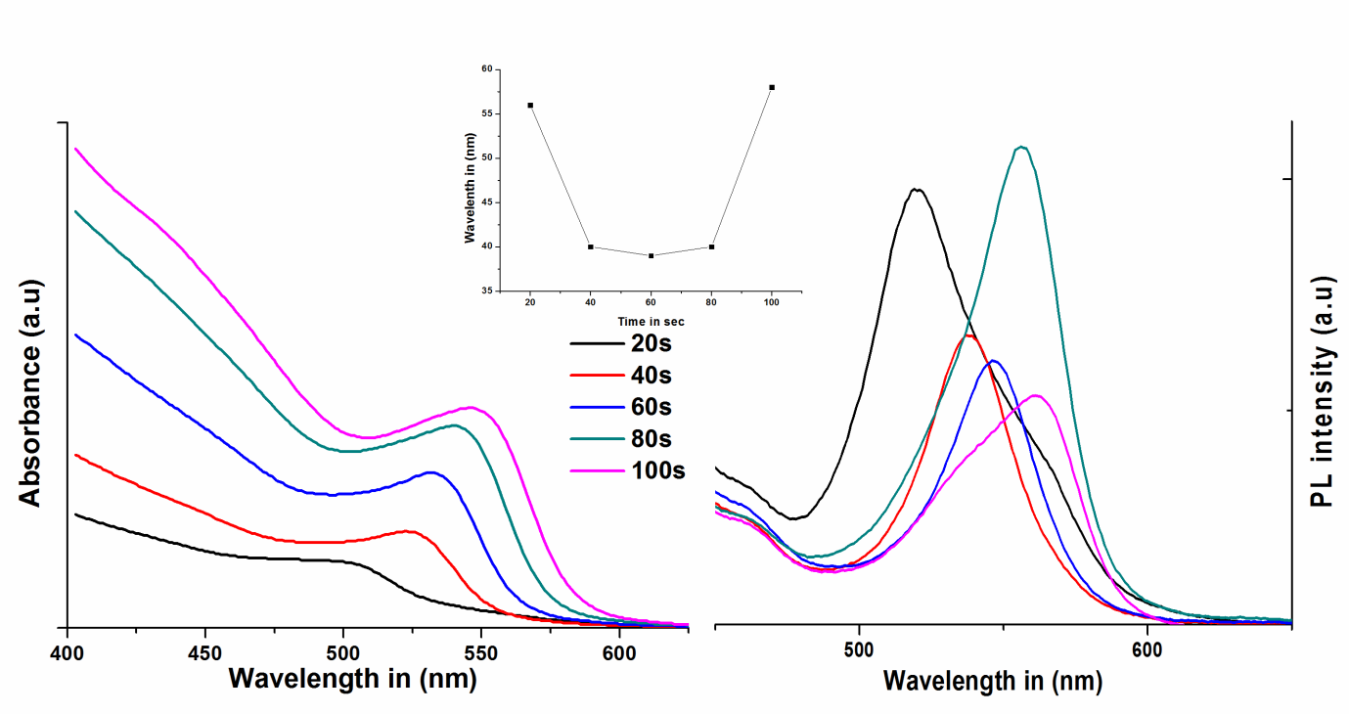
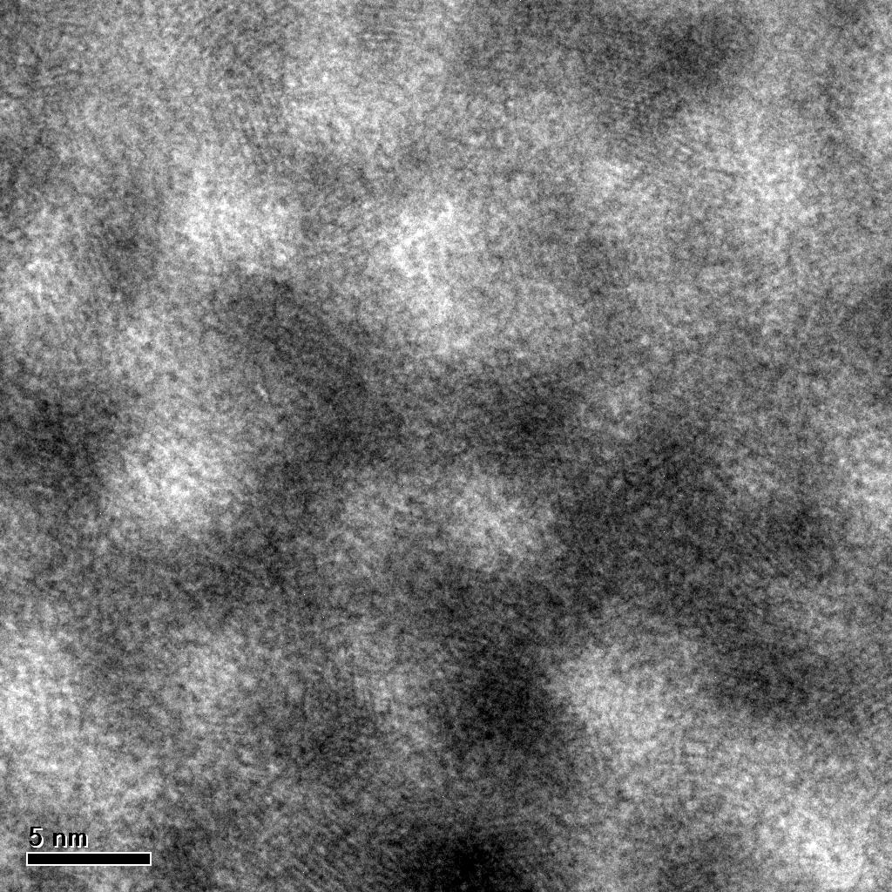

b
c
a

Figure 2. a) TEM b) UV- Visible and c) PL spectra of the QD’s synthesized using recovered solvent, Inset; effect on FWHM (dispersity) as a function of time

Figure 3. IR spectrum of 1-heptadecanol

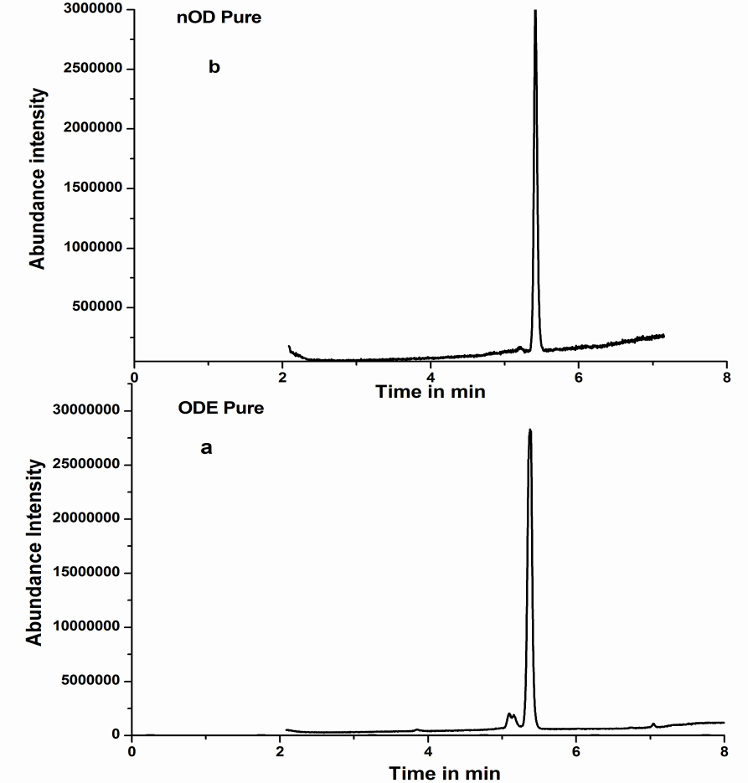

Figure 4. Total ion chromatogram of nOD and ODE pure samples before synthesis.

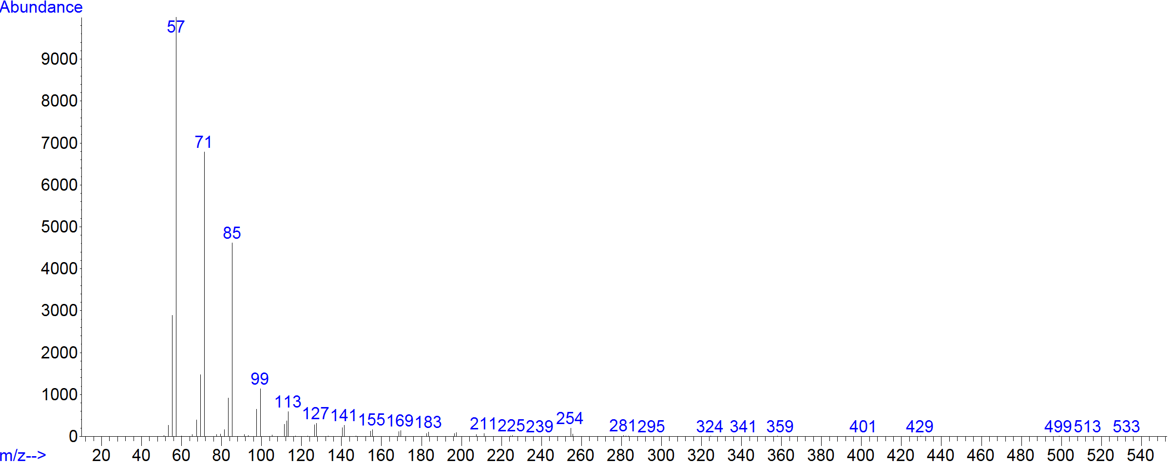
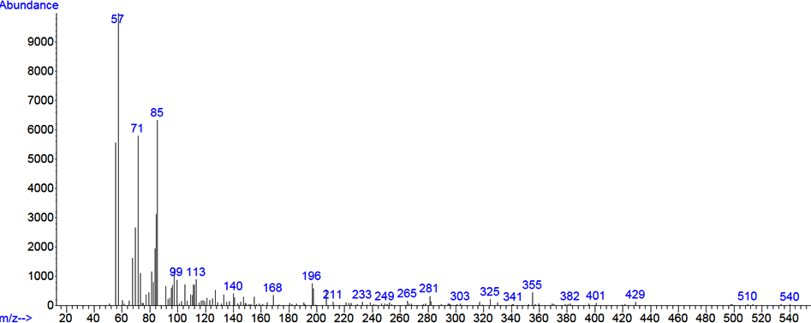
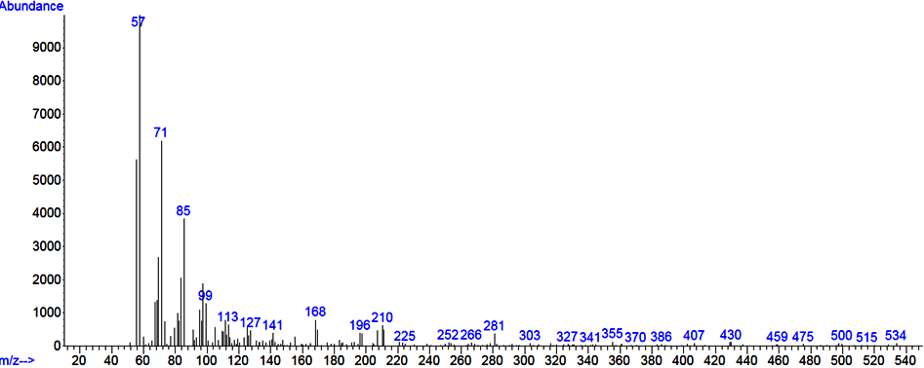
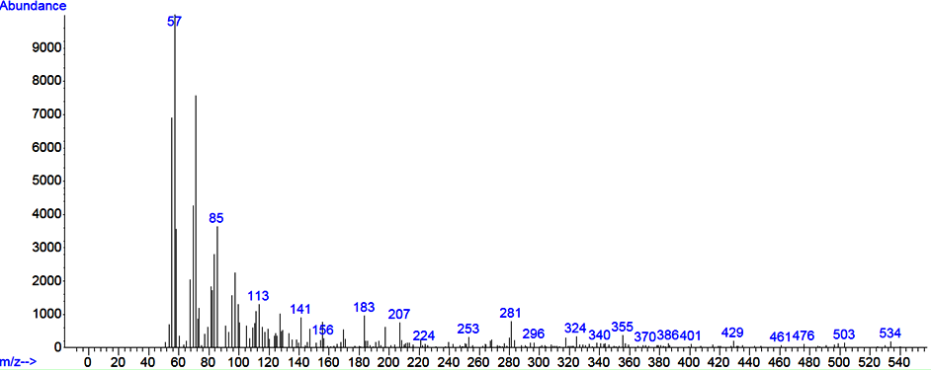
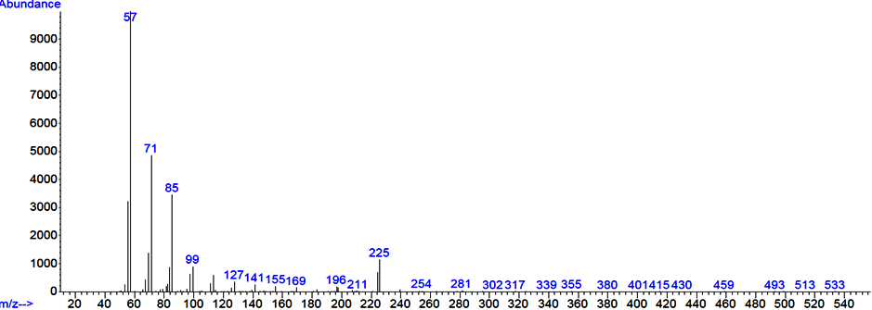
a
b
c
d
e

Figure 5: Electron ionization (EI) mass spectra of the detected peaks at the retention times (RTs) a) 5.4 min; m/z of 254 for nOD b) 5.038 min; m/z of 226 for 4-ethyl tetradecane c) 6.01 min; m/z of 324 for n- tricosane d) 6.601min; m/z of 296 for 2-methyl Eicosane and e) 5.207 min; m/z of 254 for 3-methyl heptadecane

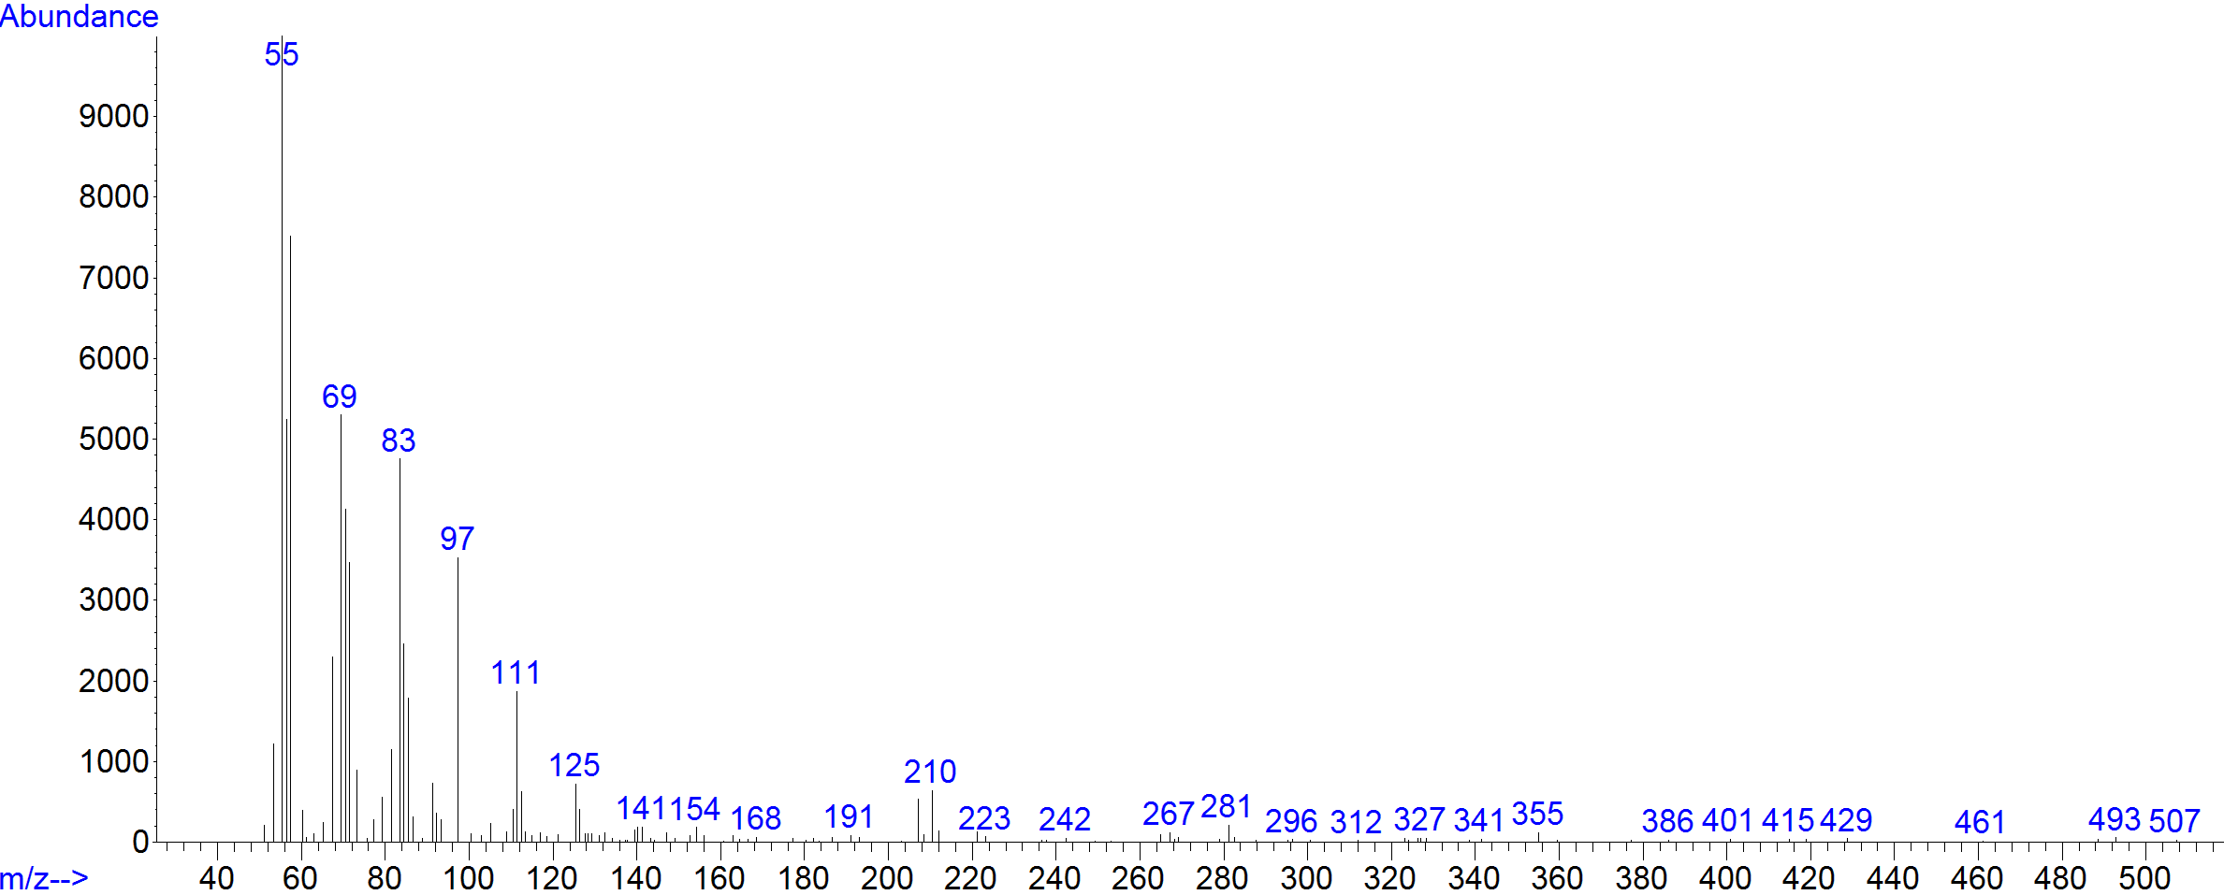
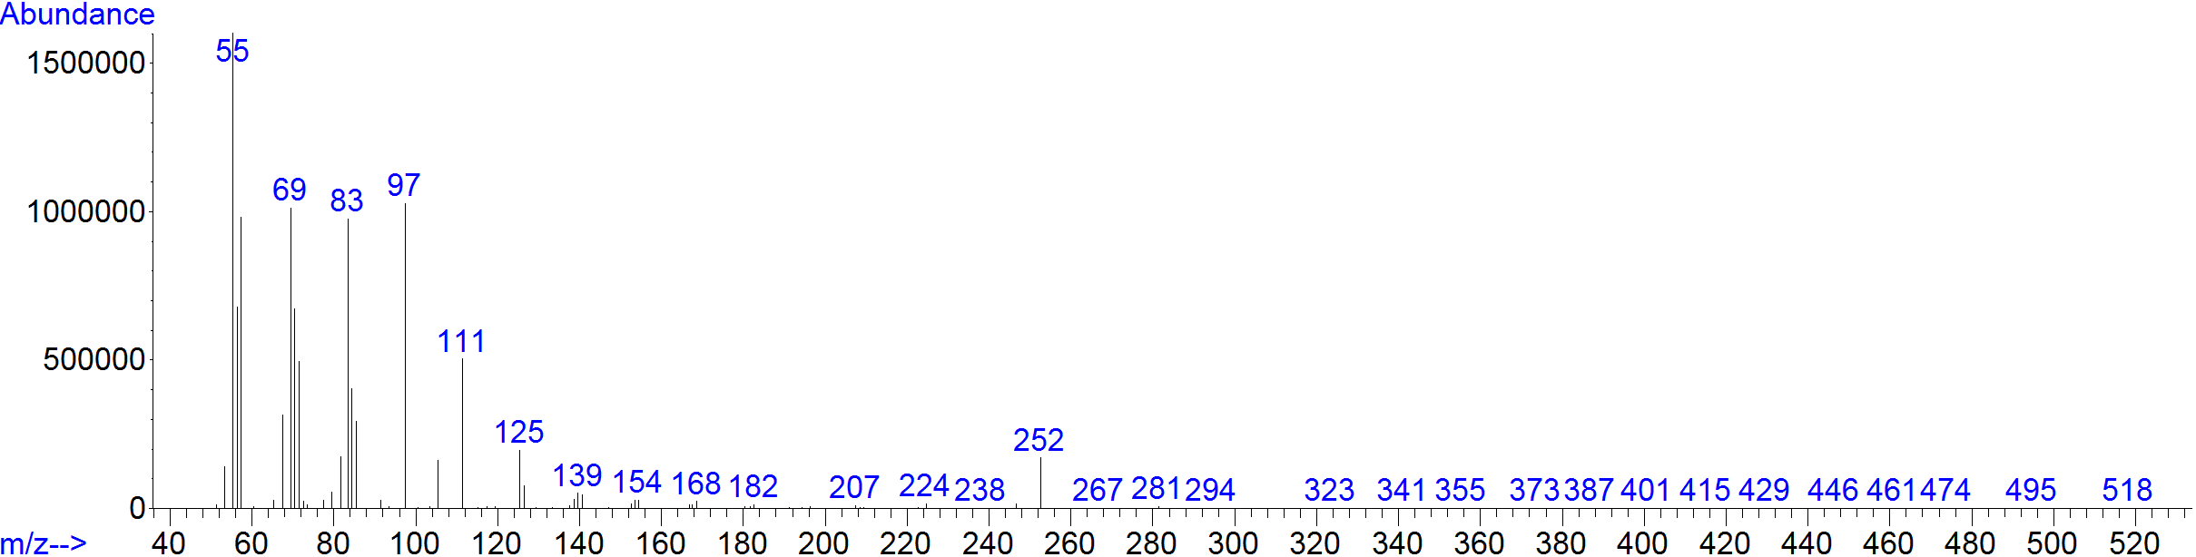
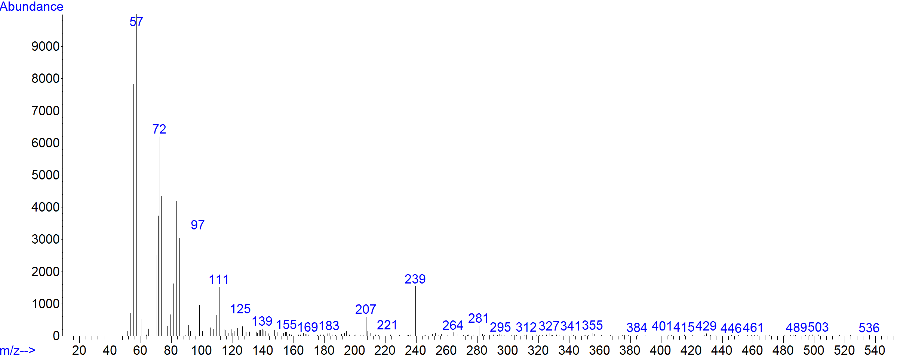
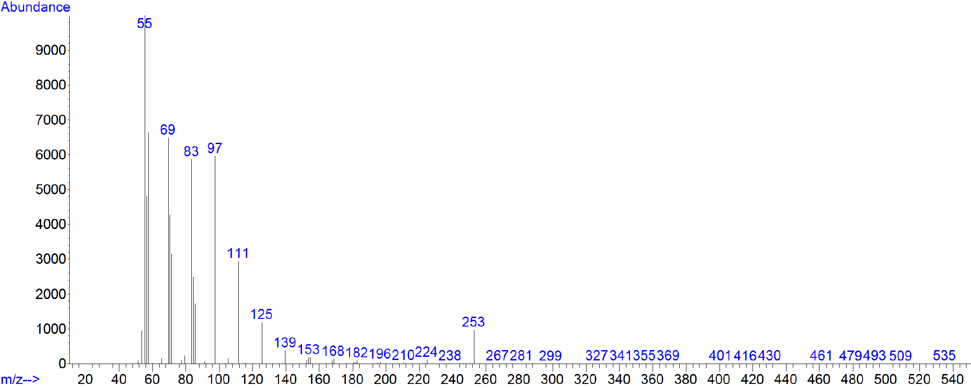
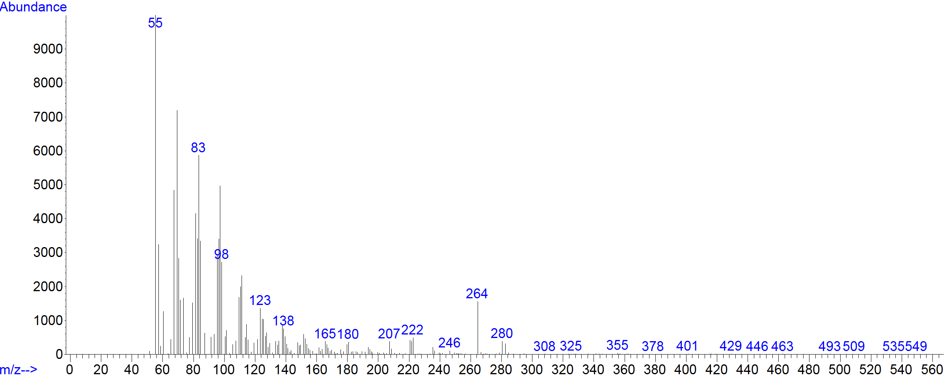
a
b
c
d
f
e

Figure 6. Electron ionization (EI) mass spectra of the detected peaks at the retention times (RTs) a) 5.35 min; m/z of 252 for ODE b) 3.24 min; m/z of 210 for methyl-7,9-tridecadienylether c) 5.585 min; m/z of 256 for 1-heptadecanol d) 7.029 min; m/z of 322 for 9-tricosene e) 7.641 min; m/z of 210 for cyclopentadecane f) 8.031 min; m/z of 282 for 6- octadecenoic acid

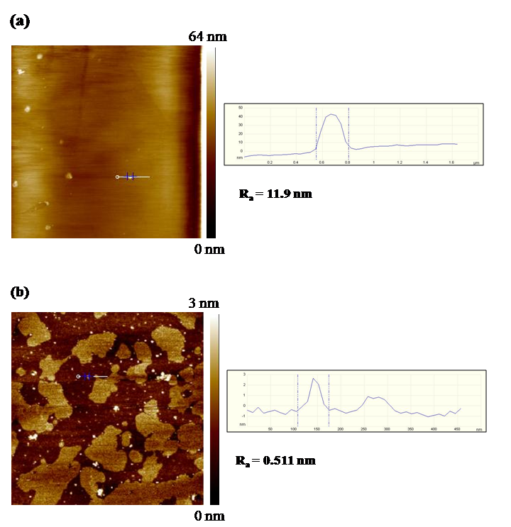
Figure 7. Depicting the growth and nucleating phase in single ligand (a) OA and (b) ODA with scan area of 2X2 µm

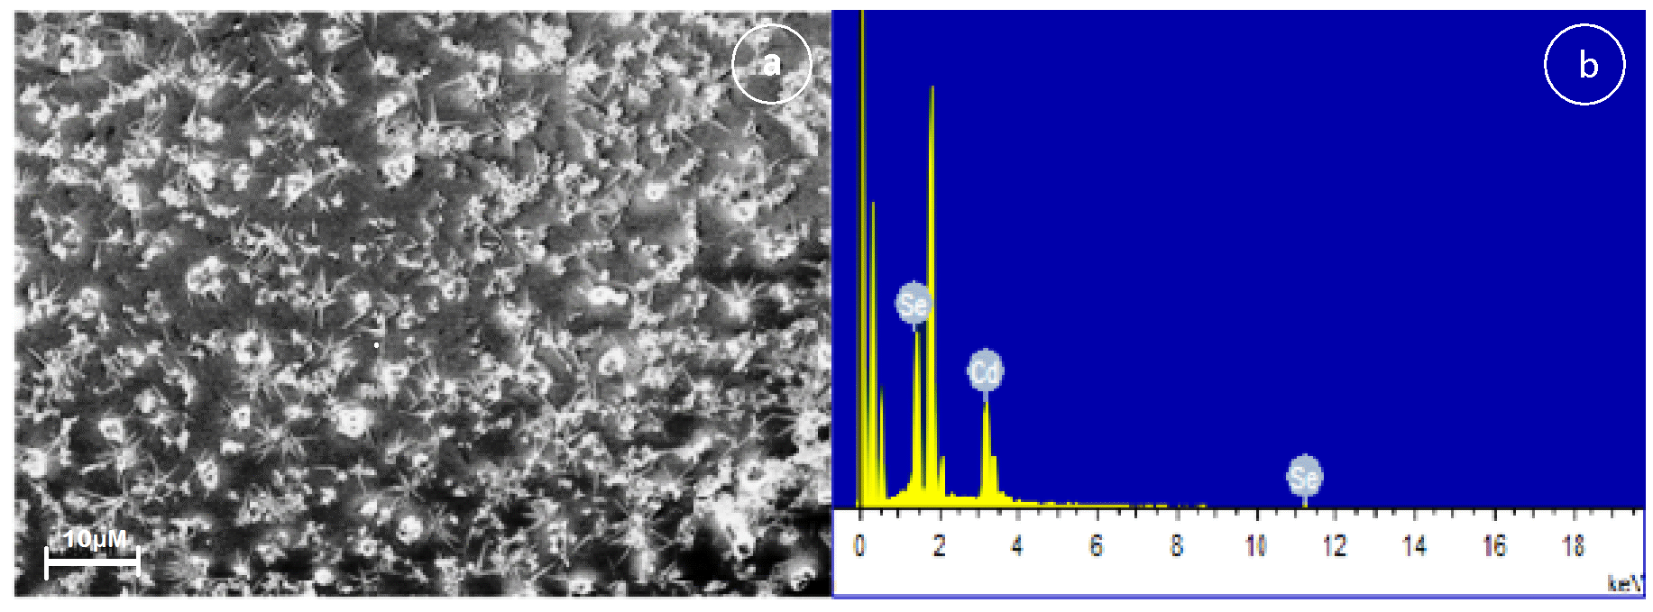
Figure 8. a FESEM image of the CdSe quantum dots showing fractal structure with corresponding EDS spectra of NCs t = 120 secs

Time in seconds (sec) | Particle size by UV- Visible (nm) | Crystallite size by XRD (nm) | TEM  ( nm) | AFM  ( nm)
20 | 2.32 | 0.9 | 3±0.11 | -
60 | 2.86 | 1.0 | 3.5±0.1 | 4±0.3
120 | 3.56 | 1.17 | 4.0±0.1 | 6±0.5

Table 4. particle size of NCs analysed by different techniques

