Supporting information

S1. Control and characterization of Gd₂O₃ nanoplates
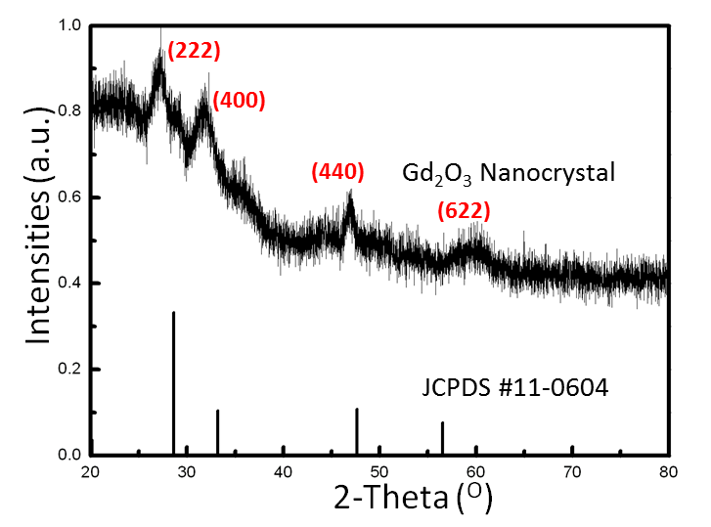
FIG.S1. XRD pattern of Gd₂O₃ nanocrystal. All peaks are assigned to standard reference (JCPDS #11-0604).

Figure. S1 showed the XRD of Gd₂O₃ nanocrystals with hydrophobic surfactant and the vertical bars below are the corresponding standard card of Gd₂O₃. For the pure Gd₂O₃, the (222), (440) and (622) peaks have distinct intensities, corresponding to a cubic crystal group. Comparing with the standard data, the X-ray peak positions and intensities generally match well with the reference (Gd₂O₃, pdf file No. 11-0604).

S2. TEM of the plate shape Gd₂O₃ before emulsion with PMAO-g-PEG

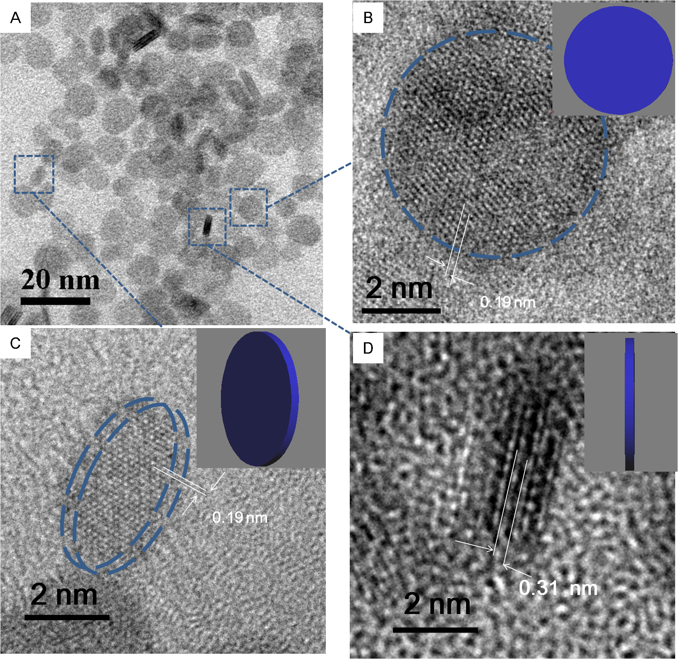
FIG.S2. TEM images of Gd₂O₃ of same branch, (A) in low magnitude, (B) in sphere shape, (C) in in long oval shape and (D) in rod shape; (B),(C) and (D) insets: 3D models of the plate in different orientations respectively; dashed blue curves highlighted the (222) facets of Gd₂O₃

FIG.S2 showed the TEM images of the Gd₂O₃ nanoplates when the oleic acid amount was optimized to 2 µl. In this 2-D TEM image of FIG.S2(A), two types of particle morphologies, rod shaped and round shaped, were easily demarcated. More details can be found in high magnitude TEM of the same branch. FIG.S 2(B), (C) and (D) are three typical single Gd₂O₃ nanoplates in same scale. FIG.S 2(B) and (C) revealed the crystalline fringes of cubic crystal group with lattice spacing of 0.19 nm, which was characteristic of vector <101> of Gd₂O₃, corresponding to the (222) facet. Dashed blue curve highlighted outline of the (222) facet, which matched with the prediction from 3D models. Moreover, FIG.S2(D) exhibited the rod shaped image with spacing of 0.31 nm, which was plane spacing of (222). So it believed that rod shape particles in FIG.S2 (A) were the projection of the standing nanoplates.

S3. Chemical Structure Analysis of PMAO-g-PEG

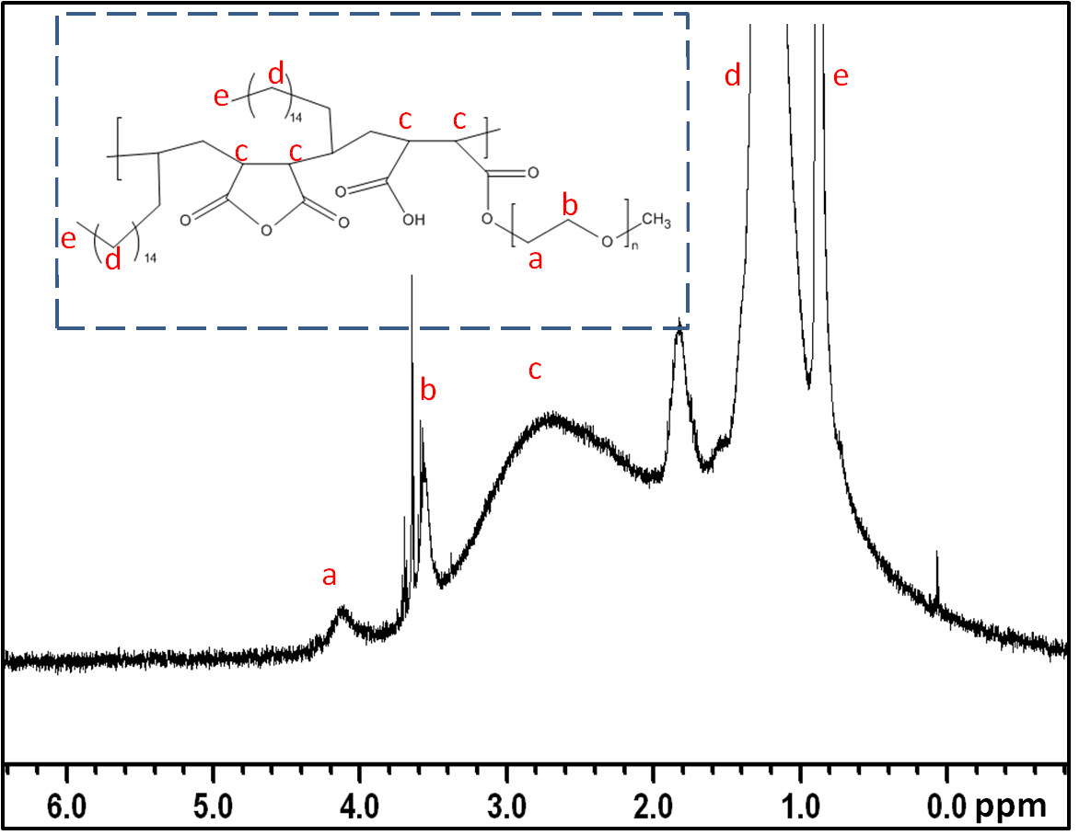
FIG.S3. 1H NMR spectrum of PMAO-g-PEG in CDCl₃. (Solvent peaks at 7.28 ppm), and 5 distinct peaks are indicated by red alphabetic symbols a to e. Theoretical formula predicted by the Chemdraw Ultra 8.0 was present in dashed line box at the up-left corner.

From the NMR spectrum (FIG.S3), the characteristic peaks of –CH₃ and –CH₂ of C₁₈ alkyl chain (octadecene) of the hydrophobic section of PMAO were observed around 0.9 ppm (e) and 1.2-1.3 ppm (d) respectively. The acid catalyzed esterification reactions would open the succinic anhydride ring, leaving one carboxylic acid and one ester bond between PMAO and PEG. The presence of PEG was confirmed by the characteristic chemical shift of the PEG chain at 3.6-3.7 ppm (b) and 4.0-4.25 ppm (a). The chemical shifts for PMAO-g-PEG:¹H-NMR (300MHz, CDCl₃), δ: 0.9 ppm (e; –CH2–CH2–CH₃), 1.2-1.3 ppm (d; –CH₂–CH₂–), 2.6-3.2 ppm (c; C–O–C–CH–CH–C), 3.6-3.7 ppm (b; O–CH₂–CH₂–O–CH₃), 4.0-4.25 ppm (a; O–CH₂–CH₂–O–CH₃), 7.28 ppm (CDCl₃ solvent peak, not shown).

S4. Determination of Gd₂O₃-loading of GNCs
The Gd₂O₃ composition of the GNCs in terms of weight percentage was determined by thermogravimetric analysis (TGA) based on dried mass. The loading percentage increased with increasing amounts of Gd₂O₃ injected into the nanoemulsion.

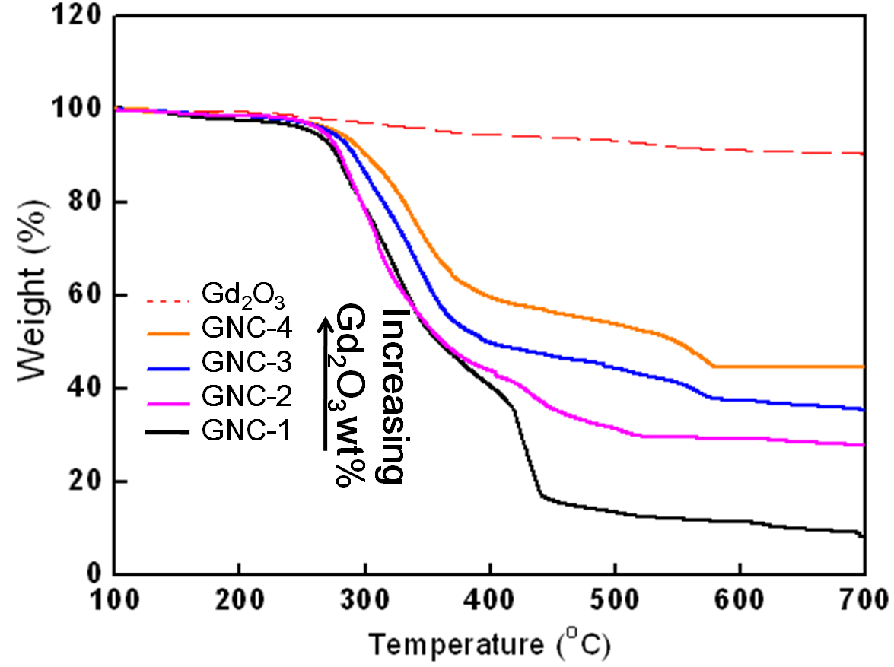
FIG.S4. TGA profiles of hydrophobic gadolinium oxides (dashed orange line) and GNCs (in black, purple, blue and orange of GNC-1 to GNC-4, respectively) in increasing order of Gd₂O₃ composition weight percentage from bottom to top.

S5. Magnetic Properties of GNCs
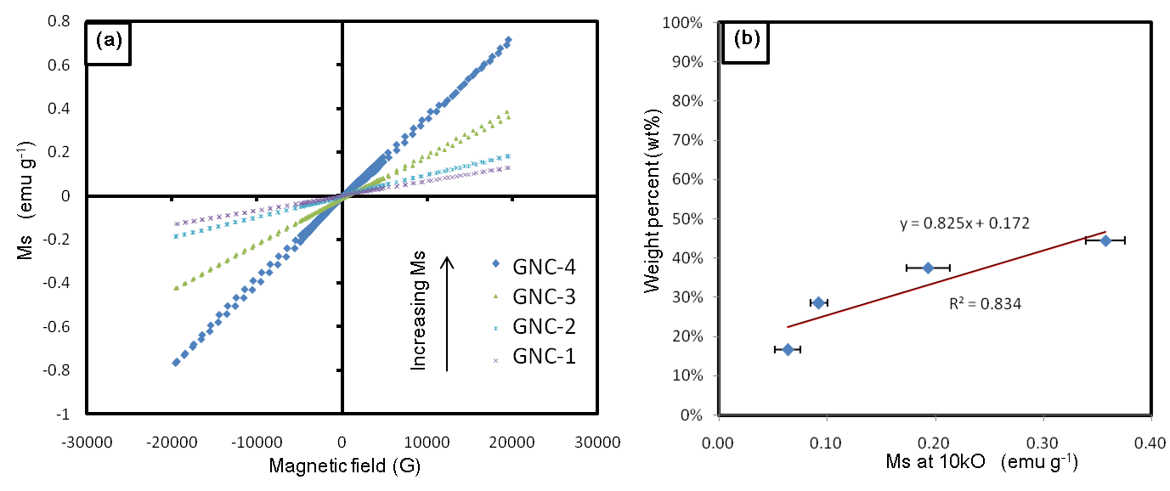
FIG.S5. (a) VSM profiles of Gd₂O₃ nanoplate-loading GNCs in increasing order of magnetization from lowest to highest: GNC-1, GNC-2, GNC-3, GNC-4 (b) Plot of saturation magnetization against Gd₂O₃ nanoplate-loading.

