Supplementary material

Improvement of carbon nanocoil purity achieved by supplying catalyst molecules from the vapor phase in chemical vapor deposition

Yoshiyuki Sudaª, Yuichi Ishiiª, Tatsuki Mikiª, Koji Maruyamaª, Hideto Tanoueª, Hirofumi Takikawaª, Hitoshi Ue^{b}, Kazuki Shimizu^{c}, Yoshito Umeda^{d}

ª Department of Electrical and Electronic Information Engineering, Toyohashi University of Technology, Toyohashi, Aichi 441-8580, Japan
^{b} Fuji Research Laboratory, Tokai Carbon Co., Ltd., Oyama, Shizuoka 410-1431, Japan
^{c} Development Department, Shonan Plastic Manufacturing Co., Ltd., Hiratsuka, Kanagawa 254-0807, Japan
^{d} Toho Gas Co., Ltd., Tokai, Aichi 476-8501, Japan
- Experimental.

FIGURE S1. Schematic of CVD reactor.

2. Classification of the shapes of the catalyst nanoparticles in the CNC tips.
We observed 100 CNCs and CNTws, ¹ and classified the catalyst nanoparticles in the CNC tips, and the CNC surface morphologies. There were four types of shapes for the catalyst nanoparticles. These catalyst nanoparticle geometries are illustrated in Fig. 1. The four geometries were:
- Symmetric structure
- Asymmetric structure
- Mirror-symmetric structure with two active facets
- Branched structure
The frequencies of appearance for the catalyst geometries followed the ratio (a)：(b)：(c)：(d) ＝ 15：20：2：1, and (b) was most frequently observed.
We reported previously that CNCs have two types of surface geometries: angular-type and round-type. ¹ However, round-type CNCs were present in only very small numbers in our experimental sample, and we therefore dealt with the angular-type CNCs in this paper. Angular-type CNCs consist of two to four thinner carbon nanofibers, and the surface of these CNCs is angular. The cross-section of these CNCs is polygonal, and shows negative curvature. ¹ Figure S2 shows SEM micrographs of angular-type CNCs with different types of catalyst nanoparticles. Figure S2 shows that different types of catalyst nanoparticles could form identical CNC surface geometries.

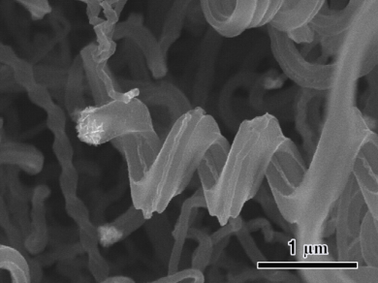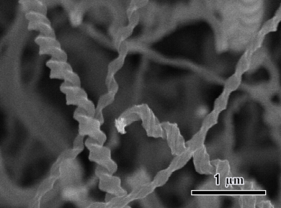
(a) (b)
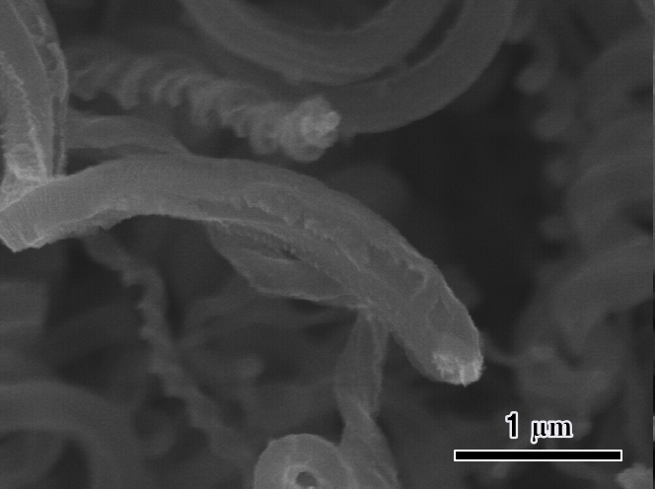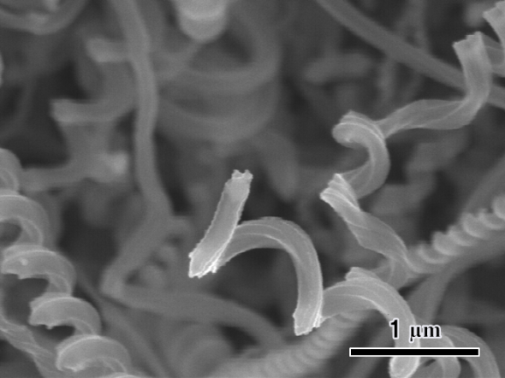
(c) (d)
FIGURE S2. SEM images of angular-type CNCs grown from catalyst nanoparticles (a) A (symmetric structure), (b) B (asymmetric structure), (c) C (mirror-symmetric structure with two active facets), and (d) D (branched structure). The scale bar represents 1 μm.
3. EDS mapping of Sn/Fe catalyst nanoparticle

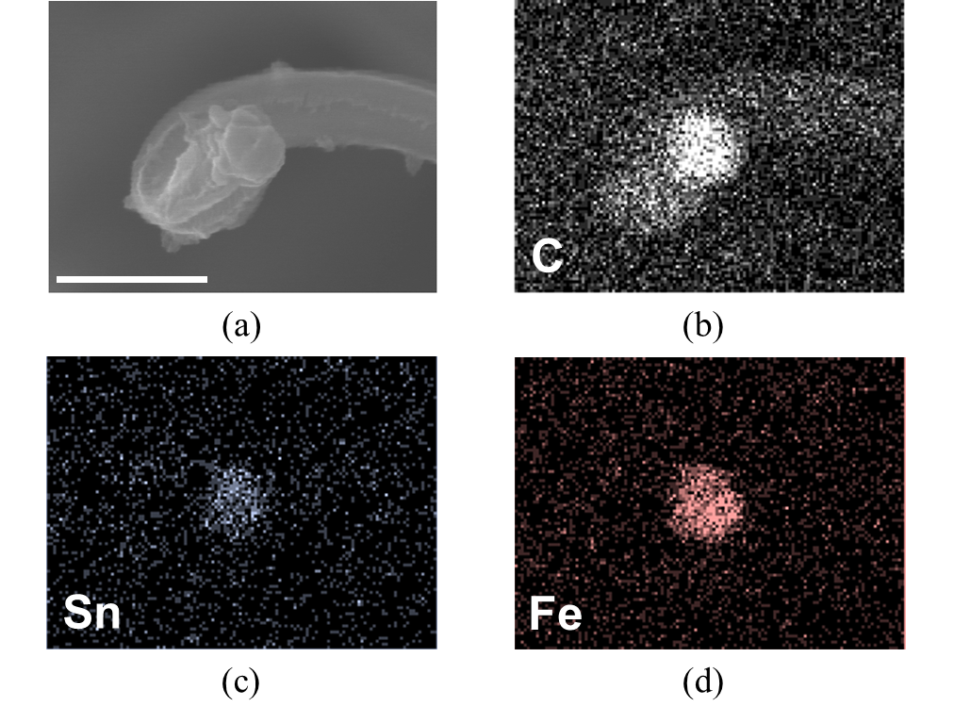
FIGURE S3. (a) SEM image of catalyst nanoparticle at the tip of angular-type CNC. The CNC was grown under the same condition as those in FIG. S2. The scale bar represents 500 nm. (b)-(d) EDS mappings of (b) carbon, (c) tin, and (d) iron in (a).

References
1. M. Yokota, Y. Shinohara, T. Kawabata, K. Takimoto, Y. Suda, H. Takikawa, Y. Fujimura, T. Yamaura, S. Itoh, H. Ue, and M. Morioki: Splitting and flattening of helical carbon nanofibers by acid treatment. J. Nanosci. Nanotechnol. 10, 3910-3914 (2010).

