Supporting Materials

A large amount of Ag low-dimensional nanostructures, such as nanowires, nanoribbons, and nanoplates, had been taken from the solution when the photocatalytic growth of Ag NPs was conducted for a longer time using TiO₂ or ZnAlO films as the reduction media, as shown in Fig. S1. These SEM images support that the reduced Ag atoms can diffuse into solution.

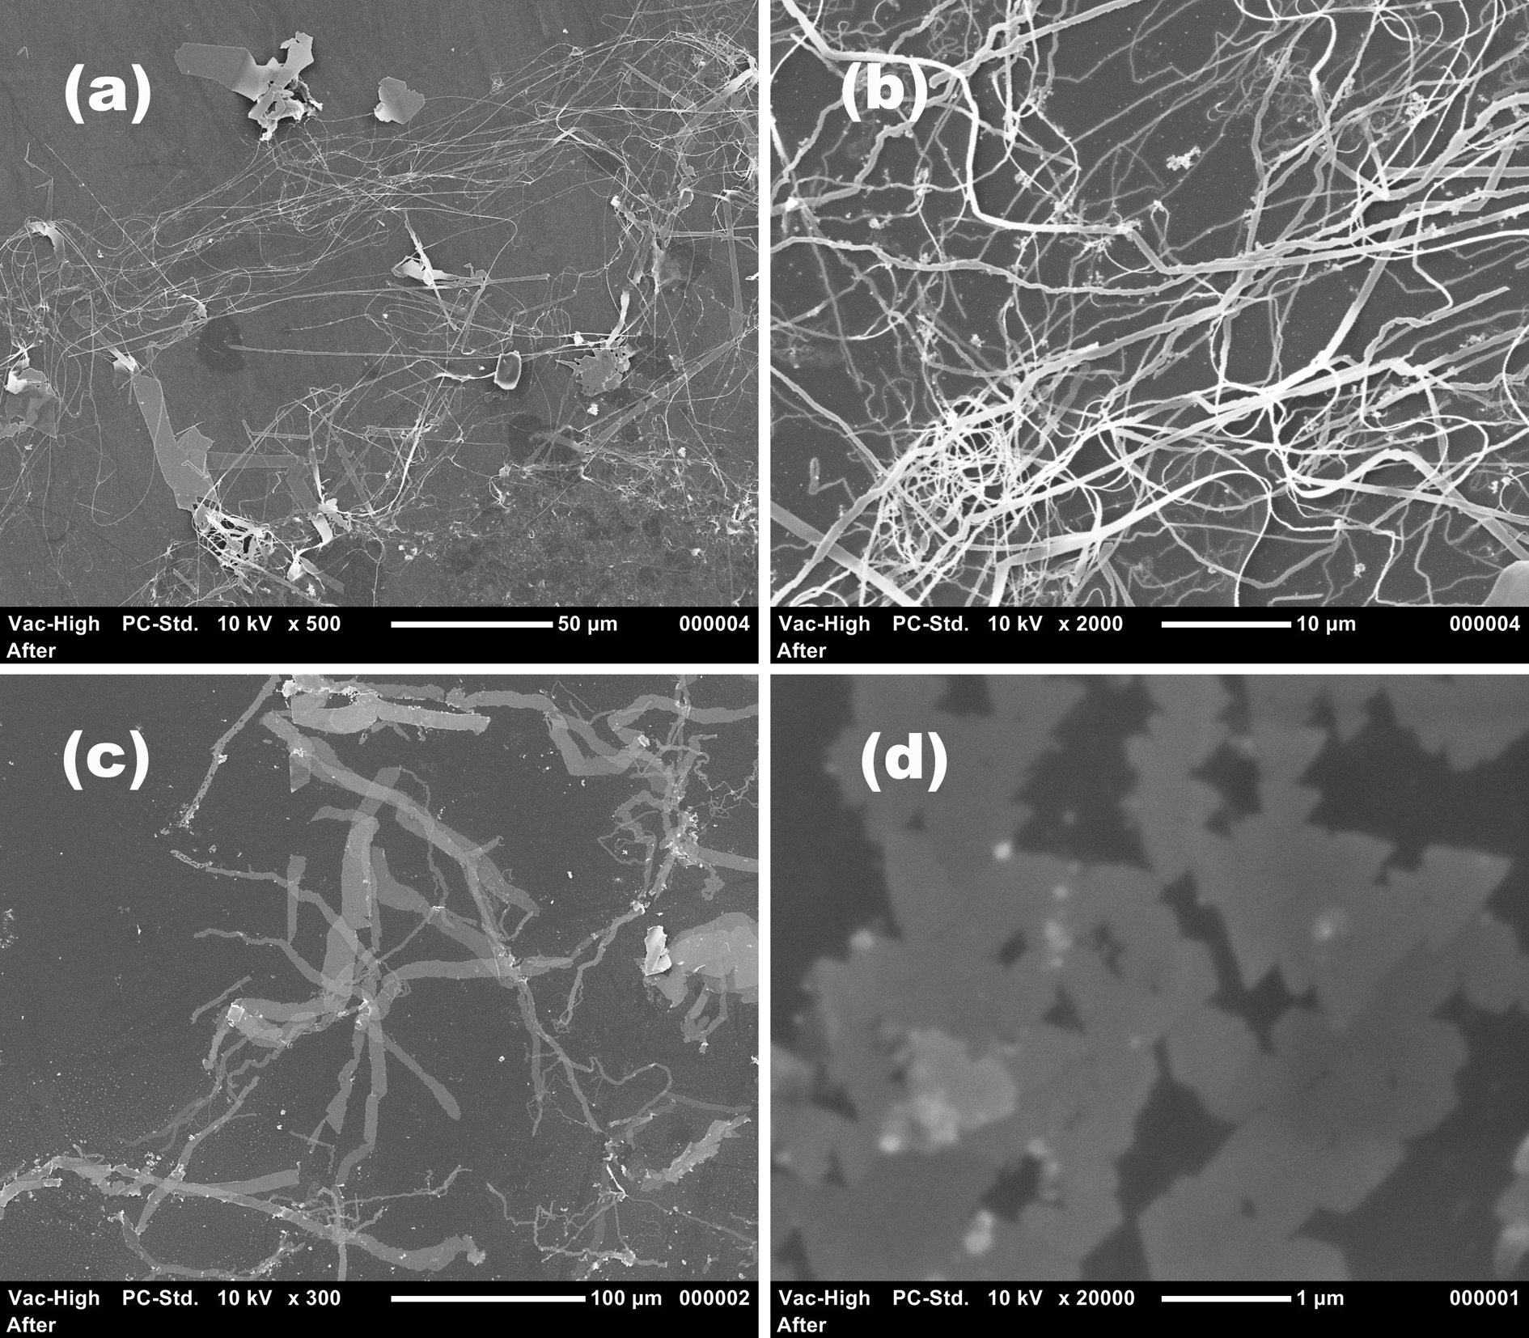
Fig. S1 Ag low-dimensional nanostructures taken from the solution using TiO₂ (a and b) and ZnAlO (c and d) films as the reduction media.

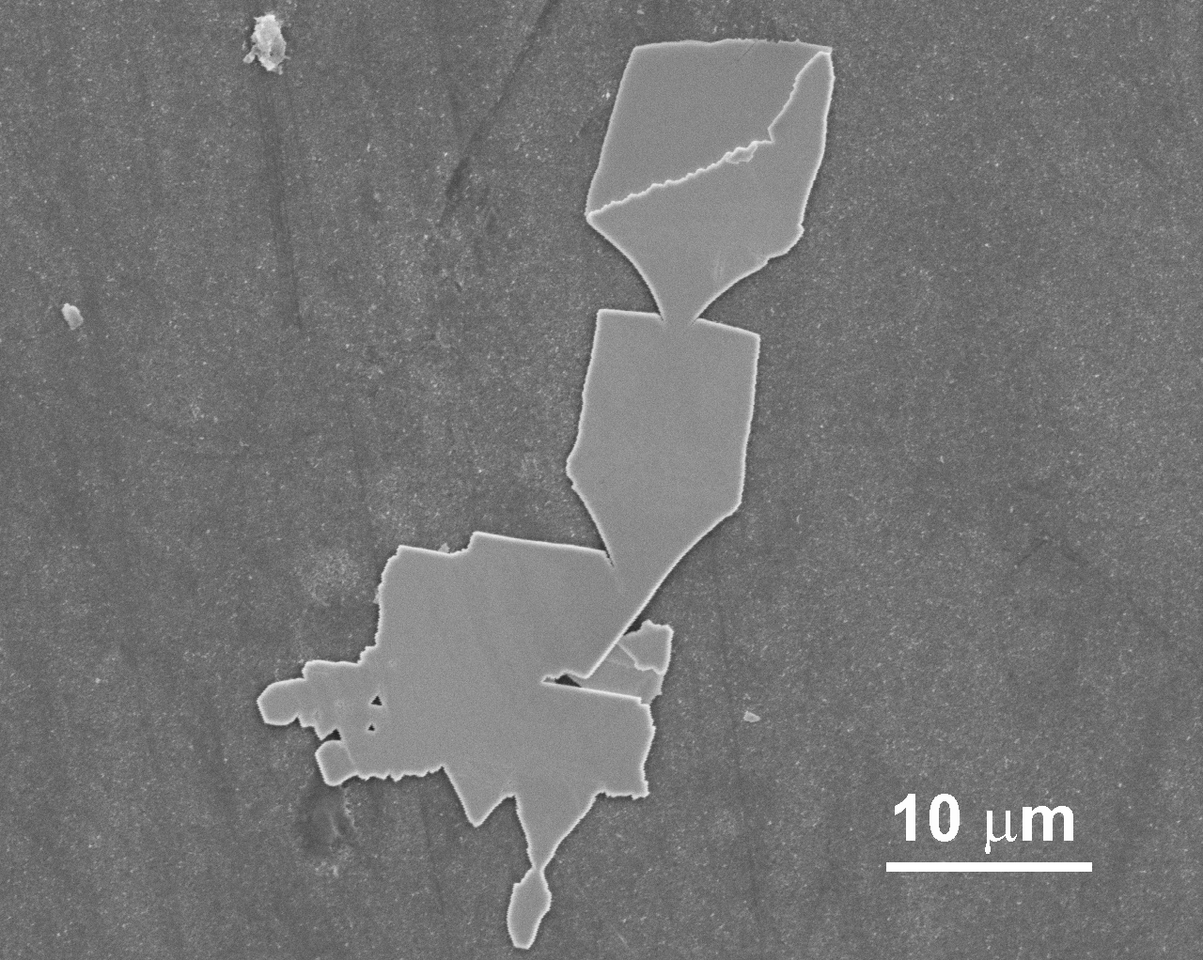

Fig. S2 SEM image of Ag foil grown on a smooth TiO₂ film using 3200 mg/L AgNO₃ solution.

