Effects of poly(para-dioxanone-co-L-lactide) on the in vitro hydrolytic degradation behaviors of poly(L-lactide)/poly(para-dioxanone) blends
Xulong Xie^{1, 2}, Wei Bai*¹, Congming Tang³, Dongliang Chen¹, Chengdong Xiong¹
1. Chengdu Institute of Organic Chemistry, Chinese Academy of Sciences, Chengdu 610041, People’s Republic of China
2. University of Chinese Academy of Sciences, Beijing 100049, People’s Republic of China
3. Chemical Synthesis and pollution Control Key Laboratory of Sichuan Province, College of Chemistry and Chemical Engineering, China West Normal University, Nanchong 637009, People’s Republic of China
*Corresponding author. Tel: 86-28-85242691; Fax: 86-28-85212672
Email address: baiwei@cioc.ac.cn
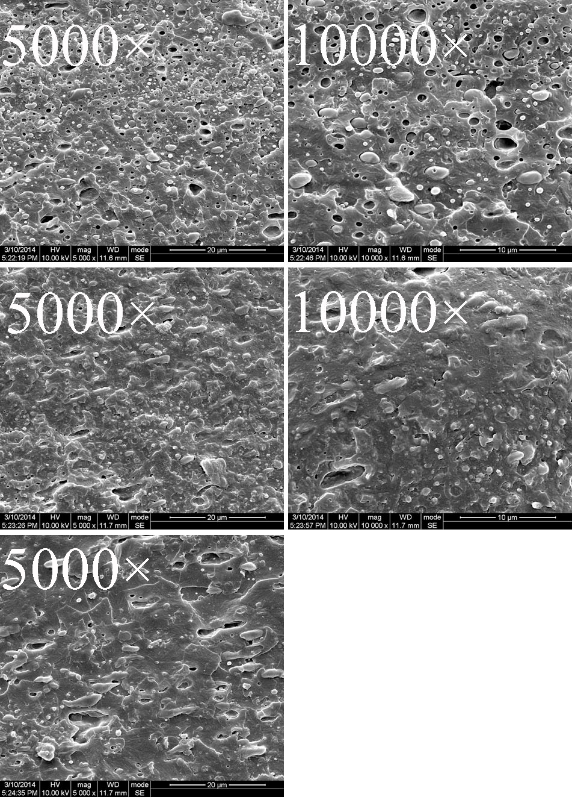
Figure S1.¹ Scanning electron micrographs of the fracture surfaces of the PLLA/PPDO blends without PDOLLA
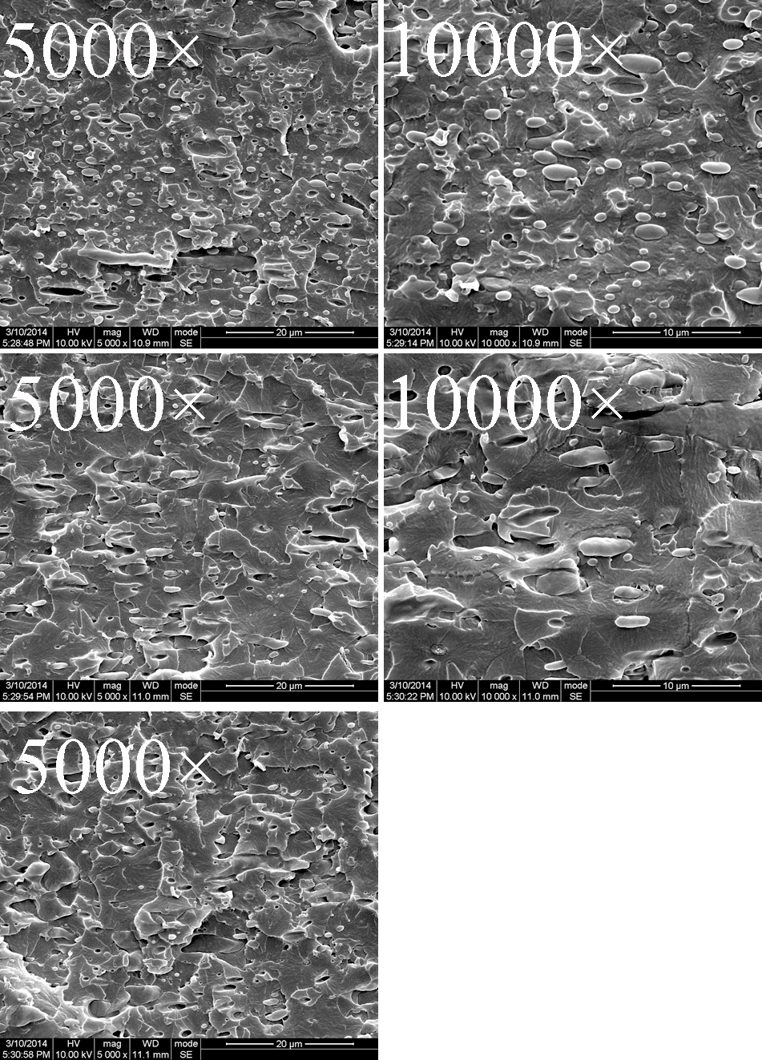
Figure S2.¹ Scanning electron micrographs of the fracture surfaces of the PLLA/PPDO blends with 1 wt%PDOLLA
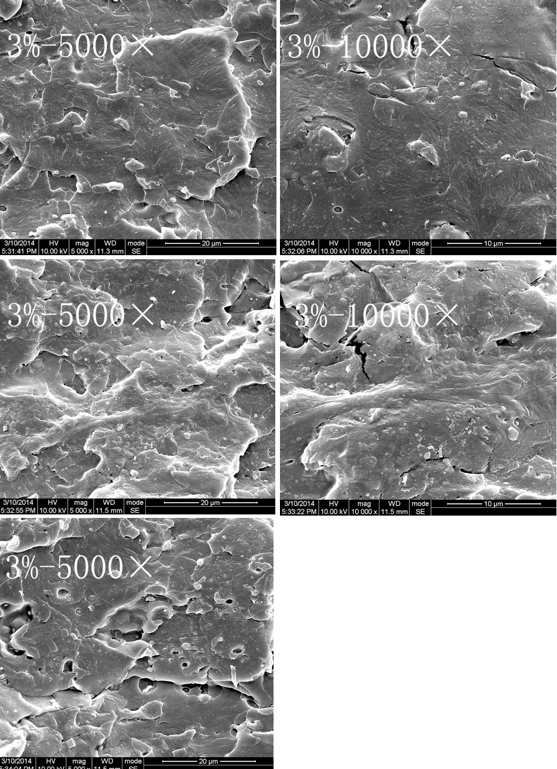
Figure S3.¹ Scanning electron micrographs of the fracture surfaces of the PLLA/PPDO blends with 3 wt%PDOLLA
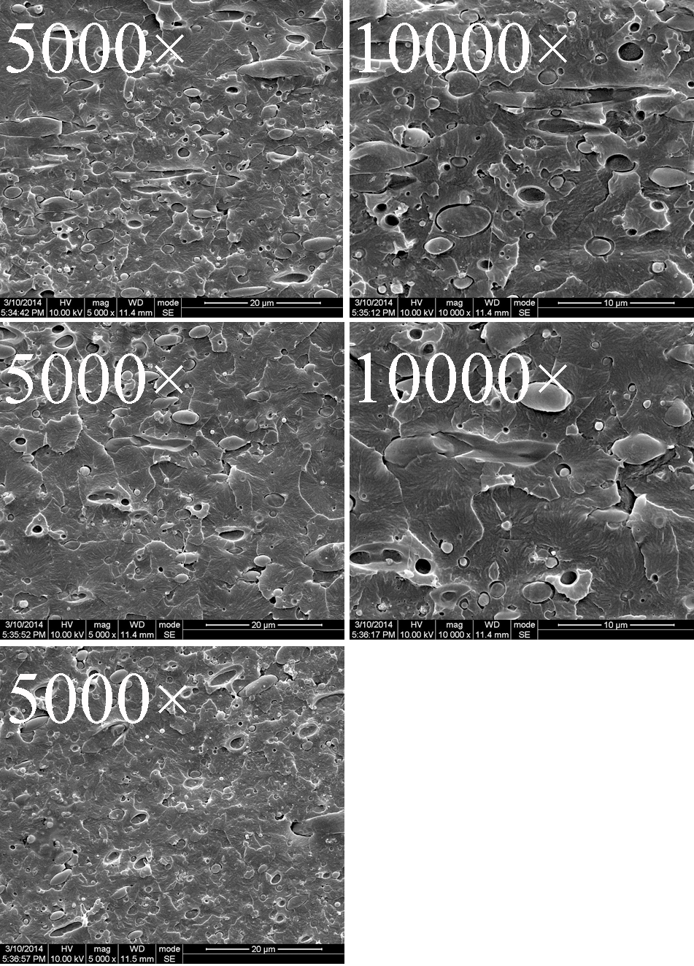
Figure S4.¹ Scanning electron micrographs of the fracture surfaces of the PLLA/PPDO blends with 5 wt%PDOLLA
1. X. Xie, W. Bai, A. Wu, D. Chen, C. Xiong, C. Tang, and X. Pang: Increasing the compatibility of poly(L-lactide)/poly(para-dioxanone) blends through the addition of poly(para-dioxanone-co-L-lactide). J. Appl. Polym. Sci. 2015, 132, 1029-1035

