Supplementary information
- Particle distribution in Mn07, 08 and 09 films (SEM and photographs) Mn09 shows visible aggregates.
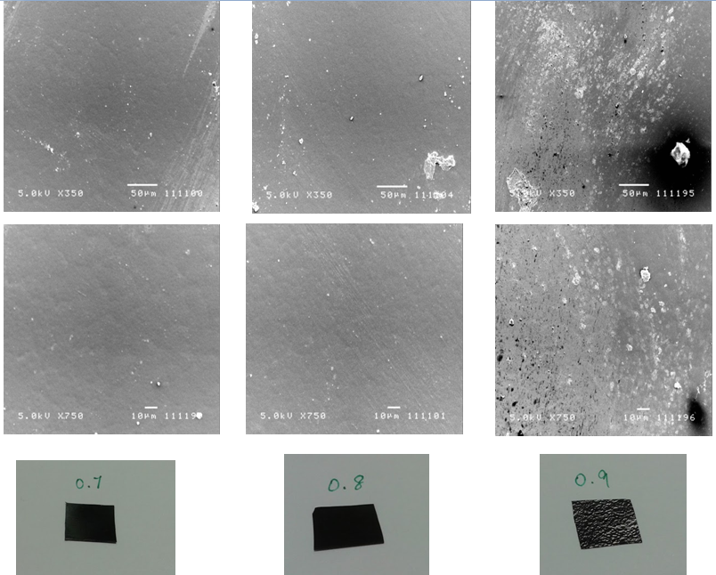
1 cm
1 cm
1 cm
Figure 1 SEM micrographs and photos of Mn composites showing particle aggregation in Mn0.9 films
- Brownian and Neel relaxation time calculated for the Magpol with matrix viscosity of 75 Pa.s at 110°C.
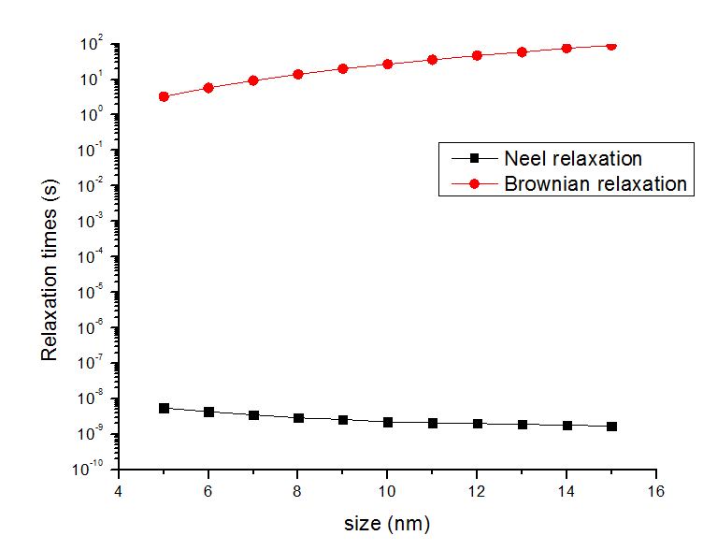
- SEM of Mn08 composite before being subjected to wear
