Supplementary materials
Formation of gold nanoparticles during the reduction of HAuBr₄ in reverse micelles of oxyethylated surfactant: Influence of gold precursor on the growth kinetics and properties of the particles

Anastasiya P. Sergievskaya*, Vladimir V. Tatarchuk, Evgeniya V. Makotchenko, and Igor V. Mironov

Nikolaev Institute of Inorganic Chemistry, Siberian Branch, Russian Academy of Sciences, Ac. Lavrentyev pr., 3, Novosibirsk, 630090, Russia

FIG. S1. (a) Photographs showing the phase transfer process of AuNPs from micellar solution to solution of 6-MP in DMSO;
(b) UV-vis spectra of micellar solutions of AuNPs (T=298 K, c′_{Au}=0.056 M, c′_{N2H4}=2.512 M, c′_{HBr}=2.658 M, V_{s}/V_{o}=0.005, l=0.5 cm) and solution of AuNPs after phase transfer in DMSO (l=1 cm); (c) IR spectra of 6-MP and Au@6-MP powder.
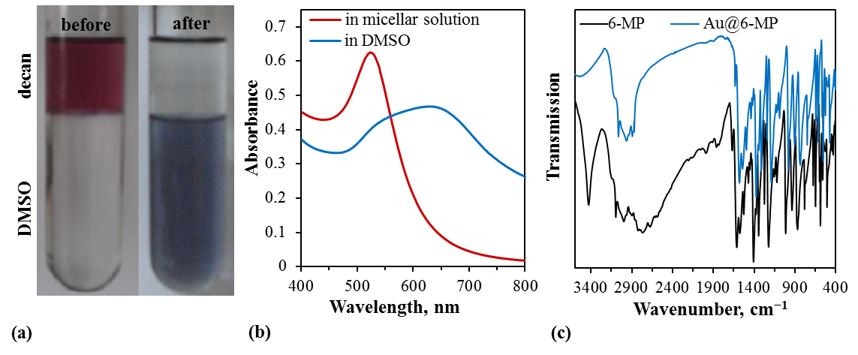
FIG. S2. Schematic illustration of the intermicellar exchange of the reagents A and B.
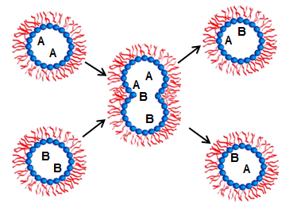

FIG. S3. The dependence of absorbance of micellar solutions A vs c_{Au} of (a) for HAuBr₄ at λ=401 nm and (b) for AuNPs at λ=525 nm.
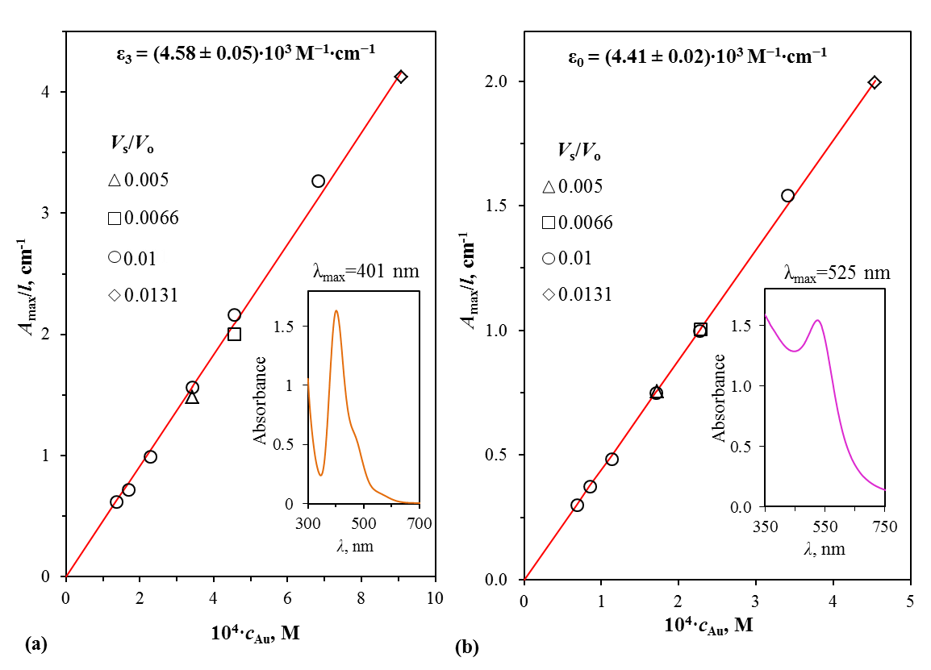
TABLE S1. The observed rate constants at T=298 K, c′_{Au}=0.056 M, c_{TRG}=0.25 M, V_{s}/V_{o}=0.005
No. | [H⁺]′, M | [N₂H₅⁺]′, M | [Br⁻]′, M | N | 10⁴(k_{g1}±s_{k}), s⁻¹ | k_{g2}±s_{k}, M⁻¹s⁻¹
1.1. | 0.015 | 2.194 | 2.153 | 98 | 1.97±0.11 | 6.53±0.07
1.2. | 0.015 | 2.194 | 2.153 | 94 | 2.15±0.15 | 6.40±0.11
2.1. | 0.105 | 2.298 | 2.347 | 115 | 1.94±0.18 | 5.84±0.07
2.2. | 0.105 | 2.298 | 2.347 | 123 | 1.85±0.21 | 5.71±0.09
3.1. | 0.126 | 2.38 | 2.45 | 146 | 1.72±0.16 | 5.61±0.06
3.2. | 0.126 | 2.38 | 2.45 | 151 | 1.78±0.14 | 5.51±0.10
4.1. | 0.158 | 2.304 | 2.406 | 187 | 1.64±0.24 | 5.36±0.09
4.2. | 0.158 | 2.304 | 2.406 | 198 | 1.69±0.34 | 5.47±0.08
5.1. | 0.202 | 2.512 | 2.658 | 226 | 1.54±0.27 | 5.02±0.06
5.2. | 0.202 | 2.512 | 2.658 | 205 | 1.46±0.34 | 5.13±0.07
TABLE S2. The observed rate constants at T=298 K, c′_{Au}=0.034 M, c_{TRG}=0.25 M, V_{s}/V_{o}=0.010
No. | [H⁺]′, M | [N₂H₅⁺]′, M | [Br⁻]′, M | N | 10⁴(k_{g1}±s_{k}), s⁻¹ | k_{g2}±s_{k}, M⁻¹s⁻¹
1.1. | 0.0145 | 1.80 | 1.78 | 57 | 9.90±2.29 | 10.1±0.19
2.1. | 0.0345 | 2.15 | 2.15 | 65 | 9.00±2.52 | 9.78±0.12
2.2. | 0.0345 | 2.15 | 2.15 | 67 | 8.80±2.76 | 9.67±0.15
3.1. | 0.0445 | 2.00 | 2.01 | 86 | 8.67±2.16 | 9.59±0.13
3.2. | 0.0445 | 2.00 | 2.01 | 89 | 8.61±2.42 | 9.69±0.07
4.1. | 0.1045 | 2.00 | 2.07 | 101 | 8.54±1.98 | 8.87±0.09
4.2. | 0.1045 | 2.00 | 2.07 | 105 | 8.40±1.42 | 8.94±0.10
5.1. | 0.1345 | 2.10 | 2.20 | 113 | 8.31±1.71 | 8.42±0.11
5.2. | 0.1345 | 2.10 | 2.20 | 119 | 8.01±1.53 | 8.69±0.07
6.1. | 0.1845 | 1.90 | 2.05 | 123 | 7.10±1.15 | 7.82±0.08
TABLE S3. Dependencies of observed rate constants vs T
(c′_{Au}=0.056 M, c′_{N2H4}=2.512 M, c′_{HBr}=2.658, c_{TRG}=0.25 M, V_{s}/V_{o}=0.005)
T, K | 10³/(RT) | 10⁴(k_{g1}±s_{k}), s⁻¹ | k_{g2}±s_{k}, M⁻¹s⁻¹
298.2 | 0.4034 | 1.46±0.34 | 5.13±0.07
298.2 | 0.4034 | 1.54±0.27 | 5.02±0.06
302.8 | 0.3973 | 6.32±1.07 | 15.09±0.43
308.2 | 0.3903 | 26.6±3.7 | 64.9±1.15
313.2 | 0.3841 | 98.1±12.6 | 216.06±3.27
TABLE S4. Dependencies of observed rate constants vs V_{s}/V_{o}
(T=298 K, c′_{Au}=0.034 M, c′_{N2H4}=2.10 M, c′_{HBr}=2.20, c_{TRG}=0.25 M)
V_{s}/V_{o} | 10⁴(k_{g1}±s_{k}), s⁻¹ | k_{g2}±s_{k}, M⁻¹s⁻¹
0.005 | 1.72±0.47 | 6.18±0.09
0.0066 | 4.06±1.05 | 6.51±0.07
0.010 | 8.31±1.71 | 8.42±0.11
0.010 | 8.01±1.53 | 8.69±0.07
0.0131 | 14.10±3.44 | 19.42±0.47
TABLE S5. Dependencies of observed rate constants vs c_{TRG}
(T=298 K, c′_{Au}=0.034 M, c′_{N2H4}=2.10 M, c′_{HBr}=2.20, V_{s}/V_{o}=0.010)
c_{TRG}, M | 10⁴(k_{g1}±s_{k}), s⁻¹ | k_{g2}±s_{k}, M⁻¹s⁻¹
0.091 | 21.90±3.15 | 27.31±0.61
0.152 | 13.40±2.03 | 14.27±0.38
0.194 | 10.11±1.88 | 9.14±0.27
0.25 | 8.31±1.71 | 8.42±0.11
0.25 | 8.01±1.53 | 8.69±0.07

