Supporting Information
DFT calculations of the Li₂O-Na₂O-V₂O₅ system and growth, structure and optical properties of birefringent LiNaV₂O₆

Qingrong Kong,^{a,b} Yun Yang,^{b}* Lili Liu,^{b} Qiang Bian,^{b} Bing-Hua Lei, ^{b} Linping Li,^{b} Zhihua Yang,^{b} Zhi Su,ª* Shilie Pan^{b}*
ªCollege of Chemistry and Chemical Engineering, Xinjiang Normal University, Urumqi 830054,China
^{b}Key Laboratory of Functional Materials and Devices for Special Environments, Xinjiang Technical Institute of Physics & Chemistry, Chinese Academy of Sciences; Xinjiang Key Laboratory of Electronic Information Materials and Devices, 40-1 South Beijing Road, Urumqi 830011, China
*To whom correspondence should be addressed
slpan@ms.xjb.ac.cn (Shilie Pan)

FIG. S1. Photograph of the LiNaV₂O₆ crystal. (The minimum scale of the ruler is one millimeter.)

FIG. S2. The Li and Na atoms are situated in V−O anionic groups in ac plane.

FIG. S3. The distance between neighboring [VO₃]∞ chains along a-axis is much longer than that along b-axis (d₁>d₂).

FIG. S4. (a)The 3D network structure of LiNaV₂O₆ along the c− axis (b) The structure of. isolated NaO₆ octahedra along the a−axis. (c) The LiO₆ octahedra connecting with the NaO₆ octahedra form a 1D chain along the a−axis (d) The structure of Li–O chains along the a−axis.

FIG. S5. Infrared spectrum of LiNaV₂O₆

TABLE. S1. Selected bond lengths (Å) and angles [deg] for LiNaV₂O₆.

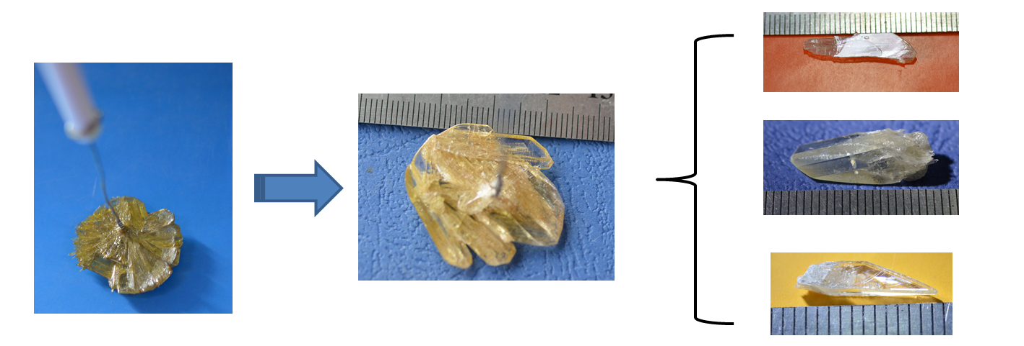
FIG. S1. Photograph of the LiNaV₂O₆ crystal. (The minimum scale of the ruler is one millimeter.)

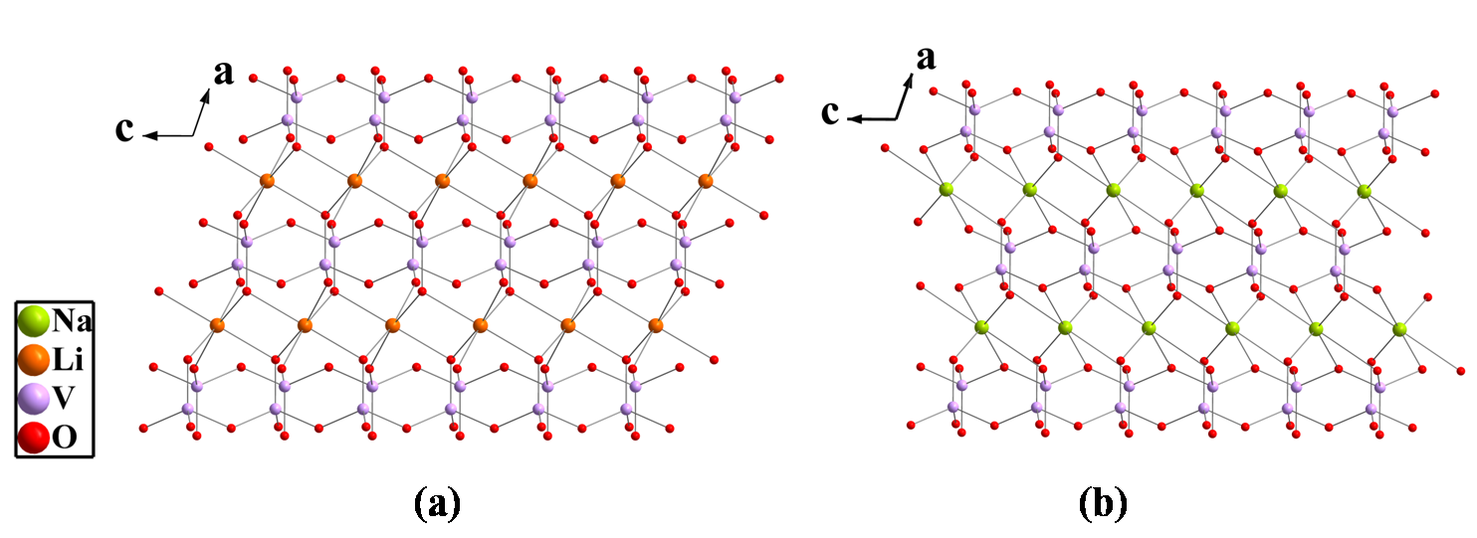
FIG. S2. The Li and Na atoms are situated in V−O anionic groups in ac plane.

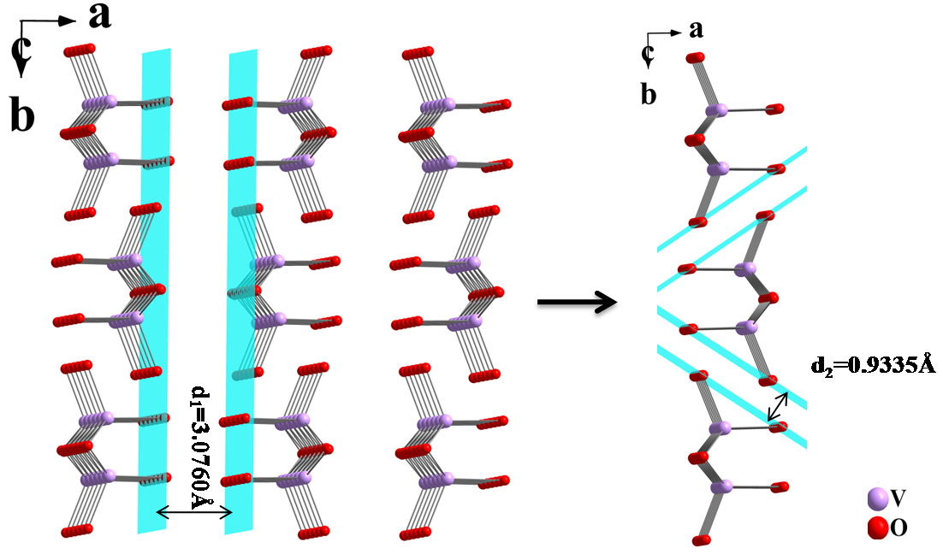
FIG. S3. The distance between neighboring [VO₃]∞ chains along a-axis is much longer than that along b-axis (d₁>d₂).

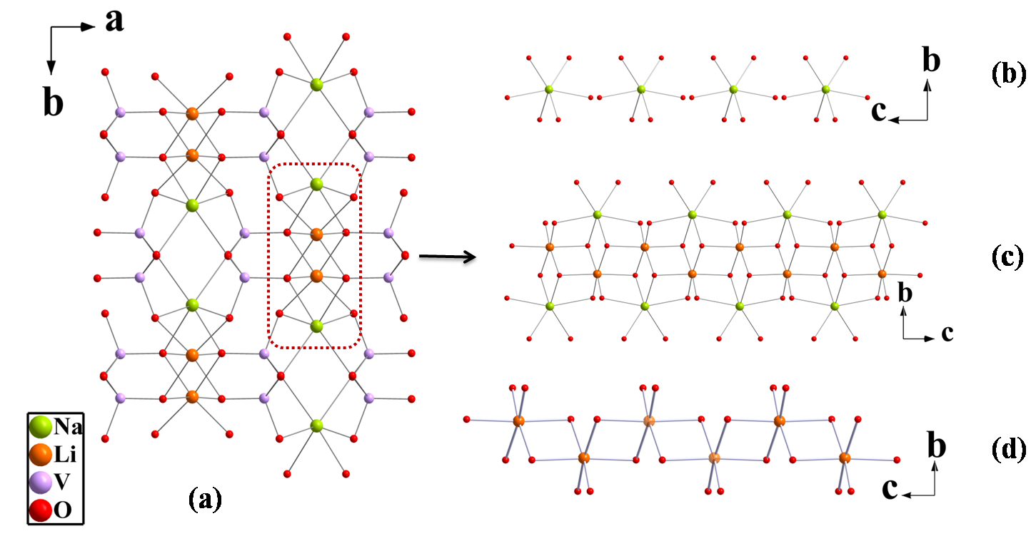
FIG. S4. (a)The three–dimensional network structure of LiNaV₂O₆ along the c−axis (b) The structure of. isolated NaO₆ octahedra along the a−axis. (c) The LiO₆ octahedra connecting with NaO₆ octahedra form a 1D chain along the a−axis (d) The structure of 1D Li–O chain along the a−axis.

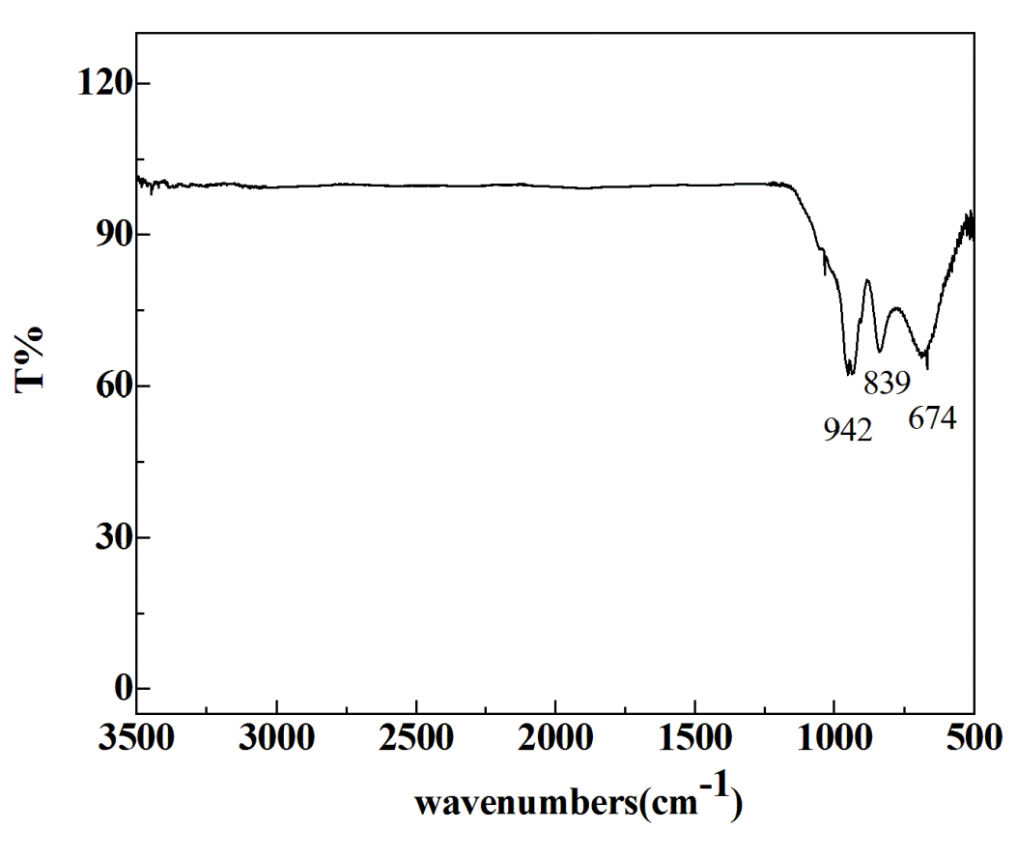
FIG. S5. Infrared spectrum of LiNaV₂O₆
TABLE. SI. Selected bond lengths (Å) and angles [deg] for LiNaV₂O₆.
Na(1)-O(1) | 2.347(3) |  | O(3)-Li(1)-O(1)#8 |  | 168.71(17)
Na(1)-O(1)#1 | 2.347(3) |  | O(1)#6-Li(1)-O(1)#8 |  | 84.9(3)
Na(1)-O(2)#2 | 2.477(3) |  | O(3)#7-Li(1)-O(1)#9 |  | 90.38(15)
Na(1)-O(2)#3 | 2.477(3) |  | O(3)-Li(1)-O(1)#9 |  | 87.03(14)
Na(1)-O(3)#3 | 2.627(3) |  | O(1)#6-Li(1)-O(1)#9 |  | 98.38(16)
Na(1)-O(3)#2 | 2.627(3) |  | O(1)#8-Li(1)-O(1)#9 |  | 84.58(14)
Li(1)-O(3)#7 | 2.153(5) |  | O(3)#7-Li(1)-O(1)#10 |  | 87.03(14)
Li(1)-O(3) | 2.153(5) |  | O(3)-Li(1)-O(1)#10 |  | 90.38(15)
Li(1)-O(1)#6 | 2.223(5) |  | O(1)#6-Li(1)-O(1)#10 |  | 84.58(14)
Li(1)-O(1)#8 | 2.223(5) |  | O(1)#8-Li(1)-O(1)#10 |  | 98.38(16)
Li(1)-O(1)#9 | 2.249(2) |  | O(1)#9-Li(1)-O(1)#10 |  | 176.0(4)
Li(1)-O(1)#10 | 2.249(2) |  | O(1)-Na(1)-O(1)#1 |  | 79.48(13)
Li(1)-O(3)#7 | 2.153(5) |  | O(1)-Na(1)-O(2)#2 |  | 136.45(8)
V(1)-O(3) | 1.632(3) |  | O(1)#1-Na(1)-O(2)#2 |  | 116.70(8)
V(1)-O(1) | 1.648(2) |  | O(1)-Na(1)-O(2)#3 |  | 116.70(8)
V(1)-O(2)#13 | 1.797(2) |  | O(1)#1-Na(1)-O(2)#3 |  | 136.45(8)
V(1)-O(2) | 1.799(2) |  | O(2)#2-Na(1)-O(2)#3 |  | 80.46(12)
O(3)#7-Li(1)-O(3) | 98.8(3) |  | O(1)-Na(1)-O(3)#3 |  | 86.18(9)
O(3)#7-Li(1)-O(1)#6 | 168.71(17) |  | O(1)#1-Na(1)-O(3)#3 |  | 77.57(9)
O(3)-Li(1)-O(1)#6 | 88.86(9) |  | O(2)#2-Na(1)-O(3)#3 |  | 135.18(10)
O(3)#7-Li(1)-O(1)#8 | 88.86(9) |  | O(3)-V(1)-O(1) |  | 110.26(13)
O(3)-V(1)-O(2) | 105.32(12) |  | O(3)-V(1)-O(2)#13 |  | 109.90(12)
O(1)-V(1)-O(2) | 111.28(11) |  | O(1)-V(1)-O(2)#13 |  | 111.46(11)
O(2)#13-V(1)-O(2) | 108.41(8)
Note. Symmetry transformations used to generate equivalent atoms:
#1 -x+1,y,-z+1/2 |  | #2 x+1/2,-y+3/2,z+1/2 |  | #3 -x+1/2,-y+3/2,-z
#4 x+1/2,y-1/2,z |  | #5 x+1/2,y+1/2,z |  | #6 -x+1/2,y+1/2,-z+1/2
#7 -x,y,-z+1/2 |  | #8 x-1/2,y+1/2,z |  | #9 -x+1/2,-y+3/2,-z+1
#10 x-1/2,-y+3/2,z-1/2 |  | #11 -x,-y+2,-z+1 |  | #12 -x,-y+2,-z
#13 x,-y+1,z+1/2 |  | #14 x-1/2,y-1/2,z |  | #15 x,-y+1,z-1/2

