Supplementary Material

Electrophoretic Deposition of Nanostructured Hematite Photoanodes for Solar Hydrogen Generation

Xiangyan Chen, Meng Wang, Jie Chen, Shaohua Shen*

International Research Center for Renewable Energy, State Key Laboratory of Multiphase Flow in Power Engineering, Xi'an Jiaotong University, Shaanxi 710049, China.
Email: shshen_xjtu@mail.xjtu.edu.cn

Effects of electrophoretic deposition conditions on the photoelectrochemical properties of hematite films
The α-Fe₂O₃ films fabricated from α-Fe₂O₃ NPs with different morphologies of nanorhombohedra, nanobars, nanospheres were denoted as Fe-n-T-U (n = r, b, s), where T and U represent deposition time (seconds) and potential (V), respectively, herein, T = 10, 30, 60, U = 5, 10, 30, 50.
It is well known that the film thickness is greatly dependent on deposition time and potential during the EPD process. One can easily find in Fig. S1 that as the deposition time increases, the thickness of α-Fe₂O₃ films increases gradually. When the deposition time is 10 s, the thickness of the film is about 200 nm (Fig. S1a). And as the time increases to 30 s, the film thickness increases to about 450 nm (Fig. S1b). When the time continues to increase, the film thickness can reach ~1 μm (Fig. S1c).
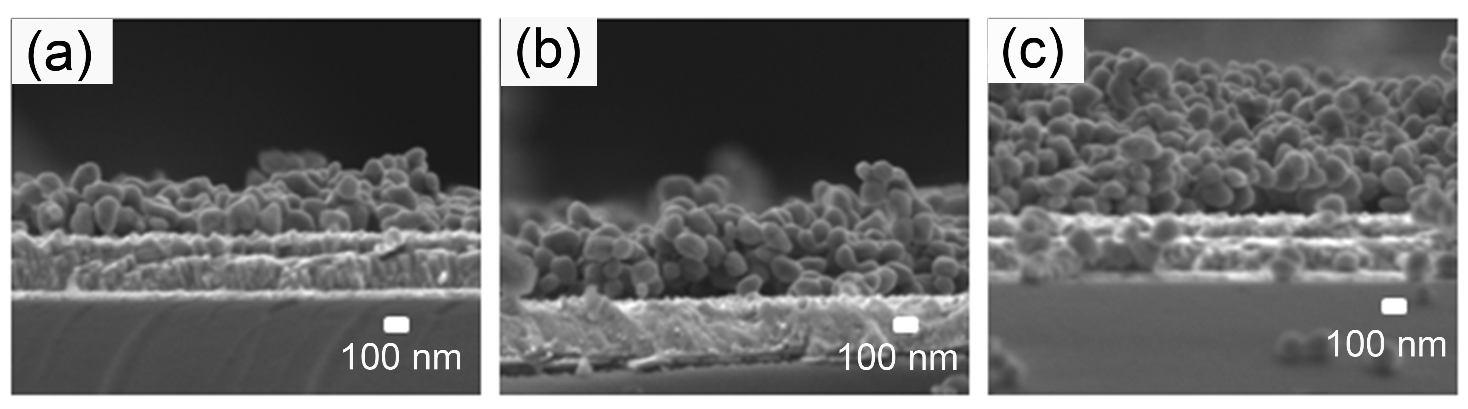
FIG. S1. Cross-sectional SEM images of α-Fe₂O₃ films prepared under different deposition times. (a) Fe-r-10-10, (b) Fe-r-30-10, and (c) Fe-r-60-10.

Fig. S2 shows the UV-Vis spectra of α-Fe₂O₃ films with different deposition times. It was found that all the UV-Vis spectra showed an absorption onset at ca. 600 nm, corresponding well with the band gap energy of 2.1 eV for α-Fe₂O₃. Moreover, the absorption intensity of the film increased with prolonged deposition time, indicating the correspondingly increased film thickness. Among them, the sample of Fe-r-60-10 with the thickness of ca. 1 μm showed the highest light absorption intensity. The thickness of Fe-r-10-10 is about 200 nm, which showed the poorest light absorption ability.
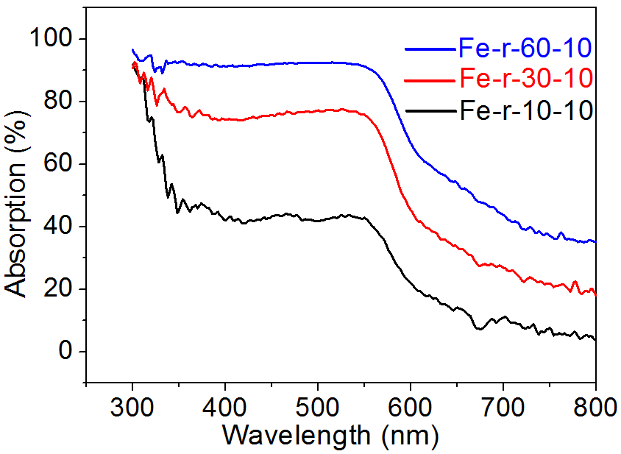
FIG. S2. UV-Vis spectra of α-Fe₂O₃ films prepared under different deposition times.

Fig. S3 shows the current-potential curves of the α-Fe₂O₃ films prepared under different deposition times. It was obvious that the film with the deposition time of 30 s showed the best photoelectrochemical properties. This is because that with the thickness increasing, the film is able to absorb more sunlight for photoelectrochemical hydrogen production. However, when the thickness increases further, the photo-induced carriers cannot transport to the surface of the photoelectrode in time and then charge recombination rate increases, resulting in degradation of the photoelectrochemical properties. For the above-mentioned α-Fe₂O₃ films, the best electrophoretic deposition time is 30 s and the obtained Fe-r-30-10 displayed the highest photocurrent density.
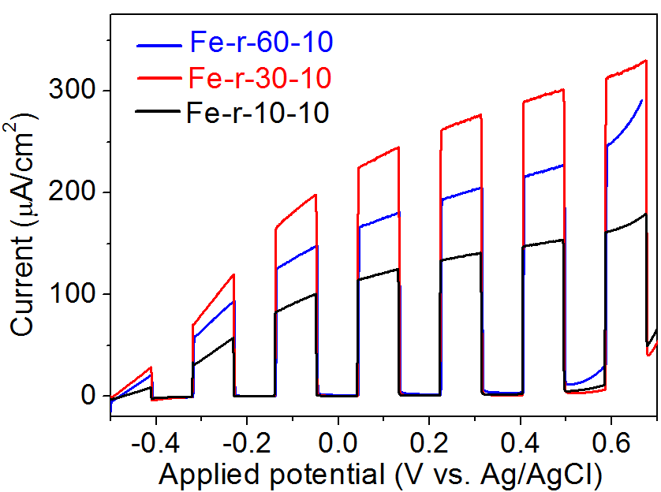
FIG. S3. Current-potential curves of α-Fe₂O₃ films prepared under different deposition times. Electrolyte: 0.1 M NaOH and 0.1 M glucose aqueous solution. Light source: 300 W Xe lamp with an AM1.5 filter. Light intensity: 100 mW/cm².

Fig. S4 shows the cross-sectional view SEM images of the α-Fe₂O₃ films prepared under different deposition voltages. It was found as the deposition voltage increases, the thickness of α-Fe₂O₃ films increases gradually from 200 nm to 1500 nm. As shown in Fig. S5, the greater the thickness of the sample is, the more light it absorbs, depending on the increased deposition voltages. It is clearly shown that the Fe-r-30-60 film showed the best ability of light absorption, while Fe-r-30-5 showed the poorest light absorption ability.
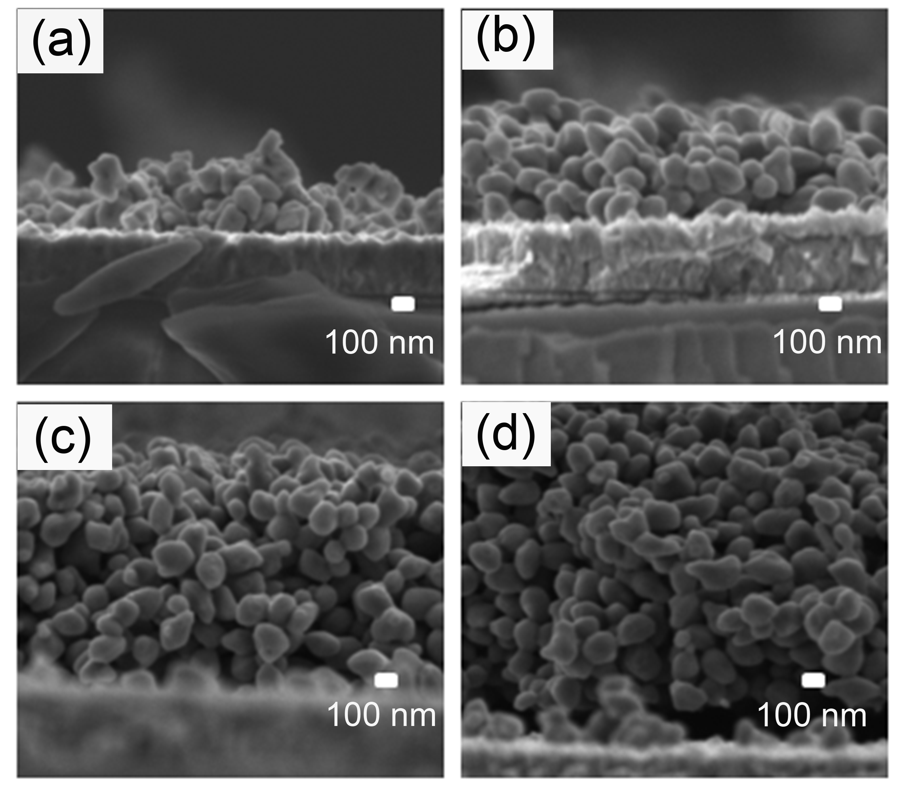
FIG. S4. Cross-sectional view SEM images of the α-Fe₂O₃ films prepared under different deposition voltages. (a)Fe-r-30-5, (b) Fe-r-30-10, (c) Fe-r-30-30, and (d) Fe-r-30-50.
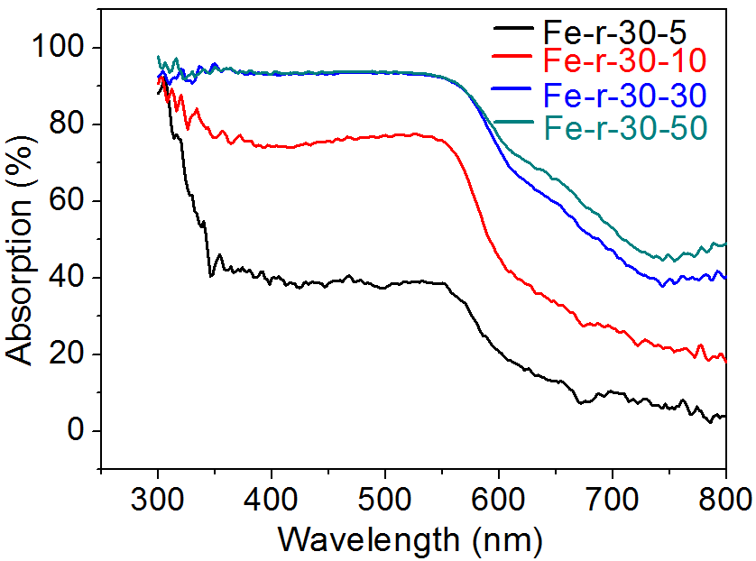
FIG. S5. UV-Vis spectra of α-Fe₂O₃ films prepared under different deposition voltages.

Fig. S6 shows the current-potential curves of the α-Fe₂O₃ films prepared under different deposition voltages. With the deposition voltages increasing, the photocurrent density increased first and then decreased; the highest photocurrent density was achieved over the Fe-r-30-10 film with deposition voltage set at 10 V.
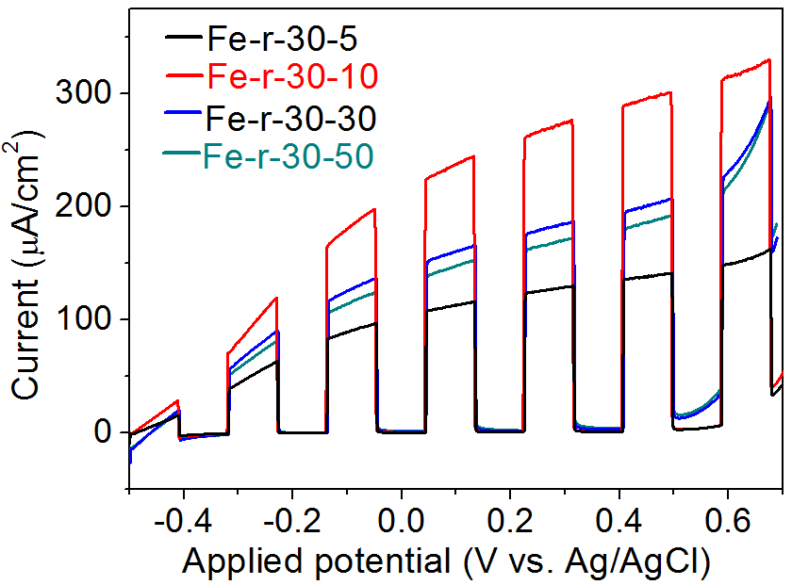
FIG. S6. Current-potential curves of α-Fe₂O₃ films prepared under different deposition voltages. Electrolyte: 0.1 M NaOH and 0.1 M glucose aqueous solution. Light source: 300 W Xe lamp with an AM1.5 filter. Light intensity: 100 mW/cm².

Based on the previous discussion on the effects of deposition time and voltage on the film thickness and hence the photoelectrochemical properties of the α-Fe₂O₃, it is of great necessity to balance the properties of optical absorption and carrier transportation for high photocurrents by tuning the film thickness. Herein, when the deposition time is 30 s and the deposition voltage is 10 V, the obtained α-Fe₂O₃ film (Fe-r-30-10) with the optimized thickness of ca. 450 nm showed the highest PEC activity.
Fig. S7 shows the XRD patterns of the α-Fe₂O₃ films after surface modification of Sn⁴⁺. It was found that after surface modification of Sn⁴⁺, the position and intensity of XRD diffraction peaks for all the α-Fe₂O₃ films did not change a lot, which indicated that after modification, the crystal structure of α-Fe₂O₃ films kept unchanged.
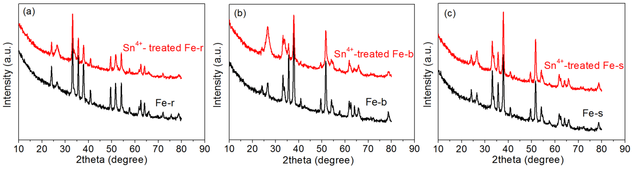
FIG. S7. XRD patterns of the α-Fe₂O₃ films after surface modification of Sn⁴⁺. (a) Fe-r, (b) Fe-b, (c) Fe-s.

Fig. S8 shows the UV-Vis spectra of α-Fe₂O₃ films after surface modification of Sn⁴⁺. It is clear that Sn⁴⁺ surface modification will not greatly change the optical absorption ability of these EPD obtained α-Fe₂O₃ films, regardless of their different morphologies.

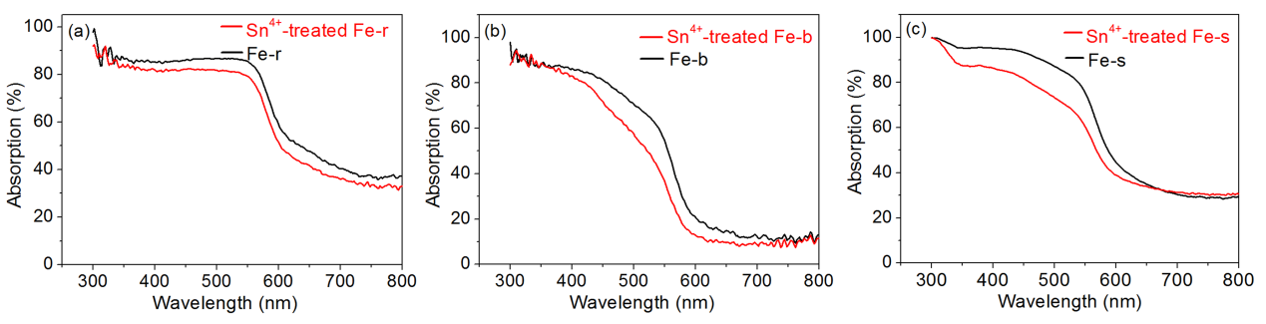
FIG. S8. UV-Vis spectra of α-Fe₂O₃ films after surface modification of Sn⁴⁺. (a) Fe-r, (b) Fe-b, (c) Fe-s.

