# Structural Commonalities and Deviations in the Hierarchical Organization of Crossed-Lamellar Shells: a Case Study on the Shell of the Bivalve Glycymeris glycymeris — Supplementary Information

*Corinna F. Böhm, Benedikt Demmert, Joe Harris, Tobias Fey, Frédéric Marin and Stephan E. Wolf*

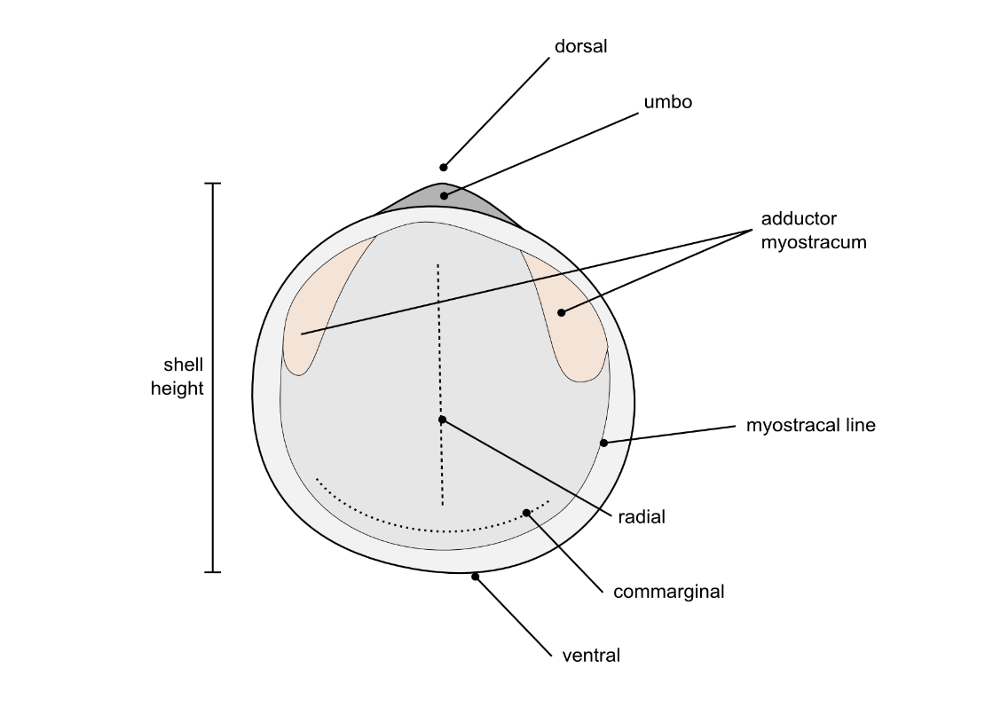

**Fig. S1 Fundamental nomenclature and principal axes in bivalve shells.** The commarginal axis is parallel to the shell margin whereas the radial axis is always perpendicular to the shell margin and can be interpreted as dorsal-ventral radiants. The height of a shell is its maximal radial extension from the dorsal to the ventral.

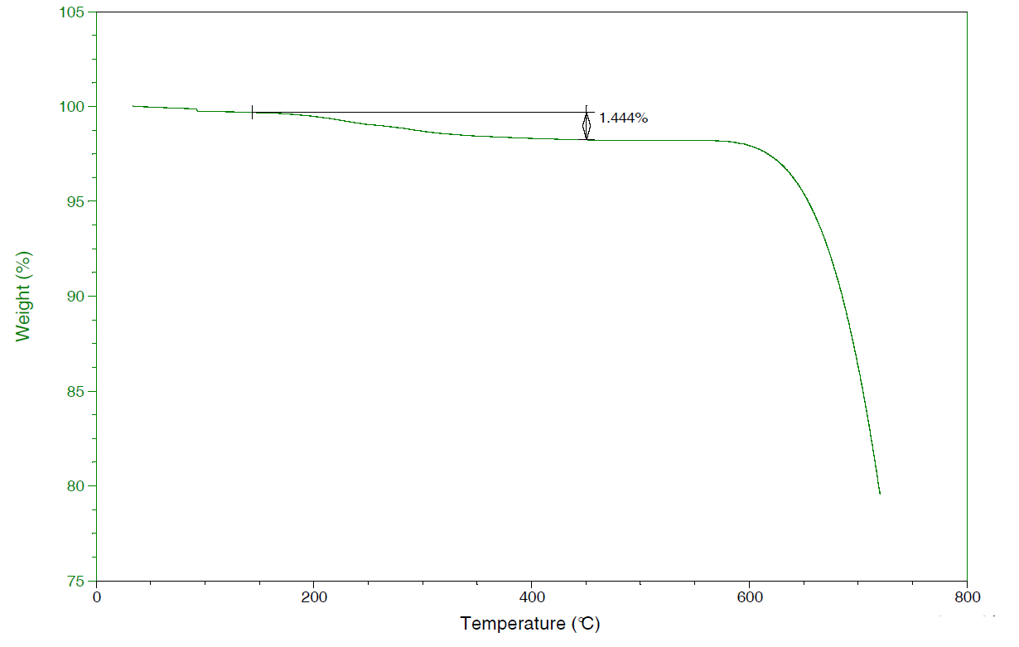

**Fig. S2 Thermogravimetric analysis (TGA) of palliostracal shell powder.** The loss of about 1.44 weight% between 200 and 600 °C corresponds to an organic fraction of less than 1.5 weight%.

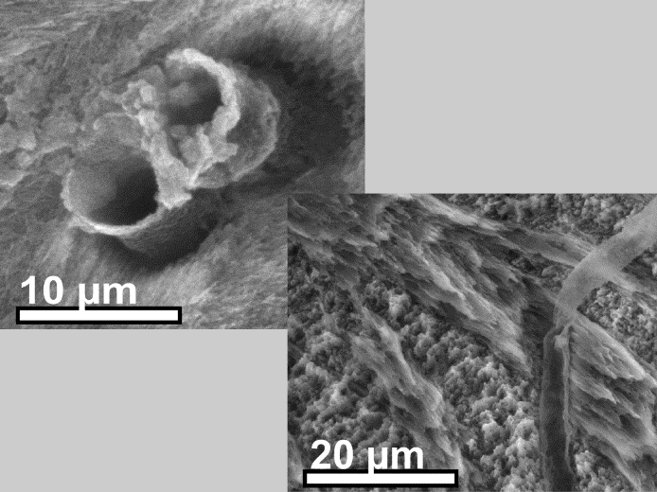

**Fig. S3 Non-colorized micrographs of Fig. 5e depicting the microtubules’ organic coating revealed by etching.** Etching of the polished micro-section dissolved the overlying mineral phase, the organic coating of the microtubules surface remain which protrudes from the surface [(upper left) transversal section, (lower right) commarginal section].