Support information

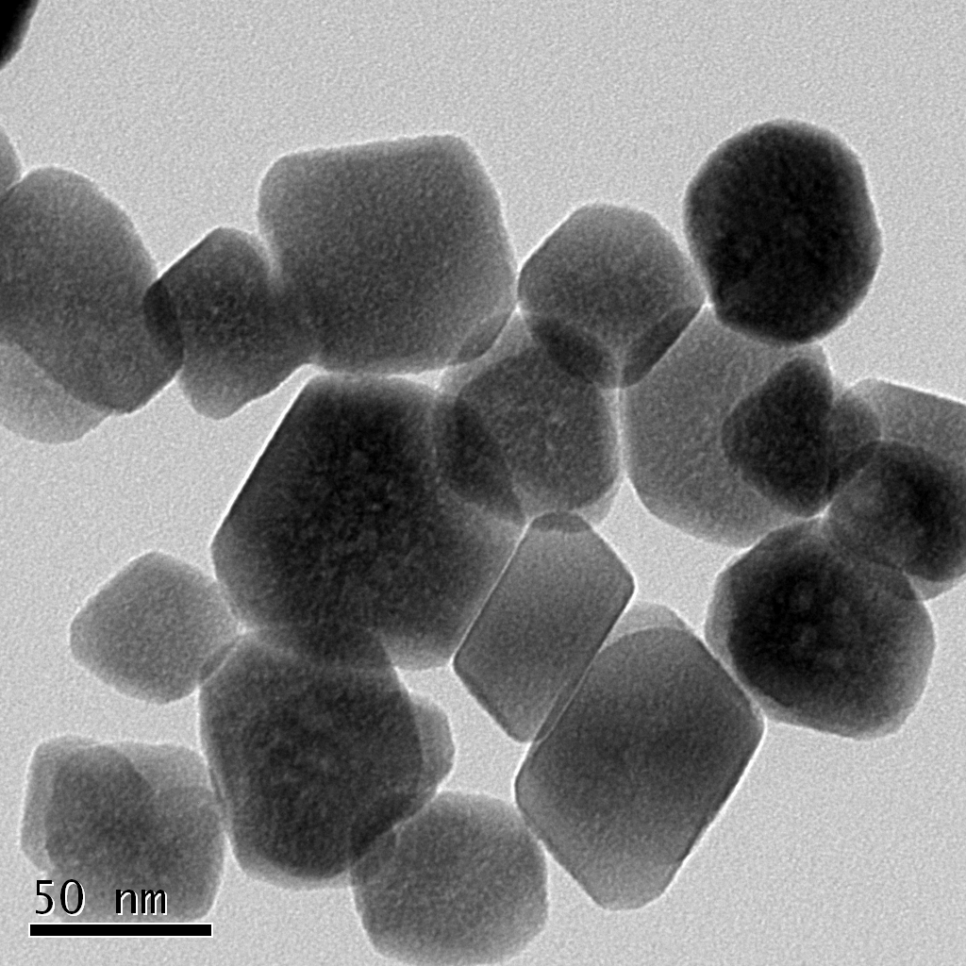

Fig..S1 Transmission electron microscopy image of FMNP

Fig. S2 X-ray powder diffraction pattern of FMNP

Fig. S3 Fourier transform infrared spectrum (KBr) of FMNP

Fig. S4 Vibrating sample magnetometer curve of FMNP with applied magnetic field

Fig. S5 The Barrett-Joiner-Halenda method adsorption for MNP

Fig. S6 The Barrett-Joiner-Halenda method adsorption for FMNP

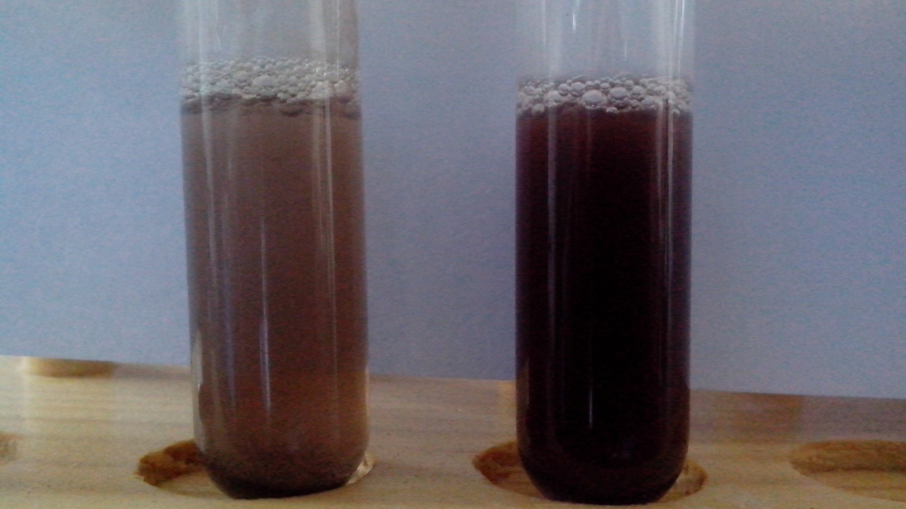
Fig. S7 The photographs MNP (left) and FMNP(right) is suspended in water within minutes interval

Fig. S8 Removal efficiency of Pb standard solution with immobilized FMNP dose compared with the literature

Fig. S9 Reusability of FMNP for As, Sb and Se ions removal (numbers1,2,3,4,5,6,7)

