Surpporting Information

Biotemplated Synthesis of Au loaded Sn-doped TiO₂ Hierarchical nanorods Using Nanocrystalline Cellulose and Their Applications in Photocatalysis

Yan Yan⊥, Tianrui Chen⊥, Yongcun Zou, Yu Wang*

State Key Laboratory of Inorganic Synthesis and Preparative Chemistry, Jilin University, 2699 Qianjin Street, Changchun, 130012, P. R. China

*Corresponding author. E-mail: wangyu@jlu.edu.cn. Tel: +86 0431 85167482.
Experimental Methods:
Preparation of nanocrystaline cellulose (NCC)
Typically, 50 g of bleached commercial cotton pulp was immersed in 1000 mL of deionized water and milled by using a commercial pulper, followed by oven-drying. Next, the milled pulp was hydrolysed in 200 mL (64 wt.%) of H₂SO₄ aqueous solution at 45 ºC and vigorously stirred for 1h. Then, the pulp slurry was diluted with plenty of cold deionized water (about ten times the volume of the acid solution used) to stop the hydrolysis and holded overnight. The clear top layer was decanted and the remaining cloudy layer was centrifuged and washed three times with deionized water. The obtained white thick suspension was dispersed into water to form 6 wt.% NCC solution for further procedures.
Synthesis of TiO₂ hierarchical nanorods:
Typically, 8 mL (6 wt.%) NCC solution was added in 180 mL ethanol. subsequently, 6 mL TBT was dissolved in 180 mL ethanol and strirred for 30 minutes unitil the homogeneous sloutions were achieved. Next, the above-menthioned solutions were mixed and stirred for 30 minutes, followed by adding 50 mL mixed solution of deionized water and ethanol with the ratio of 1:10. Then the mixed solutin was stirred for 24 hours to cover the amorphous TiO₂ on the surface of NCC. The Product was centrifuged and washed four times with ethanol and deionized water to remove the organic residues and dried at 60°C. The as-synthesized products were calcined at 520 °C for 6h in a muffle furnace at a heating rate of 1 °C/min to obtained the TiO₂ hierarchial nanorods.

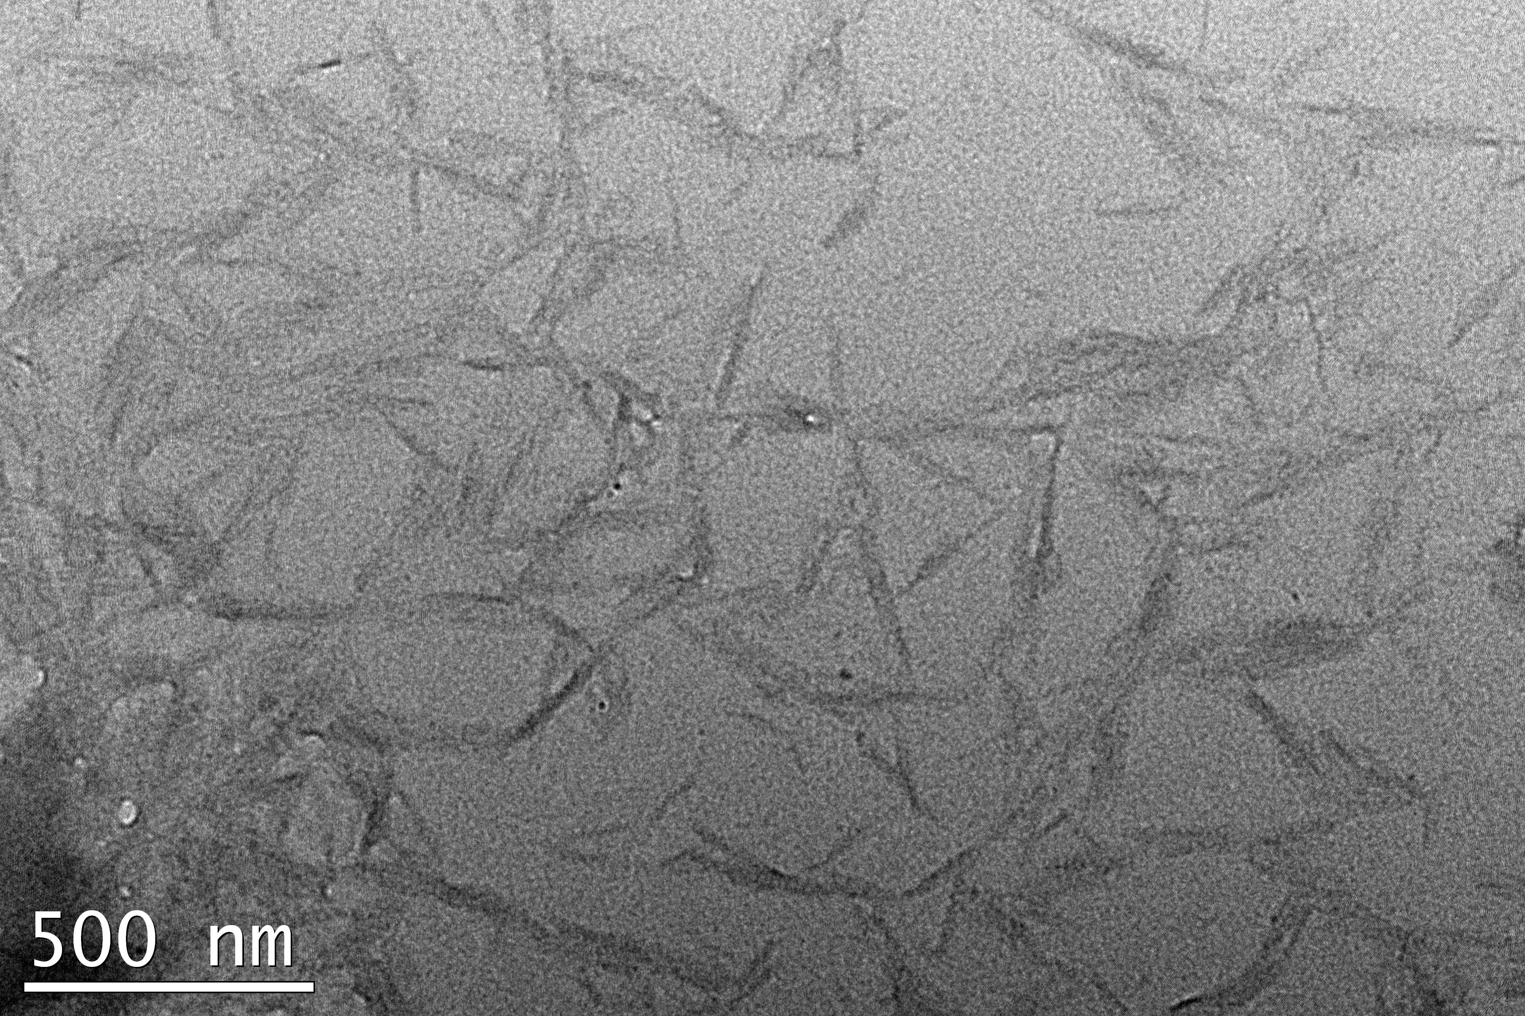

Figure S1. The TEM image of NCC.
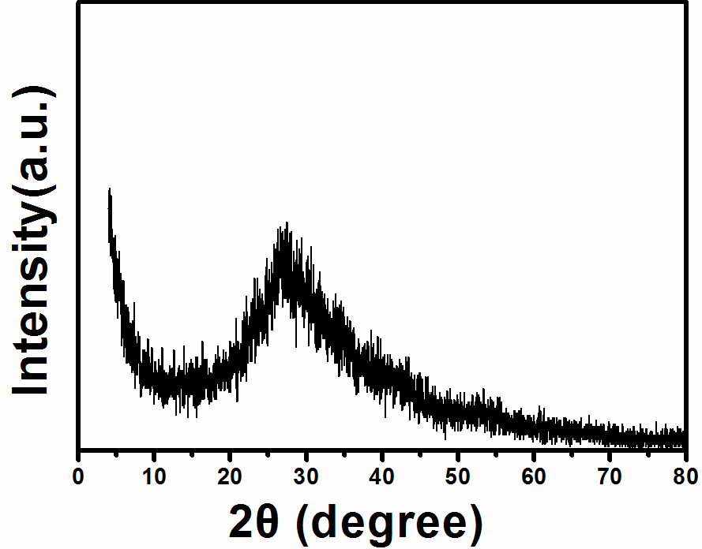

Figure S2. XRD pattern of the as-synthesized amorphous TiO₂@SnO₂@NCC hybrid nanorods.

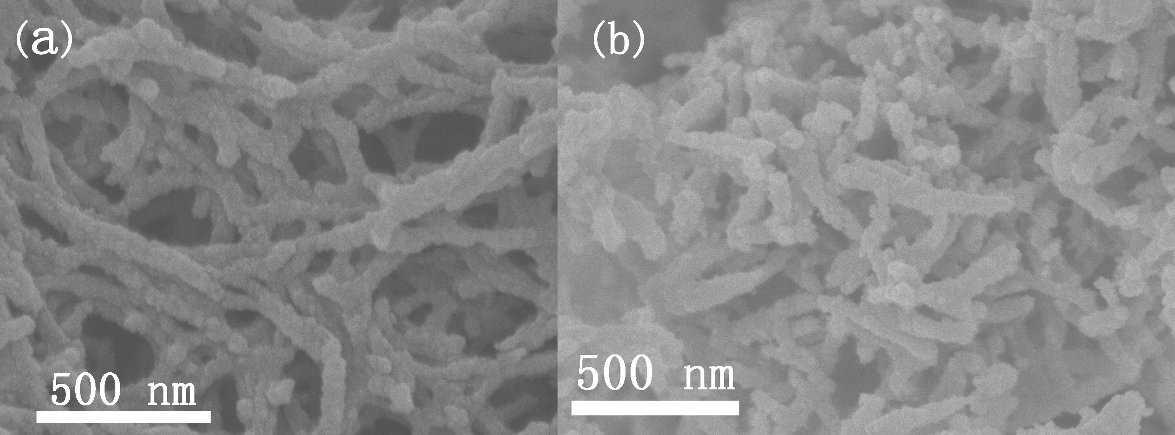

Figure S3. (a) SEM of the NCC coated with amorphous TiO₂, (b) SEM of the TiO₂ hierarchical nanorods calcined at 520°C.

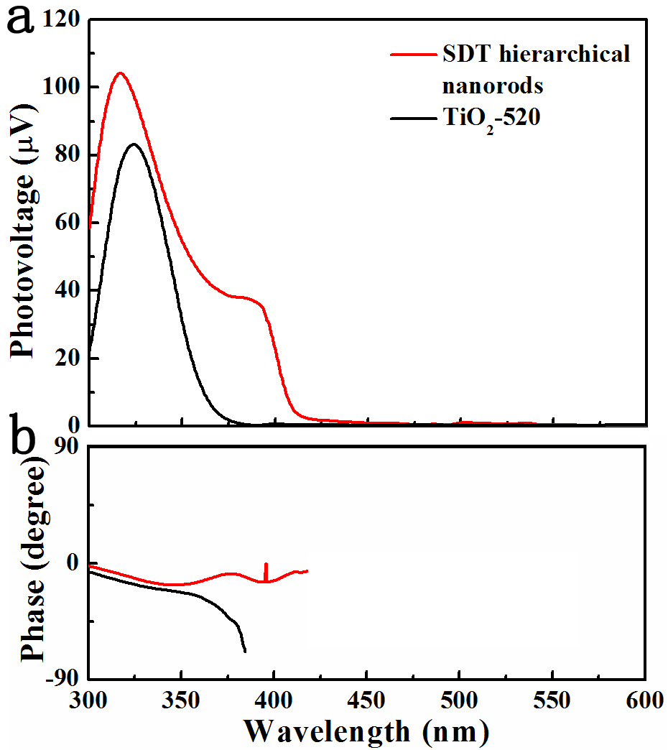

Figure S4. (a) The SPV spectrum of TiO₂-520 and SDT hierarchical nanorods, (b) the corresponding phase spectrum.

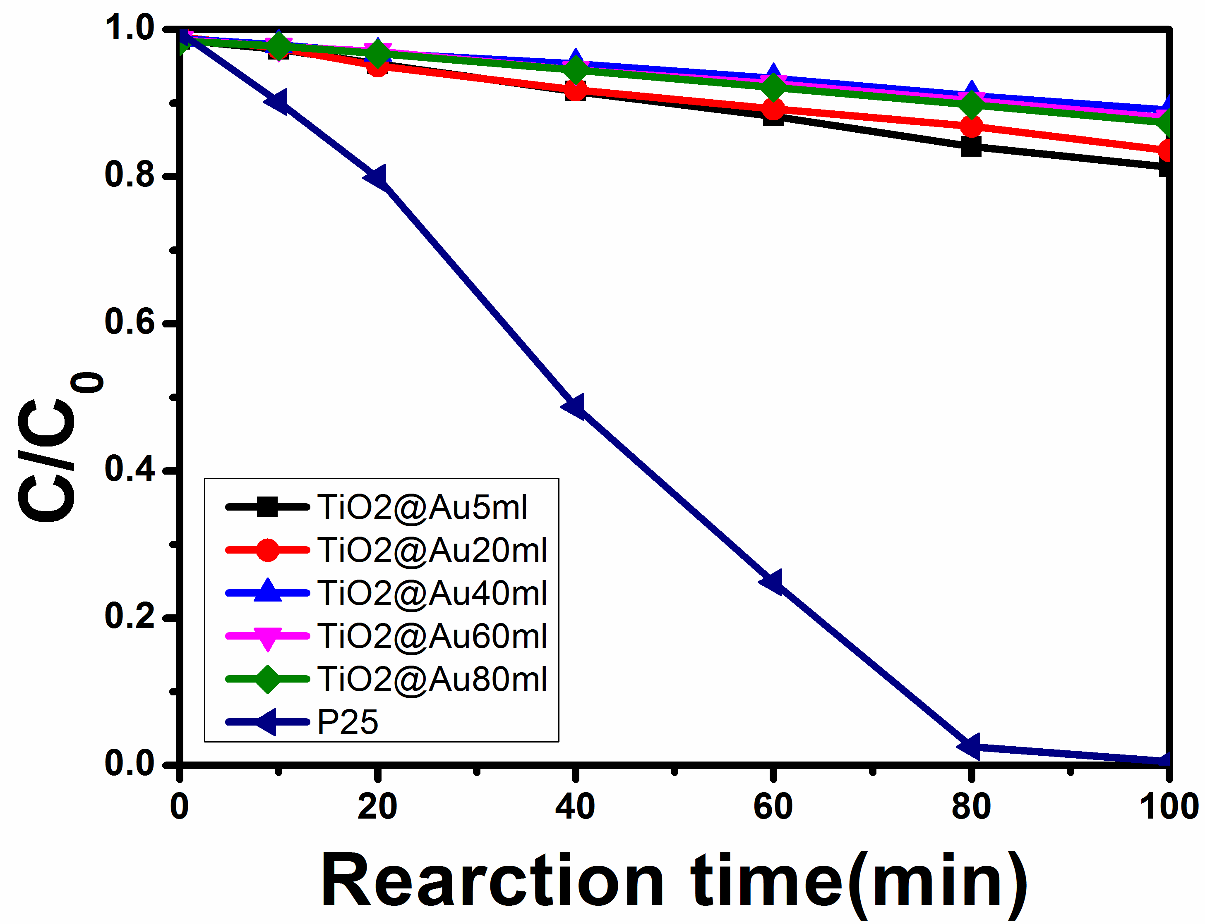

Figure S5. P25 and TiO₂ hierarchical nanorods loaded by different amounts of Au nanoparticles as catalyst, the variation of C/C₀

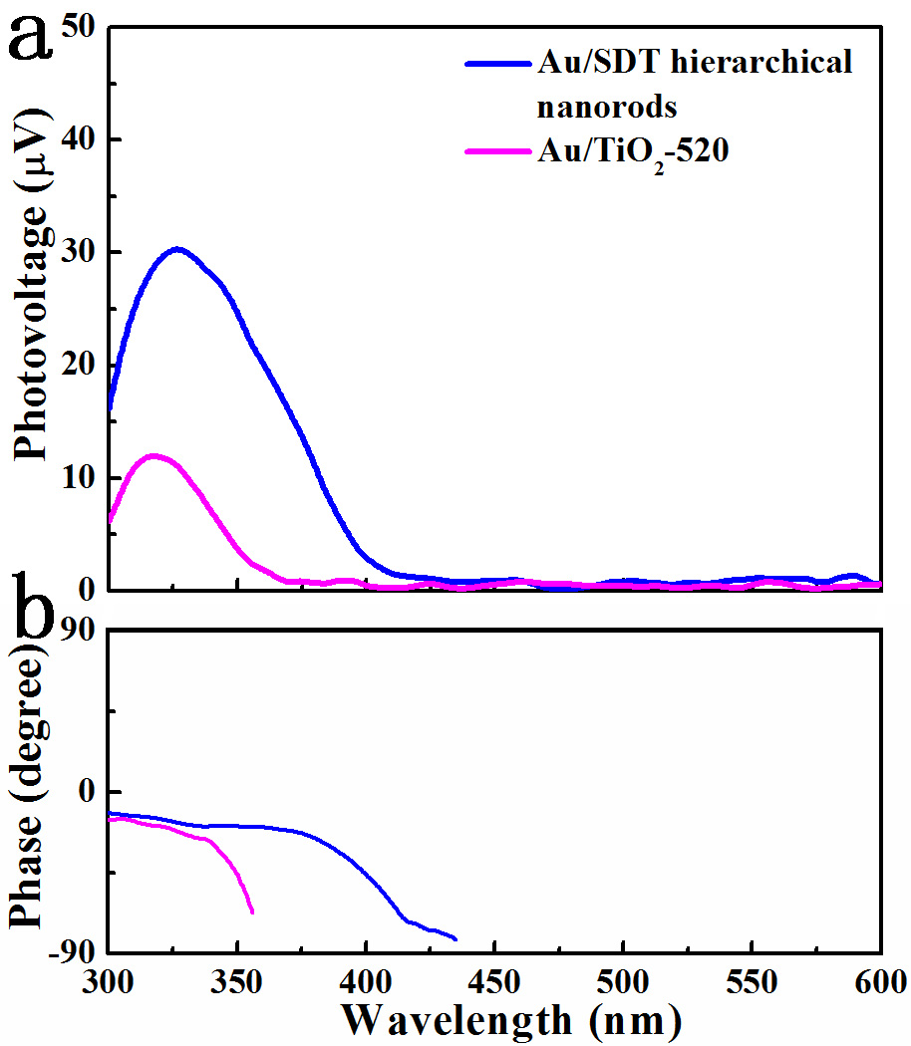

Figure S6. (a) The SPV spectrum of Au/TiO₂-520 and Au/SDT hierarchical nanorods, (b) the corresponding phase spectrum.

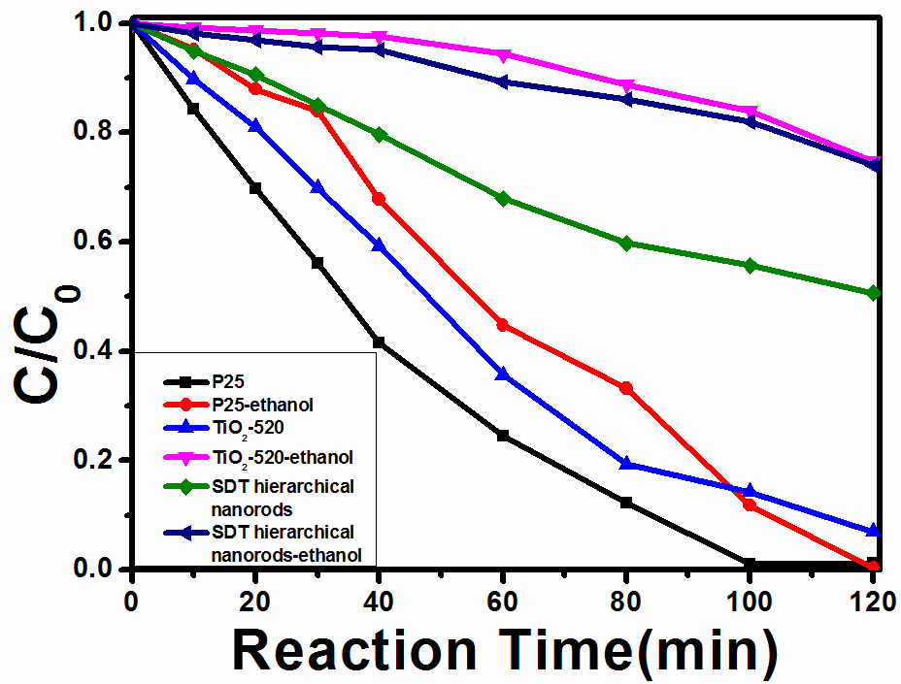

Figure S7. The influence of ethanol on the photocatalytic performance of TiO₂-520, SDT hierarchical nanorods and P25

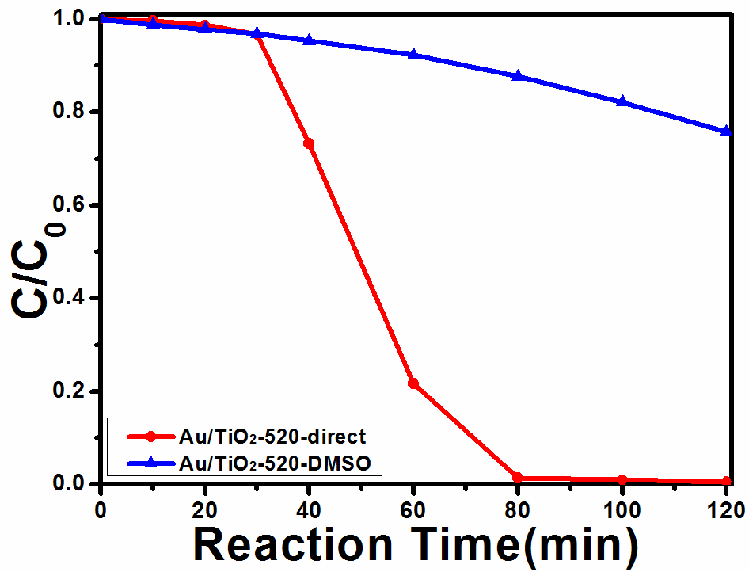

Figure S8. The influence of ethanol and DMSO on the photocatalytic performance of Au/TiO₂-520.

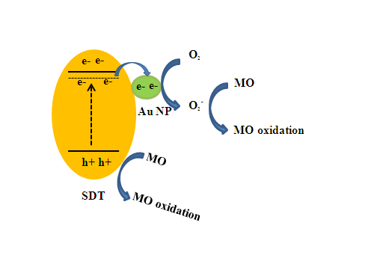

Scheme S1. Schematic illstration of the photocatalytic degradation mechanism of MO over the Au/SDT hierarchical nanorod under UV light.

