Supplementary Material

TABLE SI. Standard crystallographic data for the SrTiO₃ lattice structure.
TABLE SII. Crystallographic data of S3T lattice structure.
TABLE SIII. Formation enthalpy of Pb-doped Sr₃Ti₂O₇.
TABLE SIV. Crystallographic data of Sr₄Ti₃O₁₀ phase in SPT-125 sintered at 1550 °C for 2 h.

FIG. SI. Crystal structures of the SrTiO₃ and Sr₃Ti₂O₇ phases.
FIG. SII Rietveld fittings of Sr₃Ti₂O₇.
FIG. SIII. Crystal structure of Sr₄Ti₃O₁₀.

TABLE SI. Standard crystallographic data for the SrTiO₃ lattice structure.
Lattice parameter/10⁻¹⁰m | a=b=c =3.905
Bond length/10⁻¹⁰m | Ti-O_{i} (i=1, 2, 3) | 1.952 | Sr-O_{j} (j=1, 2, 3, 4, 5, 6) | 2.761
Bond angle/° | O₁-Ti-O₂ | 90 | O₂-Sr-O_{i} (i=3, 6) | 60
Bond angle/° | O₁-Ti-O₃ | 90 | O₂-Sr-O₄ | 90
Bond angle/° | O₂-Ti-O₃ | 90 | O₂-Sr-O₅ | 120
Bond angle/° | O₁-Ti-O₁ | 180 | O₃-Sr-O₄ | 60
Bond angle/° | O₂-Ti-O₂ | 180 | O₃-Sr-O_{i} (i=5, 6) | 120
Bond angle/° | O₃-Ti-O₃ | 180 | O₄-Sr-O₅ | 60
Bond angle/° | O₁-Sr-O_{i}  (i=2, 4, 5, 6) | 60 | O₄-Sr-O₆ | 90
Bond angle/° | O₁-Sr-O_{i}  (i=2, 4, 5, 6) | 60 | O₅-Sr-O₆ | 90
Bond angle/° | O₁-Sr-O₃ | 90 | Sr-O-Sr | 180

TABLE SII. Crystallographic data of S3T lattice structure.
Bond length/10⁻¹⁰m |  |  | Bond angle/°
Ti-O₁ |  | 1.951 | O₁-Ti-O₂ | 90
Ti-O₂ |  | 1.951 | O₁-Ti-O₃ | 90
Ti-O₃ |  | 1.933 | O₂-Ti-O₃ | 90
Sr₁-O₁ |  | 2.759 | O₁-Sr₁-O₂ | 59.85
Sr₁-O₂ |  | 2.746 | O₁-Sr₁-O₃ | 59.85
Sr₁-O₃ |  | 2.746 | O₂-Sr₁-O₃ | 60.3
Sr₂-O₁ |  | 2.761 | O₁-Sr₂-O₂ | 87.89
Sr₂-O₂ |  | 2.544 | O₁-Sr₂-O₃ | 60.66
Sr₂-O₃ |  | 2.676 | O₂-Sr₂-O₃ | 133.19
Lattice parameter  /10⁻¹⁰m | a=b | 3.9014 | O₁-Sr₂-O₁ | 175.78
Lattice parameter  /10⁻¹⁰m | c | 20.3484 | O₃-Sr₂-O₃ | 62.06

TABLE SIII. Formation enthalpy of Pb-doped Sr₃Ti₂O₇.
Super cell | Doping concentration | Atomic number |  |  |  | Formation enthalpy/eV
Super cell | Doping concentration | Sr | Ti | O | Pb | Sr1 position | Sr2 position
1×1×1 | 0 | 6 | 4 | 14 | 0 | -3.438 | -3.438
2×2×2 | 0.0208 | 48 | 32 | 112 | 1 | -3.417 | -3.422
2×3×1 | 0.0278 | 35 | 24 | 84 | 1 | -3.408 | -3.414
3×3×1 | 0.0370 | 52 | 36 | 126 | 2 | -3.404 | -3.410
2×2×1 | 0.0417 | 23 | 16 | 56 | 1 | -3.393 | -3.399
3×1×1 | 0.0556 | 17 | 15 | 42 | 1 | -3.378 | -3.385
2×1×1 | 0.0833 | 11 | 8 | 28 | 1 | -3.348 | -3.356
1×1×1 | 0.167 | 5 | 4 | 14 | 1 | -3.256 | -3.269
1×1×1 | 0.334 | 4 | 4 | 14 | 2 | -3.069 | -3.088

TABLE SIV. Crystallographic data of Sr₄Ti₃O₁₀ phase in SPT-125 sintered at 1550°C for 2 h.
 | Symbols | Standard data* | SPT-125
Lattice parameter/10⁻¹⁰m | a=b | 3.9 | 3.9017
Lattice parameter/10⁻¹⁰m | c | 28.1 | 28.1499
Ti-O bond length/10⁻¹⁰m | D1 | 1.911 | 1.914
Ti-O bond length/10⁻¹⁰m | D2 | 1.855 | 1.858
Ti-O bond length/10⁻¹⁰m | D3 | 1.967 | 1.970
Sr₂-O₂ bond length/10⁻¹⁰m | S1 | 2.557 | 2.562
* Lattice parameter data from PDF No. 97-003-4630 and the bond length calculated by Jade.

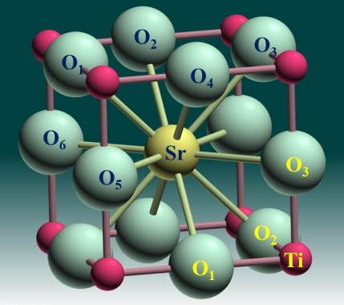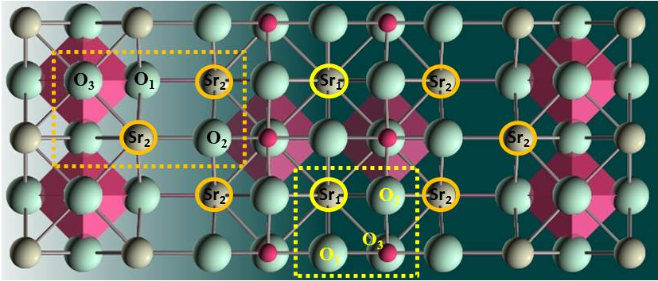
(a) SrTiO₃ (b) Sr3Ti2O7
FIG. SI. Crystal structures of the SrTiO₃ and Sr₃Ti₂O₇ phases.

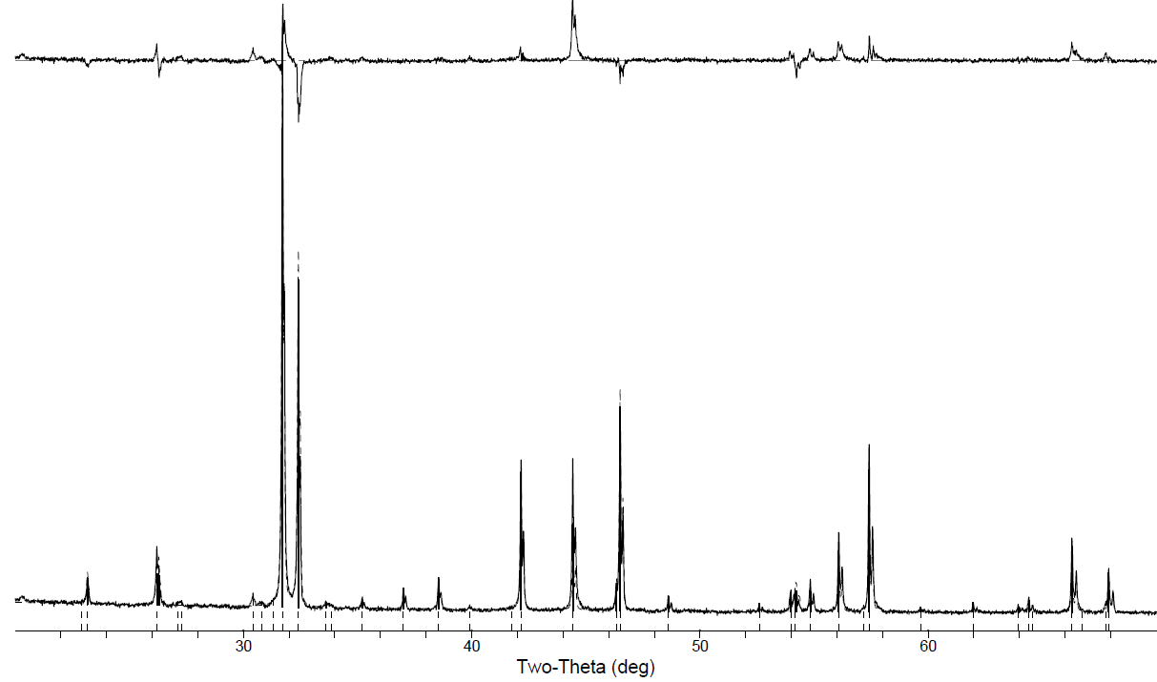
FIG. SII. Rietveld fitting of Sr₃Ti₂O₇.

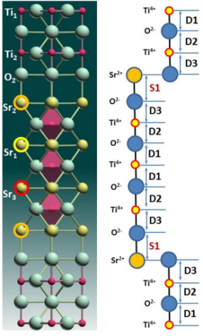
FIG. SIII. Crystal structure of Sr₄Ti₃O₁₀.

