Supplementary Material

Near-zero thermal expansion and phase transition in In_{0.5}(ZrMg)_{0.75}Mo₃O₁₂
Luciana P. Prisco,¹ Patricia I. Pontón,¹ W. Paraguassu², Carl P. Romao,³ Mary Anne White,^{3,4,5} Bojan A. Marinkovic^{1*}
¹ Departamento de Engenharia Química e de Materiais, Pontifícia Universidade Católica 22451-900 Rio de Janeiro, RJ, Brasil, Brasil
² Faculdade de Física, Universidade Federal do Pará, P.O. Box 479, Belém, PA, 66075-110, Brasil
³ Department of Chemistry, Dalhousie University, Halifax, Nova Scotia, B3H 4R2, Canada
⁴ Institute for Research in Materials, Dalhousie University, Halifax, Nova Scotia, B3H 4R2, Canada
⁵ Department of Physics and Atmospheric Sciences, Dalhousie University, Halifax, Nova Scotia, B3H 4R2, Canada
∗ Corresponding author. Tel: +55-21-35271954;
E-mail address: bojan@puc-rio.br (Bojan Marinkovic)

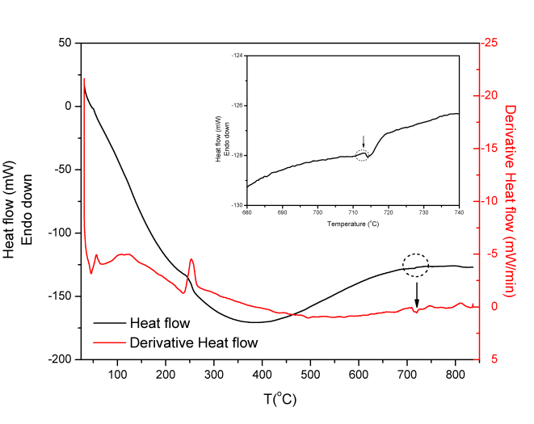
FIG. S1. DSC (black) and first derivate DSC (red) curves of In_{0.5}(ZrMg)_{0.75}Mo₃O₁₂ raw precursor powder (inset figure: magnified view of DSC curve, showing the exothermic peak corresponding to crystallization of the In_{0.5}(ZrMg)_{0.75}Mo₃O₁₂ phase).

TABLE SI. Mass percentage of each element of In_{0.5}(ZrMg)_{0.75}Mo₃O₁₂ obtained by EDS.
Element | Measure 1 (%) | Measure 2 (%) | Average (%) | Theoretical value (%)
In | 9.68 | 7.86 | 8.8 | 9.20
Zr | 10.12 | 9.25 | 9.7 | 10.97
Mg | 2.59 | 3.26 | 2.9 | 2.89
Mo | 43.38 | 39.03 | 41.2 | 46.15
O | 34.23 | 45.45 | 39.8 | 30.78

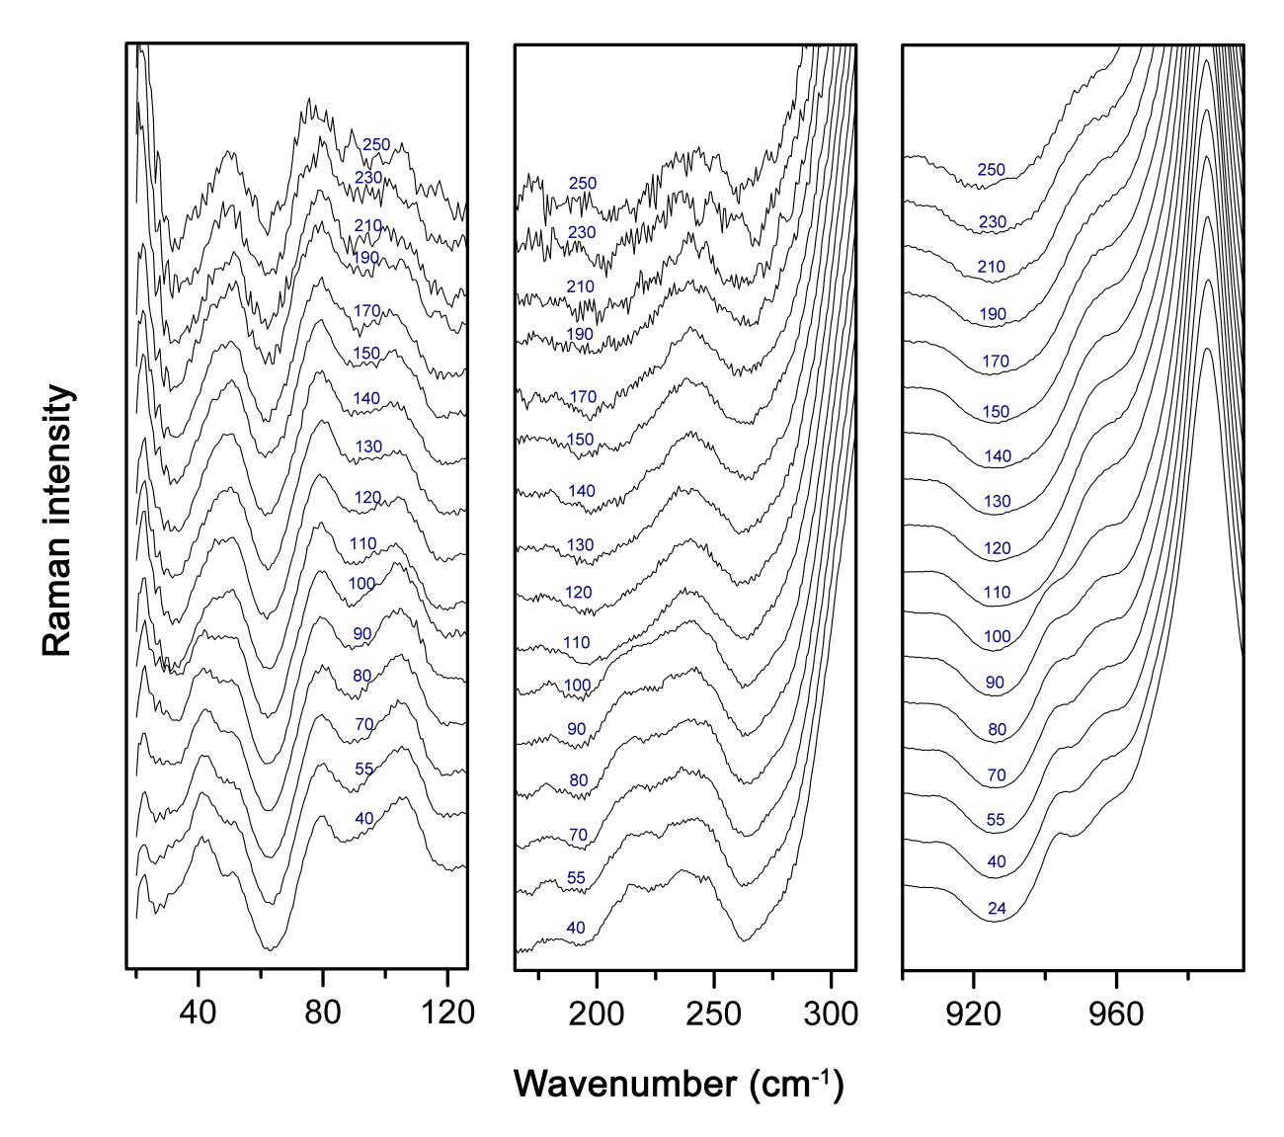
FIG. S2. Raman spectra of In_{0.5}(ZrMg)_{0.75}Mo₃O₁₂ for different temperatures between 24 °C and 250 °C (blue numbers) in the wavenumber range of (a) 20–120 cm⁻¹, (b) 125–325 cm⁻¹ and (b) 900–990 cm⁻¹.

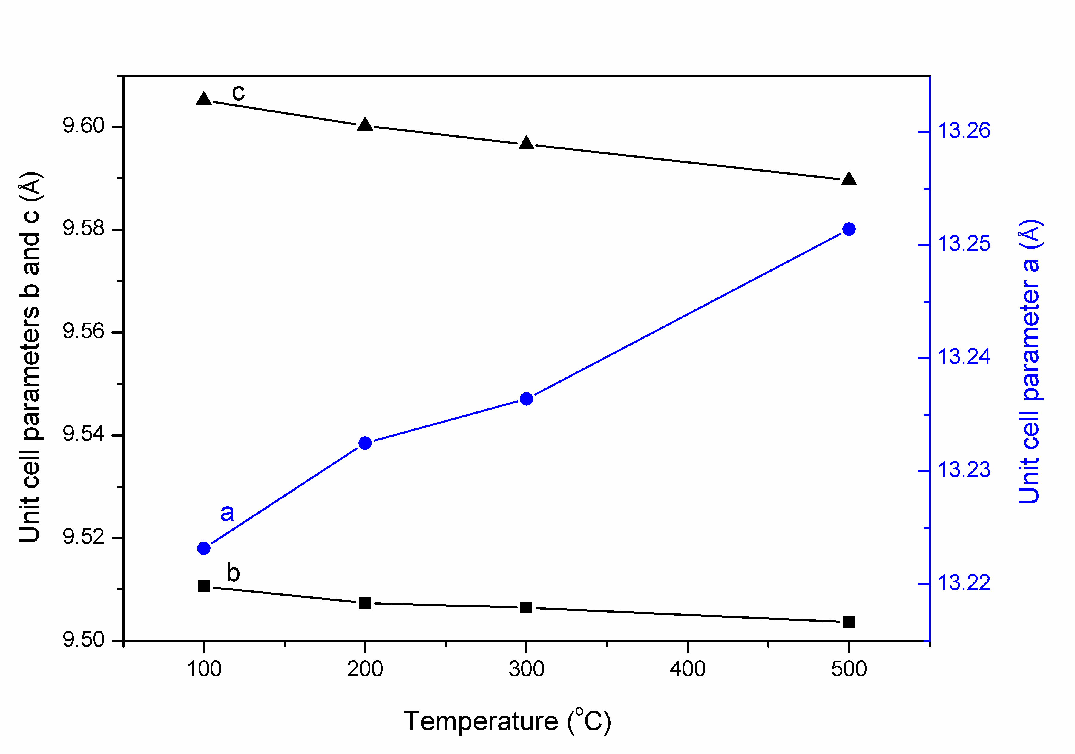
FIG. S3. Temperature dependence of the orthorhombic unit cell parameters of In_{0.5}(ZrMg)_{0.75}Mo₃O₁₂ (estimated standard deviation bars are not shown, because they are smaller than the symbols).

