Supplementary Figures
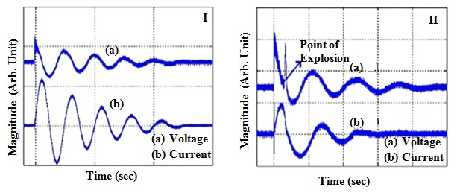

FIG. S1. The characteristic voltage measured across R and the current flow through it (I) without explosion (II) during the explosion.

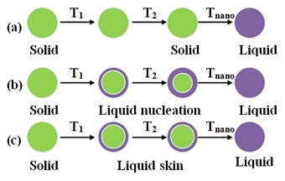

FIG.S2. Various melting modes (a) HMM (b) LNG (c) LSM

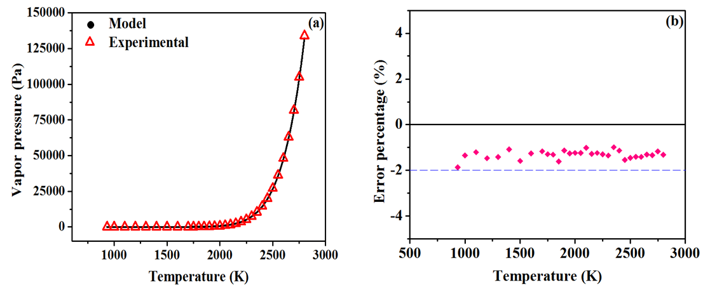

FIG.S3. (a) Comparison of experimental [33, 34, 35] and model vapour pressures of aluminium at various temperatures and (b) error in the model vapour pressure compared to the experimental values.

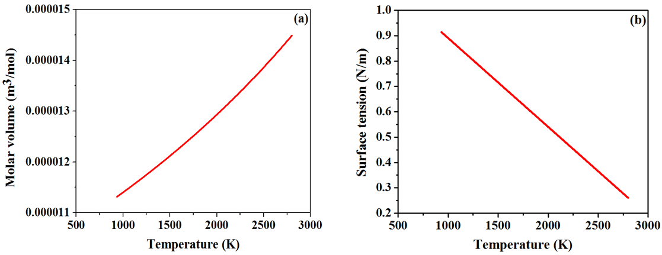

FIG.S4. Temperature dependent variations in (a) molar volume and (b) surface tension of liquid aluminium.

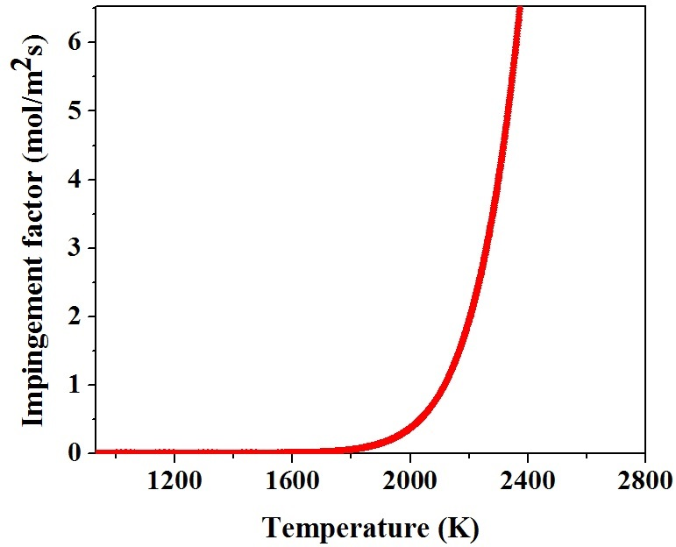

FIG.S5. Variation of impingement factor with temperature.

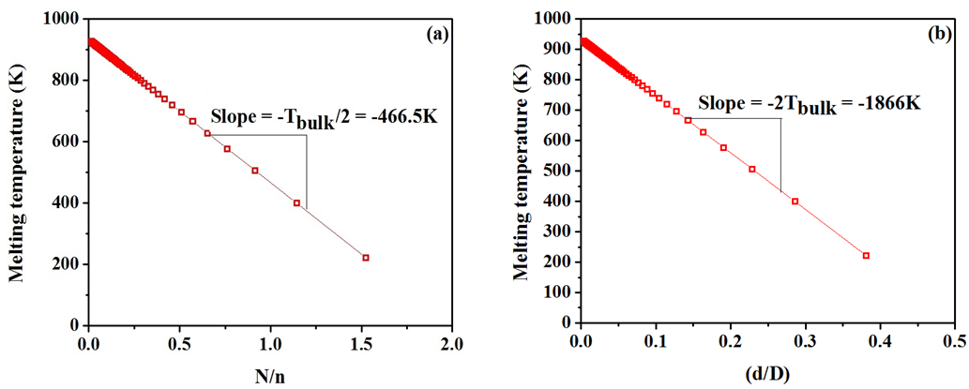
FIG.S6. (a) Size dependent melting temperature vs N/n (b) Size dependent melting point vs d/D.
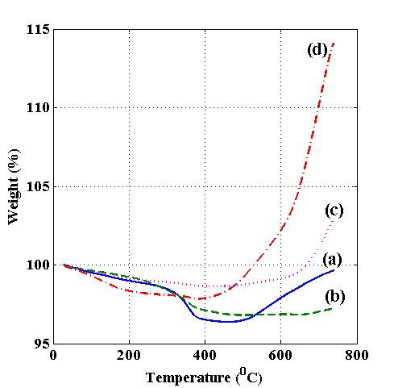
FIG. S7. TGA curves for aluminium nanoparticles produced at (a) k=1at 1atm, (b) k=1 at 0.25atm (c) k=2 at 0.5atm and (d) k=3 at 0.25atm.

