Supplementary Material

FIG. S1. SEM surface morphologies of spin-coated Ti-10 films baked at 150 ºC for 20 min after (a) 200 pulses irradiation and (b) further post-annealing in a furnace at 600 ºC for 3 hours. (c) TEM image and (d) SAED pattern of the Ti-10 film after 200 pulses irradiation. (e) Raman spectra of the Ti-10 films after 200 pulses irradiation and further post-annealing at 600 ºC for 3 hours.

We synthesized amorphous TiO₂ thin film using the spin-coated Ti-10 film baked at 150 ºC for 20 min to remove organic components. As shown in Fig. S1(d), the SAED pattern of the film after 200 pulses irradiation shows amorphous ring without any discernible reflection pattern, which means the film is still amorphous phase. Compared to Fig. S1(a), Fig. S1(b) shows an apparent crystalline surface morphology of the film after a further post-annealing treatment in a furnace at 600 ºC for 3 hours. From Raman spectra shown in Fig. S1(e), there is no peak corresponding to TiO₂ mode except for fused silica glass in the baked precursor film after 200 pulses irradiation while three Raman-active phonons corresponding to anatase TiO₂ were clearly observed in the film post-annealed at 600 ºC for 3 hours, which further confirms the SEM and SAED results and indicates that the amorphous film transformed into anatase TiO₂ crystalline film after the post-annealing. It is believed that the pulsed light irradiation under the parameters setting could not work as rapid thermal annealing because the 1.93 milliseconds flash irradiation for each pulse and 0.83 seconds pulse interval could not supply enough time for amorphous TiO₂ film to be thermally activated and crystallized even though the simulated surface temperature of fused silica substrate already reaches 460 ºC after the 200th pulse of light irradiation and the accumulated time above 350 ºC is a little less than 1 min, as shown in Fig. 3.

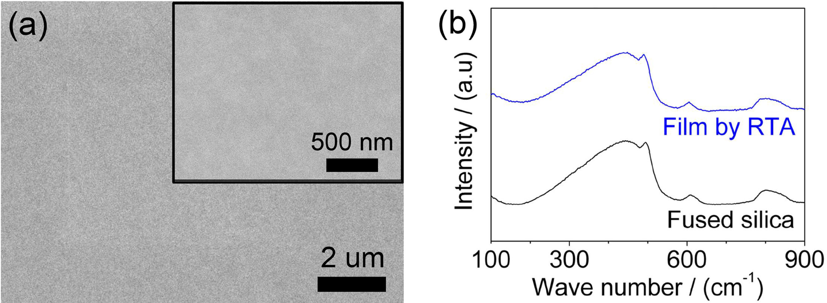
FIG. S2. (a) SEM surface morphology and (b) Raman spectrum of spin-coated Ti-10 film treated by rapid thermal annealing from room temperature to 500 ºC in 180 seconds.

We also performed a rapid thermal annealing (RTA) treatment on the spin-coated Ti-10 film over quartz substrate in a RTA furnace (with IR lamp) from room temperature to 500 ºC in 180 seconds. As shown in Fig. S2, it is apparently that the RTA-treated Ti-10 film is an amorphous film with a flat surface.

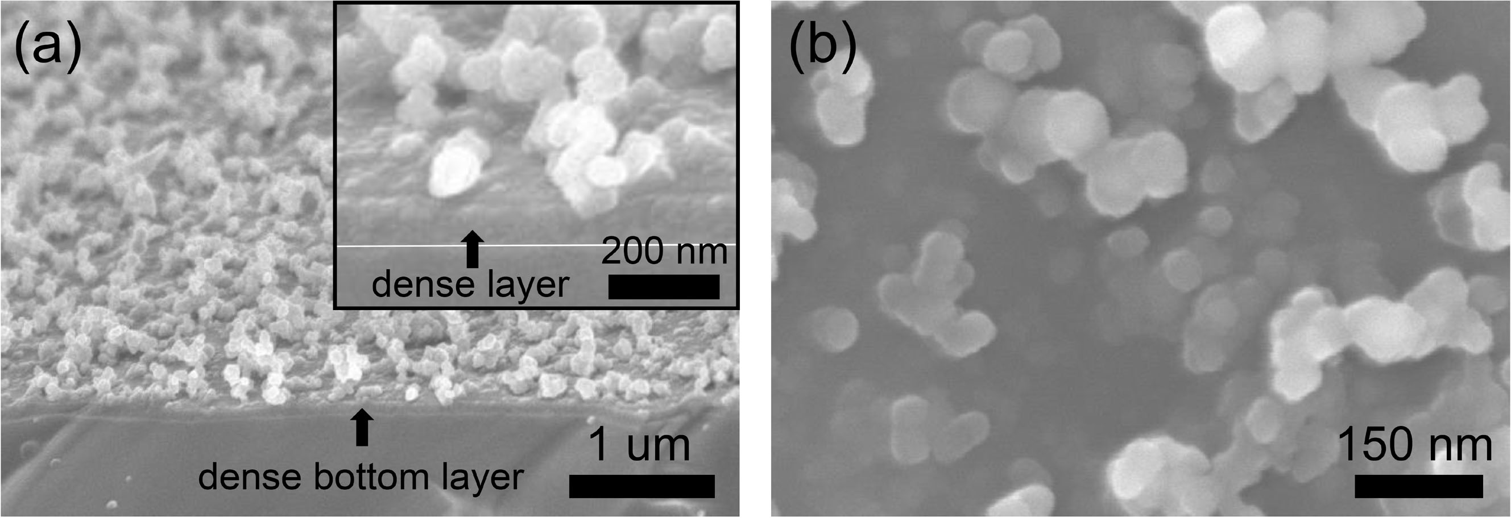
FIG. S3. Field Emission SEM high magnification images of (a) cross-sectional morphology with a tilt angle and (b) surface morphology of the Ti-10 film after 100 pulses irradiation.

Table SI. Area fractions of C1s peaks in the XPS core-level spectra
Item | Etching for 180 s
Item | 1 pulses | 100 pulses | 200 pulses
C=C | 31.5 % | 48.2 % | 70.5 %
C-H or C defect | 27.9 % | 17.3 % | 1.8 %
C-C | 23.8 % | 21.3 % | 18.6 %
C-OH | 8.0 % | 7.6 % | 5.3 %
C-O-C | 3.4 % | 1.9 % | 1.2 %
C=O | 0.6 % | 1.3 % | 0.8 %
O-C=O | 4.7 % | 2.4 % | 1.8 %

Table SII. Area fractions of Ti2p peaks in the XPS core-level spectra
Item | Etching for 180 s
Item | 1 pulse | 100 pulses | 200 pulses
Ti²⁺ | 3.8 % | 4.1 % | 5.0 %
Ti³⁺ | 29.3 % | 26.3 % | 15.6 %
Ti⁴⁺(-O) | 48.4 % | 55.9 % | 72.5 %
Ti⁴⁺(-OH) | 18.5 % | 13.7 % | 6.9 %

