Supplementary Information

An impedance sensor for the detection of formaldehyde vapor using ZnO

nanoparticles

Padmanathan Karthick Kannan^{a,b}, Ramiah Saraswathi^{a,}*
ªDepartment of Materials Science, School of Chemistry, Madurai Kamaraj University, Madurai – 625021,
Tamil Nadu, India.
^{b}School of Chemical Engineering, Sungkyunkwan University, Suwon 16419, Republic of Korea
E-mail: drrsaraswathi@gmail.com

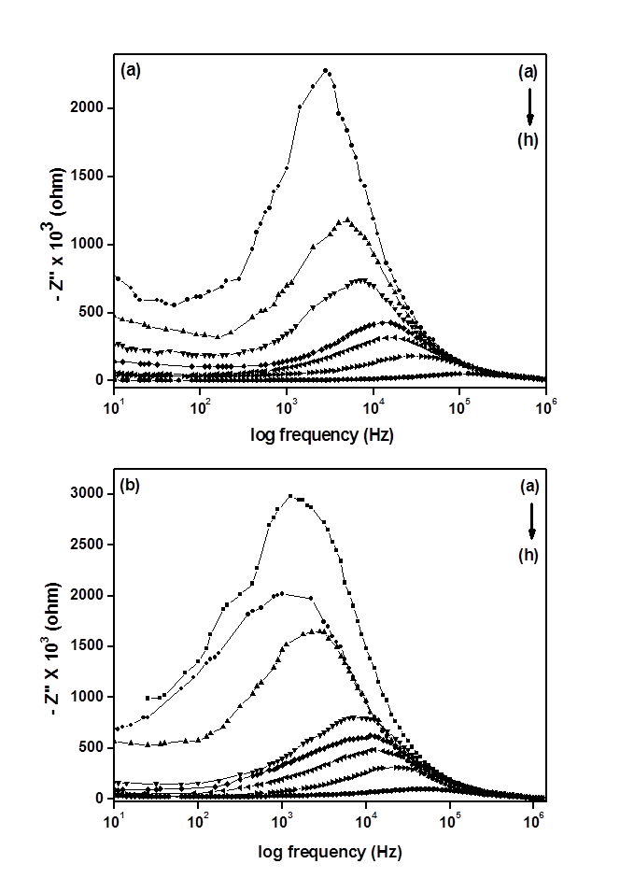

Fig. S1. Plots of Z’’ against log frequency at various concentration of formaldehyde (A) laboratory prepared ZnO sample (B) commercial ZnO sample. Concentration of formaldehyde: (a) 100 (b) 200 (c) 300 (d) 400 (e) 500 (f) 600 (g) 700 and (h) 800 ppm

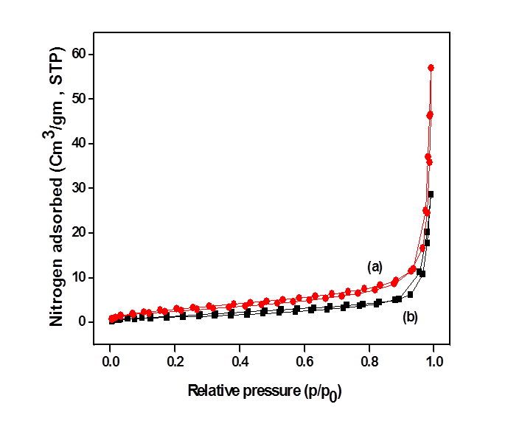

Fig. S2. Nitrogen adsorption and desorption isotherms of ZnO (a) laboratory prepared sample and (b) commercial sample at 77 K

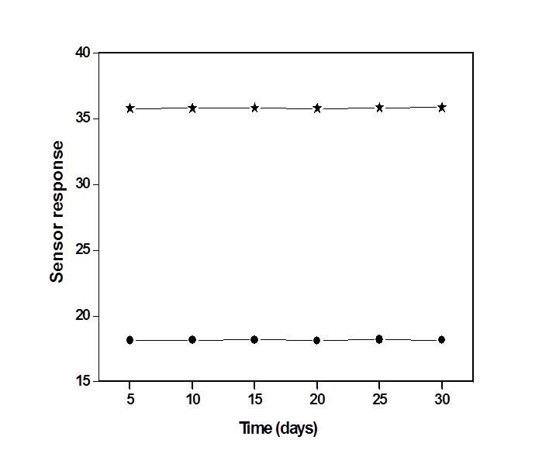

Fig. S3. Stability data of sensor at 100 ppm of formaldehyde for laboratory prepared sample () and commercial sample ()

Table SI. Variation in relaxation frequency (f_{r}) with concentration of formaldehyde

Concentration  of formaldehyde  (ppm) | Relaxation frequency, (f_{r})  (Hz)
Concentration  of formaldehyde  (ppm) | Laboratory prepared ZnO sample | Commercial ZnO sample
100 | 891 | 1260
200 | 2818 | 1590
300 | 5000 | 2820
400 | 7000 | 7000
500 | 15900 | 11200
600 | 17800 | 12600
700 | 28300 | 22400
800 | 126000 | 25000

Table SII. Equivalent circuit parameters for laboratory prepared ZnO sample on exposure
to air and different concentration of formaldehyde

Air / Concentration of  formaldehyde in ppm | R_{g}  (ohm) | R_{gb}  (ohm) | C_{g}  (F) | C_{gb}  (F)
Air | 1.598 × 10⁸ | - | 1.167 × 10⁻¹¹ | -
100 | 5.503 × 10⁶ | 2.544 × 10⁵ | 1.174 × 10⁻¹¹ | 2.965 × 10⁻¹¹
200 | 3.529 × 10⁶ | 2.523 × 10⁵ | 2.058 × 10⁻¹¹ | 3.708 × 10⁻¹¹
300 | 2.343 × 10⁶ | 1.6277 × 10⁵ | 2.446 × 10⁻¹¹ | 4.605 × 10⁻¹¹
400 | 1.466 × 10⁶ | 1.557 × 10⁵ | 1.658 × 10⁻¹¹ | 3.340 × 10⁻¹¹
500 | 7.973 × 10⁵ | 1.520 × 10⁵ | 2.817 × 10⁻¹¹ | 2.638 × 10⁻¹¹
600 | 4.991 × 10⁵ | 1.078 × 10⁵ | 2.535 × 10⁻¹¹ | 1.304 × 10⁻⁹
700 | 2.245 × 10⁵ | 6.805 × 10⁴ | 3.773 × 10⁻¹¹ | 1.310 × 10⁻⁹
800 | 1.057 × 10⁵ | 1.522 × 10⁴ | 1.432 × 10⁻¹¹ | 2.817 × 10⁻⁹

Table SIII. Equivalent circuit parameters for commercial ZnO sample on exposure to air and
different concentration of formaldehyde

Air / Concentration of  formaldehyde in ppm | R_{g}  (ohm) | R_{gb}  (ohm) | C_{g}  (F) | C_{gb}  (F)
Air | 1.583 × 10⁸ | - | 1.169 × 10⁻¹¹ | -
100 | 5.336 × 10⁶ | 2.905 × 10⁵ | 1.030 × 10⁻¹¹ | 3.332 × 10⁻¹¹
200 | 3.445 × 10⁶ | 2.046 × 10⁵ | 1.059 × 10⁻¹¹ | 4.065 ×10⁻¹¹
300 | 3.252 × 10⁶ | 2.023 × 10⁵ | 4.284 × 10⁻¹¹ | 3.289 × 10⁻¹¹
400 | 6.651 × 10⁵ | 1.138 × 10⁵ | 1.951 × 10⁻¹¹ | 2.960 × 10⁻¹¹
500 | 5.253 × 10⁵ | 1.045 × 10⁵ | 2.673 × 10⁻¹¹ | 2.084 × 10⁻¹¹
600 | 2.930 × 10⁵ | 1.013 × 10⁵ | 3.196 × 10⁻¹¹ | 1.647 × 10⁻¹¹
700 | 2.265 × 10⁵ | 9.837 × 10⁴ | 1.316 × 10⁻¹¹ | 1.038 × 10⁻⁹
800 | 1.314 × 10⁵ | 5.512 × 10⁴ | 1.396 × 10⁻¹¹ | 1.459 × 10⁻⁹

