Supporting Information
Reduced Graphene Oxide Modified Activated Carbon for Improving Power Generation of Air-Cathode Microbial Fuel Cells
Yang Yang ^{a,b,c}, Tianyu Liu ^{c}, Hanyu Wang ^{c}, Xun Zhu ^{a*}, Dingding Ye ª,
Qiang Liao ª, Ke Liu ^{c}, Shaowei Chen ^{c}, Yat Li ^{c**}

ª Key Laboratory of Low-grade Energy Utilization Technologies and Systems, Institute of Engineering Thermophysics, Chongqing University, Chongqing 400030, P. R. China
^{b} Ministry of Education Key Laboratory of Micro/Nano Systems for Aerospace, School of Mechanical Engineering, Northwestern Polytechnical University, Xi’an 710072, P. R. China
^{c} Department of Chemistry and Biochemistry, University of California, Santa Cruz, California 95060

Xun Zhu* -Ph.D., Corresponding Author, Professor;
Address: Institute of Engineering Thermophysics, Chongqing University, Chongqing 400030, P. R. China
Tel/Fax: +86-23-6510-2474
Email: zhuxun@cqu.edu.cn

Yat Li** -Ph.D., Co-Corresponding Author, Associate Professor;
Address: 1156 High Street, Santa Cruz, CA, 95064, United States
Tel: +1-831-502-7363
Email: yatli@ucsc.edu
Supplementary Figures and Tables
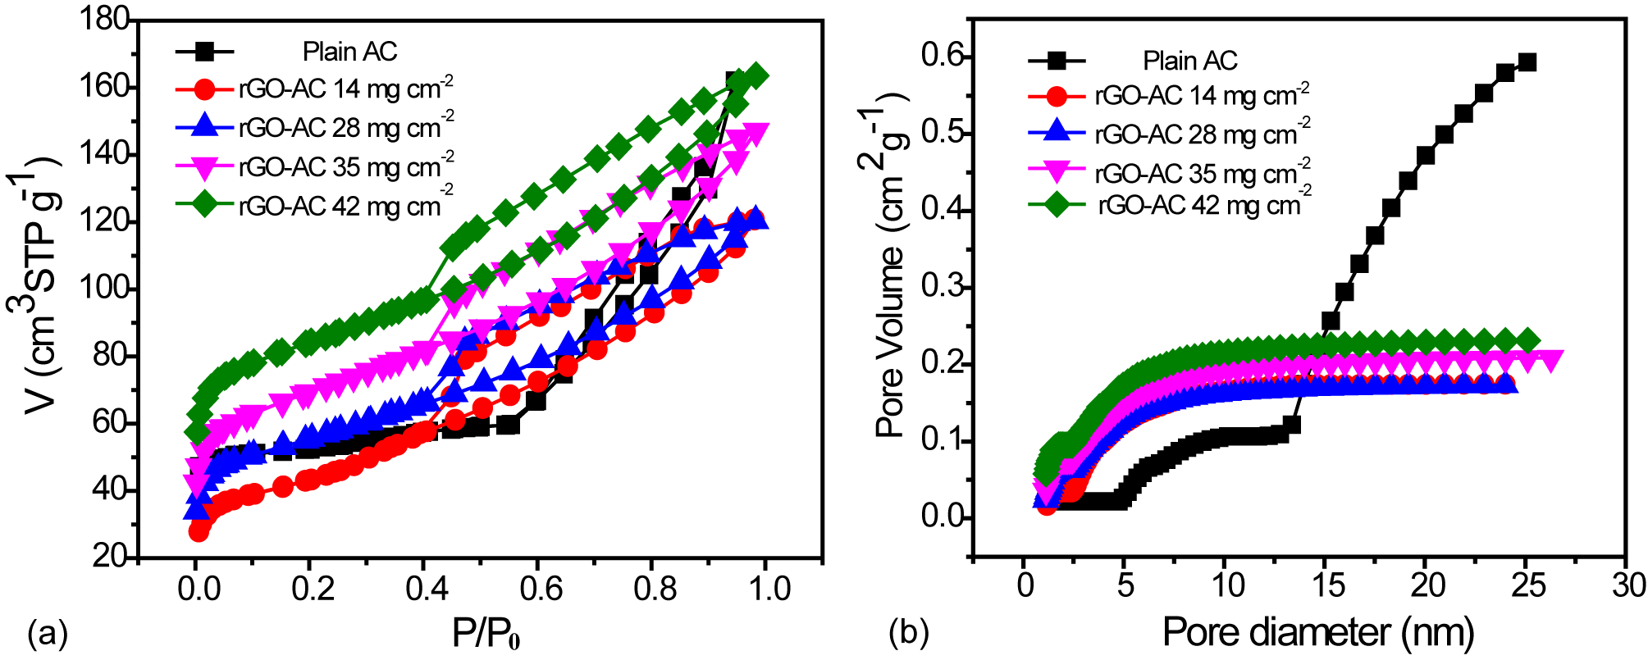
Fig.S1 (a) N₂ adsorption/desorption isotherms collected at 77.3 K; (b) A plot of pore diameter as a function of incremental pore volume.

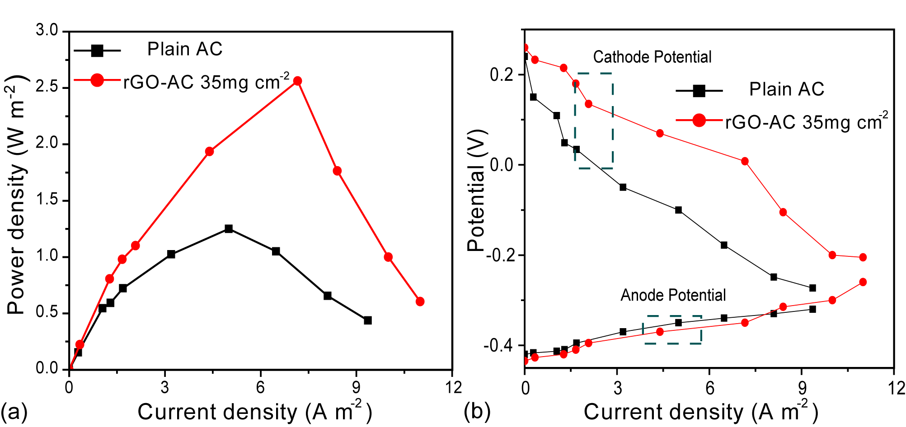
Fig.S2 Plot of power density (a) and (b) anode/cathode potential-curves as a function of current density of MFCs with plain AC and rGO-AC 35 mg cm⁻² air-cathodes.

The variation of cathode and anode along with the current was summarized in Figure S2b. Experimental results showed that the anode potential of both MFC devices with either plain AC cathode or rGO-AC cathode (35 mg cm⁻²) were almost the same, irrespective of the current density, whilst the cathode potential of the MFC device with rGO-AC cathode (35 mg cm⁻²) was much higher than that of the MFC device with plain AC cathode. These results unequivocally proved that the enhanced performance should be primarily ascribed to the cathode variation.

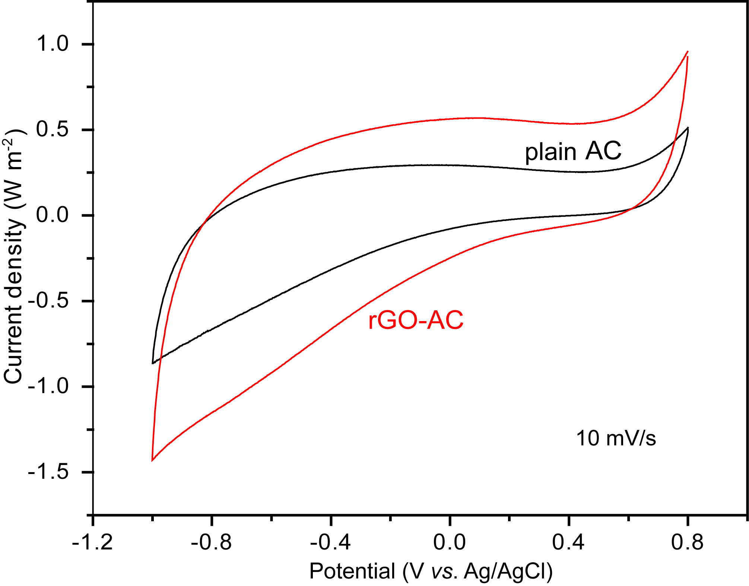

Fig.S3 Cyclic volammograms collected for plain AC and rGO-AC (35 mg cm⁻²) in 50 mM phosphate buffer solution (PBS).

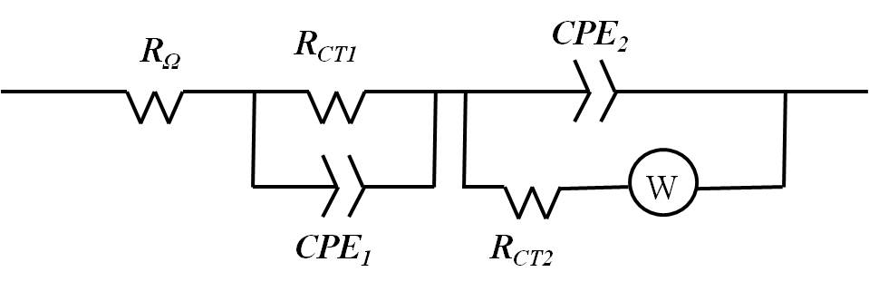
Fig.S4 The equivalent circuit used for EIS data analysis.

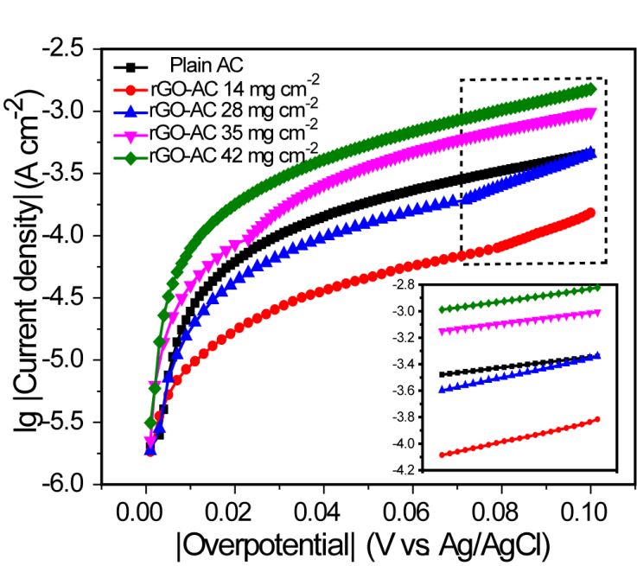
Fig.S5 Tafel plots of the air-cathode with different rGO-AC catalysts obtained in 50 mM PBS (pH≈6.8) at a scan rate of 1 mV s⁻¹. Inset is the linear fit for the Tafel plots at the overpotential from 80 to 100 mV.

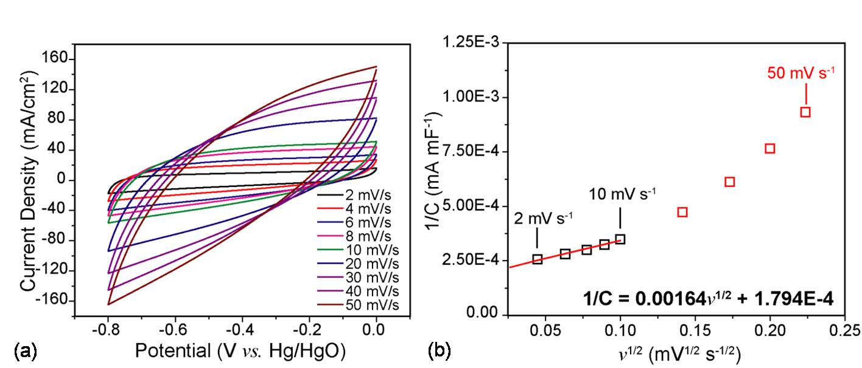
Fig.S6 (a) Cyclic voltammograms collected for rGO-AC (35 mg cm⁻²) at various scan rates. (b) Plots of reciprocal of areal capacitance (1/C) against square root of scan rate (v^{1/2}). Data points in red were masked during linear fitting. Working area of the electrode is 0.8 cm².
Trasatti method was used to estimate the ion-accessible area for rGO-AC. Cyclic voltammograms were collected for the rGO-AC in range at different scan rates between 2 mV s⁻¹ and 50 mV s⁻¹ shown in Figure S6 (a). Then, corresponding areal capacitances were evaluated based on the following equation:
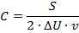
where C stands for the areal capacitance (in mF cm⁻²), ΔU the potential window (in V), S the area enclosed by the shown cyclic voltammograms (in mA cm⁻² V) and v the scan rate (in V s⁻¹). Plotting the reciprocal of areal capacitances (1/C) against the square root of scan rates (v^{1/2}) should yield a linear correlation between them, if assuming a semi-infinite diffusion of ions. Specifically, the correlation can be described by the following equation:
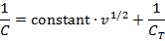
where C, v and C_{T} is experimental areal capacitance, scan rate and total areal capacitance, respectively. However, data points collected at larger scan rates deviated from the linear relationship due to intrinsic resistance of the electrode (Figure S6 (b)) [1]. Thus, we only fitted the points with a straight line at slow scan rate region (≤ 10 mV s⁻¹) by using the “linear fit” functions using the OriginPro 8.5 software. The reciprocal of the y-intercept is the total capacitance, which represents the maximum capacitance that can be obtained when all ion-accessible areas are reached by ions. In this case, we obtained a C_{T} of 5574.14 mF cm⁻² (normalized to a geometric area of 0.8 cm²). Assuming the areal capacitance of the rGO-AC electrode was almost from electrical double layer capacitance (because rGO was almost completely covered by AC and AC is a conventional electrical double layer capacitive material) and using following equation, the ion-accessible area can be evaluated via the following equation:
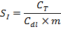
where S_{I} is the ion-accessible surface area (unit in m² g⁻¹), C_{T} the total capacitance estimated by Trasatti method (5574.14 mF cm⁻²=55741.4 F m⁻²), C_{dl} the theoretical value of electrical double layer capacitance (21 μF cm⁻²=0.21 F m⁻²), m the density of the electrode (105 mg cm⁻² =1050 g m⁻²). The calculated S_{I} is 252.80 m² g⁻¹, which is similar as 251.37 m² g⁻¹ shown in Table S1.

Tab.S1 Porous structural characteristics of plain AC and rGO-AC with various AC loadings
 | Plain AC | rGO-AC 14 mg cm⁻² | rGO-AC 28 mg cm⁻² | rGO-AC 35 mg cm⁻² | rGO-AC 42 mg cm⁻²
Average pore diameter (nm) | 18.22 | 4.81 | 3.70 | 3.62 | 3.22
Total volume (cm³ g⁻¹₎ | 0.72 | 0.19 | 0.18 | 0.23 | 0.25
Specific surface area (BET, m² g⁻¹) | 157.81 | 155.47 | 201.10 | 251.37 | 313.41
BJH desorption average pore width (nm) | 1.47 | 2.73 | 3.70 | 3.73 | 3.71
BJH adsorption average pore width (nm) | 1.95 | 0.92 | 0.84 | 0.82 | 0.85

Average pore diameter (APD) of a porous material can be calculated as follows [2]:
Where V represents the total volume, and A is the specific surface area. As shown in the BET results shown in Table S1, total pore volumes of all the rGO-AC samples are smaller than that of AC (due to the incorporation of rGO with less pore volume than AC) but surface areas significantly increase when increasing the loading amount of AC (due to the larger surface area of AC than that of rGO). As APD is directly proportional to V but inversely proportional to A as shown in the above equation, it is reasonable to conclude that increasing the AC loading decreases the APD.

References
1. Duay, J., Sherrill, S. A., Gui, Z., Gillette, E., Lee, S. B. ACS Nano. 7, 1200 (2013).
2. Y, Ho. Water Res. 40, 119 (2006).

