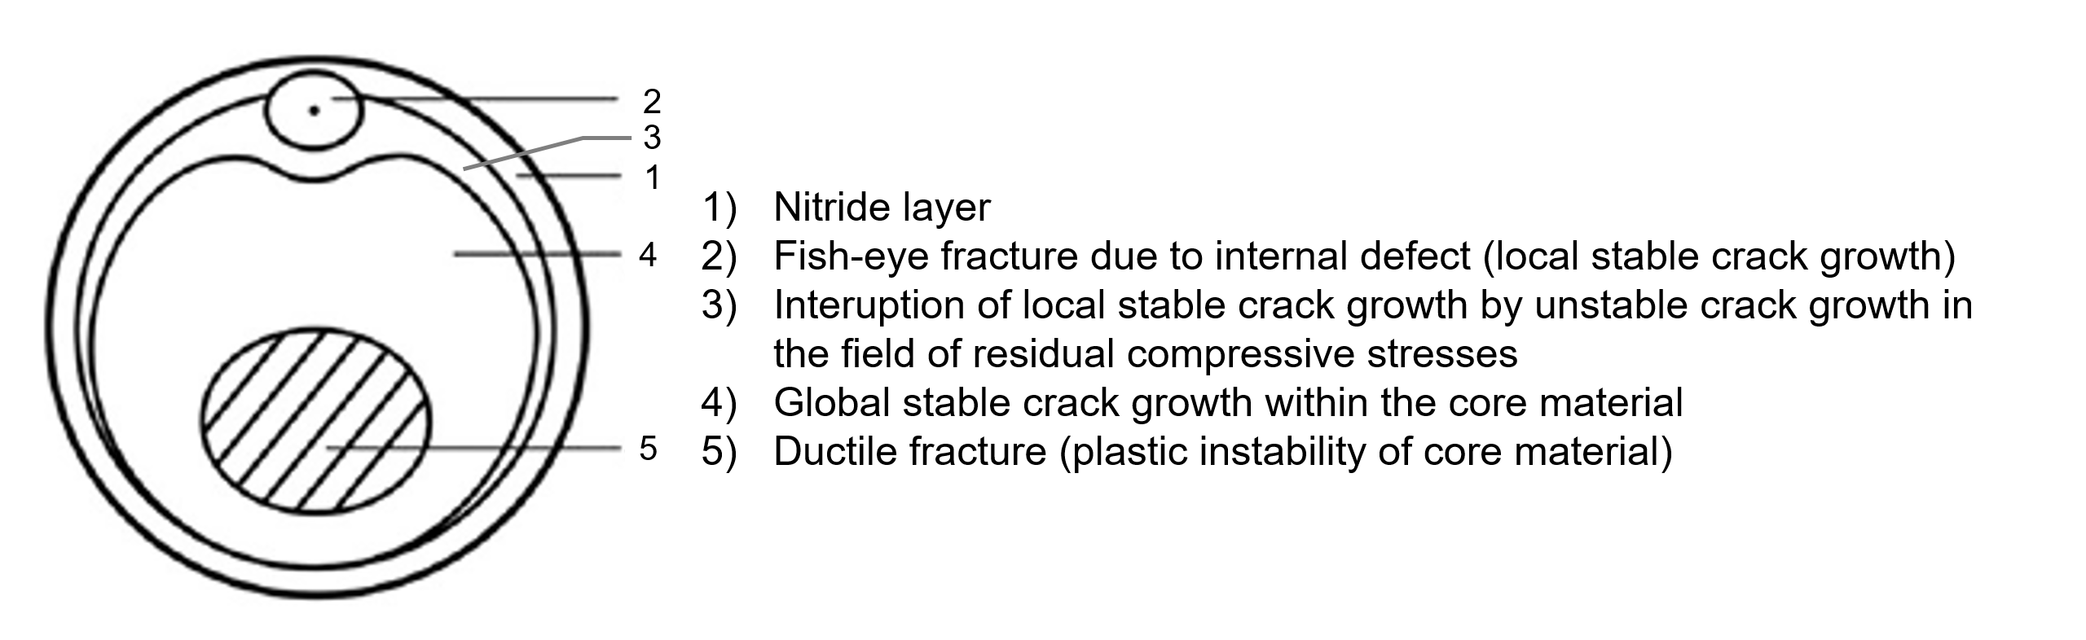
FIG. 1S. Fracture surface of a cyclically deformed specimen with a nitrided surface layer. Schematic representation according to [36] of fatigue surfaces obtained in low cycle fatigue (LCF) and high cycle fatigue (HCF) regimes.
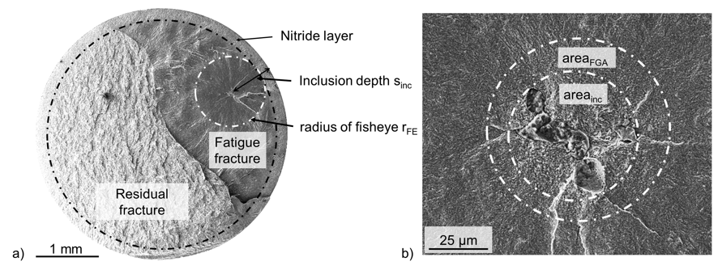
FIG. 2S. Fracture surface of a cyclically deformed specimen with a nitrided surface layer obtained in the very high cycle fatigue regime with typical parameters indicated that describe the different stages of crack initiation and propagation. (a) Overview of the entire fracture surface. (b) Detail of the fisheye fracture with non-metallic inclusion and fine granular area.

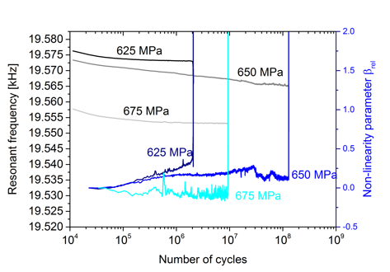
FIG. 3S. In situ parameters of the ultrasonic fatigue testing f_{res} and β_{rel} for the three specimens with NHD = 0.47 mm, which failed at the first stress amplitude level applied.
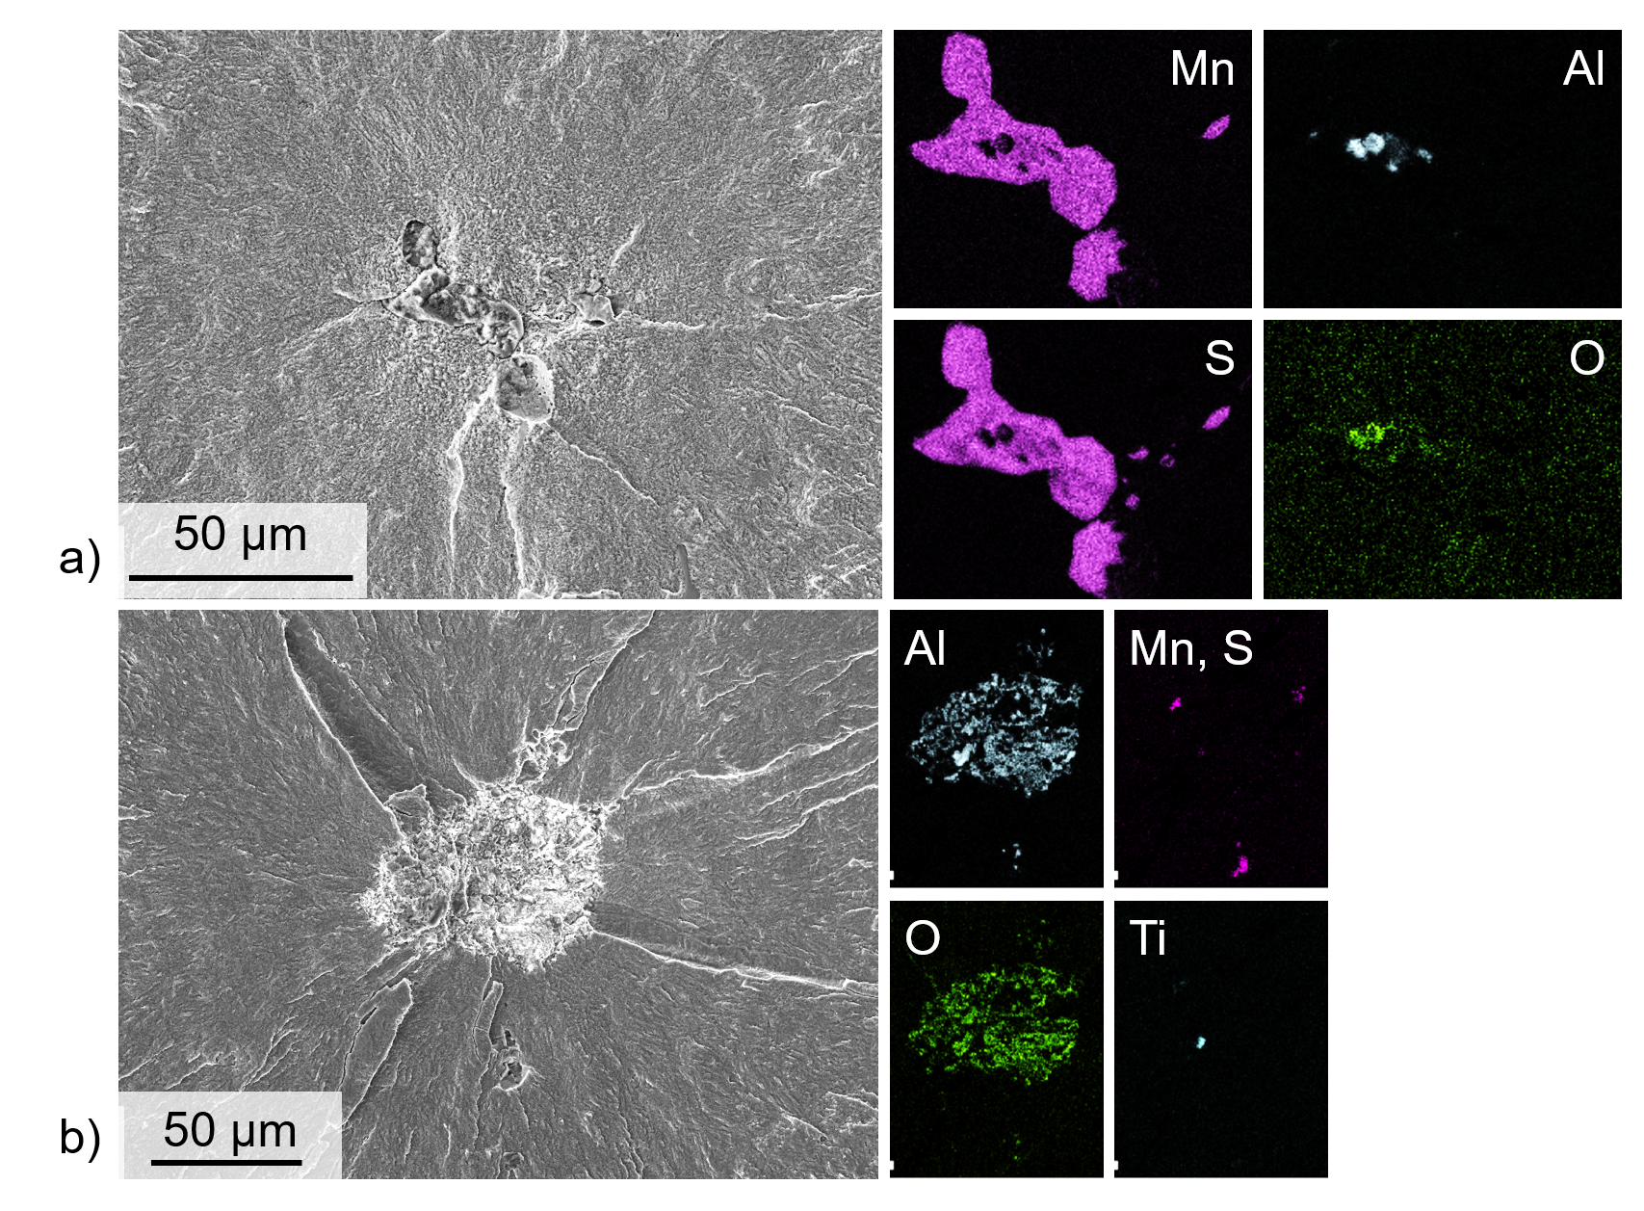
FIG. 4S. (a) Crack initiation accompanied by the formation of a fine granular area (N_{i} = 49,477,000, σ_{ai} = 650 MPa). SEM micrograph in SE contrast showing a crack-initiating MnS inclusion in the centre of the fisheye (s_{inc} = 1170 µm, √area_{inc} = 48 µm) together with EDS element maps of manganese, sulfur, aluminum and oxygen. (b) Crack initiation without the formation of a fine granular area (N_{i} = 5,580,000, σ_{ai} = 650 MPa). SEM micrograph in SE contrast with a crack-initiating oxide inclusion cluster in the center of the fisheye (s_{inc} = 688 µm, √area_{inc} = 83 µm) together with EDS element maps of aluminum, oxygen, manganese/sulfur and titanium.

