Supporting information
Carbon Nanofibers Prepared by Electrospinning Accompanied with Phase-Separation Method for Supercapacitors: Effect of Thermal Treatment Temperature
Yongtao Tan ^{1, 2,‡}, Dongshan Lin ^{2,‡}, Chang Liu ^{2,3}, Wenchun Wang ², Fen Ran ^{1,2,*}
¹ State Key Laboratory of Advanced Processing and Recycling of Non-ferrous Metals, Lanzhou University of Technology, Lanzhou 730050, P. R. China
² School of Material Science and Engineering, Lanzhou University of Technology, Lanzhou 730050, Gansu, P. R. China
³ Department of Chemistry, University of New Hampshire, Durham, NH 03824, United States
*Corresponding author: ranfen@163.com or ranfen@lut.cn.
‡These authors contributed equally.

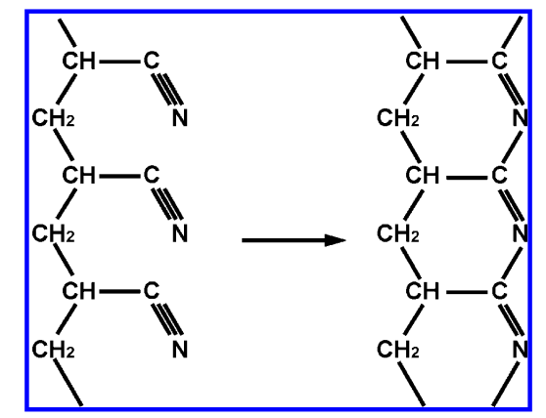
Figure S1 Structural change in PAN ﬁbers from open chain polymers to ladder polymers in stabilization stage [S1]

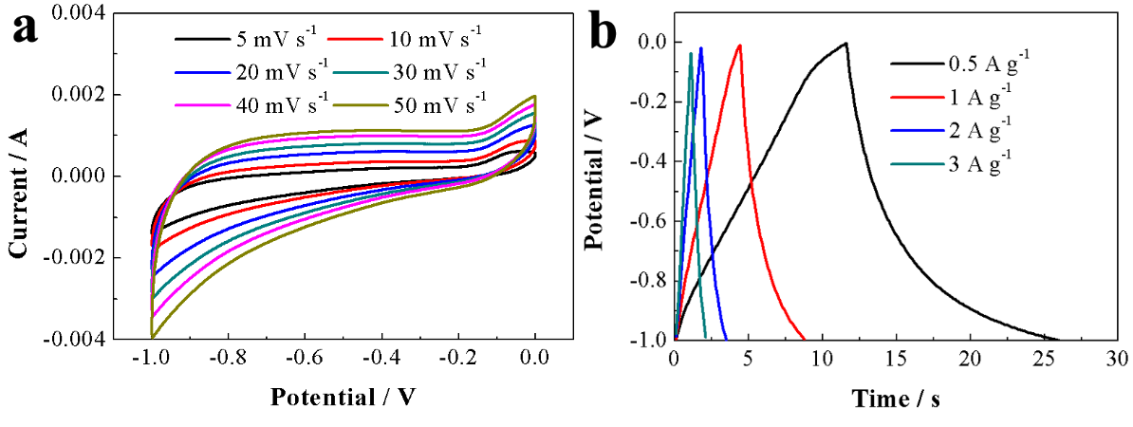
Figure S2 CV and GCD curves of sample without pre-oxidation

References
[S1] A. Shokuhfar, A. Sedghi, R.E. Farsani, Effect of thermal characteristics of commercial and special polyacrylonitrile fibres on the fabrication of carbon fibres, Materials Science and Technology, 22 (2006) 1235-1239.

