**Supporting Information**

**High Performance Aqueous AsymmetricSupercapacitor based on Iron Oxide Anode and Cobalt Oxide Cathode**

Rahul Pai, Vibha Kalra*

*Department of Chemical and Biological Engineering, Drexel University,*

*3141 Chestnut Street, Philadelphia, PA-19104*

\**Email: vk99@drexel.edu*

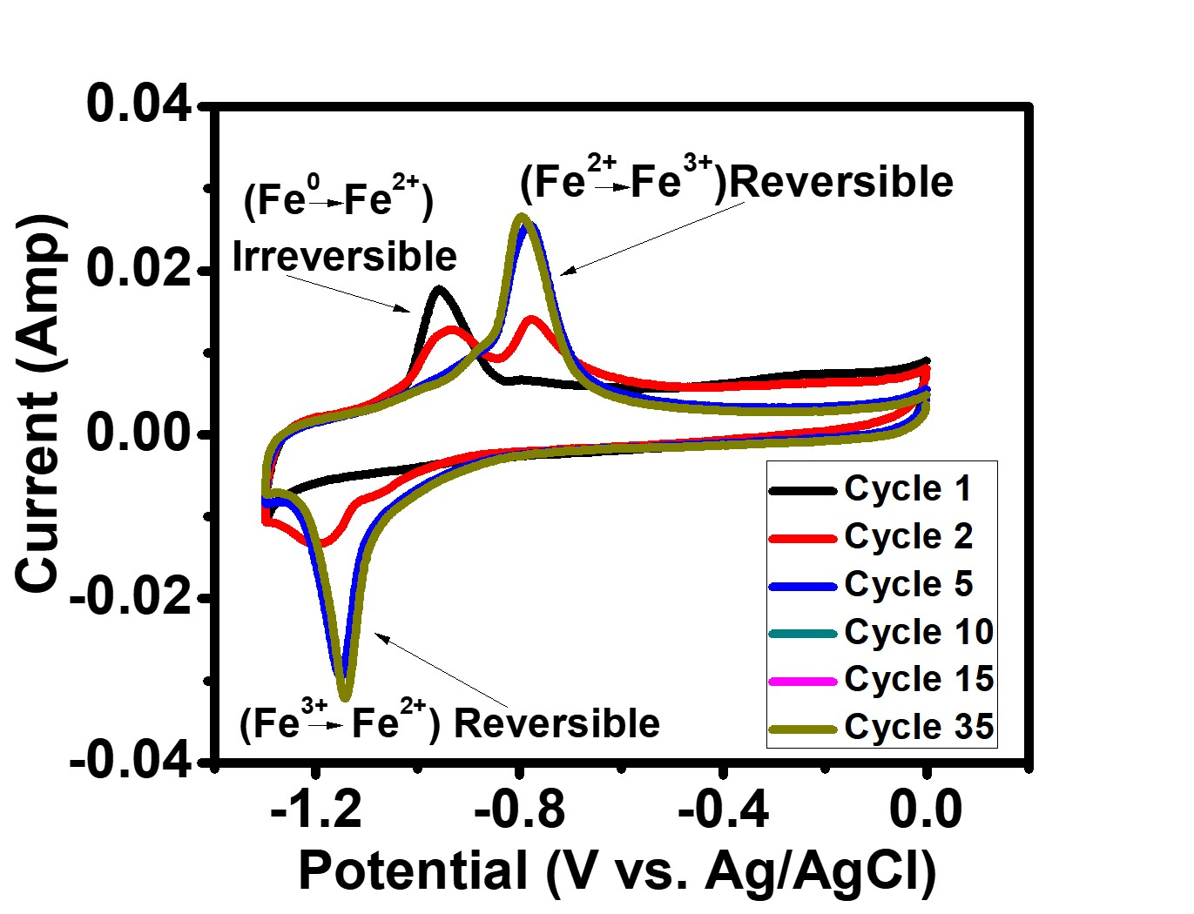

Figure S1. Initial *insitu* conversion of Iron and Iron carbide to Iron oxide.

*In-situ* Conversion: The Fe-CNFs electrode is electrochemically cycled in a 3-electrode system in 6 M KOH electrolyte. Figure S1 shows first 35 cyclic voltammetry cycles. We can see no dominant peaks in reduction of 1st cycle, in the oxidation of 1st cycle we can see at ~1 V vs Ag/AgCl the irreversible reaction of Iron takes place and gets converted to Iron oxide1, 2. The peak goes on reducing in subsequent cycles as the iron gets converted to redox active material. We see stable peaks at -0.7 and -1.1 V vs Ag/AgCl which is conversion of Iron hydroxide to Iron oxide in oxidation cycle and vice versa in reduction cycle. The reversible peaks go on increasing as the iron depletes and converts to iron hydroxide (irreversible peak reduces). The reversible peaks are stable after 10 cycles which can be further elucidated by the stability curve.

References:

1. K. Ujimine and A. Tsutsumi: Electrochemical characteristics of iron carbide as an active material in alkaline batteries *Journal of Power Sources.* **160**(2), 1431 (2006).

2. R. Li, Y. Wang, C. Zhou, C. Wang, X. Ba, Y. Li, X. Huang and J. Liu: Carbon-Stabilized High-Capacity Ferroferric Oxide Nanorod Array for Flexible Solid-State Alkaline Battery-Supercapacitor Hybrid Device with High Environmental Suitability *Advanced Functional Materials.* **25**(33), 5384 (2015).