Supporting Information
Black titania/GO nanocomposite films with excellent photothermal property for solar steam generation
Xinghang Liu, Baofei Hou, Gang Wang, Zhenqi Cui, Xiang Zhu, Xianbao Wang*
Hubei Collaborative Innovation Center for Advanced Organic Chemical Materials, Ministry-of-Education Key Laboratory for the Green Preparation and Application of Functional Materials, Hubei Key Laboratory of Polymer Materials (Hubei University), School of Materials Science and Engineering, Hubei University. Wuhan 430062, PR China.
* Corresponding author. Tel.: +86 27 88661729; fax: +86 27 88661729.
E-mail addresses: wangxb68@aliyun.com (Xianbao Wang)

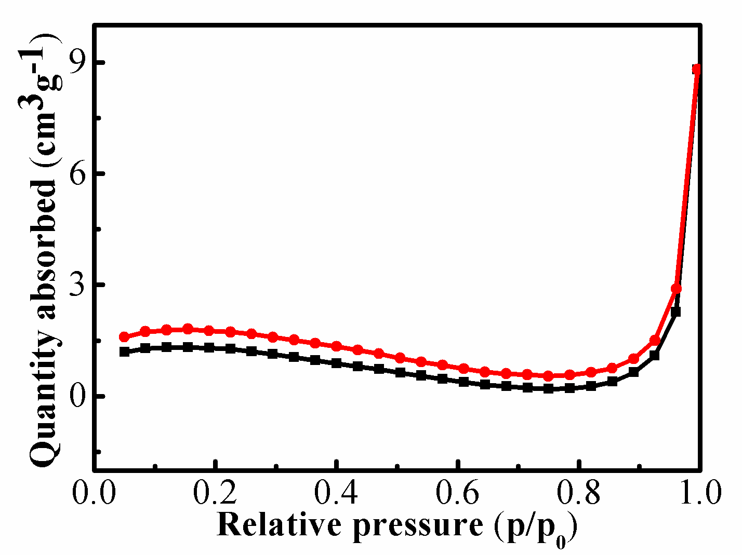
Figure S1. N2 adsorption-desorption isotherm for black titania/GO nanocomposite film.

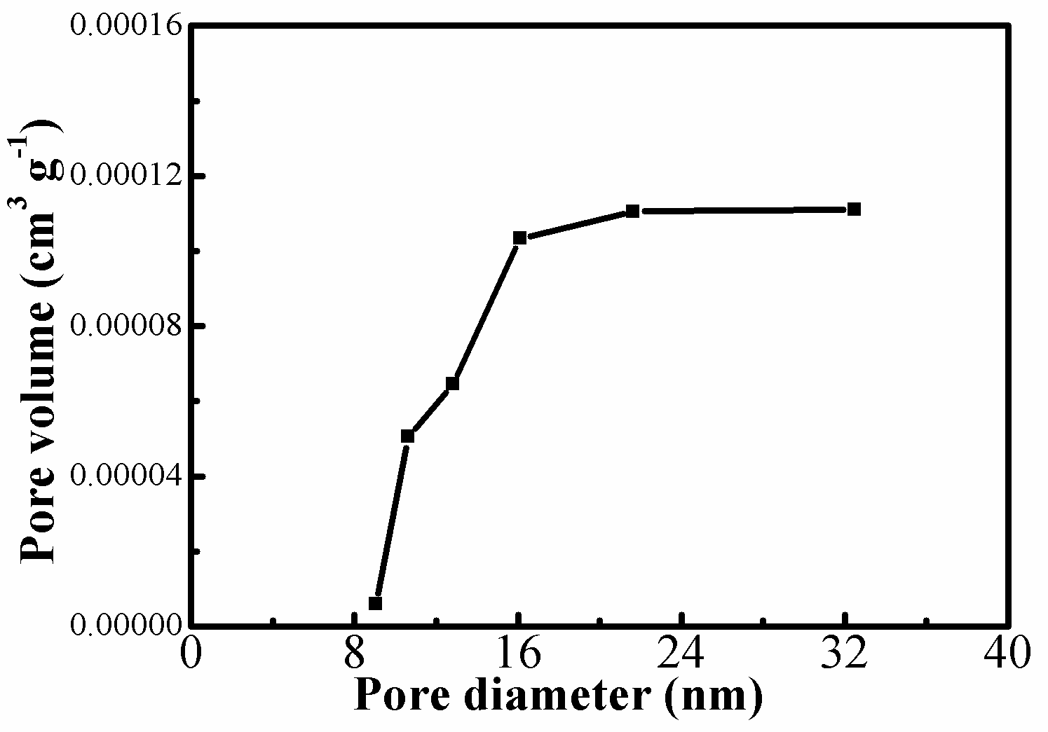
Figure S1. Pore size distribution curve of the black titania/GO nanocomposite film.

