Supporting Information for
Polymer g-C₃N₄ wrapping bundle-like ZnO nanorod heterostructures with enhanced gas sensing properties
Liwei Wang ^{a,b,c}, Hongjie Liu ^{d}, Hao Fu ª, Yinghui Wang ^{a,b,c}*, KefuYu ^{a,b,c}*, Shaopeng Wang ^{a,b,c}
ª School of Marine Sciences, Guangxi University, Nanning, 530004, China
^{b} Coral Reef Research Center of China, Guangxi University, Nanning, 530004, China
^{c} Guangxi Laboratory on the Study of Coral Reefs in the South China Sea, Nanning 530003, China
^{d} Shiyuan College of Guangxi Teachers Education University, Nanning, 530226, China
*Corresponding Author
Prof. Yinghui Wang
Tel.:+86 7713227177; Fax: +86 7713227522; E-mail: wyh@gxu.edu.cn
Prof. Kefu Yu
Tel.:+86 7713227746; Fax: +86 7713227522; E-mail: kefuyu@gxu.edu.cn

Summary
Three pages, including two images and experimental details
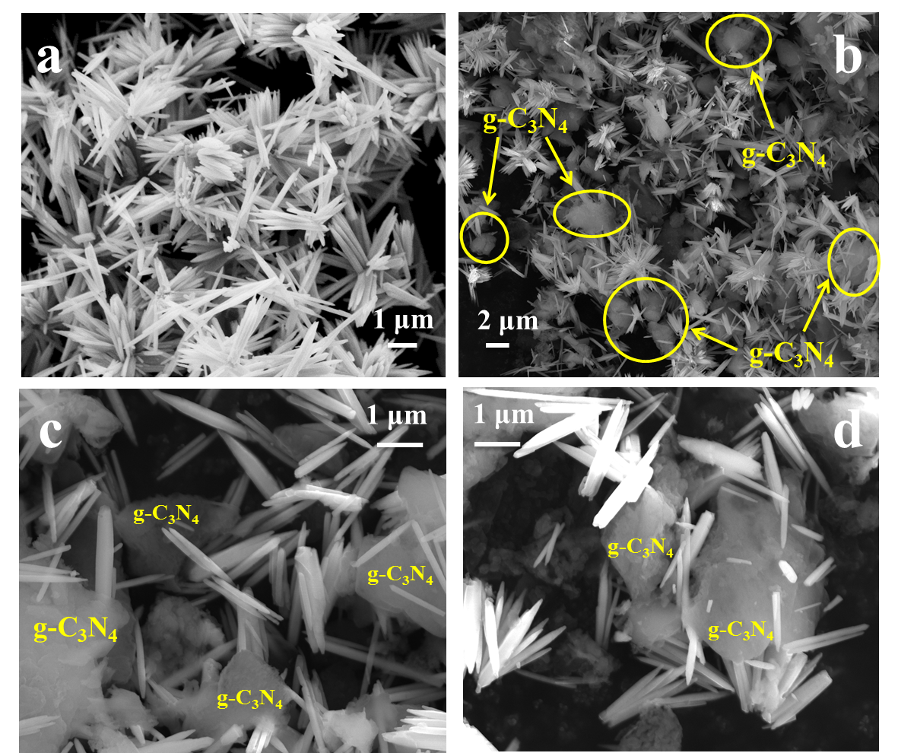
Fig. S-1. Typical SEM images of as-prepared (a) pure ZnO NR bundles, and (b-d) ZnO/g-C₃N₄ nanoheterostructure.

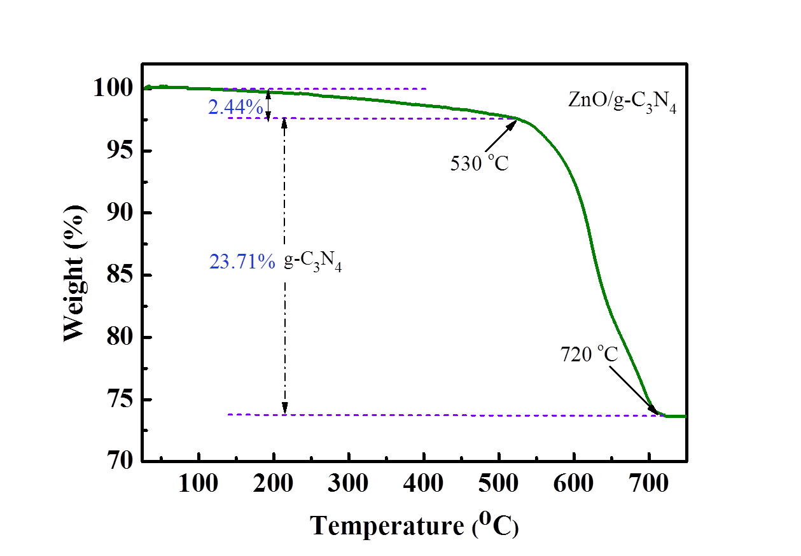
Fig. S-2. TG curves of the prepared ZnO/g-C₃N₄ nanoheterostructure.

Experimental Details
Synthesis of bundle-like ZnO NRs.
At room temperature, SDS (0.8 mmol) and NaOH (0.096 mol) were dissolved into 40 ml of distilled water to form a transparent solution under vigorous stirring. Then, Zn(NO₃)₂ aqueous solution (0.016 mol of Zn(NO₃)₂·6H₂O dissolved into 40 ml of distilled water) was added to the above solution under continuous stirring. After another 1 h vigorous stirring, the resulted solution was transferred to a 100 ml of Teflon-lined autoclave and heated at 90 ºC for 15 h. Then the solution was cooled down, centrifuged, washed with distilled water and absolute ethanol for four times, respectively, and finally dried in air at 60 ºC to separate the white solid product. The yield by this process is about 88.5%.

Sensor fabrication and gas-sensing test.
Typically, a proper amount of the sample was mixed with several drops of distilled water to form slurry, which was then coated onto an alumina tube (diameter of 1 mm, length of 4 mm) with two Au electrodes and four Pt wires on both ends. A Ni–Cr alloy filament was put through the alumina tube and used as a heater by tuning the heating voltage (V_{h}). The alumina tube was finally welded onto a pedestal with six probes to get the sensor unit and put on the circuit board. A load resistance (R_{L}) was connected in series to the sensor.
Gas sensing test was carried out on the HW-30A Gas Sensing Measurement System (Weisheng Electronics Co., Ltd., Zhengzhou, China). The fabricated sensor worked in the temperature range of 200 to 300 ºC with air as the diluting and reference gas and a relative humidity (RH) of ~ 40%. Before testing, the sensor was aged in the gas chamber at 200 ºC for 36 h, and then tested gases such as ethanol were introduced into the gas chamber by injecting a calculated volume of liquid with a microsyringe onto the heating board. The gas concentrations were calculated according to the total volumes (18 L) of gas chamber. The sensor signal voltage (V_{out}) was collected by a computer at a test circuit voltage of 5 V (V_{c}). And when the test was completed, the sensor was exposed to air again by opening the chamber.

