**Supplementary Information For:**

Changes in hydrodesulfurization activity, selectivity, dispersion, sulfidation and extent of promotion for CoMo and NiMo catalysts supported on Al2O3 and SiO2/Al2O3

Adolfo Romero-Galarzaa*, Jorge Ramírezb, Aída Gutiérrez-Alejandreb, Dora Alicia Solís-Casadosc.

a Departamento de Ingeniería Química, Facultad de Ciencias Químicas, Universidad Autónoma de Coahuila, Blvd. V. Carranza e Ing. José Cárdenas V. S/N, Saltillo, Coahuila 25280, Mexico

b UNICAT, Depto. de Ingeniería Química, Facultad de Química, UNAM, Cd. Universitaria, 04510 Cd de México, Mexico

cUniversidad Autónoma del Estado de México. Centro Conjunto de Investigación en Química Sustentable, UAEM-UNAM, Km 14.5, Carretera Toluca-Atlacomulco, San Cayetano, Toluca, Estado de México 50200, México

* Corresponding Author:

[a_romero@uadec.edu.mx](mailto:a_romero@uadec.edu.mx)

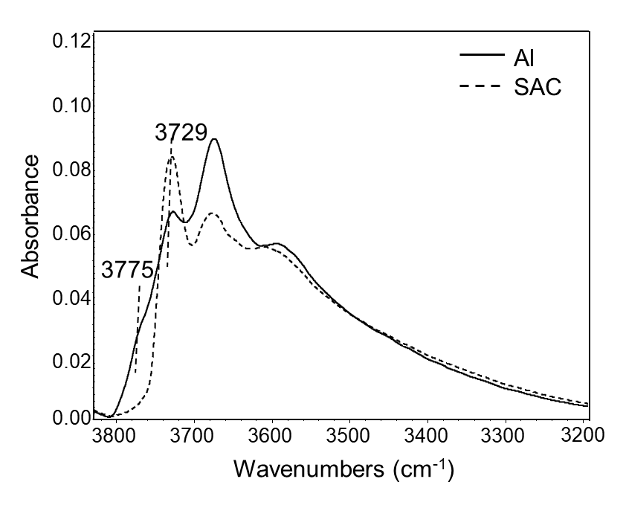

**FIG. S1.** FTIR spectra of supports in the hydroxyl region. After outgassing at 450 °C, 2 h.

1.- Routes for hydrodesulfurization (HDS) of 4,6-DMDBT

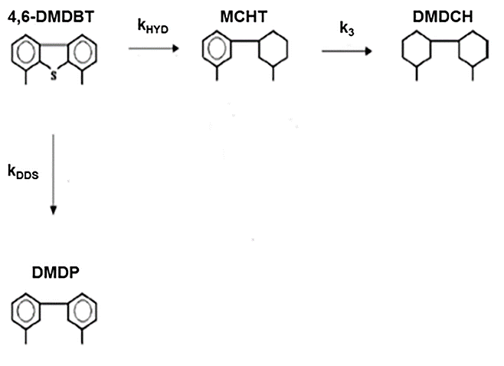

**FIG. S2.** Reaction scheme for 4,6-dimethyldibenzothiophene.

2.- Characterization of oxide catalysts

UV-Visible DRS spectroscopy.

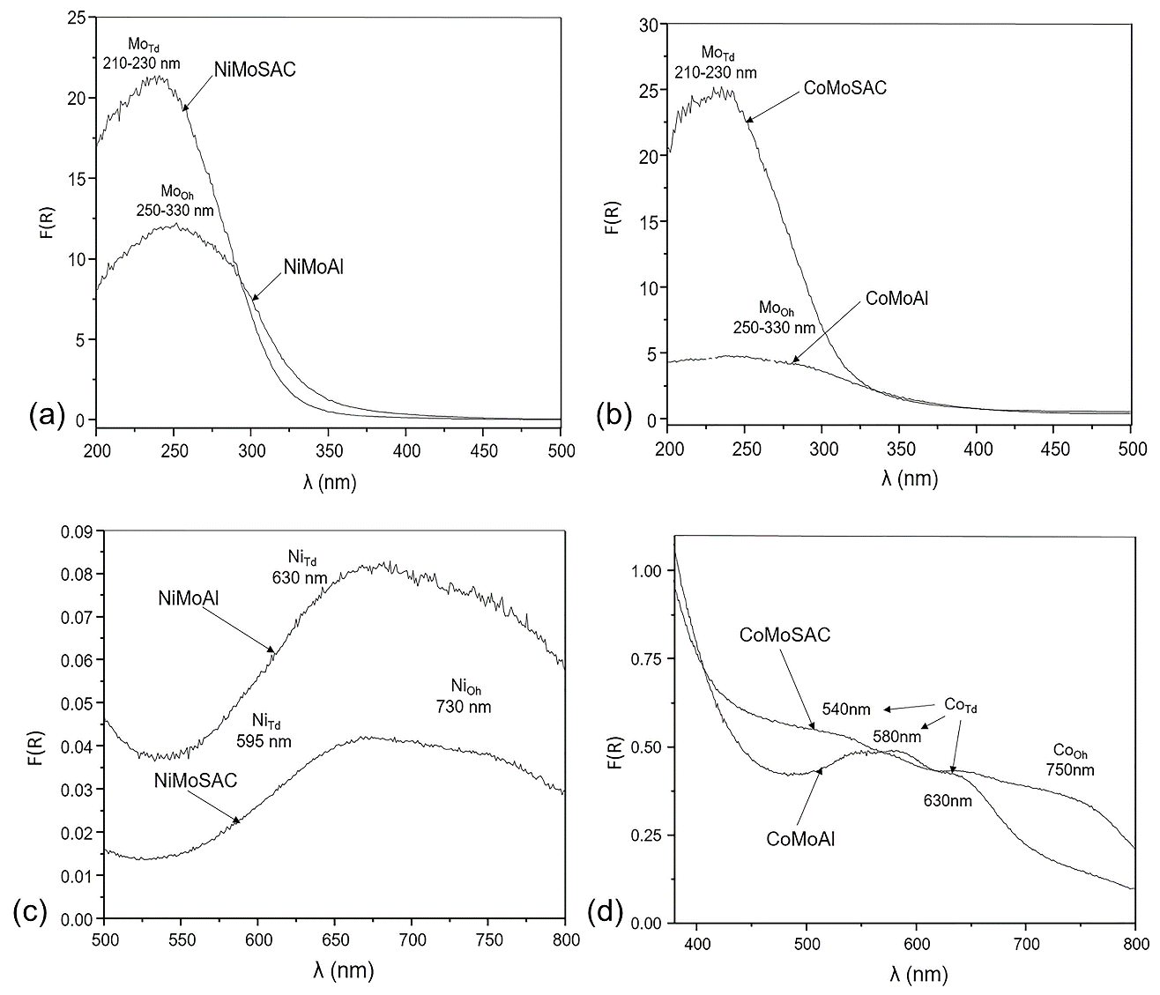

**FIG. S3.** UV-VIS-DRS spectra of (a) NiMoAl and NiMoSAC in the 200-500 nm region, (b) CoMoAl and CoMoSAC in the 200-500 nm region, (c) NiMoAl and NiMoSAC in the 500-800 nm region, (d) CoMoAl and CoMoSAC in the 400-800 nm region.

3.- Characterization of sulfided catalysts.

3.1 Transmission Electron Microscopy (TEM)

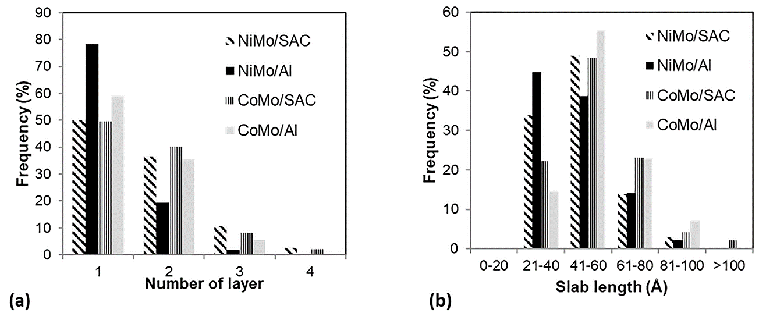

**FIG. S4.** (a) Frequency distribution for the number of layers in MoS2 crystallites for Ni(Co)MoAl and Ni(Co)MoSAC, and (b) Frequency distribution for the slab length of MoS2 crystallites for Ni(Co)MoAl and Ni(Co)MoSAC.

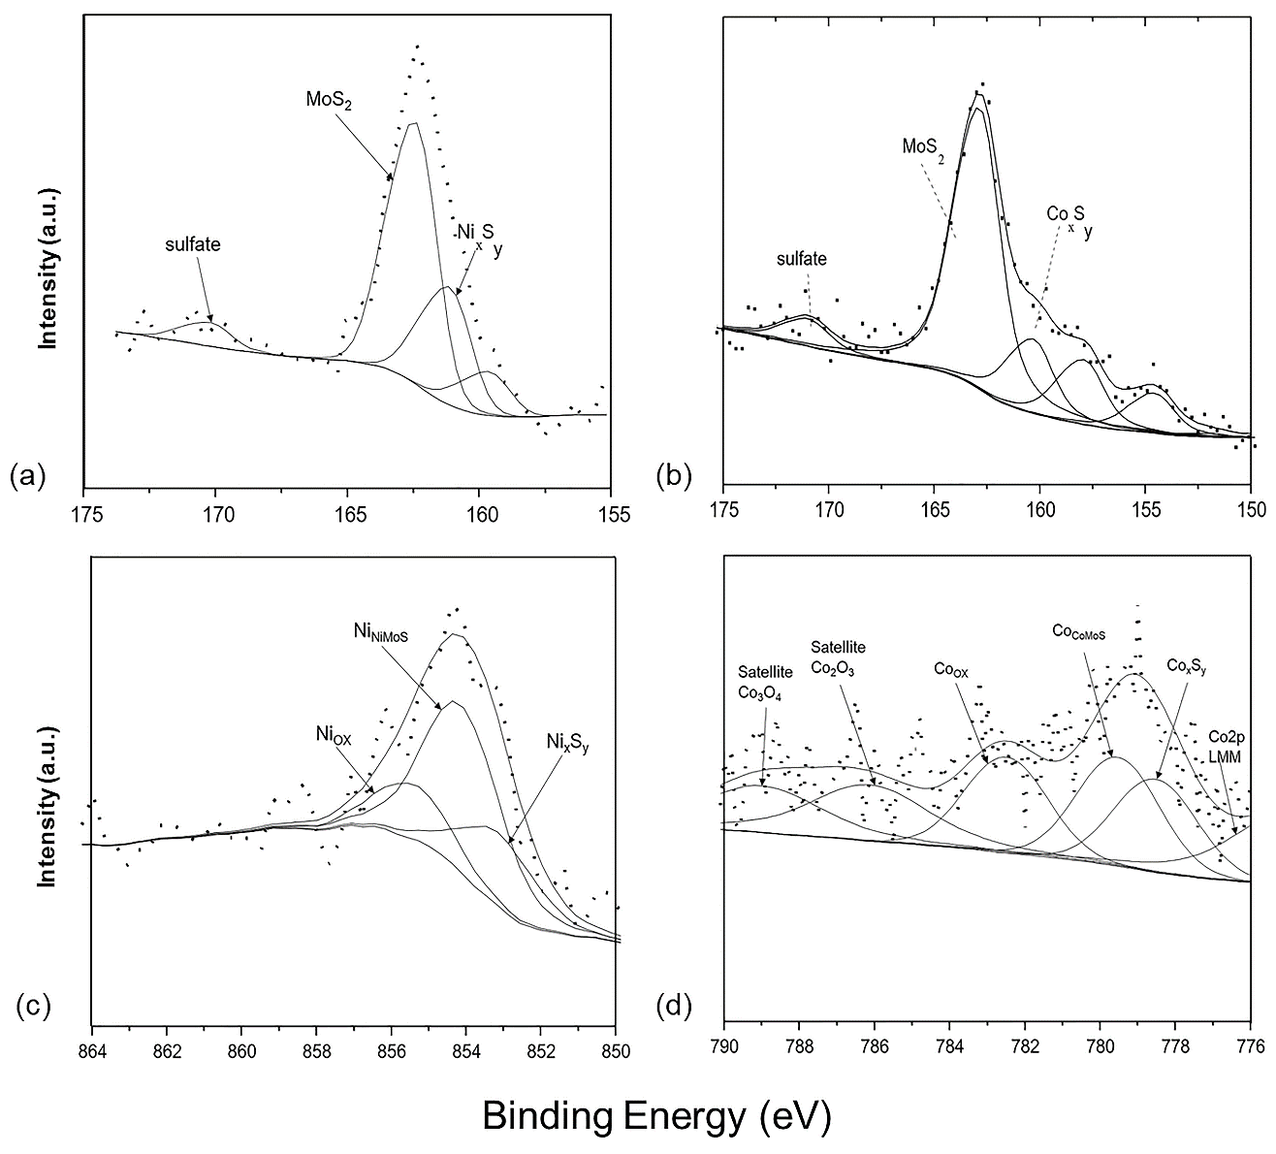3.2 X-ray Photoelectron Spectroscopy (XPS)

**FIG. S5.** XPS spectra of the sulfided catalysts (a) S2p for NiMoSAC, (b) S2p for CoMoAl, (c) Ni 2p for NiMoSAC, and (d) and Co2p for CoMoAl.

4. Catalytic activity

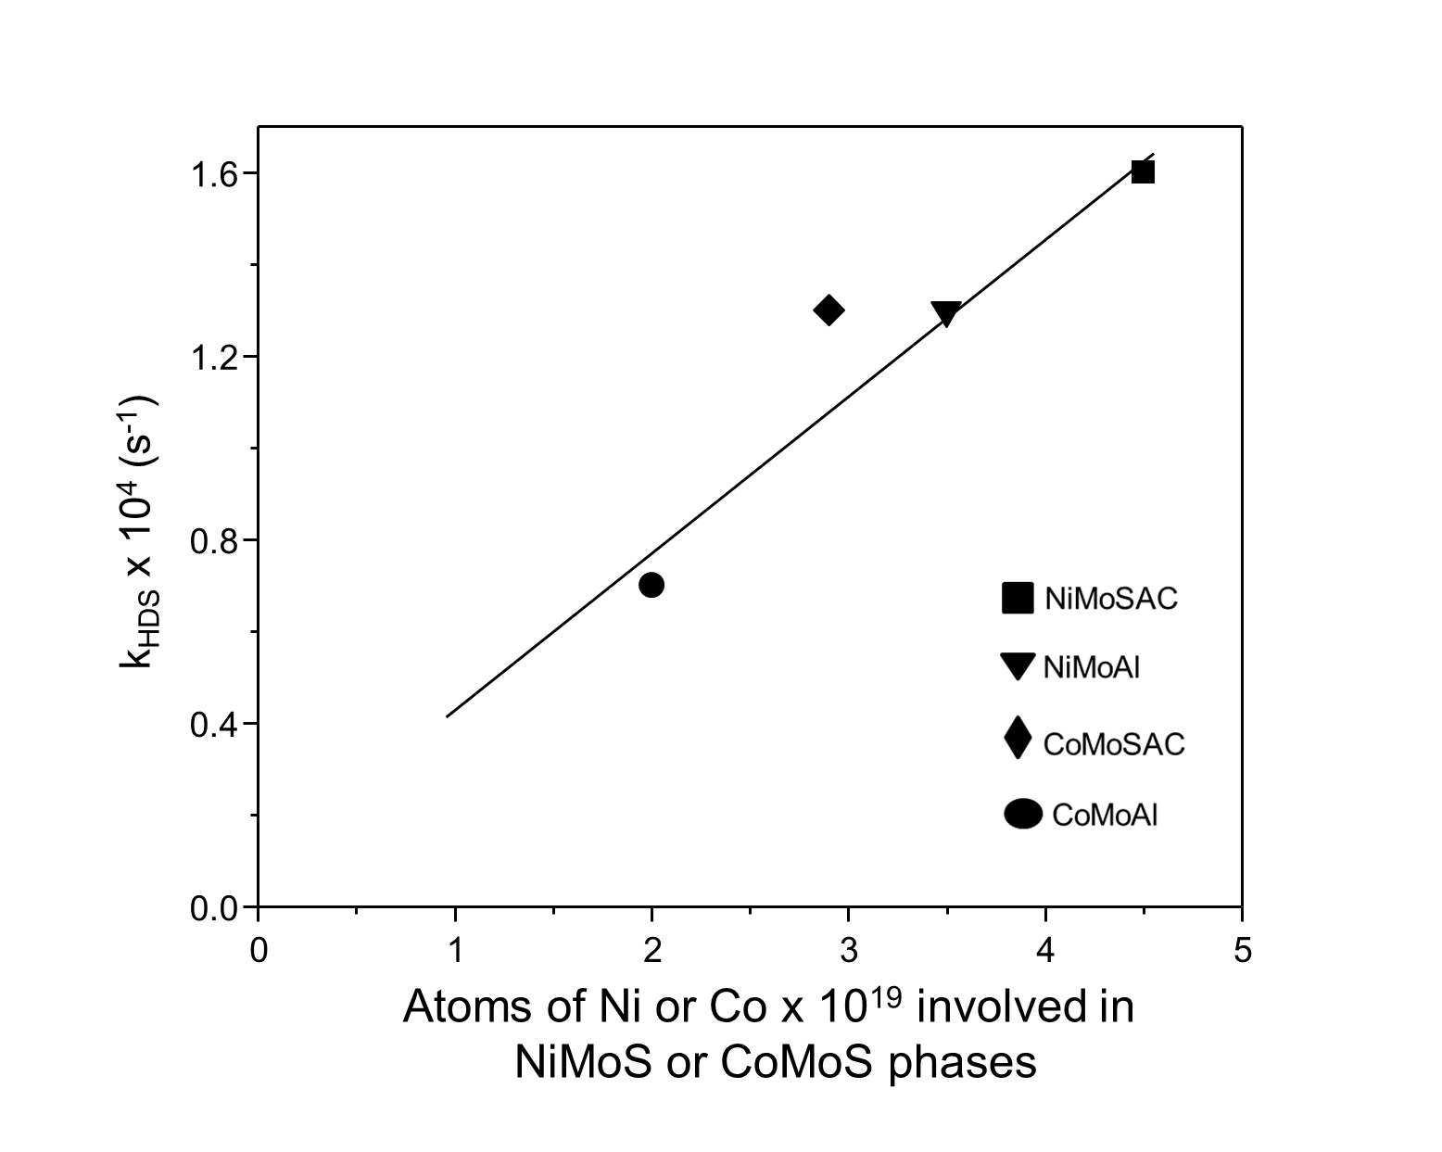

**FIG. S6.** Relationship between the global HDS reaction rate constant for 4,6-DMDBT and the Ni or Co atoms involved in the NiMoS or CoMoS phases.