New insights on the basicity of ZnAl-Zr hydrotalcites activated at low temperature and their application in transesterification of soybean oil
Supplementary Material
Denis A. Cabrera-Munguiaª, Horacio González^{a,}*, Francisco Tzompantzi^{b}, Aída Gutiérrez-Alejandre^{c}, Dora A. Solís-Casados^{d}, José L. Ricoª
ªFacultad de Ingeniería Química, Universidad Michoacana de San Nicolás de Hidalgo
58030, Morelia, Michoacán, México
^{b}Depto. de Química, Facultad de Química, Universidad Autónoma Metropolitana- Iztapalapa, 09340, Ciudad de México, México
^{c}UNICAT, Depto. de Ingeniería Química, Facultad de Química, Universidad Nacional Autónoma de México, 04510, Ciudad de México, México
^{d}Centro Conjunto de Investigación en Química Sustentable, UAEM-UNAM, 50200, Toluca, México

TABLE SI. Lattice parameters and textural properties of ZnAl-Zr(X) catalysts. Reproduced with permission from ref. 23. Copyright 2017 Elsevier.
Catalyst | Parameter a (Å) | Parameter c (Å) | S_{BET} (m²/g) | D_{BJH} (nm)
ZnAl-Zr(0.0) | 2.9347 | 22.6732 | 30 | 15
ZnAl-Zr(0.10) | 2.9362 | 22.7521 | 41 | 13
ZnAl-Zr(0.25) | 2.9367 | 22.7916 | 76 | 10

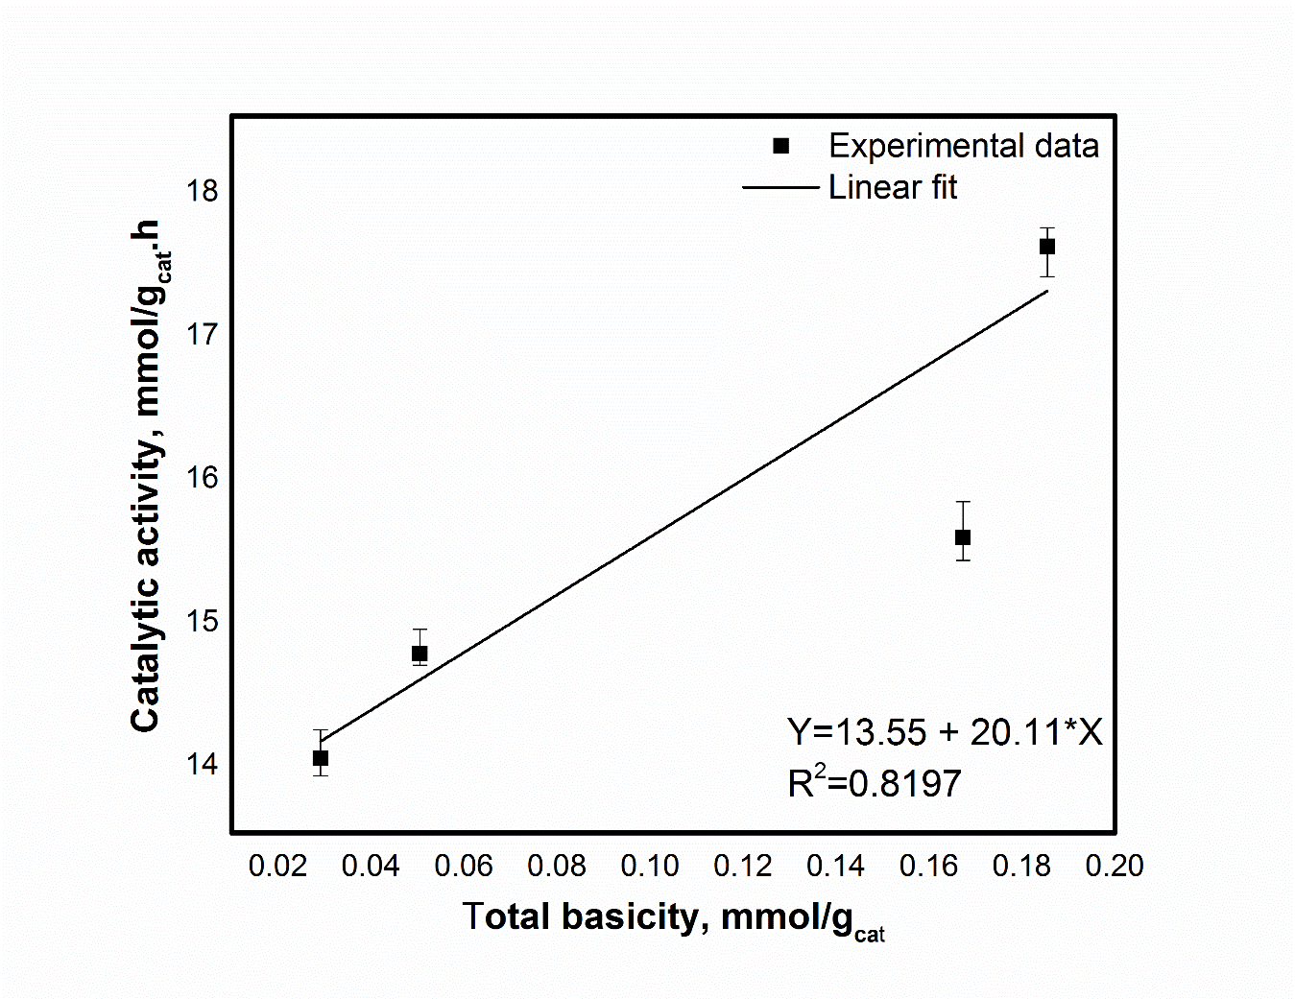
FIG. S1. Correlation between catalytic activity and total basicity for ZnAl-Zr(0.0) catalysts activated at different temperatures.

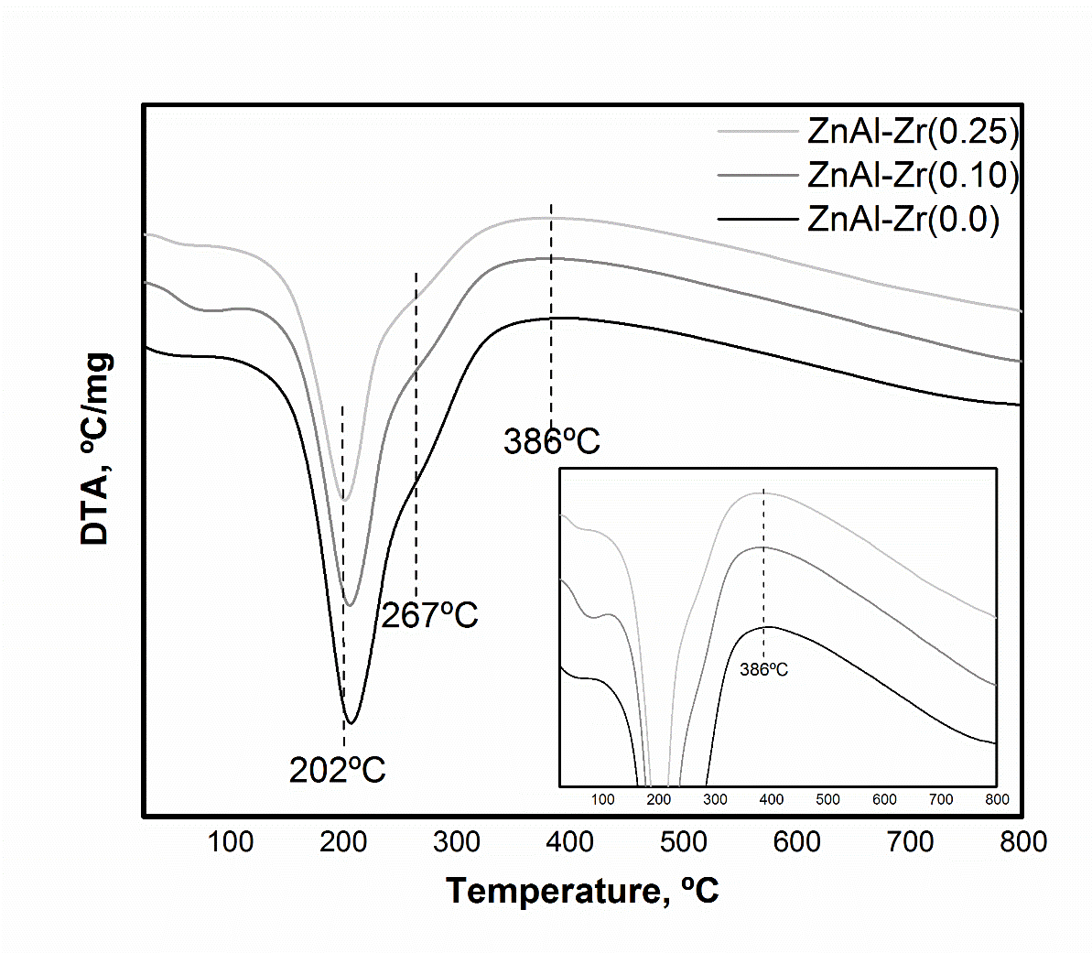
FIG. S2. DTA curves of ZnAl-Zr(X) materials. Reproduced with permission from ref. 23. Copyright 2017 Elsevier.

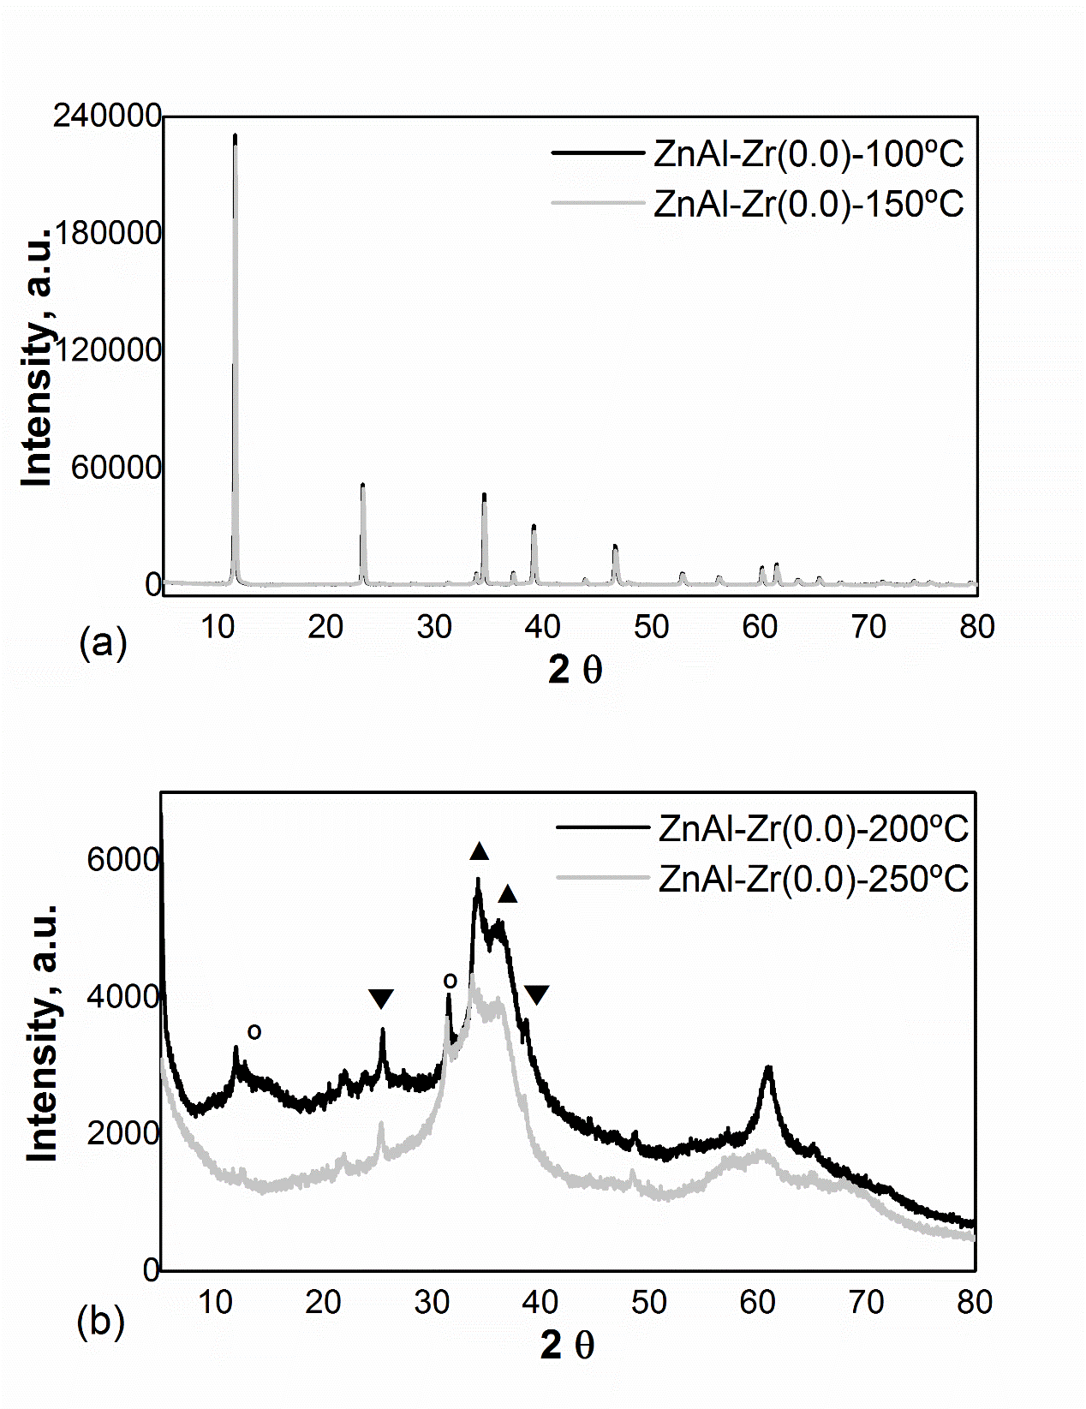
FIG. S3. XRD patterns of ZnAl-Zr(0.0) as a function of activation temperature (a) 100ºC and 150ºC and (b) 200ºC and 250ºC, identified species: º Hydrozincite (Zn₅(CO₃)₂(OH)₆), ▼Zinc carbonate (ZnCO₃), ▲ Zincite (ZnO). Reproduced with permission from ref. 23. Copyright 2017 Elsevier.

