Supplementary Information

Self-Organized Wrinkling of Liquid Crystalline Polymer with Plasma Treatment

Jaehyun Sim¹, Sihwa Oh¹, Se-Um Kim², Kyuyoung Heo³, Seung-Chul Park⁴, and Jun-Hee Na^{1,5}*

¹Department of Electric, Electronic and Communication Engineering Education, Chungnam National University, 99 Deahak-ro, Yuseong-gu, Daejeon 34134, Republic of Korea
²Department of Physics and Astronomy, University of Pennsylvania, Philadelphia, Pennsylvania 19104, USA
³Reliability Assessment Center, Korea Research Institute of Chemical Technology, Daejeon 34114, Republic of Korea
⁴Department of Nature Inspired Nanoconvergence Systems, Korea Institute of Machinery and Materials, Daejeon 34103, Republic of Korea
⁵Department of Convergence System Engineering, Chungnam National University, 99 Deahak-ro, Yuseong-gu, Daejeon 34134, Republic of Korea

*E-mail: junhee.na@cnu.ac.kr

Figure S1
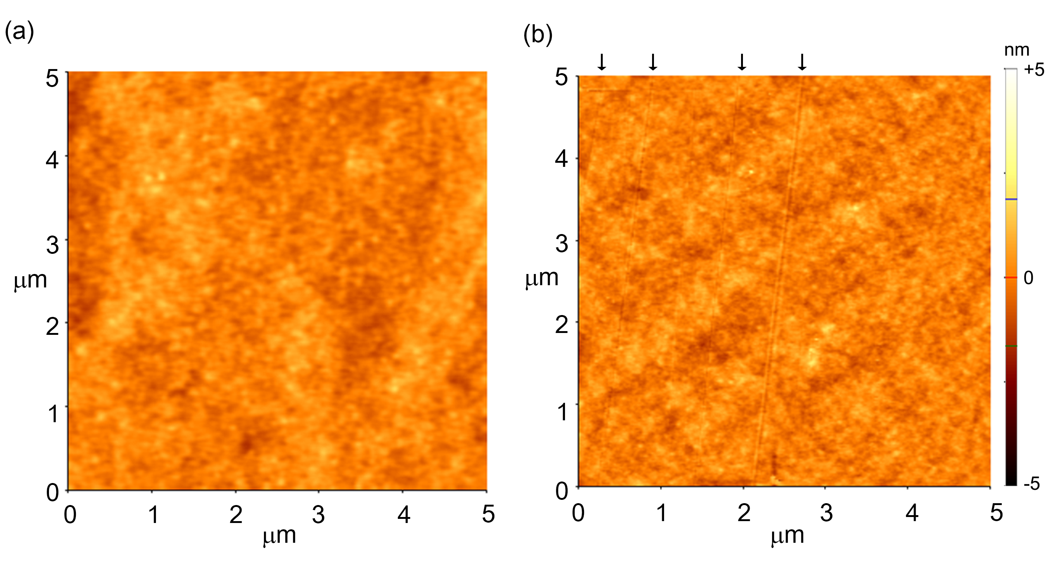
Figure S1. Influence of the rubbing process on PVA film. Atomic force microscopic images of (a) unrubbed surface and (b) homogeneously aligned PVA film with 3000 rpm in speed. Here, arrows indicate the location of the scratches that occurred during the rubbing process.

