Acid properties of M-SBA-15 and M-SBA-15-SO3H (M=Al, Ti) materials and their role on esterification of oleic acid.
Supplementary Material
Denis A. Cabrera-Munguiaª, Horacio González^{a,}*, Edgar Tututí-Ríosª, Aída Gutiérrez-Alejandre^{b}, José L. Ricoª
ªFacultad de Ingeniería Química, Universidad Michoacana de San Nicolás de Hidalgo
58030, Morelia, Michoacán, México
^{b}UNICAT, Depto. de Ingeniería Química, Facultad de Química, Universidad Nacional Autónoma de México, 04510, Ciudad de México, México

TABLE SI. Deconvolution of UV-Vis-DRS spectra of Ti-SBA-15 and Ti-SBA-15-SO₃H.

 | Wavelenght, nm |  |  | Abundance, %
Catalyst | Ti^{IV} | Ti^{VI} | Ti^{Polymeric} | Ti^{IV} | Ti^{VI} | Ti^{Polymeric}
Ti-SBA-15 | 215 | 251 | 281 | 45.0 | 38.3 | 16.7
Ti-SBA-15-SO₃H | 213 | 251 | 290 | 38.9 | 37.0 | 24.1

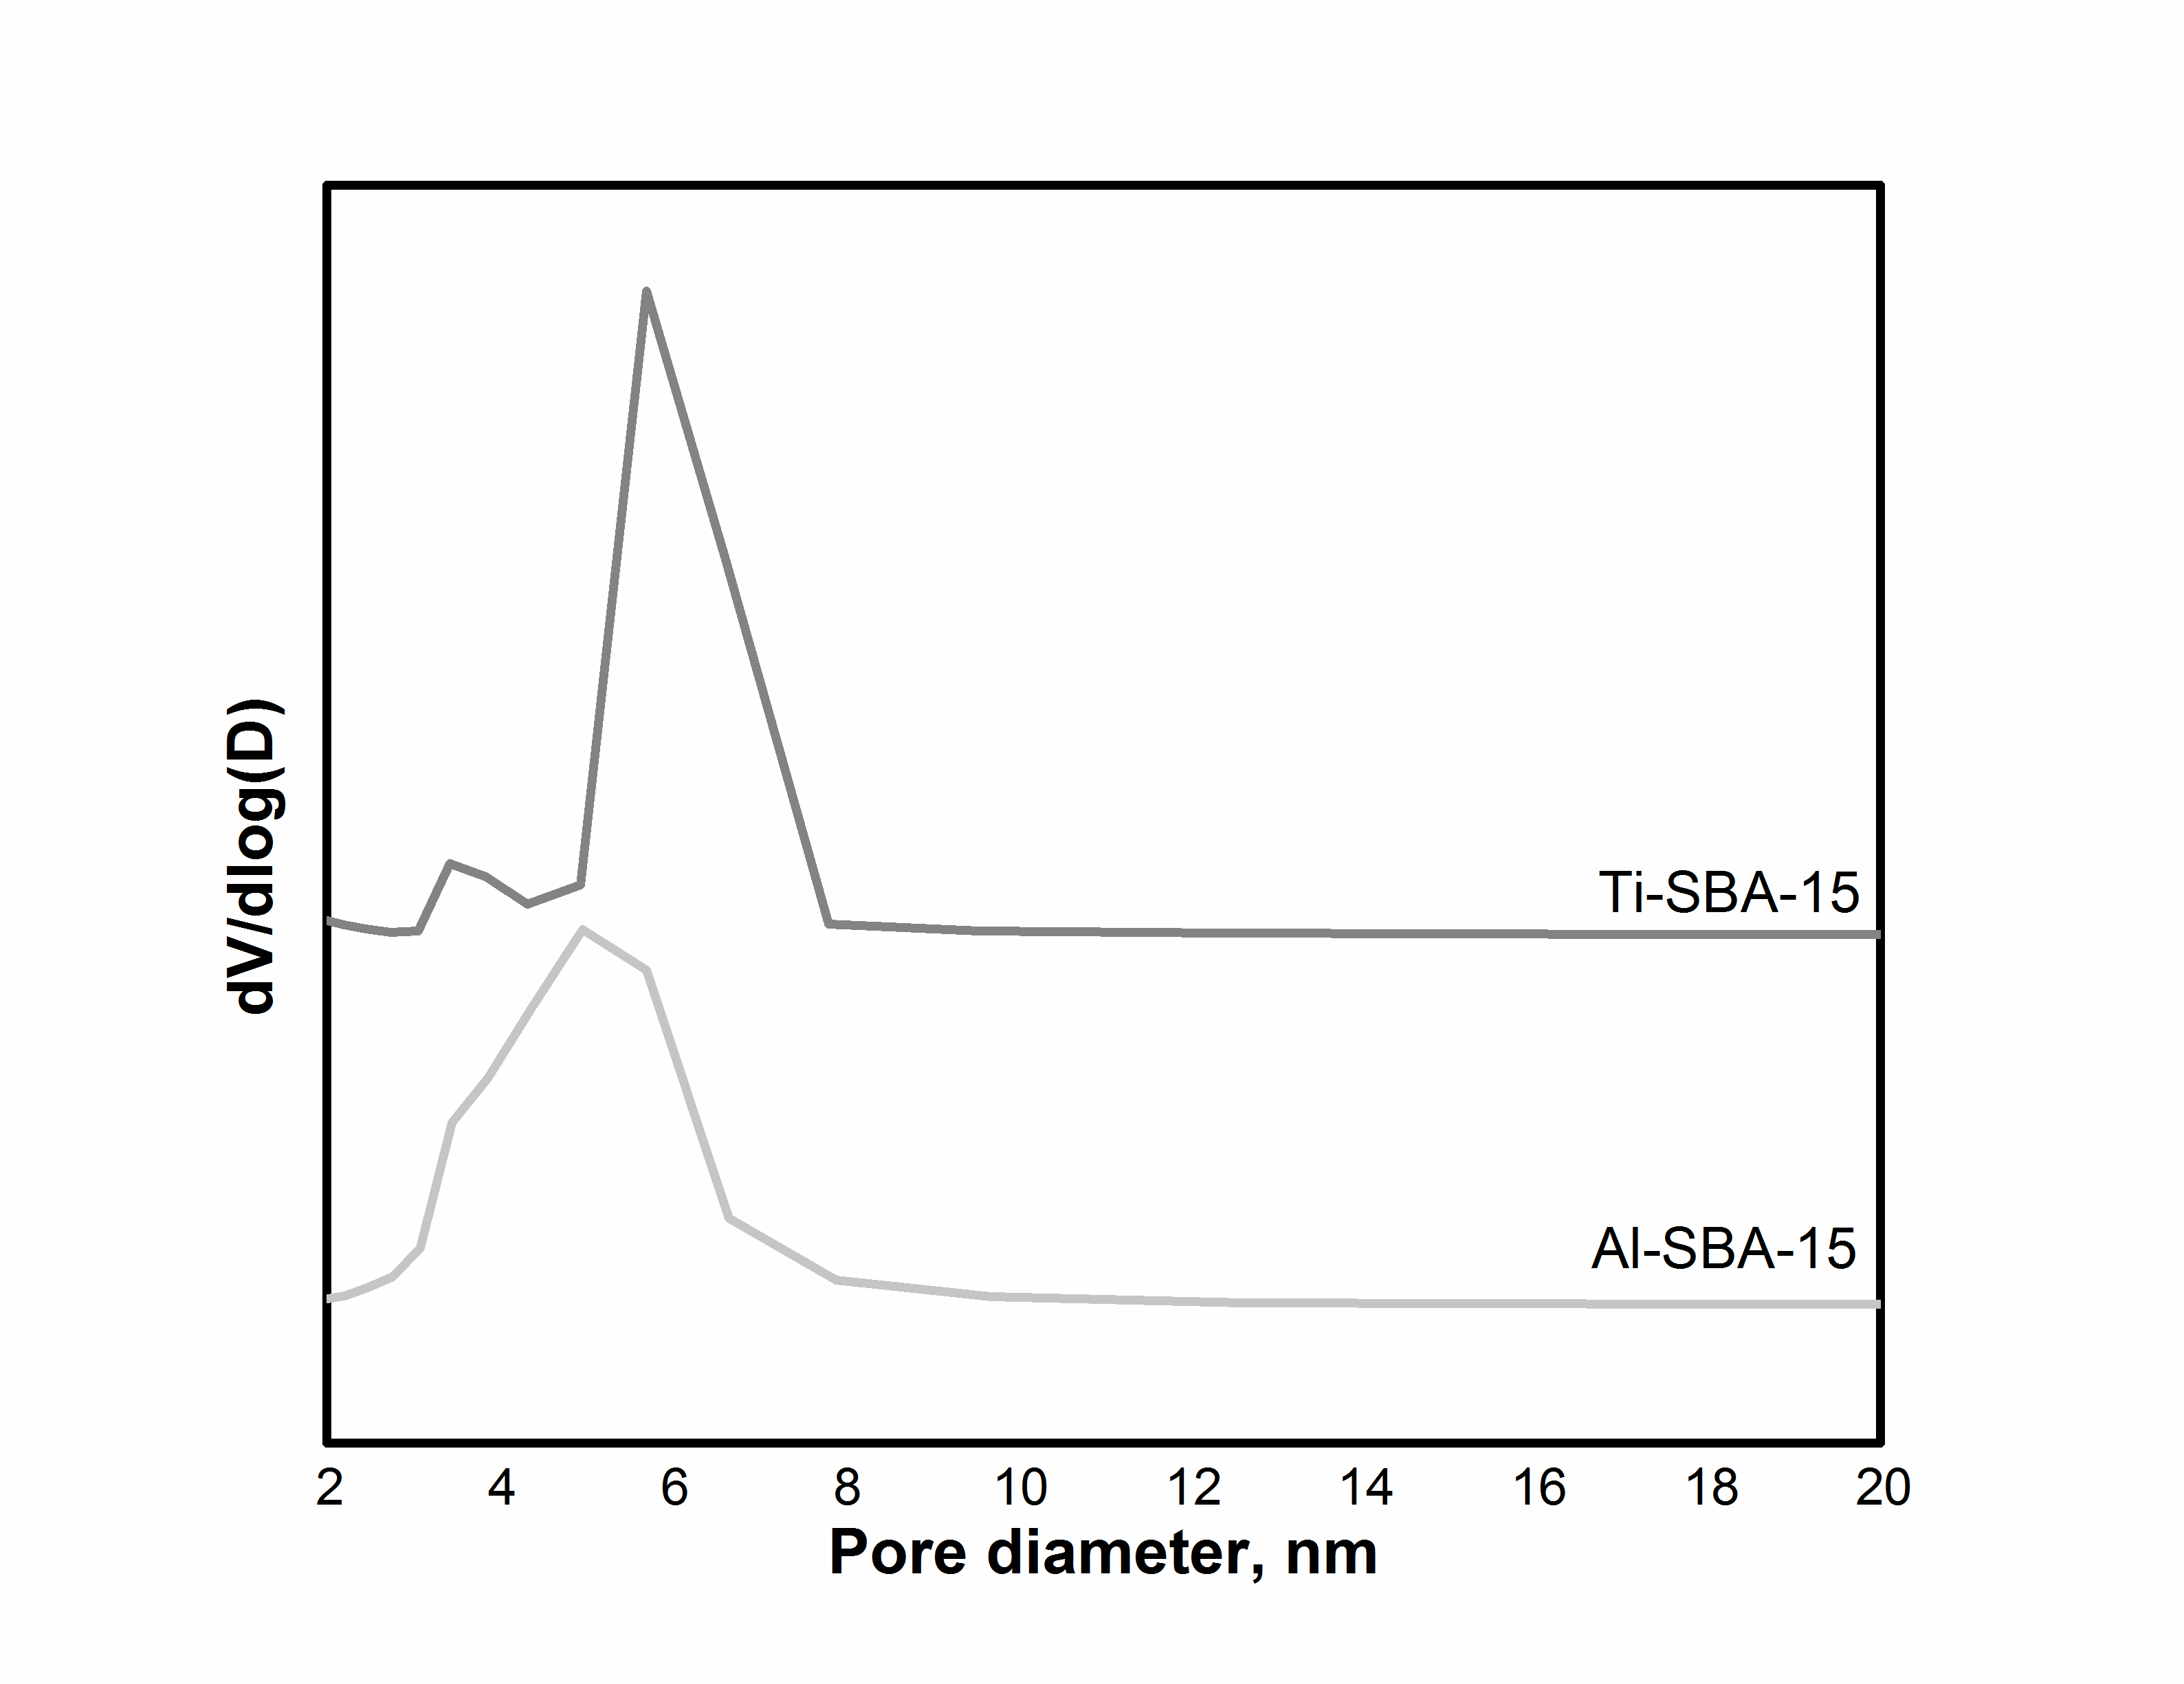
FIG. S1. Pore size distribution of Al-SBA-15 and Ti-SBA-15 materials.

