Supplementary information

Surface modification of biodegradable cardiovascular stent materials Mg-Zn-Y-Nd via conjugating REDV peptide for better endothelialization
Li Chen¹, Jingan Li^{1,}*, Shuo Wang¹, Shijie Zhu¹, Chao Zhu¹, Boyuan Zheng¹, Ge Yang¹, Shaokang Guan^{1,}*

¹School of Material Science and Engineering, Zhengzhou University, 100 Science Road, Zhengzhou 450001, PR China

*Corresponding author:
E-mail addresses: lijingan@zzu.edu.cn (J. A. Li); skguan@zzu.edu.cn (S. K. Guan)

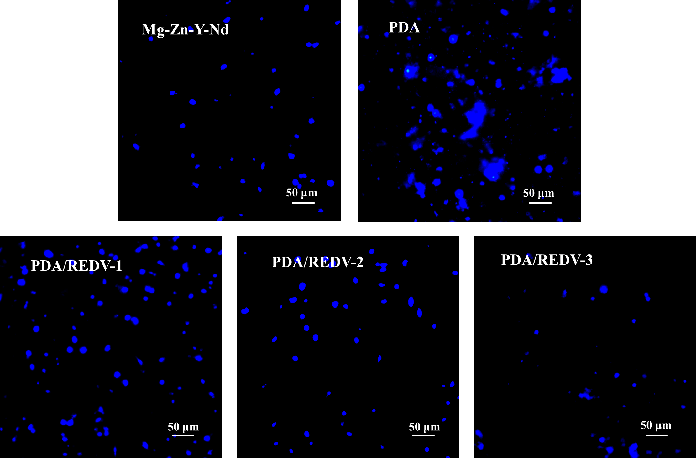
Figure S1. Fluorescence images of HUASMCs stained with DAPI on samples of PDA/REDV-1, PDA/REDV-2, PDA/REDV-3, PDA and Mg-Zn-Y-Nd, respectively. (The blue dots indicated the HUASMC nucleus that stained with DAPI)

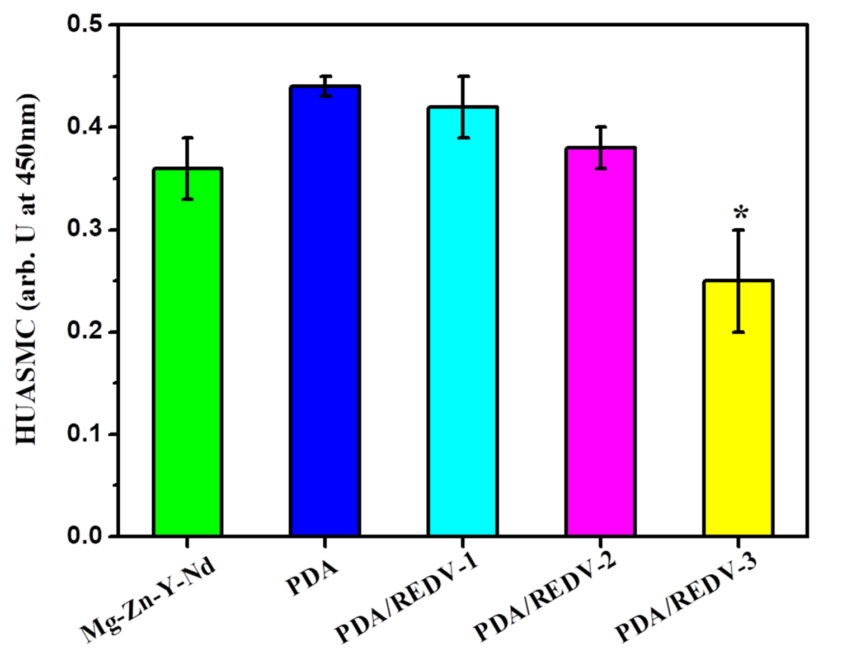
Figure S2. Quantitative characterization of HUASMCs on samples of PDA/REDV-1, PDA/REDV-2, PDA/REDV-3, PDA and Mg-Zn-Y-Nd, respectively. (mean ± SD, *p<0.05 compared with other samples, n=3)

