Supplementary Information

Kinetic Control of CeO₂ nanoparticles for Catalytic CO Oxidation
Bingqi Han,¹ Huixia Li,¹ Liping Li,¹ Yan Wang,¹ Yuelan Zhang,¹ Guangshe Li^{1,a)}
¹State Key Laboratory of Inorganic Synthesis and Preparative Chemistry, College of Chemistry, Jilin University, Changchun 130012, People’s Republic of
China
^{a)}Address all correspondence to this author. e-mail: guangshe@jlu.edu.cn

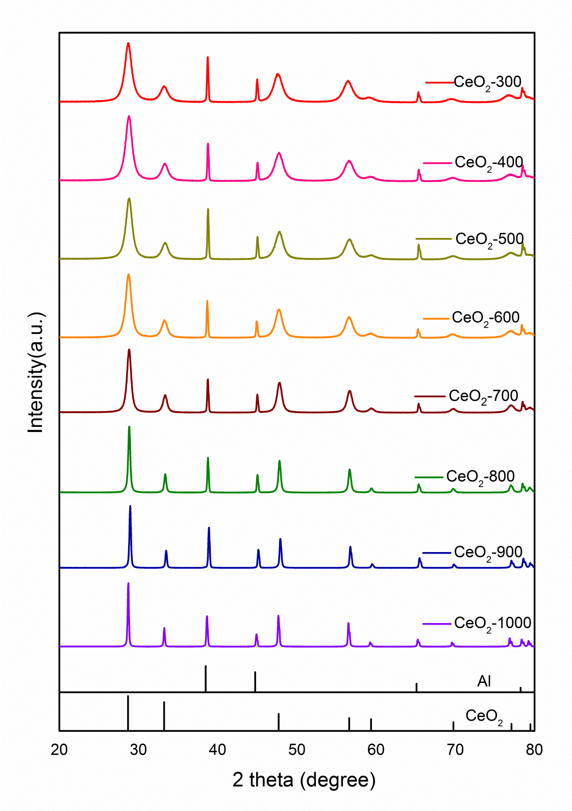
Fig. S1. Powder XRD patterns of CeO₂ obtained by sintering cerium nitrate at the temperature ranged from 300 to 1000ºC for 2h

Table S1 Average particle sizes of CeO₂ nanoparticles determined by TEM and XRD analyses
Label | Nanoparticle Size (avg.)
Label | TEM (nm) | XRD (nm)
CeO₂-700 | 19.1 | 18.9
CeO₂-800/8h | 58.0 | 57.5
CeO₂-900 | 67.1 | 66.7
CeO₂-1000 | 100.3 | 79.7

Table S2 Peak areas of O1s components and their ratios
samples | O1 area | O2 area | Ratio
Pt/CeO₂-500 | 3595.78 | 5791.87 | 0.620
Pt/CeO₂-700 | 5168.94 | 8309.08 | 0.622
Pt/CeO₂-900 | 1961.06 | 7126.78 | 0.275

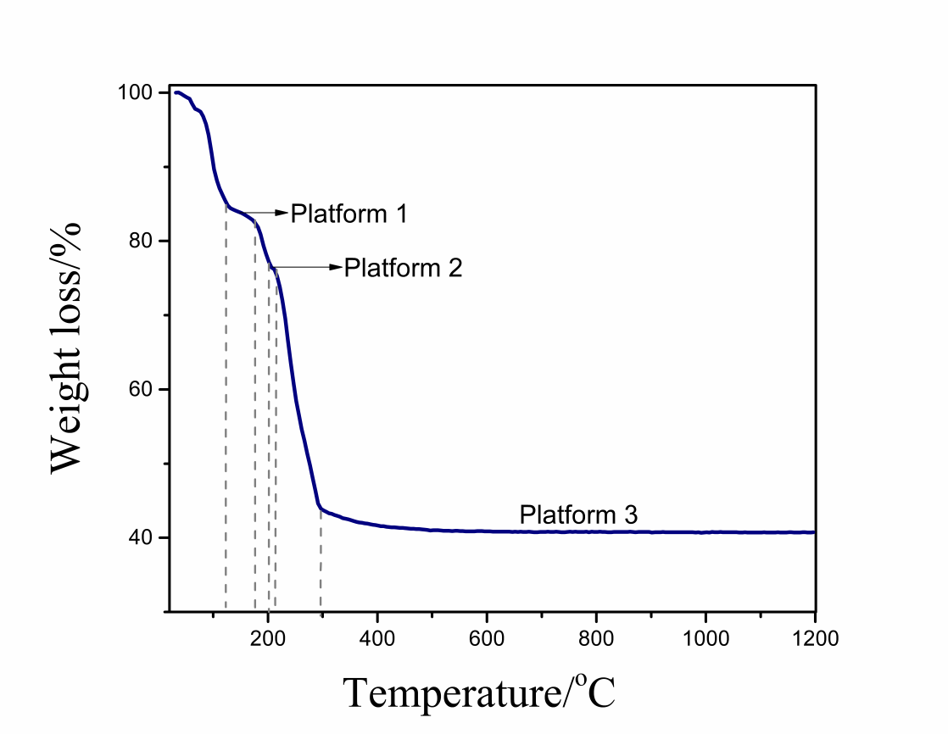
Fig. S2. TG curve of Ce(NO₃)₃·6H₂O recorded in the temperature range from 25 to 1200ºC.

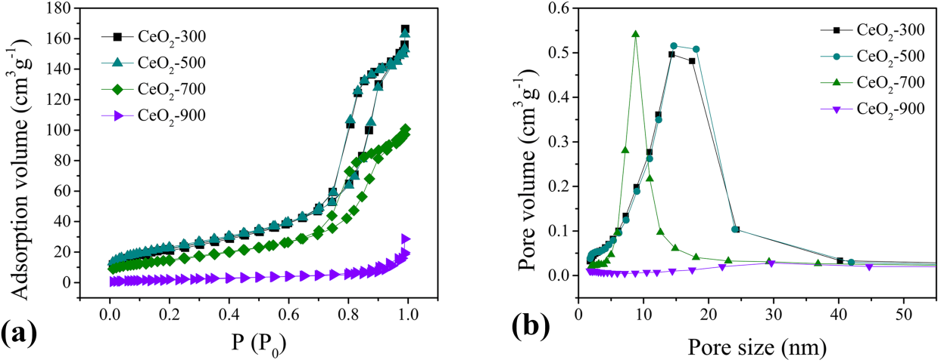
FIG. S3. (a) Nitrogen desorption/adsorption isotherms and (b) the corresponding BJH (Barret-Joyner-Halenda) pore size distribution curves for the given samples.

Table S3 Average particle sizes for the different CeO₂ nanoparticles obtained by XRD analysis.
samples | Nanoparticle Size (avg.)
CeO2-600/1h | 13.48948
CeO2-600/2h | 14.6007
CeO2-600/4h | 15.05496
CeO2-600/6h | 16.18135
CeO2-600/8h | 16.31761

