Supplementary Material
Luminescent material with functionalized graphitic carbon nitride as a photovoltaic booster in DSSCs: enhanced charge separation and transfer
Yanzhou Zhang¹, Kai Pan¹, Yang Qu¹, Guofeng Wang¹*, Qilin Dai², Dingsheng Wang³ and Weiping Qin⁴
¹Key Laboratory of Functional Inorganic Material Chemistry, Ministry of Education, School of Chemistry and Materials Science, Heilongjiang University, Harbin, 150080, China. Email: wanggf_w@163.com
²Department of Physics, Jackson State University, Jackson, 17660, US
³Department of Chemistry, Tsinghua University, Beijing 100084, China
⁴College of Electronic Science and Engineering, Jilin University, 120012, China

TABLE SI. Parameters obtained by fitting the impedance spectra of the composite solar cells using the equivalent circuit in the inset of Fig.9.
DSSCs | R_{s}(Ω) | C₁(F) | R₁(Ω) | Y_{o1}(S) | B(S^{1/2}) | R₂(S) | CPE
Pure TiO₂ | 36.06 | 1.28×10⁻⁵ | 10.19 | 0.00455 | 0.1731 | 17.23 | 0.00351
TiO₂-YONP-C₃N₄ | 32.84 | 1.75×10⁻⁵ | 9.723 | 0.00408 | 0.1587 | 12.27 | 0.00277

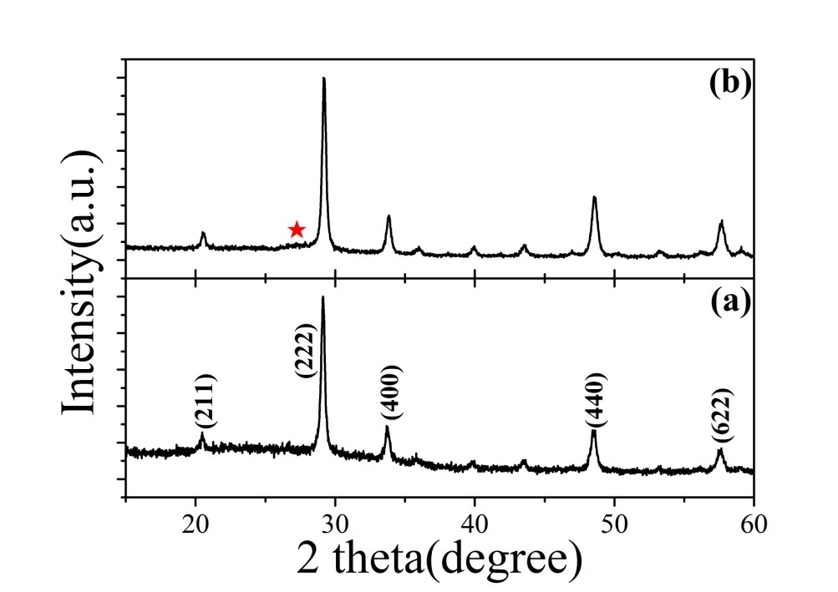
FIG. S1. XRD patterns of YONT/C₃N₄ nanocomposites with different YONT/C₃N₄ mass ratios: (a) YONT/C₃N₄ (1:0.065) and (b) YONT/C₃N₄ (1:0.75).

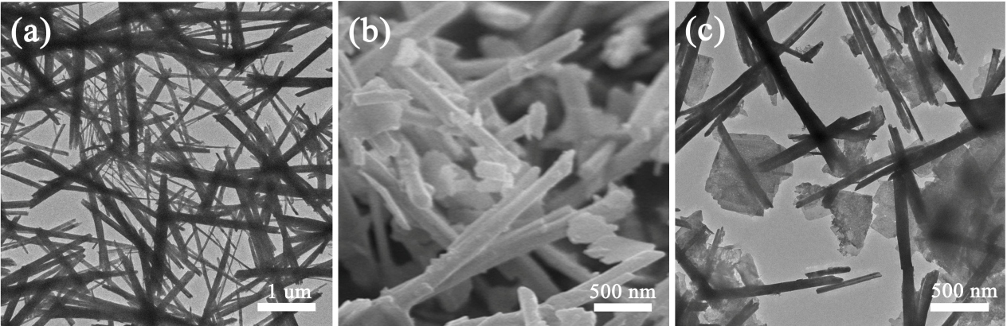
FIG. S2. (a) TEM image of YONT, (b,c) SEM and TEM images of YONT/C₃N₄ (1:0.05) nanocomposites.

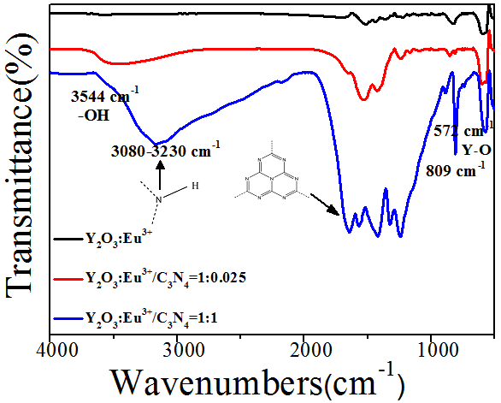
FIG. S3. The IR spectra of YONT and YONT/C₃N₄ nanocomposites with different YONT/C₃N₄ mass ratios.

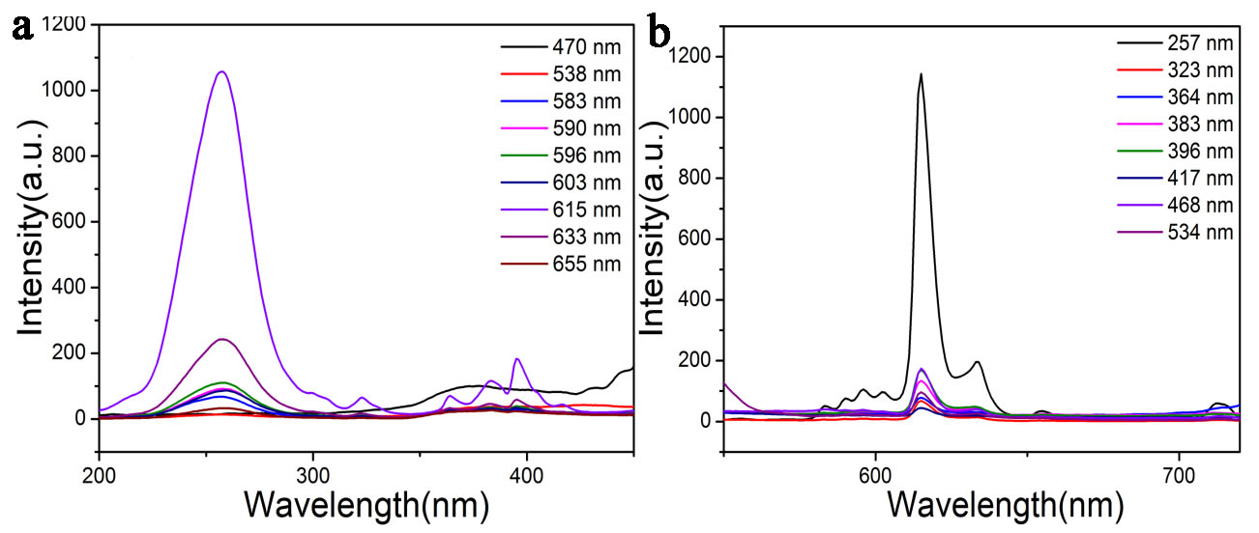
FIG. S4. (a) Excitation spectra of YONP monitored at different wavelengths. (b) Emission spectra of YONP excited at different wavelengths.

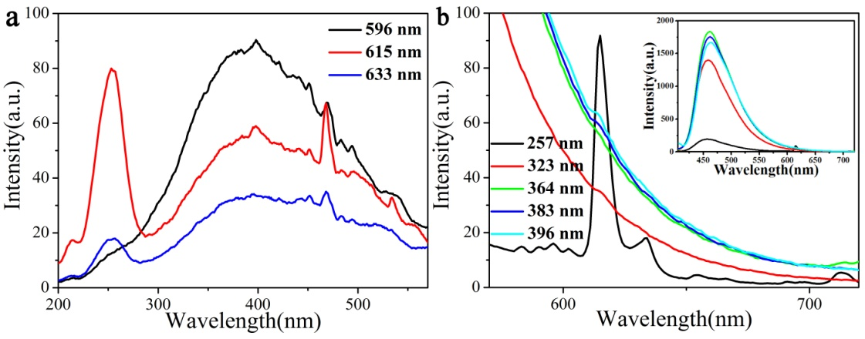
FIG. S5. (a) Excitation spectra of YONP/C₃N₄ (1:2) nanocomposites monitored at different emission wavelengths. (b) Emission spectra of YONP/ C₃N₄ (1:2) nanocomposites excited at different emission wavelengths.

