Supplementary Material for

High-efficiency Photocatalytic Performance and Mechanism of Silver-based Metal-Organic Framework
Xiu-Ju Yin^{1,2}* and Long-Guan Zhu¹*
¹Department of Chemistry, Zhejiang University, Hangzhou 310027, P. R. China
²College of Chemistry and Biology Engineering, Hechi University, Yizhou 546300, P. R. China
*Correspondence and requests for materials should be addressed to Long-Guan Zhu or Xiu-Ju Yin (Email: gxyxj505@163.com; chezlg@zju.edu.cn)

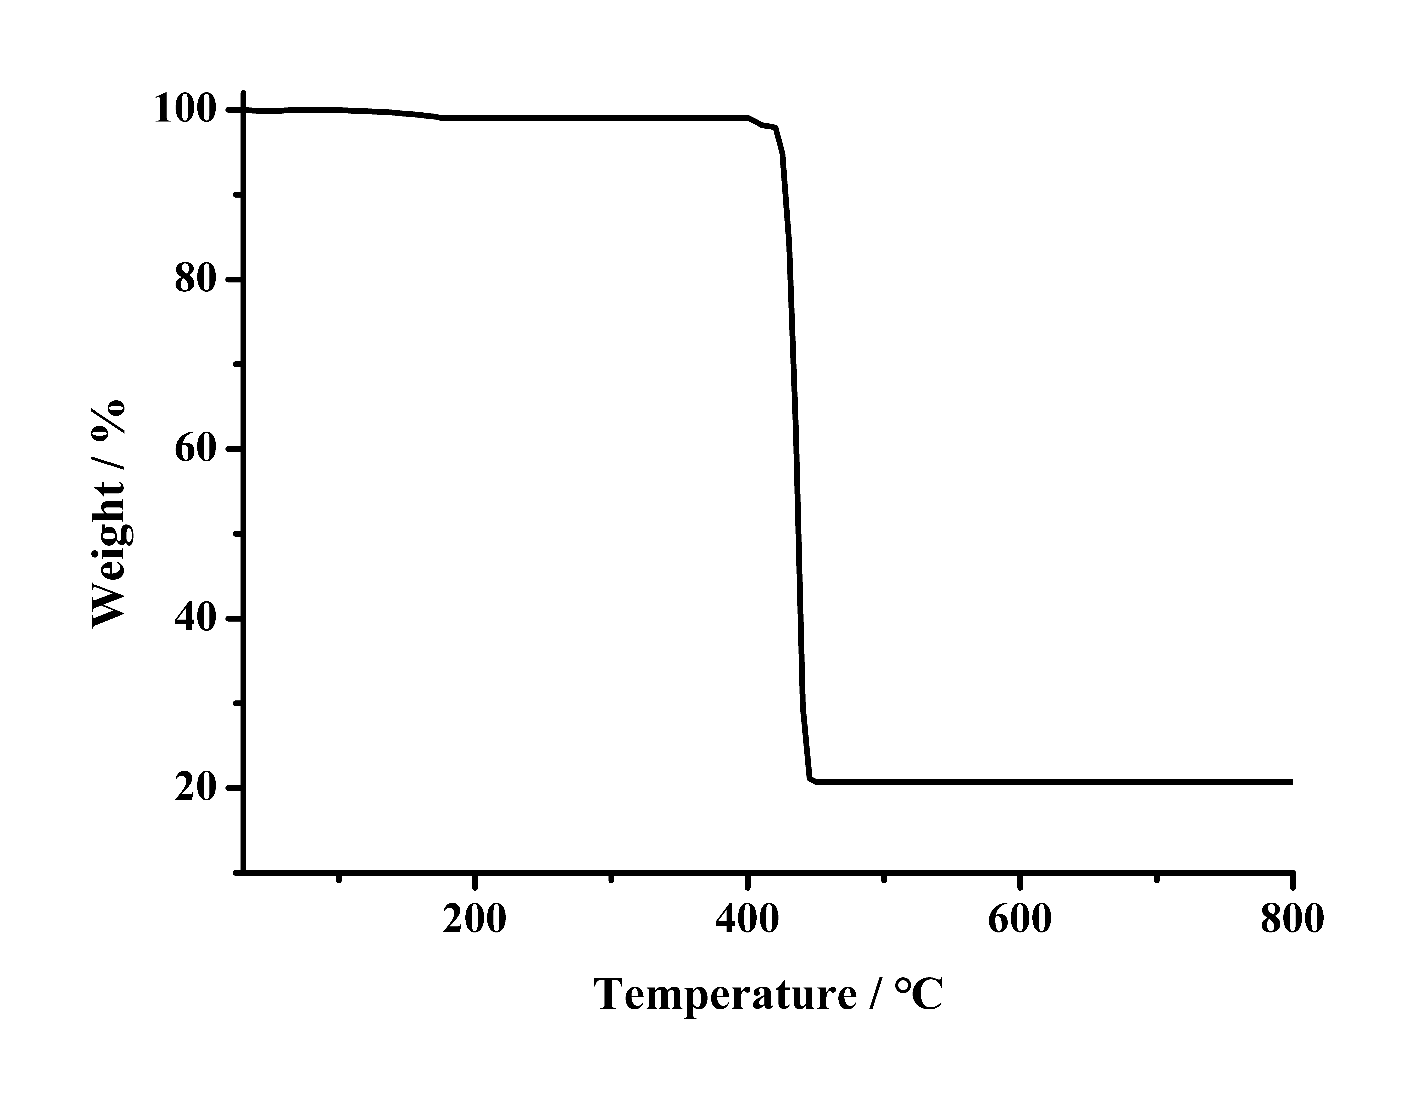
Figure S1. The TGA for 1.

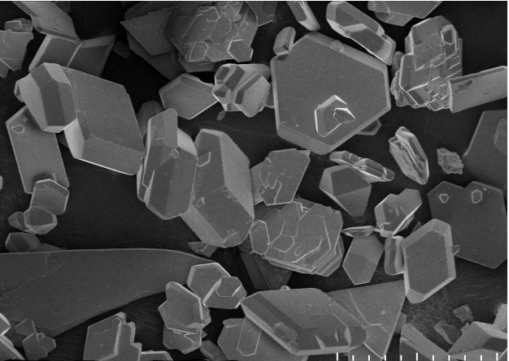
100 μm
Figure S2. Scanning electron microscopy (SEM) micrograph of 1.
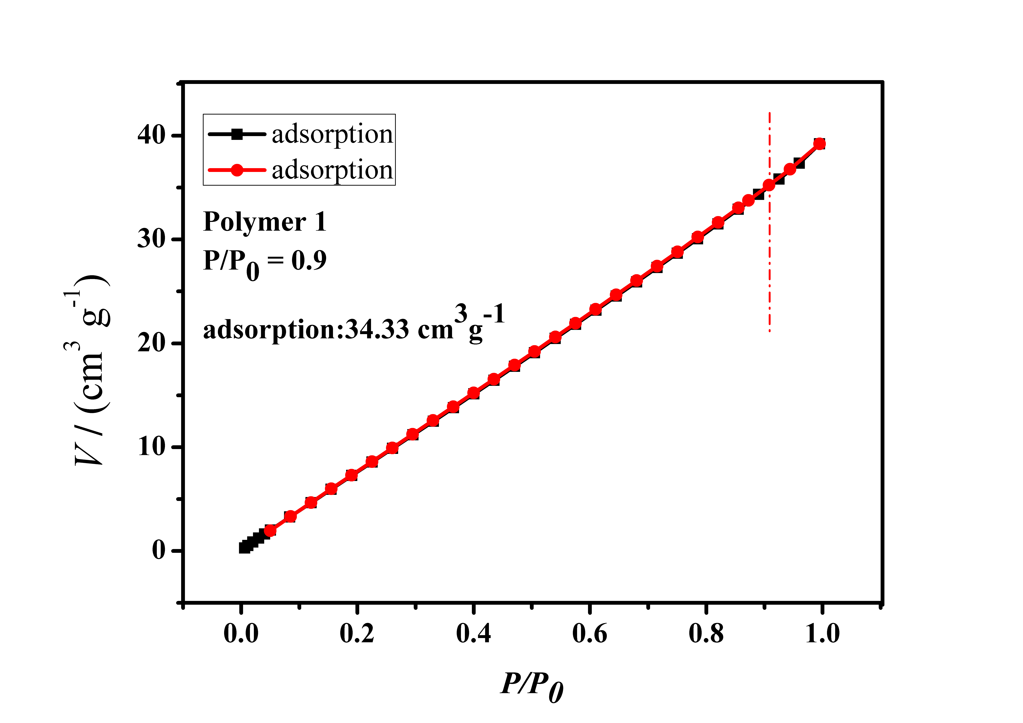
Figure S3. The N₂ adsorption/desorption experiment of 1.

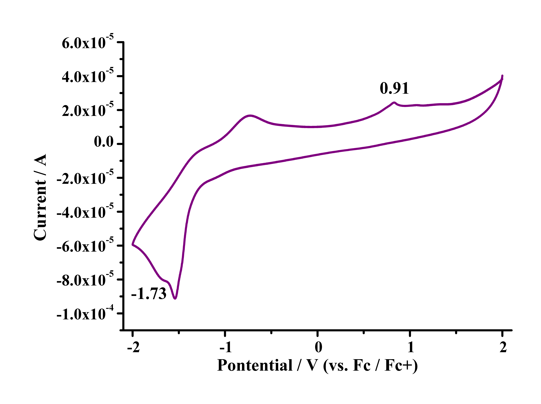
Figure S4. Cyclic voltammograms of 1 on platinum plates in an acetonitrile solution of 0.1 mol·L⁻¹ Bu₄NPF₆ at a sweep rate of 0.1 V·s⁻¹.

Figure S5. The photocatalytic degradation products of MB by ESI mass spectra.

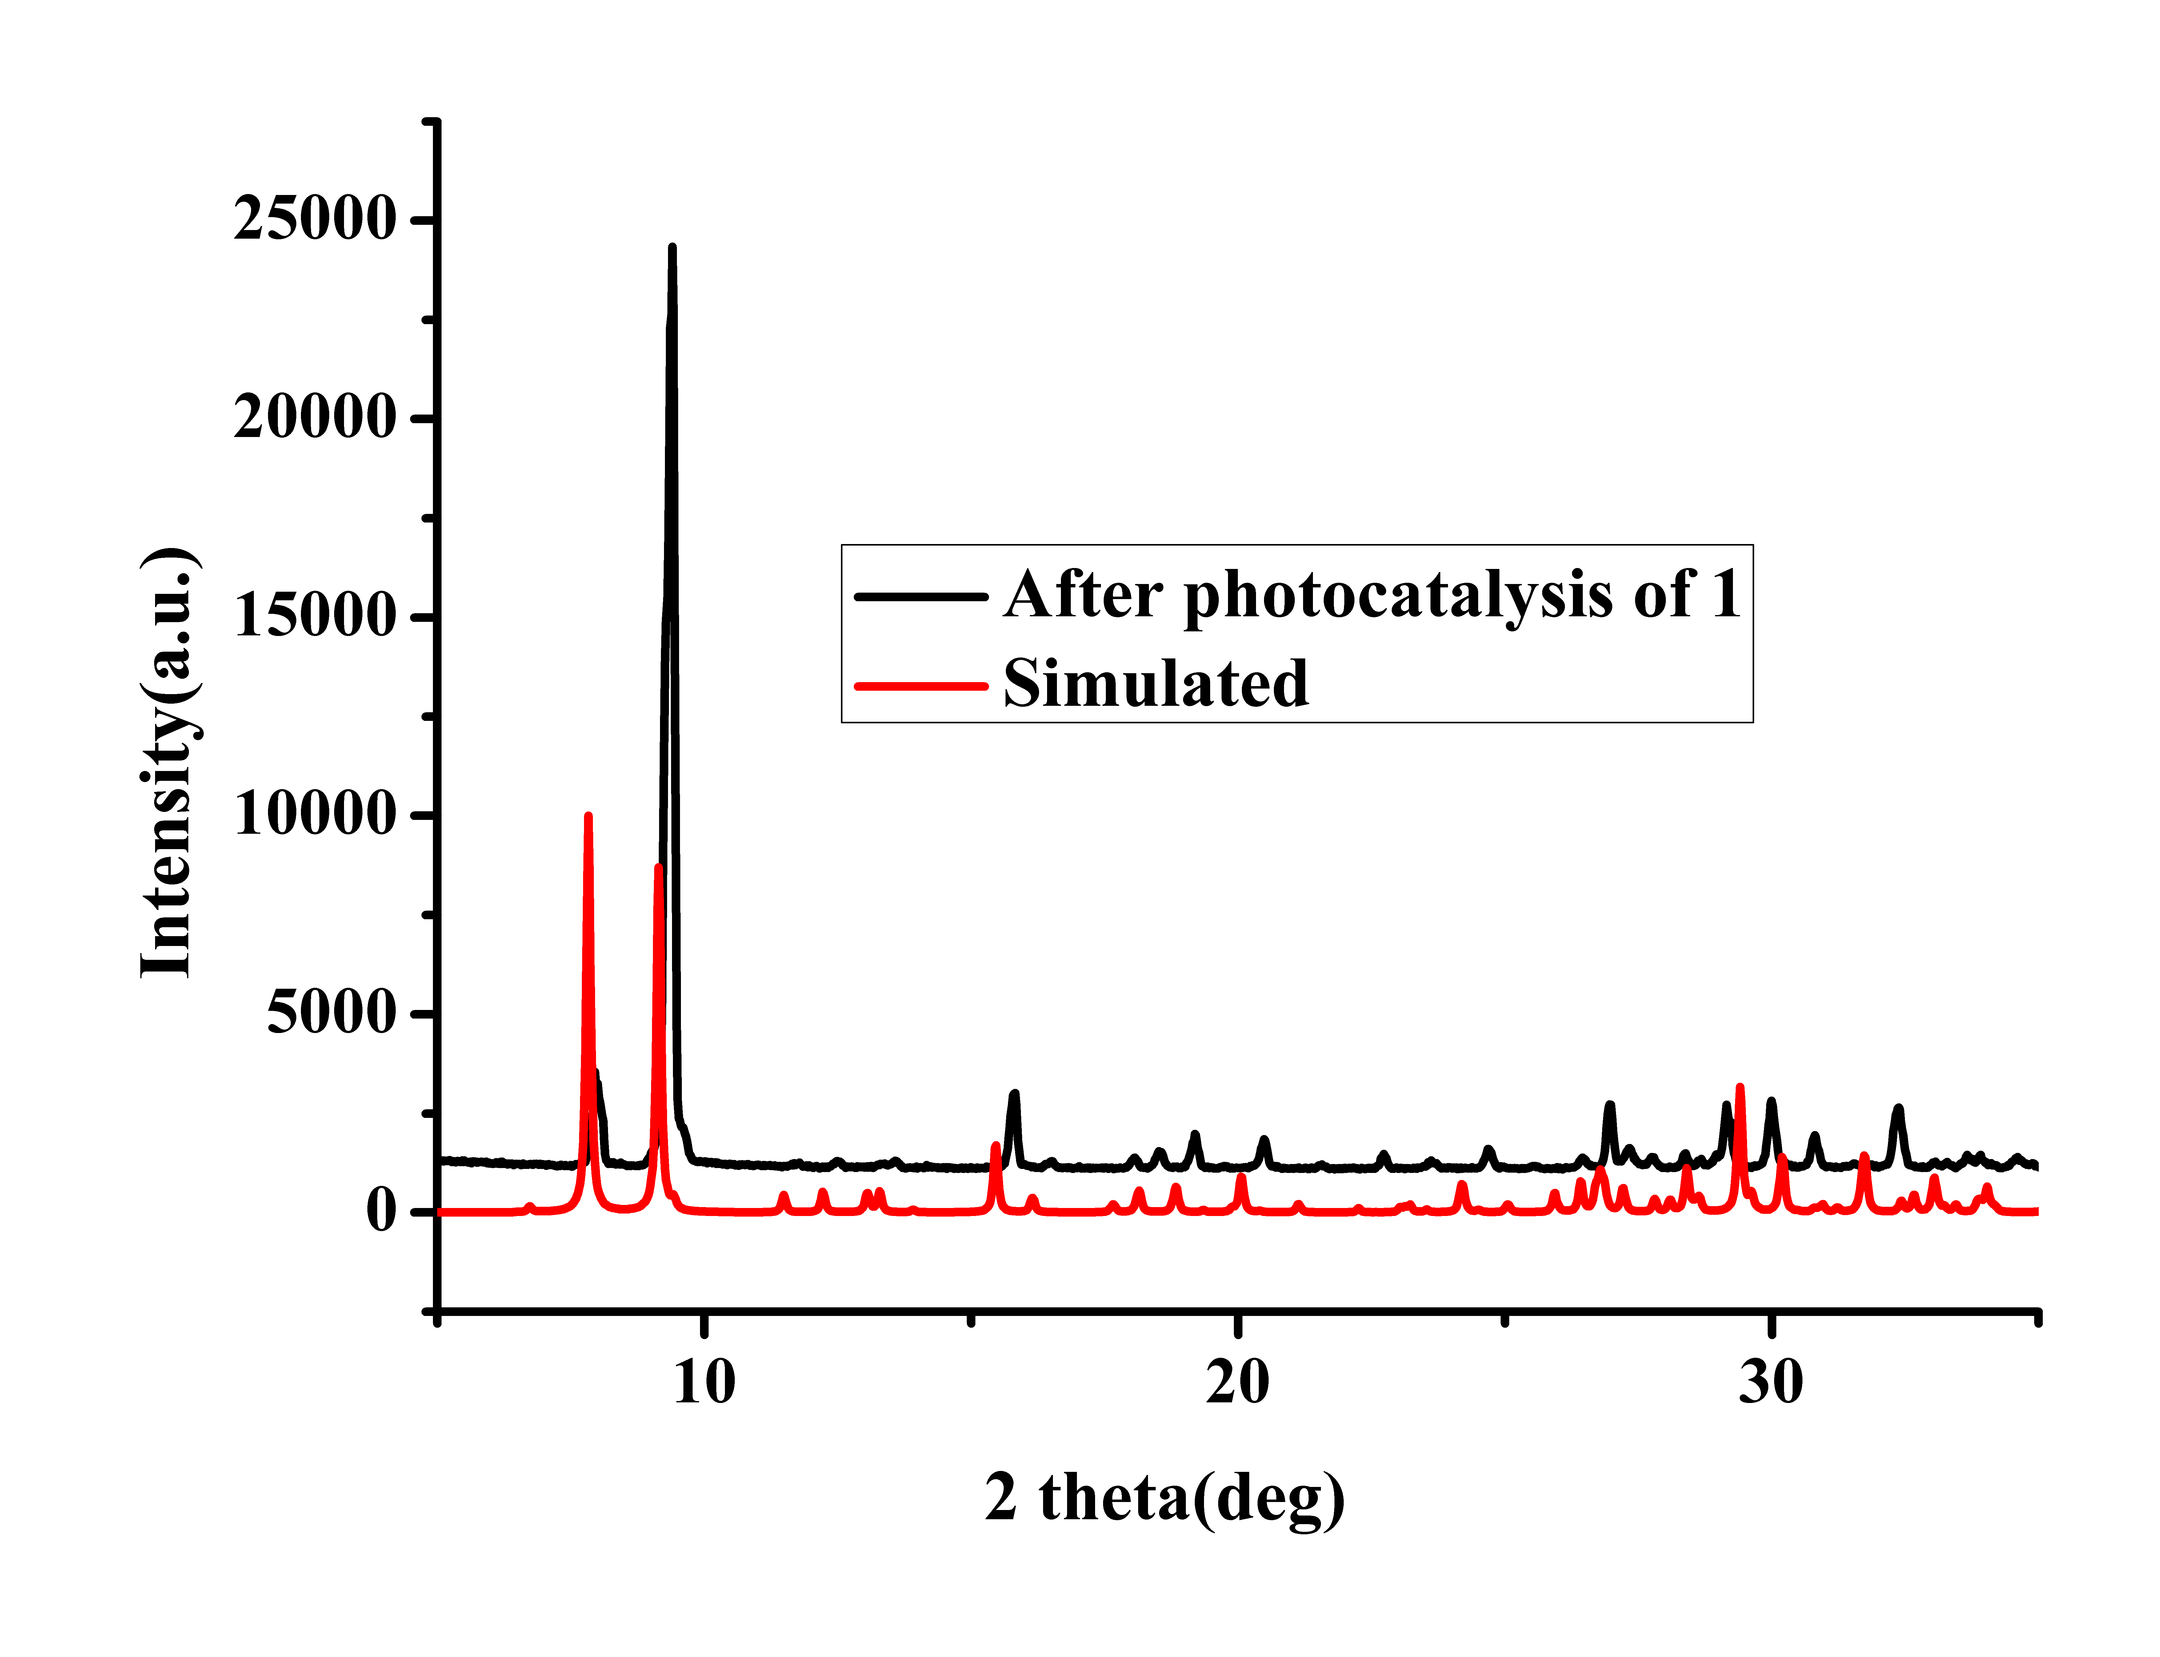
Figure S6. The PXRD of 1.
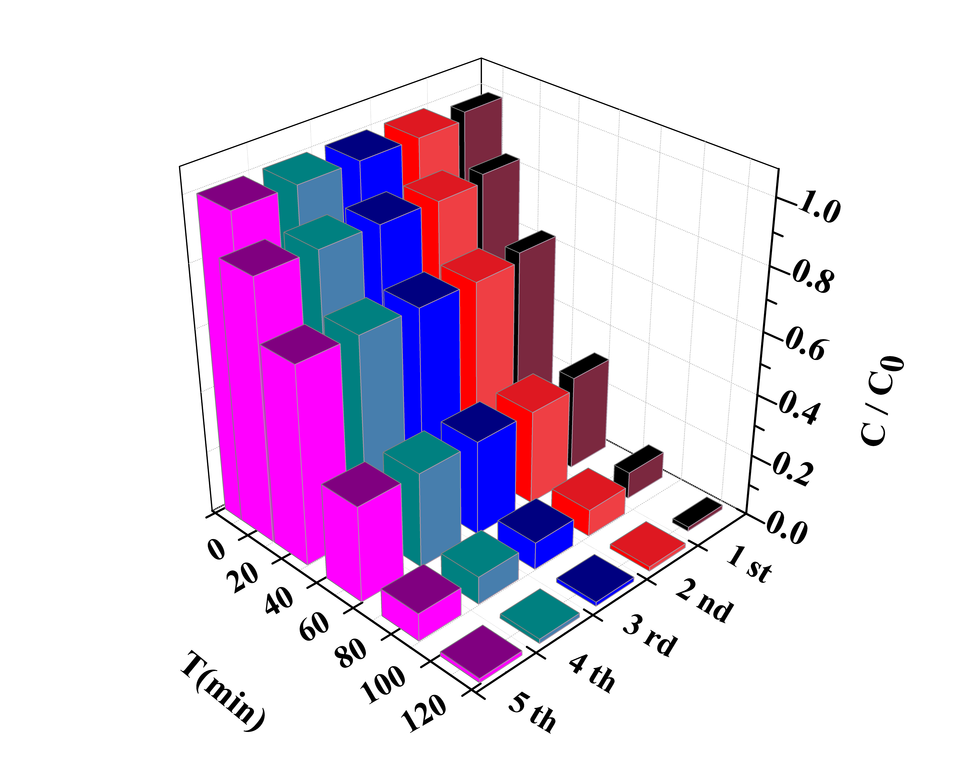
Figure S7. Cycle runs of 1 for the degradation of MB.

Table SI. Crystallographic Data of 1.
1
Empirical formula | C₁₈H₈Ag₃O₁₂
Formula weight | 739.85
Temperature (K) | 296(2)
Wavelength (Å) | 0.71073
Crystal system | Orthorhombic
Space group | Fddd
a (Å); b (Å); c (Å) | 14.8812(7); 25.8729(14); 36.3742(18)
α ( º); β ( º); γ ( º) | 90; 90; 90
Volume (Å³); Z | 14004.8(12);195
D_{caled}, (g.cm⁻³) | 2.807
Limiting indices | -20 ≤ h ≤ 19; -33 ≤ k ≤ 35; -48 ≤ l ≤44
F(000) | 11217
Θ range for data collection(º) | 3.8 ~29.0
Reflections/parameters/restraints  /unique | 3085/301/0
R_{int} | 0.041
R[F² > 2σ(F²)] | 0.024
wR(F²) | 0.085
S | 0.97
(Δ/σ)_{max} | 0.001
Δρ_{max/}Δρ_{min(}e Å⁻³) | 0.88/-1.13
CCDC | 1851398

Table SII. Selected Bond Lengths (nm) and Bond Angles (°) for 1.
1
Bond | Dist. (Å) | Bond | Dist. (Å) | Bond | Dist. (Å)
Ag(1)-Ag(1)^{A} | 2.9891 (6) | Ag(1)-Ag(2) | 3.3766 (4) | Ag(1)-Ag(4)^{B} | 3.1838 (3)
Ag(2)-Ag(2)^{E} | 2.9653 (6) | Ag(2)-Ag(2)^{A} | 2.9677 (6) | Ag(3)-Ag(4) | 3.2111 (6)
Ag(1)-O(8) | 2.564 (2) | Ag(1)-O(9)^{C} | 2.271 (2) | Ag(1)-O(10)^{D} | 2.231 (2)
Ag(2)-O(3) | 2.477 (2) | Ag(2)-O(5)^{F} | 2.212 (2) | Ag(2)-O(6)^{G} | 2.220 (2)
Ag(3)-O(7)^{B} | 2.551 (2) | Ag(3)-O(7) | 2.551 (2) | Ag(3)-O(11)^{H} | 2.499 (2)
Ag(3)-O(11)^{K} | 2.499 (2) | Ag(4)-O(8) | 2.108 (2) | Ag(4)-O(8)^{B} | 2.108 (2)
Angle | (°) | Angle | (°) | Angle | (°)
Ag(4)^{B}-Ag(1)-Ag(2) | 130.492 (10) | O(8)-Ag(1)-Ag(2) | 156.61 (6) | O(8)-Ag(1)-Ag(4)^{B} | 41.30 (5)
Ag(2)^{A}-Ag(2)-Ag(1) | 79.544 (8) | Ag(2)^{E}-Ag(2)-Ag(1) | 156.155 (13) | Ag(1)^{B}-Ag(4)-Ag(1) | 155.863 (17)
Ag(3)-Ag(4)-Ag(1)^{B} | 102.069 (9) | Ag(3)-Ag(4)-Ag(1) | 102.069 (9) | Ag(4)^{A}-Ag(4)-Ag(1)^{B} | 77.931 (9)
Ag(4)^{A}-Ag(4)-Ag(1) | 77.931 (9) | Ag(4)^{A}-Ag(4)-Ag(3) | 180.0 | O(8)^{B}-Ag(4)-Ag(1)^{B} | 53.38 (7)
O(9)^{C}-Ag(1)-Ag(2) | 53.10 (6) | O(9)^{C}-Ag(1)-Ag(4)^{B} | 78.42 (6) | O(9)^{C}-Ag(1)-O(8) | 109.12 (8)
O(10)^{D}-Ag(1)-Ag(2) | 109.89 (6) | O(10)^{D}-Ag(1)-Ag(4)^{B} | 111.47 (6) | O(10)^{D}-Ag(1)-O(8) | 91.61 (8)
O(8)-Ag(4)-Ag(1)^{B} | 125.29 (7) | O(8)-Ag(4)-Ag(1) | 53.38 (7) | O(8)^{B}-Ag(4)-Ag(1) | 125.29 (7)
O(8)^{B}-Ag(4)-Ag(3) | 92.56 (7) | O(8)-Ag(4)-Ag(3) | 92.56 (7) | O(8)-Ag(4)-O(8)^{B} | 174.87 (13)
Symmetry codes: (A) x, −y+5/4, −z+5/4; (B) −x+5/4, y, −z+5/4; (C) x+1/4, −y+1, z+1/4; (D) x+1/4, y+1/4, −z+1; (E) −x+9/4, y, −z+5/4; (F) −x+2, y+1/4, z+1/4; (G) −x+2, −y+1, −z+1; (H) x−1/4, y−1/4, −z+1; (I) −x+3/2, y−1/4, z+1/4; (J) −x+2, y−1/4, z−1/4; (K) x−1/4, −y+1, z−1/4.

Table SIII. Hydrogen bonds for 1.
1
D–H···A | d(D–H)/Å | d(H···A)/Å | d(D···A)/Å | D–H···A/(º)
O(2)-H(2)···O(9)^{L} | 0.82 | 1.77 (1) | 2.582 (4) | 174 (4)
O(12)-H(12)···O(7)^{D} | 0.82 | 1.77 (1) | 2.585 (3) | 173 (3)
Symmetry codes: (D) x+1/4, y+1/4, −z+1; (L) −x+3/2, y−1/4, z+1/4.

