Supplementary Material
Bimetallic metal-organic frameworks-derived mesoporous Cd_{x}Zn_{1-x}S polyhedrons for enhanced photocatalytic hydrogen evolution

Feihu Mu
State Key Laboratory of Materials-Oriented Chemical Engineering, College of Chemical Engineering, Nanjing Tech University, Nanjing, 210009, P. R. China
School of Chemistry and Chemical Engineering, Huaiyin Normal University, Huaian 223300, P. R. China
Shijian Zhou, Yun Wang, Jian Wang, and Yan Kong a)
State Key Laboratory of Materials-Oriented Chemical Engineering, College of Chemical Engineering, Nanjing Tech University, Nanjing, 210009, P. R. China
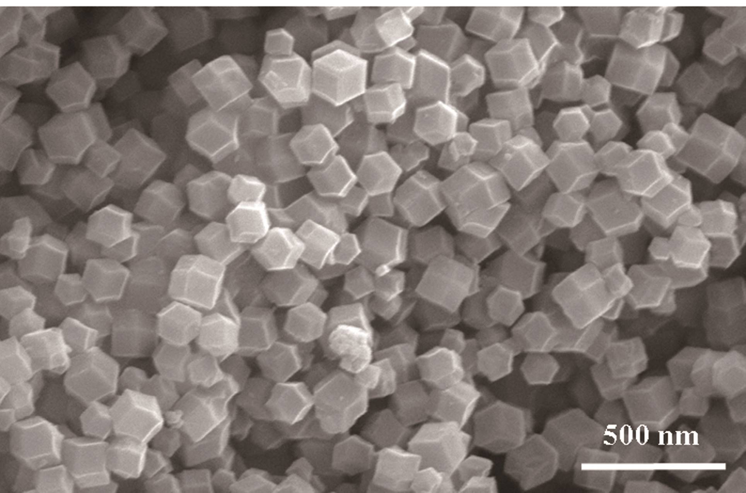
FIG. S1. SEM images of ZnCd-ZIFs-2.
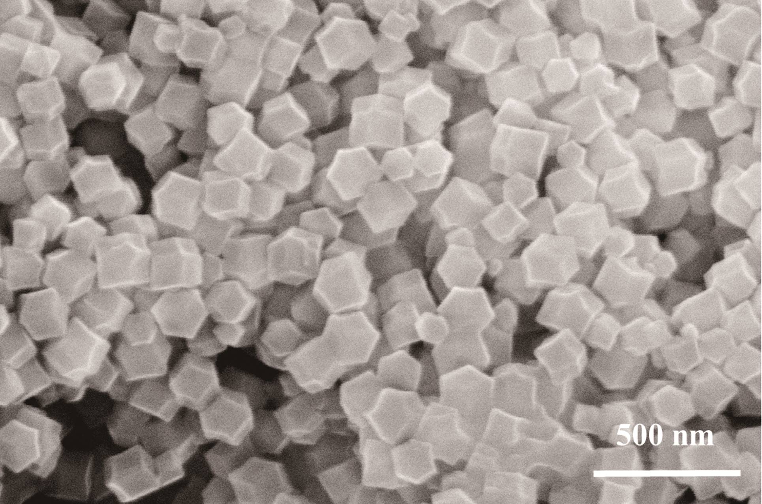
FIG. S2. SEM images of ZnCd-ZIFs-4.
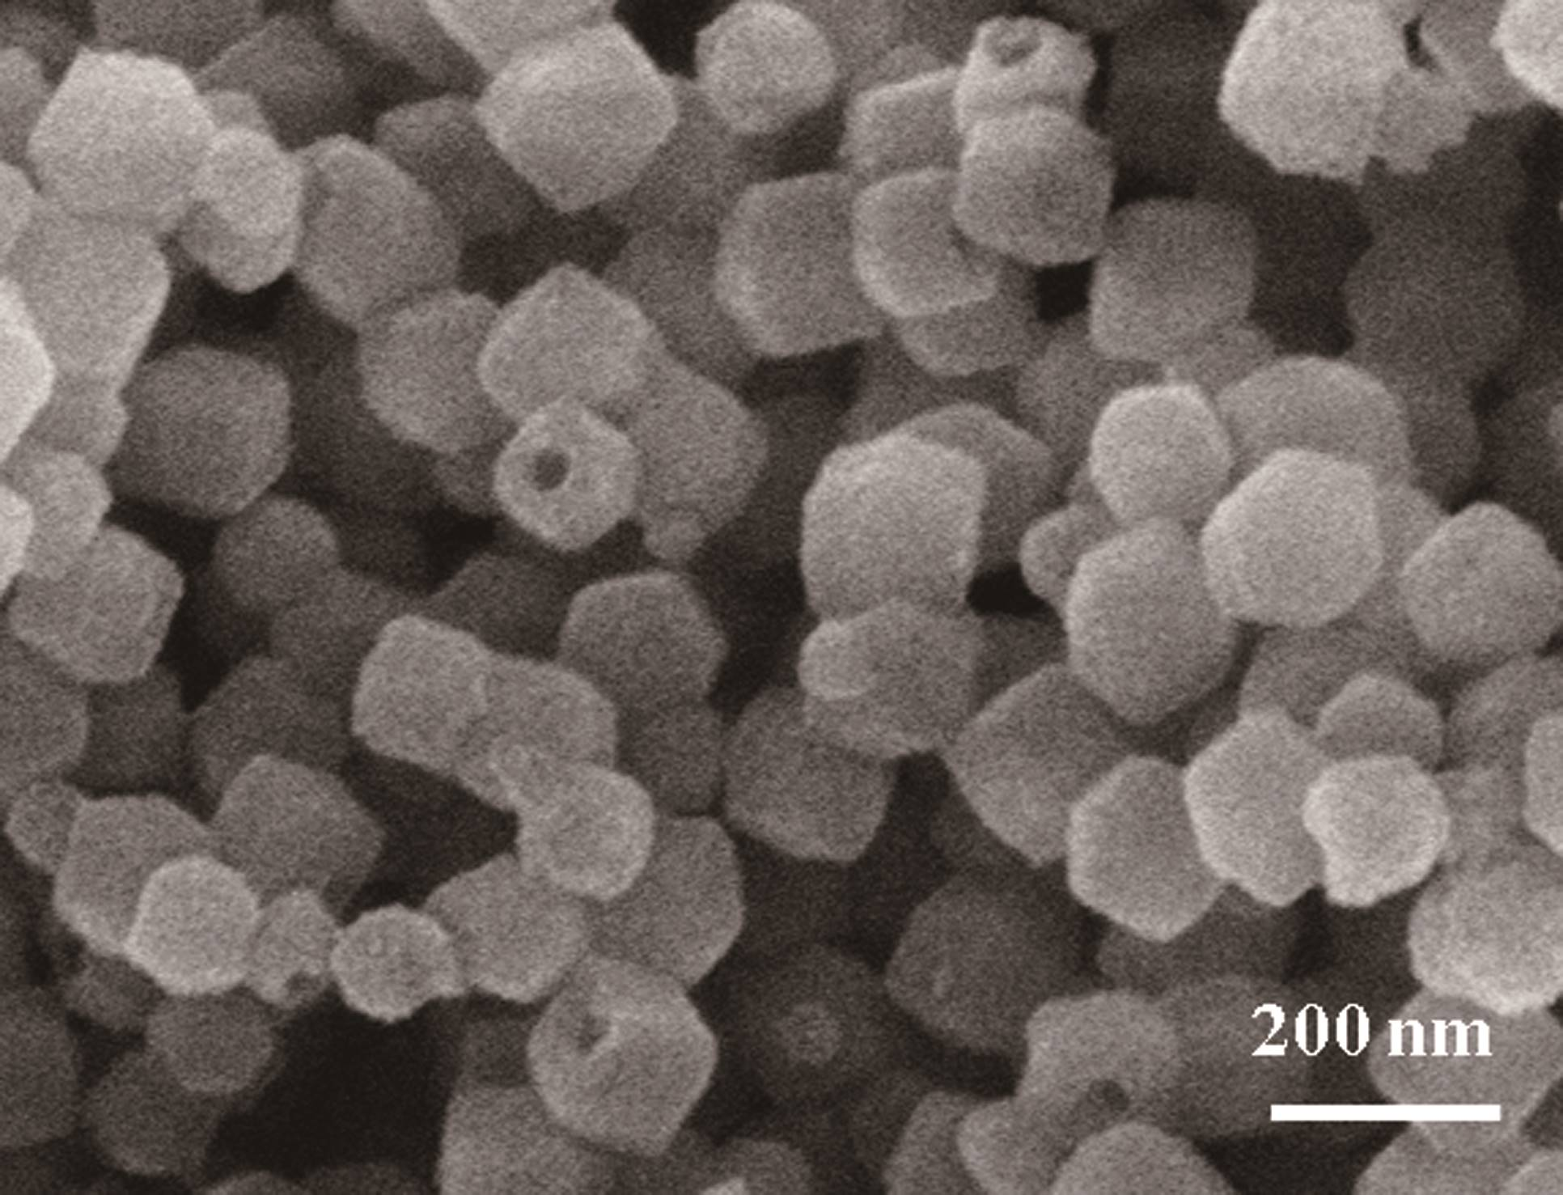
FIG. S3. TEM image of CZS1.
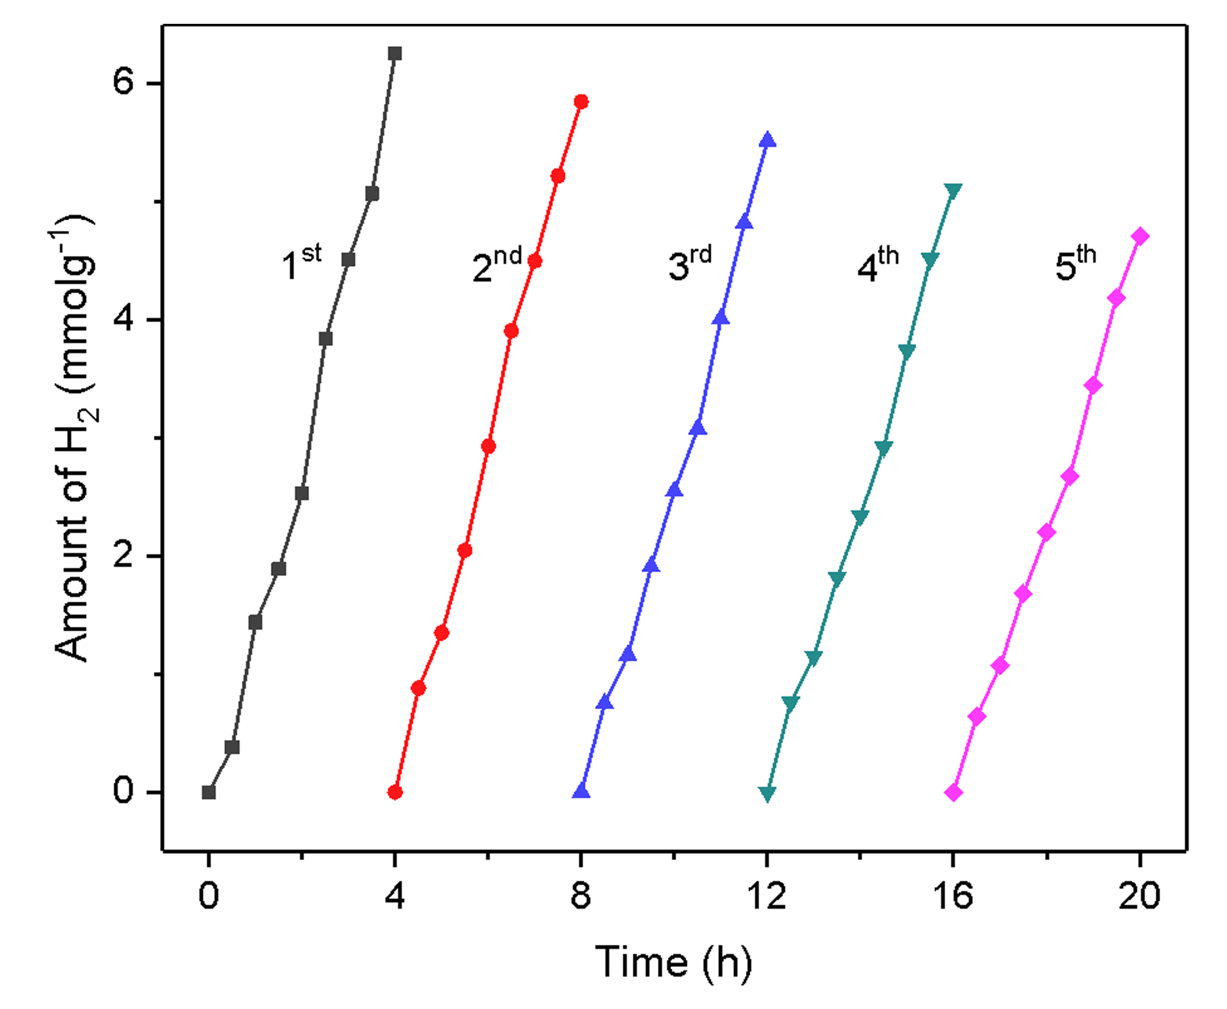
FIG. S4. Recycling stability experiments in five consecutive cycles of CdS-ZnS mixture.
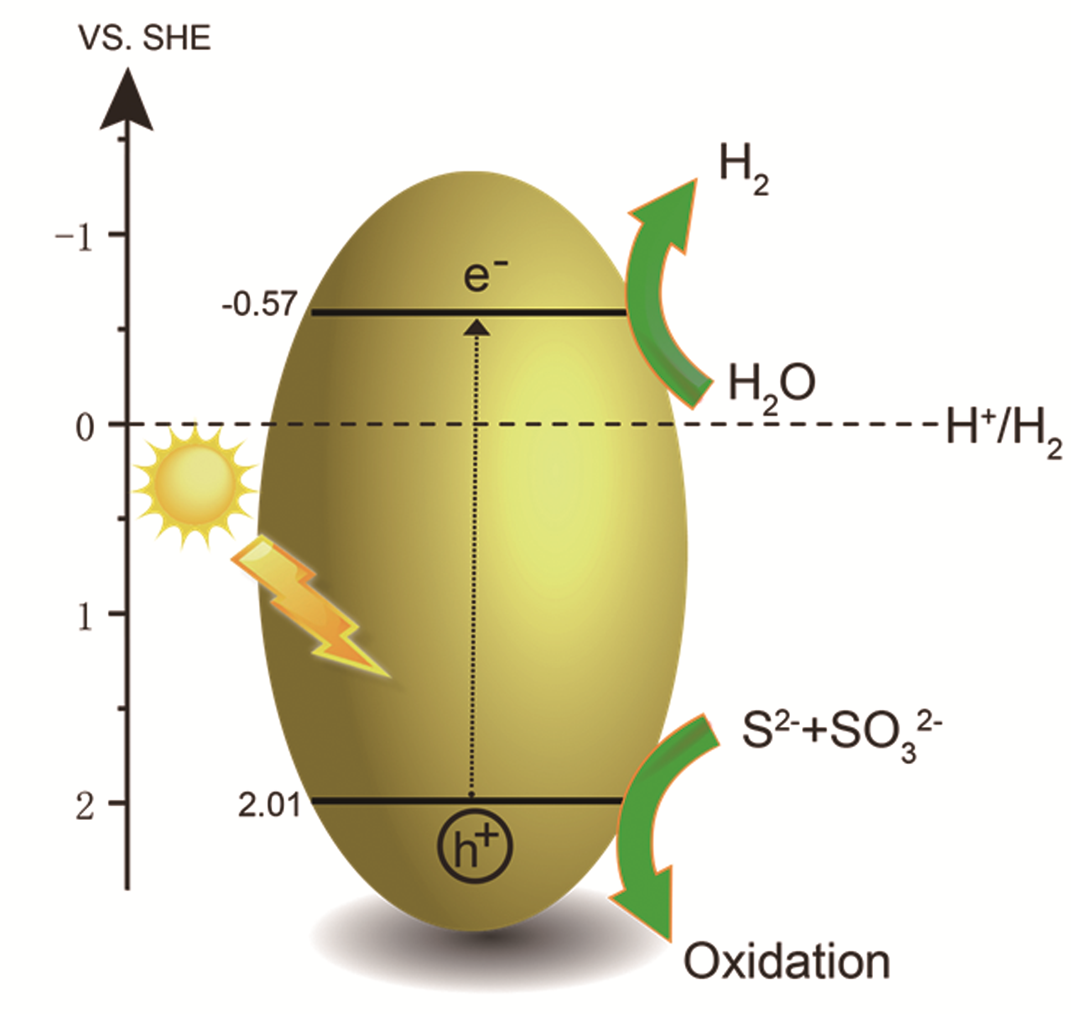
FIG. S5. Plausible reaction mechanism of mesoporous Cd_{x}Zn_{1-x}S polyhedrons for water splitting.
TABLE SI. Comparison of the H₂-generation rates for various photocatalysts under visible light irradiation (300 W Xe).
Photocatalyst | Co-catalyst | Rate of H₂ evolution  (mmol g⁻¹ h⁻¹) | Reference
CSZ3 | - | 4.10 | this work
Zn_{0.4}Cd_{0.6}S | - | 3.62 | [1]
ZnCdS | CoPt₃ | 2.34 | [2]
ZnCdS | Fe_{0.3}Pt_{0.7} | 2.26 | [3]
Zn_{0.5}Cd_{0.5}S | CoP | 0.73 | [4]
Zn_{0.5}Cd_{0.5}S | Pt | 0.36 | [4]

Additional references
1. Z. Mei, M. Zhang, J. Schneider, W. Wang, N. Zhang, Y. Su, B. Chen, S. Wang, A.L. Rogach and F. Pan: Hexagonal Zn1−xCdxS (0.2 ≤ x ≤ 1) solid solution photocatalysts for H2 generation from water. Catal. Sci. Technol. 7, 982 (2017).
2. H. Wang, Y. Li, D. Shu, X. Chen, X. Liu, X. Wang, J. Zhang and H. Wang: CoPtx‐loaded Zn0.5Cd0.5S nanocomposites for enhanced visible light photocatalytic H2 production. Int. J. Energy Res. 40, 1280 (2016).
3. D. Shu, H. Wang, Y. Wang, Y. Li, X. Liu, X. Chen, X. Peng, X. Wang, P. Ruterana and H. Wang: Composition dependent activity of Fe 1−x Pt x decorated ZnCdS nanocrystals for photocatalytic hydrogen evolution. Int. J. Hydrogen Energy. 42, 20888 (2017).
4. D. Dai, H. Xu, L. Ge, C. Han, Y. Gao, S. Li and Y. Lu: In-situ synthesis of CoP co-catalyst decorated Zn 0.5 Cd 0.5 S photocatalysts with enhanced photocatalytic hydrogen production activity under visible light irradiation. Appl. Catal., B. 217, 429 (2017).

a) Address all correspondence to this author. e-mail: kongy36@njtech.edu.cn Tel & Fax: (86)-25-83587860

