Supplementary information

Effect of two-step doping pathway on the morphology, structure, composition and electrochemical performance of three-dimensional N, S-co-doped graphene framework

Mengting Shi^{a†}, Binhong He^{a†}, Minjie Zhouª, Chenxi Xu^{a,b}, Zhengu Chenª, Liang Chen^{*a,b}, Yafei Kuang^{*b}
ªSchool of Chemistry and Chemical Engineering, Hunan Institute of Science and Technology, Yueyang 414006, China
^{b}College of Chemistry and Chemical Engineering, Hunan University, Changsha, 410082, China

*Corresponding authors
E-mail addresses: clvilance@163.com (L. Chen) ;
yafeik@163.com (Y. F. Kuang)

S1. Materials
All reagents (Sinopharm Chemical Reagent Co., Ltd., China) were of analytical grade without further treatment. Ultrapure water was used in this study.
S2. Electrochemical measurement
All electrochemical measurements were conducted in a typical three-electrode system. During the capacitance testing, 6 M KOH was used as electrolyte. Meanwhile, a platinum foil (~1 cm²) and Hg/HgO electrode were adopted as counter electrode and reference electrode, respectively. A homogeneously-distributed suspension containing carbon material, poly(vinylidene difluoride) (PVDF) and conductive additive (carbon black) with mass ratio of 8:1:1 was coated onto a nickel foam (~1 cm²), then utilized as working electrode. Every electrode comprised ~1.5 mg of active material. Cyclic voltammetry (CV) was carried out at different scan rates within a voltage from -1 to 0 V. Galvanostatic charge/discharge (GCD) curves were measured at various current densities varying from 0.5 to 10 A g⁻¹. The electrochemical impedance spectroscopy (EIS) was tested on open circuit potential within frequency range from 0.01 to 100 kHz. The capacitance value of every carbon-based electrode was figured out by the following equation:
$$C=\frac{I×Δt}{m×ΔU}$$
Where C points to capacitance value (F g⁻¹), I refers to current density (A), Δt represents discharge time (s), m is the mass of active material (g), and ΔU stands for voltage window.
For the ORR test, 8 mg of the carbon sample was distributed in distilled water (4 mL) and sonicated for half an hour. 10 μL of the obtained ink was transferred onto the pre-polished glassy carbon electrode (GCE, 5 mm in diameter), then covered by 6 μL of Nafion solution (0.05 wt.%). The ORR tests were also conducted in a three-electrode system on electrochemical workstation (CHI 660E). A platinum foil and an Ag/AgCl electrode filled with saturated KCl solution were utilized as auxiliary electrode and reference electrode, respectively. The ORR activity was tested in oxygen-saturated 0.1 M KOH electrolyte using a rotating disk electrode (RDE, Pine Instrument). The related kinetic parameters were figured out by Koutechy-Levich (K-L) equation:
$$\frac{1}{i}=\frac{1}{i_{k}}+\frac{1}{i_{L}}=\frac{1}{{\text{nFAkC}}_{o}}+\frac{1}{0\text{.}\text{62}{\text{nFAD}}^{\frac{2}{3}}C_{o}υ^{\frac{−1}{6}}ω^{\frac{1}{2}}}$$
Where i represents tested current, i_{k} and i_{L} are kinetic- and limiting- currents, respectively. n refers to electron transfer number during ORR, F is Faraday constant (96485 C mol⁻¹), A is geometric area of RDE, D stands for diffusion coefficient of oxygen in 0.1 M KOH electrolyte (1.9×10⁻⁵ cm² s⁻¹), C₀ is bulk concentration of oxygen (1.2×10⁻³ M), ν is kinetic viscosity of electrolyte (0.01 cm² s⁻¹), ω is angular velocity of RDE (ω=2πN, N is the linear rotation speed) and k is electron transfer rate constant. Cyclic voltammetry (CV) was carried out within a voltage from 0.2 to -1.0 V (vs. Ag/AgCl electrode). Linear sweep voltammetry (LSV) was tested at scan rate of 10 mV s⁻¹ at different rotation speeds from 400 to 1600 rpm.

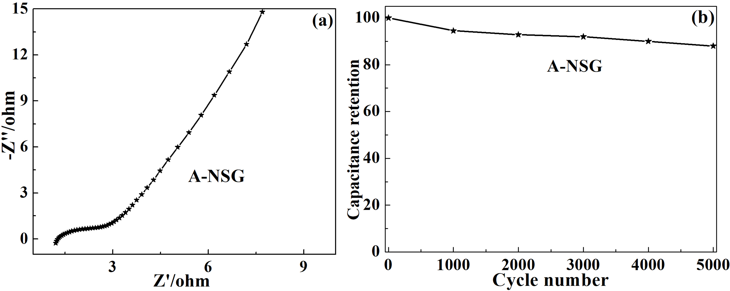
FIG. S1. The Nyquist plot (a) and cycling stability (b) at scan rate of 100 mV s⁻¹ over 5000 cycles for A-NSG

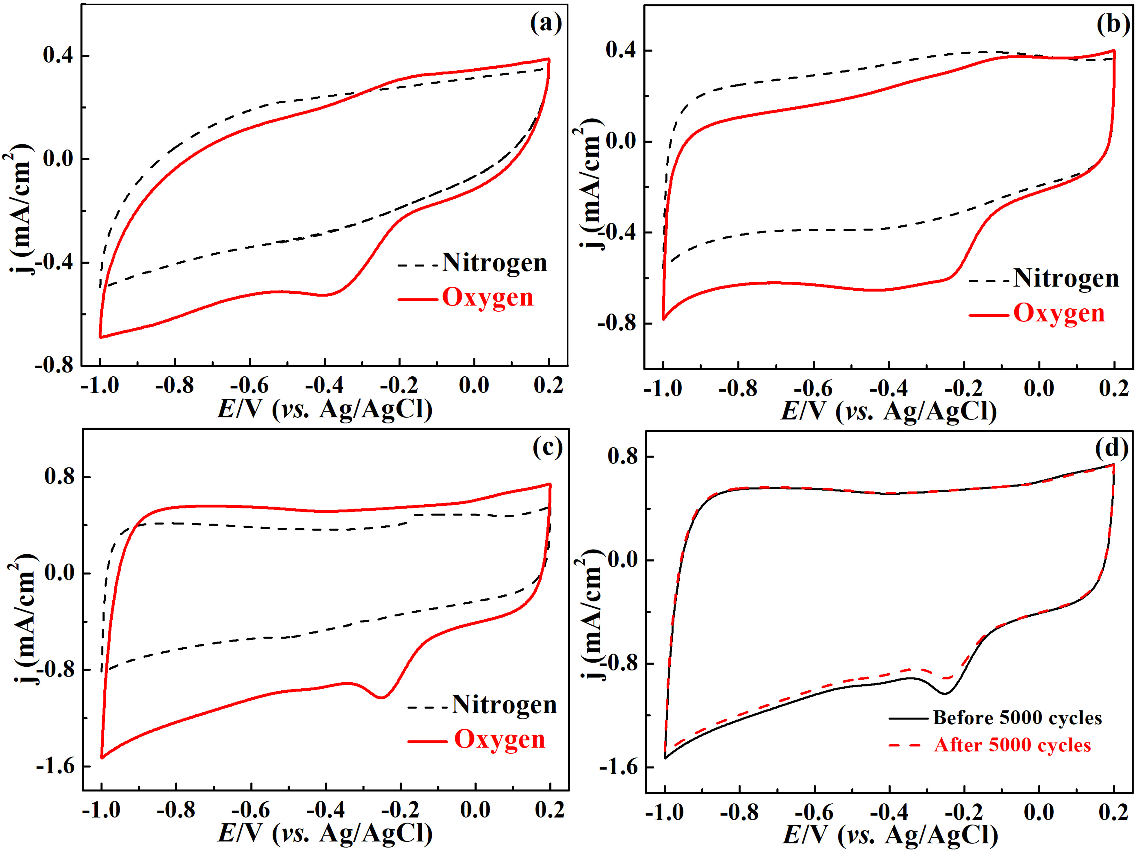
FIG. S2. CV curves on G (a), NSG (b) and A-NSG (c) electrodes in N₂ and O₂ saturated 0.1 M KOH electrolyte at a scan rate of 50 mV s⁻¹; CV curves (d) on A-NSG electrode in O₂ saturated KOH electrolyte before and after 5000 cycles (scan rate: 50 mV s⁻¹)

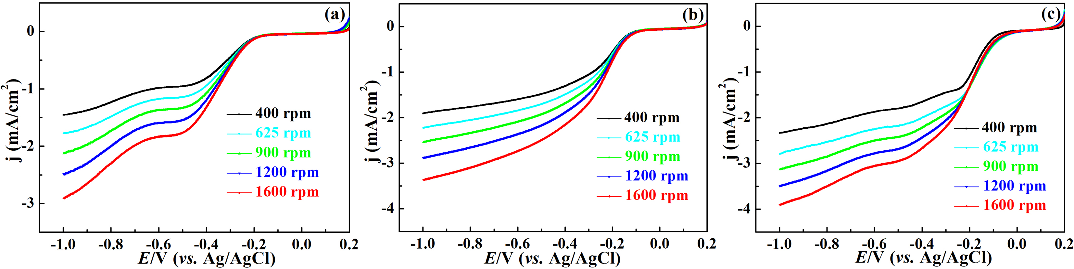
FIG. S3. LSV curves for ORR on G (a), NSG (b) and A-NSG (c) electrodes at different rotation rates

TABLE S Ⅰ. The specific BET results of NSG and A-NSG
Sample | specific surface area/(m²/g) | pore volume/(cm³/g)
NSG | 312 | 0.63
A-NSG | 431 | 0.77

TABLE S Ⅱ. XPS results on the atomic percentages and C/O ratios of NSG and A-NSG
Sample | C/at.% | O/at.% | C/O | N/at.% | S/at.%
NSG | 80.24 | 12.50 | 6.40 | 5.02 | 2.24
A-NSG | 91.33 | 5.13 | 17.80 | 1.97 | 1.57

TABLE S Ⅲ. XPS results on the N and S distributions of NSG and A-NSG
Sample | N distribution (%) |  |  | S distribution (%)
Sample | pyridinic N | pyrolic N | graphitic N | C-S-C | C-SO_{x}-C
NSG | 35.6 | 58.5 | 5.9 | 70.3 | 29.7
A-NSG | 51.2 | 19.9 | 28.9 | 82.8 | 17.2

