Supplementary Material for
The effect of plastic on performance of activated carbon and study on adsorption of methylene blue
Peiyong Maª, Meina Maª, Jinzhou Wuª, Guizhi Qian^{b}, , Dongqiang Wu^{c}, Xianwen Zhang^{b,*}
ª School of Mechanical Engineering, Heifei University of Technology, 193 Tunxi Road, Hefei, 230009, China
^{b} Advanced Energy Technology and Equipment Research Institute, Heifei University of Technology, 193 Tunxi Road, Hefei, 230009, China
^{c} School of Automotive and Transportation Engineering, Heifei University of Technology, 193 Tunxi Road, Hefei, 230009, China
* Corresponding author. Advanced Energy Technology and Equipment Research Institute, Heifei University of Technology, 193 Tunxi Road, Hefei, 230009, China
E-mail sddress: xianwen.zhang@hfut.edu.cn (X. Zhang)
TABLE SⅠ: Peak assignments for the FTIR spectra of the AC sample
Wavenumbers (cm⁻¹) | Infrared absorption
3440 | -OH stretching
1610~1370 | C=O stretching, C=C stretching of aliphatic ketone
1550~1500 | benzene ring
1373 | CH stretching of alkanes
1100~1020 | C-O、C-O-C stretching
860~670 | Out of plane bending of =CH on benzene ring

TABLE SⅡ: Parameters and determination coefficients of the isotherm models for MB adsorption onto AC
Langmuir | Freundlich | Redlich-Peterson | Dubinin-Radushkevich
q_{m} = 472.19 | K_{F} = 309.23 | K_{RP} = 9400.19 | q_{m} = 470.93
K_{L} = 16.63 | n_{F}=10.73 | a_{RP} = 21.92 | K_{DR} = 1.40*10⁻⁸
R_{L} = 0.00007-0.0006 |  | g = 0.9765 | E = 5.97 kJ/mol
R² = 0.9824 | R² = 0.8919 | R² = 0.9894 | R² = 0.9771
Δq (%) = 2.43 | Δq (%) = 4.46 | Δq (%) = 3.56 | Δq (%) = 3.73

TABLE SⅢ: Parameters and determination coefficients of the kinetic models for MB adsorption
 | Initial concentrations (mg/L)
 | 300 | 400 | 500 | 600
q_{e.exp} (mg/g) | 300.02 | 399.21 | 475.90 | 490.64
Pseudo-1st-order
q_{e} (mg/g) | 297.56 | 386.46 | 438.23 | 461.96
k₁ (1/min) | 2.4742 | 1.6730 | 1.4953 | 1.8976
h_{o} (mg/(g.min)) | 736.21 | 646.54 | 655.30 | 876.59
R² | 0.9971 | 0.9852 | 0.9600 | 0.9704
Δq_{e} (%) | 1.70 | 3.87 | 6.30 | 5.56
Pseudo-2st-order
q_{e} (mg/g) | 300.15 | 394.49 | 450.32 | 472.01
k₂ (1/min) | 0.0310 | 0.0093 | 0.0062 | 0.0085
h_{o} (mg/(g.min)) | 2794.35 | 1450.86 | 1253.20 | 1889.03
R² | 0.9994 | 0.9975 | 0.9825 | 0.9875
Δq_{e} (%) | 0.80 | 1.60 | 4.15 | 4.10
Elovich
α (mg/(g.min)) | 1.26*10³¹ | 2.15*10¹² | 5.75*10⁰⁸ | 2.79*10¹¹
β (g/mg) | 0.2486 | 0.0765 | 0.0474 | 0.0587
R² | 0.9963 | 0.9924 | 0.9956 | 0.9971
Δq_{e} (%) | 1.80 | 2.79 | 2.19 | 2.44

TABLE SⅣ: Proximate and ultimate analysis of the SS
Proximate analysis /wt.% (ad) |  |  |  |  | Ultimate analysis /wt.% (ad)
Moisture | Ash | Volatile | Fixed carbon |  | C | H | O | N
9.40 | 3.96 | 73.10 | 13.54 |  | 40.12 | 4.56 | 41.75 | 0.15
Ad: air-dried basis

TABLE SⅤ: Components analysis of the SS
Components analysis /wt.%
cellulose | hemicellulose | lignin
50.64 | 17.50 | 18.73

TABLE SⅥ: Kinetic and Isotherm models
 | Freundlich
 | Langmuir | 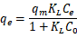
 |  | 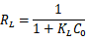
Isotherm | Redlich-Peterson | 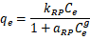
 | Dubinin-Radushkevich
 |  | 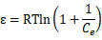
 |  | 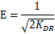
 | Pseudo-first-order
 | Pseudo-second-order | 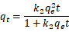
Kinetic
 | Intraparticle diffusion | 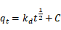
 | Elovich | 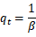

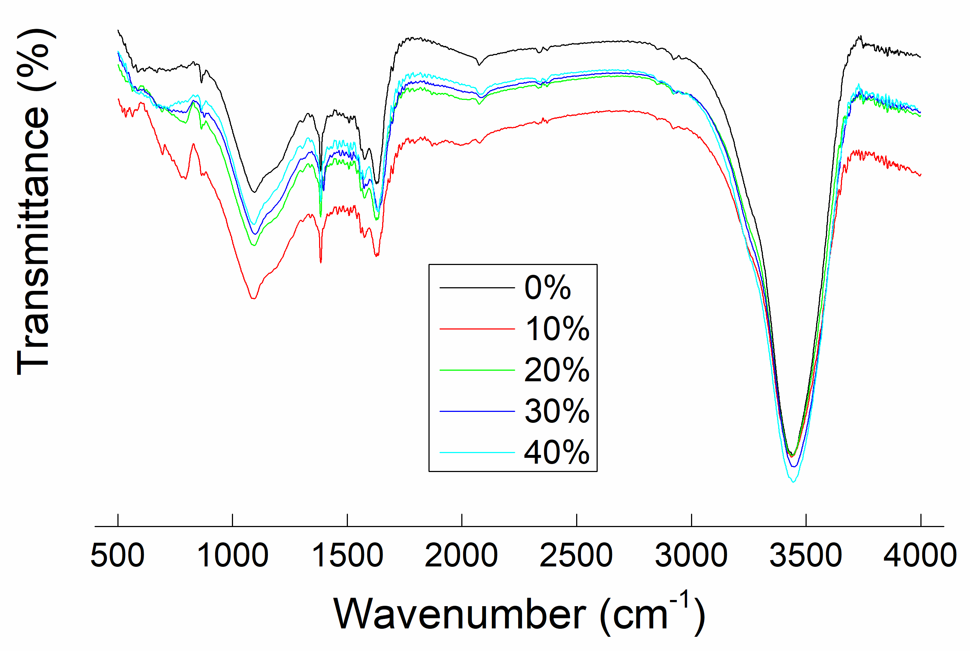
Fig.S1 FTIR spectrum of granular AC with different PP content

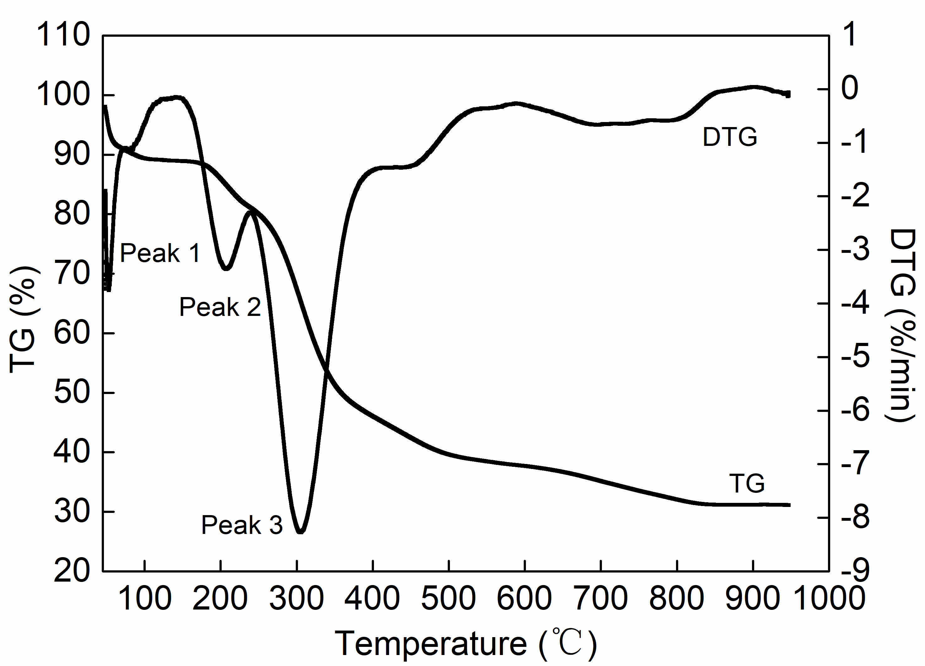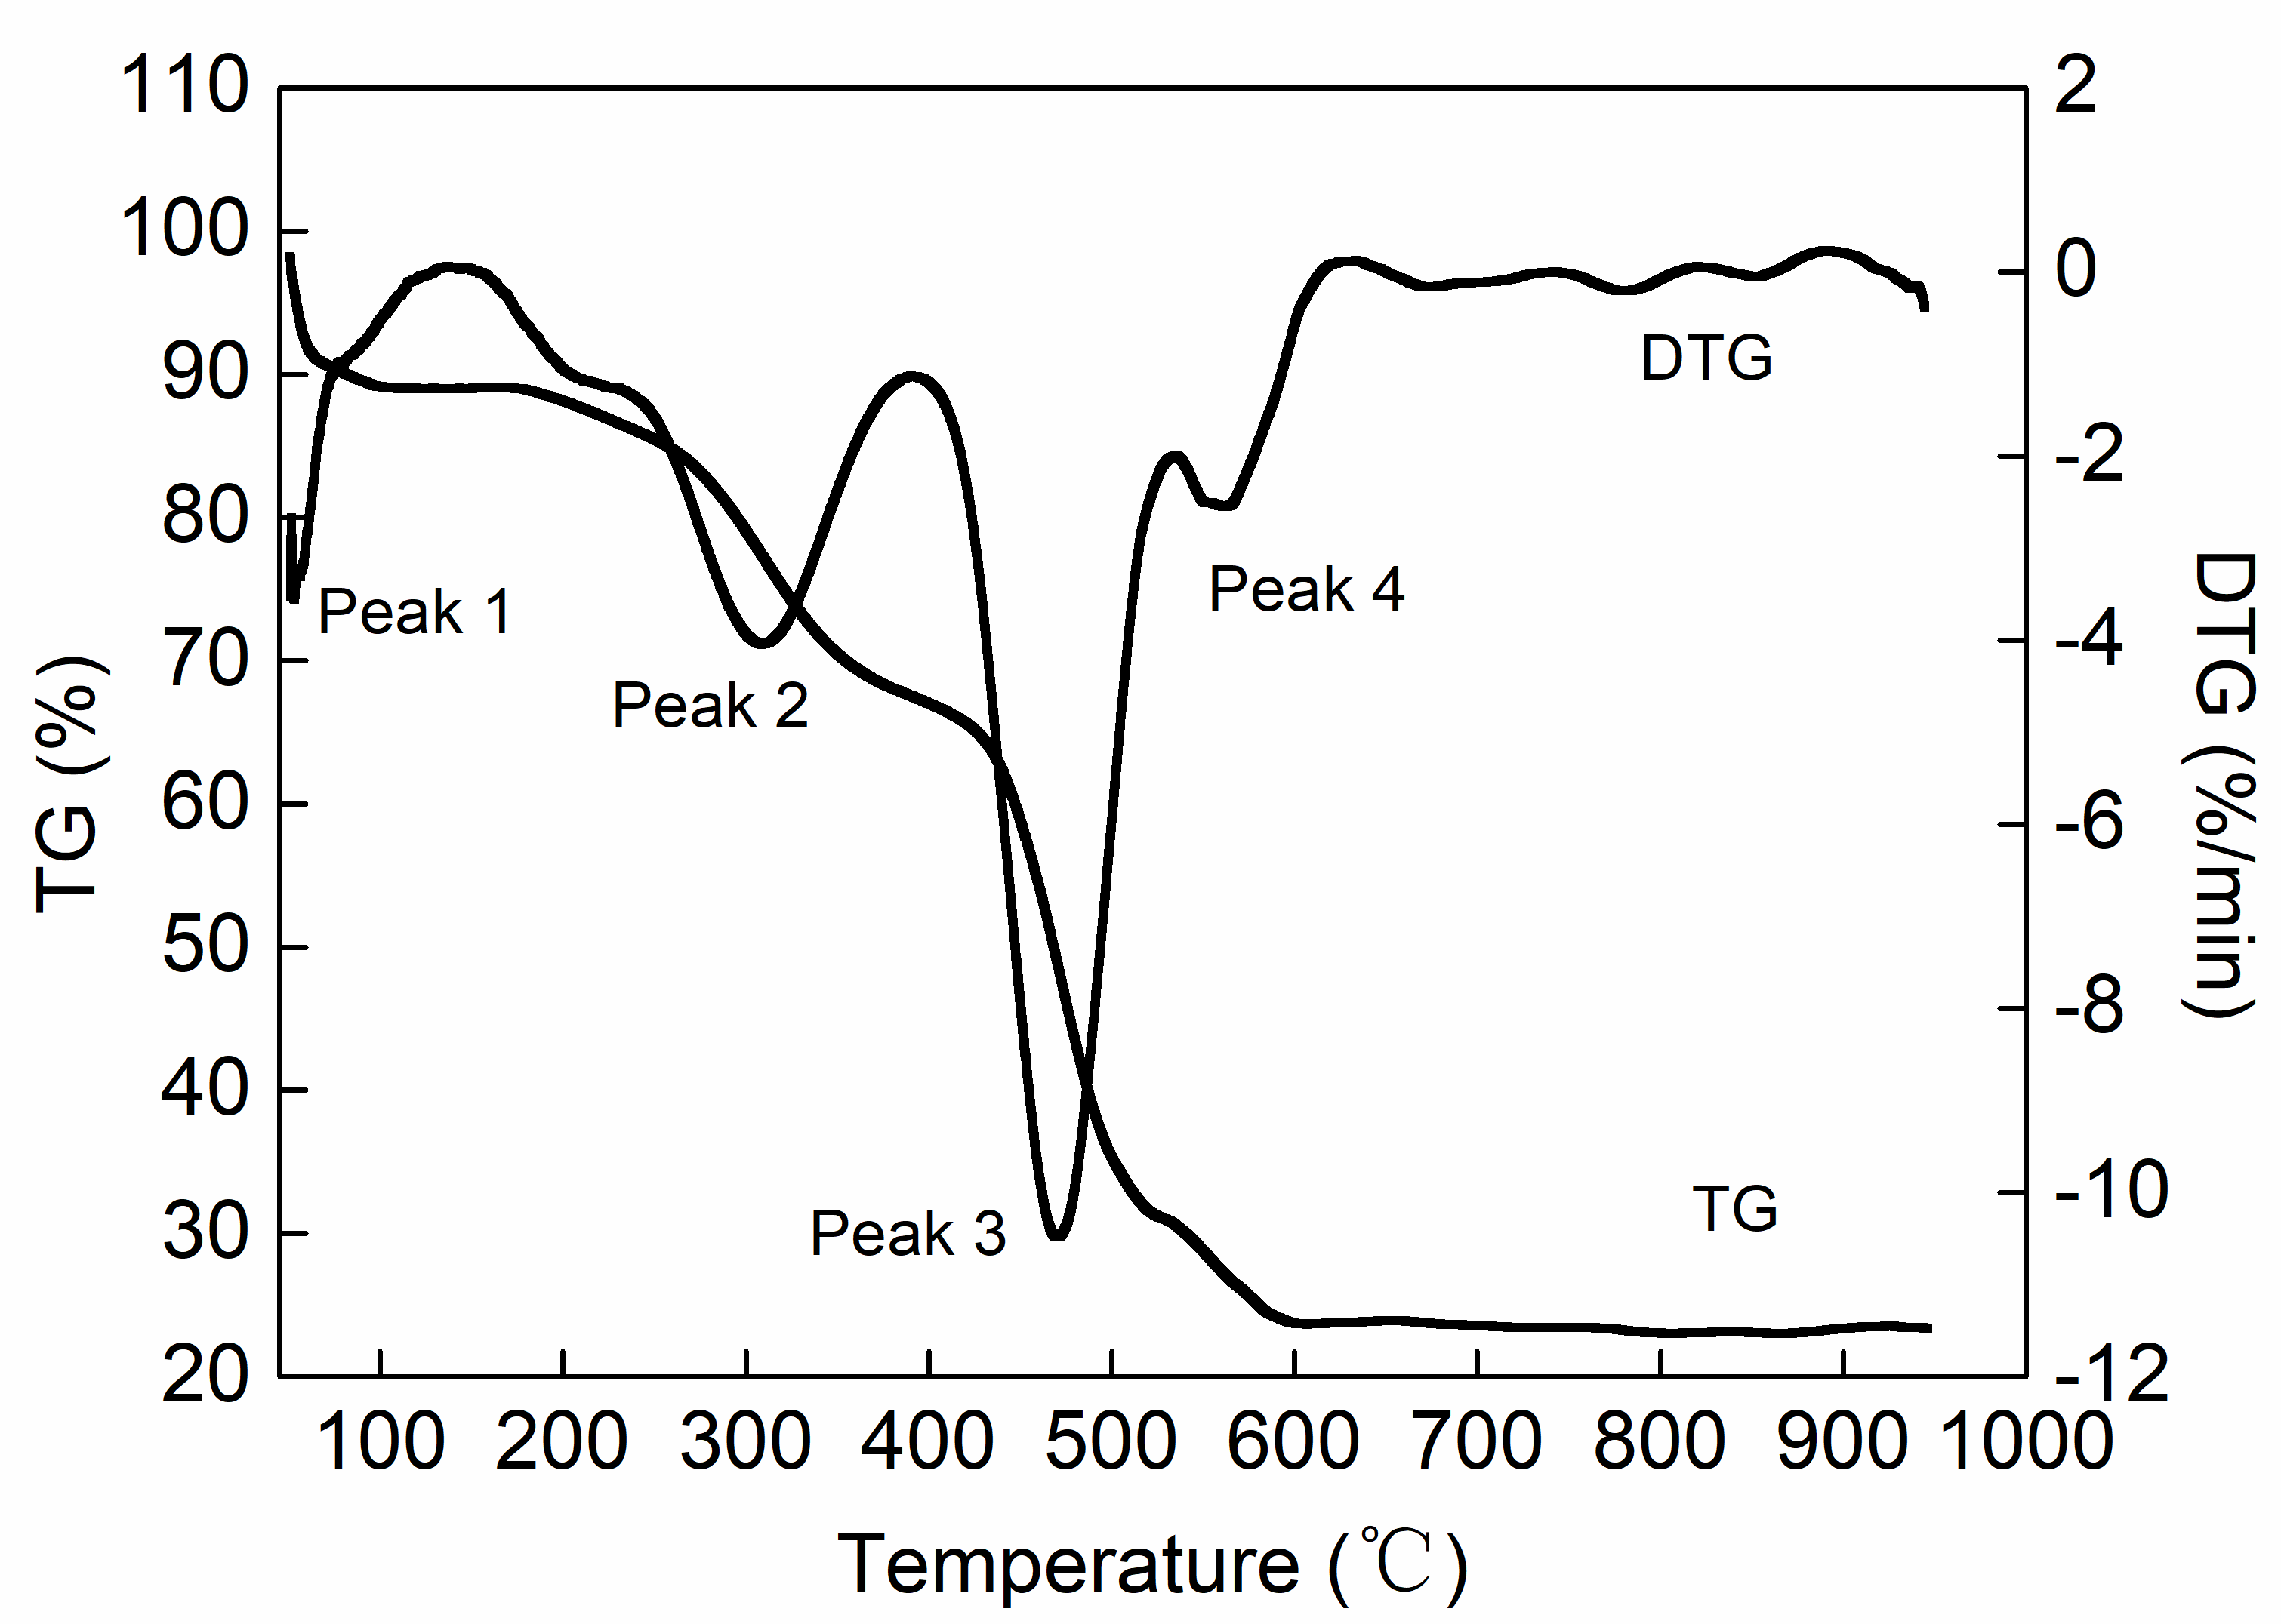
(a) (b)
Fig. S2 The TG-DTG curves of AC. (a) Curve of pure SS. (b) Curve of mixture.

