Supplementary materials

Hierarchical mesoporous Zn-Ni-Co-S microspheres grown on reduced graphene oxide/nickel foam (rGO/NF) for asymmetric supercapacitors.

Uwamahoro Evariste,^{a,b,c} Guohua Jiang,*^{,a,b,c,d} Bo Yu,^{a,b,c} Yongkun Liu,^{a,b,c} Zheng Huang, ^{d} Qiuling Lu,^{d} Pianpian Ma *^{,a,b,c,d}

ª National Engineering Laboratory for Textile Fiber Materials and Processing Technology (Zhejiang), Hangzhou 310018, P. R. China
^{b} Key Laboratory of Advanced Textile Materials and Manufacturing Technology (ATMT), Ministry of Education, Hangzhou 310018, P. R. China
^{c} Institute of Smart Fiber Materials, Zhejiang Sci-Tech University, Hangzhou 310018, P. R. China
^{d} Department of Polymer Engineering, Zhejiang Sci-Tech University, Hangzhou 310018, P. R. China

* Corresponding author. Tel: +86 571 86843527; E-mail address: ghjiang_cn@zstu.edu.cn (G. Jiang) and pianpianma@126.com (P. Ma)
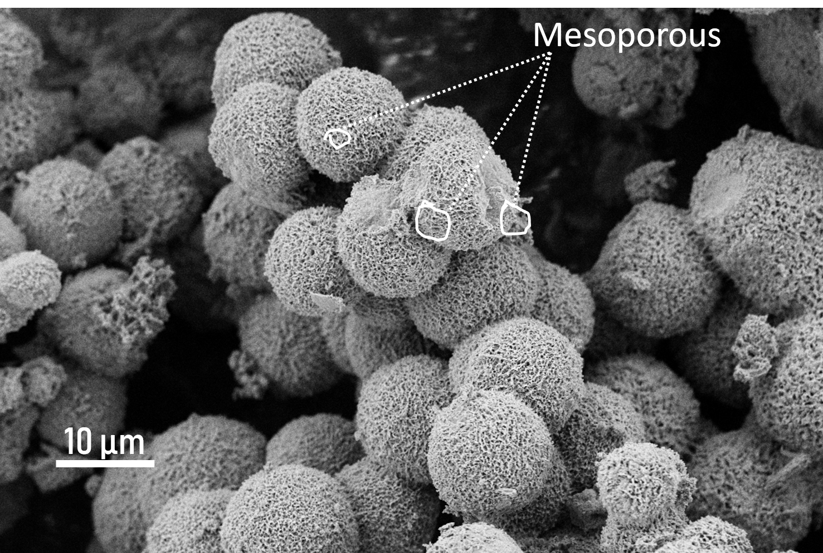
Fig. S1 SEM image showing the porous of the Zn-Ni-Co-S- rGO /NF-3h composites which are essential for electron diffusion.

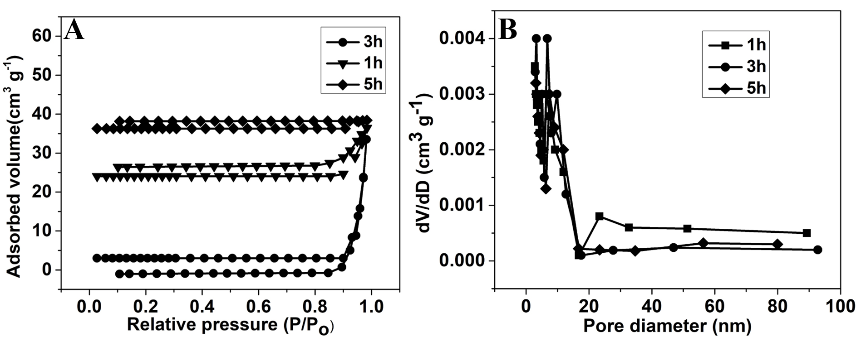

Fig. S2 The surface area and the porous distributions of the Zn-Ni-Co-S- rGO /NF composites.
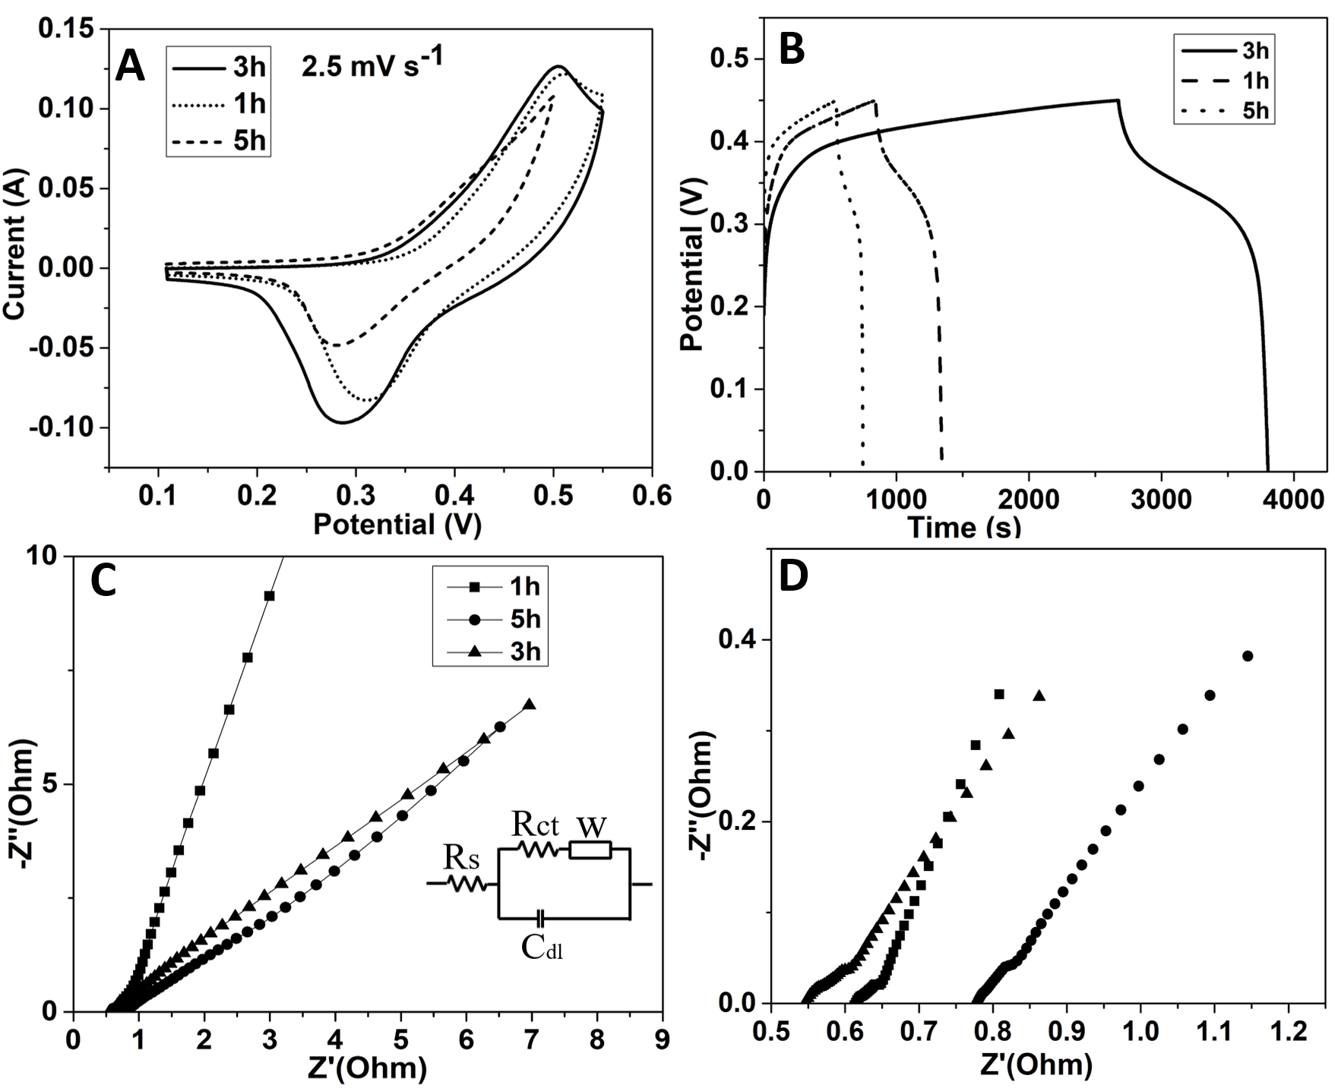
Fig. S3 CV (A), GCD (B), Nyquist plots (C) and HR Nyquist plots (D) of Zn-Ni-Co-S- rGO /NF with sulfurization time at 1h, 3h and 5h.

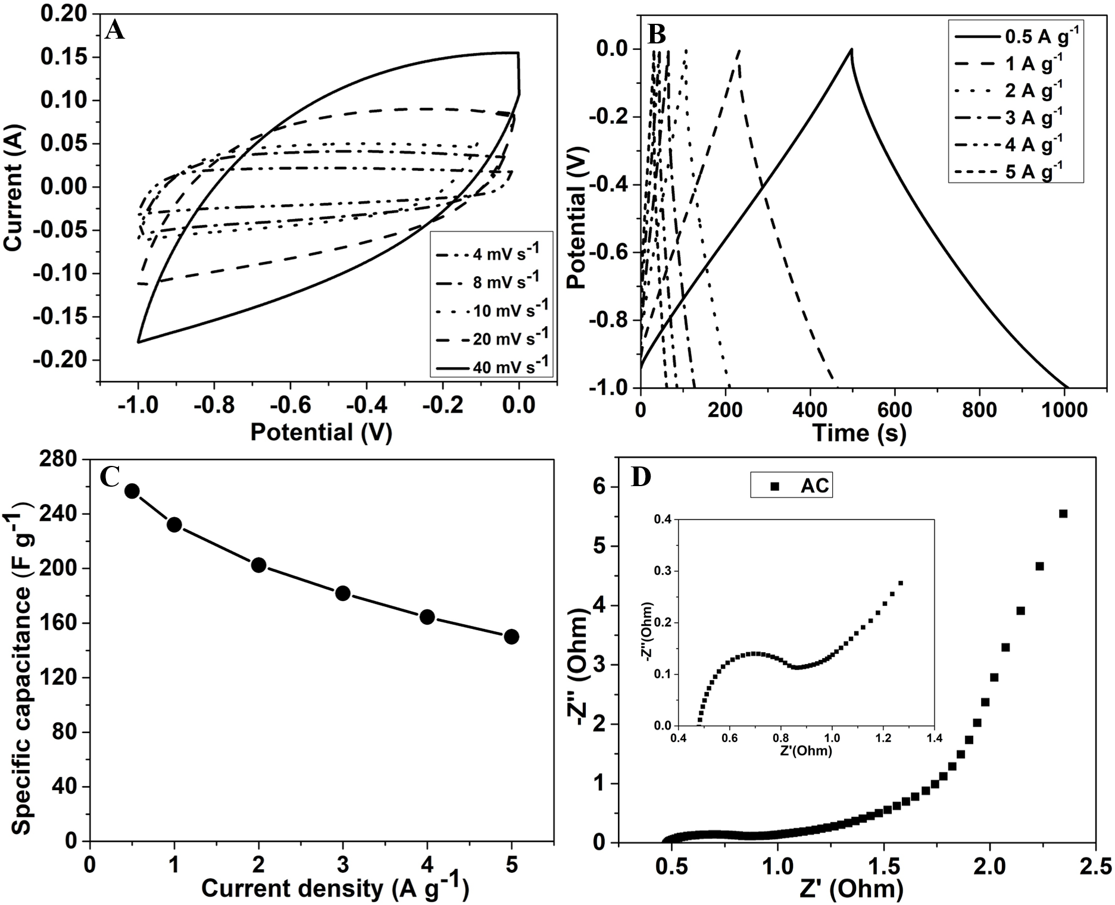
Fig. S4 CV curves of activated carbon (AC) at different scan rates (A). GCD curves (B) and calculated specific capacitance (C) of AC at different current density, Nyquist plots of AC (D).

Based on the all CV curves are an almost rectangular shape from 4 to 40 mV s⁻¹ scan rates demonstrating the good capacitive performance of the AC electrode (Fig.S4A). Fig. S4B shows the GCD curves where the AC electrode displays a high specific capacitance of 256.7 F g⁻¹ at the current density of 0.5 Ag⁻¹ and maintains the specific capacitance of 150 F g⁻¹ at the high current density of 5 Ag⁻¹ as shown in Fig. S4 C, indicating the good stability of the AC electrode. From the EIS Nyquist plots (Fig. S4D), the AC electrode exhibits the small faradic charge transfer resistance (Rct) showing the good electrical conductivity and ion diffusion behavior of the electrode.
Table SI. Electrochemical performance comparison between our electrodes (Zn-Ni-Co-S rGO/NF-3h) with other ternary metal sulfides electrodes.
Electrode | Specific capacitance  (F.g⁻¹) | Current density  (A.g⁻¹) | Electrolyte | Cycle stability | Cycles number | Ref.
Zn-Co-S/NF nanosheet | 2354.3 | 0.5 | 1M KOH | 88.6% | 1000 | [1]
Zn_{0.76}Co_{0.24}S/NGN/CTs film | 2484 | 2 | 2MKOH | 100% | 10000 | [2]
NF/G/Ni-Co-S | 2526 | 2 | 6M KOH | 77% | 2000 | [3]
CNTs@NC@CuCo₂S₄ | 1604 | 2 | 6M KOH | 93.6% | 2000 | [4]
CuCo₂S₄ | 1742 | 10 | 6M KOH | 93.4% | 2000 | [5]
Ni-Co-S@NpCNFs | 520.2 | 0.2 | 3MKOH | 92.6% | 5000 | [6]
NiCo₂S₄@RGO | 2003 | 1 | 2MKOH | 86.0% | 3500 | [7]
Zn-Ni-Co-S-O/NF-3h | 627.7 | 0.25 | 2MKOH | 97.7% | 4000 | This work

Table SII. Comparison of our ASCs device (Zn-Ni-Co-S-O/NF-3h//AC) performance with other based metal sulfides supercapacitors.
ASCs devices | Energy density  (Whkg⁻¹) | Power density  (W kg⁻¹) | Cycle stability | Cycles number | Ref.
NiCo₂S₄/NiS//AC | 43.7 | 160 | 90.3% | 1000 | [8]
Ni-Co-Fe-S@NCAs-NP//rGO-NF | 35.9 | 375 | No reported | - | [9]
MCS/GNF//AC | 14.33 | 74.87 | No reported | - | [10]
Ppy@NiCo₂S₄//N-C | 50.82 | 160 | 126.6% | 2000 | [11]
NiCo₂S₄ (NCS)//CF | 25 | 168 | 90% | 5000 | [12]
NiCo₂S₄Nanosheets/AC | 27.5 | 0.747 | 91.5% | 5000 | [13]
GN-CoMoS₄//AC | 42.84 | 900 | 86.0% | 3500 | [14]
Zn-Ni-Co-S-O/NF//AC | 75.96 | 362.49 | 91.2% | 5000 | This work

References
1. K. Tao, Q. Cheng, Y. Yang, Z. Yang, Q. Ma, and L. Han: A zinc cobalt sulfide nanosheet array derived from a 2D bimetallic metal-organic frameworks for high-performance supercapacitors, Chem. Eur. J. 24, 12584 (2018).
2. H. Tong, S. Yue, Z. Gao, L. Lu, L. Shen, S. Dong, J. Zhu, J. He, and X. Zhang: Zinc cobalt sulfide nanosheets were grown on nitrogen-doped graphene/carbon nanotube film as a high-performance electrode for supercapacitors, J. Mater. Chem. 4, 11256 (2016).
3. P. Miao, Z. Sang, F. Zhang, J. Guo, D. Su, X. Yan, X. Li, and H. Ji: Hydrothermal growth of 3D graphene on nickel foam as a substrate of nickel-cobalt-sulfur for high-performance supercapacitors, Alloys Compd. 732, 613 (2018).
4. R. Jin, S. Gao, S. Zhang, L.Yang, and G. Li: CNTs@NC@CuCo₂S₄ nanocomposites: An advanced electrode for high-performance lithium-ion batteries and supercapacitors, Electrochim. Acta. 43, 273 (2018).
5. C. Liang, Z. Yu, and G. Yanmin: Facile synthesis of ultrathin CuCo₂S₄ nanosheets for high-performance supercapacitors, Int. J. Electrochem. Sci. 13, 1343(2018).
6. Y. Liu, Z. Huang, S. Sun, B. Yu, U. Evariste, G. Jiang, and J. Yao: Electrodeposition of Ni-Co-S nanosheet arrays on N-doped porous carbon nanofibers for flexible asymmetric supercapacitors, Alloys Compd. 301, 762 (2018).
7. F. Wang, Q. Zhou, J. Zheng, C. Yang, and Q. Wang: One-step hydrothermal synthesis of sandwich-type NiCo₂S₄@reduced graphene oxide composite as active electrode material for
Supercapacitors, Appl. Surf. Sci. 425, 180 (2017).
8. R. Xu, J. Wu, M. Huang, L. Fan, X. He, Y. Wang, and Z. Xu: A two-step hydrothermal synthesis approach to synthesize NiCo₂S₄/NiS hollow nanospheres for high-performance asymmetric supercapacitors, Appl. Surf. Sci. 422, 597 (2017).
9. R. Sajad, and H. Hadi: Ternary nickel cobalt iron sulfides ultrathin nanosheets grown on 3-D nickel nanocone arrays-nickel plate current collector as a binder-free electrode for the fabrication of high-performance supercapacitors, J. Electroanal. Chem. 78, 810 (2018).
10. M. Yu, Y. Ma, R. Liu, J. Liu, and S. Li: Nanohoneycomb-like manganese cobalt sulfide/three-dimensional graphene-nickel foam hybrid electrodes for high-rate capability supercapacitors, Appl. Surf. Sci. 396, 1816 (2017).
11. Y. Zheng, X. Yang, Y. Zhang, Y. Shang, and X. Hu: Decoration NiCo₂S₄ nanoflakes onto Ppy nanotubes as core-shell heterostructure material for high-performance asymmetric supercapacitor, Chem. Eng. J. 333, 111 (2018).
12. S. Hussain, M. S. Javed, N. Aslam, N. Shaheen, S. Zhao, W. Zeng, and J. Wang: Amaryllis-like NiCo₂S₄ nanoflowers for high-performance flexible carbon-fiber-based solid-state supercapacitor, Ceram. Int. 42, 11851(2016).
13. L. Liu, H. Rong, and Z. Wang: NiCo₂S₄ nanosheets network supported on Ni foam as an electrode for hybrid supercapacitors, Alloys Compd. 766, 149 (2018).
14. M. Wei, Y. Yao, S. Yu, L Wei, H. Ren, J. Sun, R. Wong, and C. Ping: Toward high-performance all-solid-state supercapacitors using facilely fabricated graphite nanosheet-supported CoMoS₄ as an electrode material, Chem. Eng. J. 355, 891 (2019).

