**Quantitative assessment of degradation, cytocompatibility and *in vivo* bone regeneration of silicon incorporated magnesium phosphate bioceramic**

Vinod Kumar‡,a, Kaushik Sarkar‡,b, K. Bavya Devi b, Debaki Ghosha, Samit Kumar Nandi*a, and Mangal Roy*b

**a**Department of Veterinary Surgery & Radiology, West Bengal University of Animal & Fishery Sciences, Kolkata 700037, India

**b**Department of Metallurgical and Materials Engineering, Indian Institute of Technology- Kharagpur, Kharagpur 721302, India



**FIG.S1.**EDS patterns of magnesium phosphate containing various amount of silicon dopant, (a-d) before immersion and (e-h) after immersion in SBF for 8 weeks.

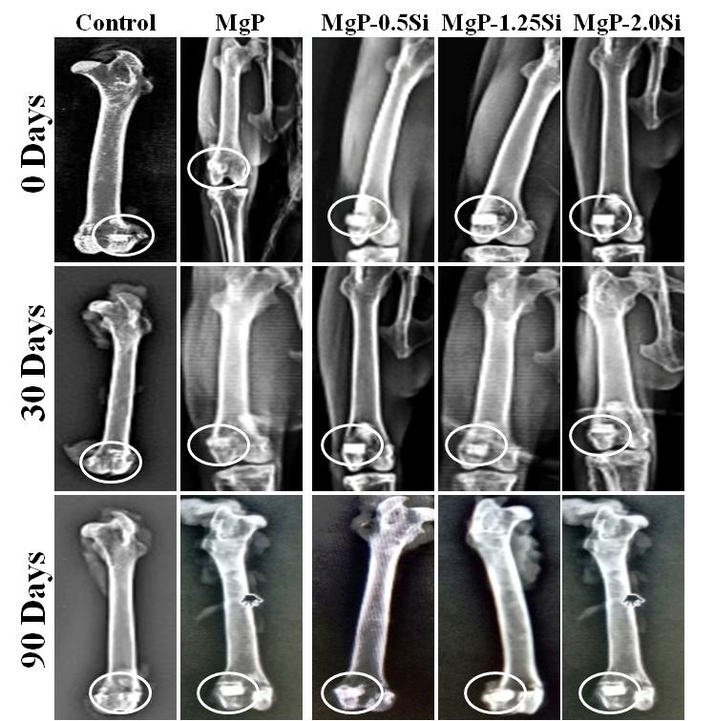

**FIG.S2.** X-ray radiographs of undoped and Si-doped MgP for various time interval (White circle showing the defect site).



**FIG.S3.**Representative SEM images of bone-implant interface of undoped and Si doped MgP after 30 days and 90 days of implantation. Red arrow-showing the interface between the bone and the implant. (Scale bar =100µm)