Supplementary material:
Novel 4ZnO∙B₂O₃∙H₂O:Ln³⁺/HTC (where Ln = Eu or Tb) phosphors: synthesis, morphology and luminescence properties
Lili He, Xiao Han, Chunhua Ge*, Rui Zhang, Yufang Hou, Xiangdong Zhang*
College of Chemistry, Liaoning University, Chongshan Road No. 66, Shenyang 110036, P. R. China
E-mail: chhge@lnu.edu.cn (C. Ge), xd623@sina.com (X.-D. Zhang)

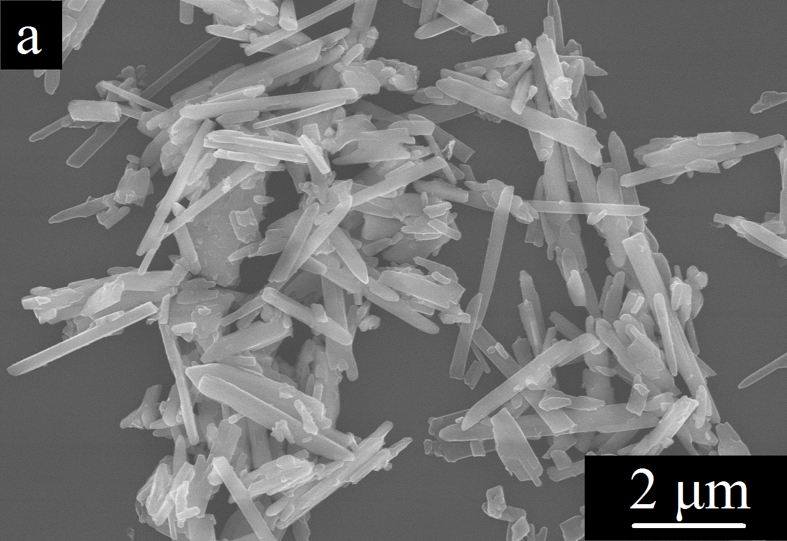
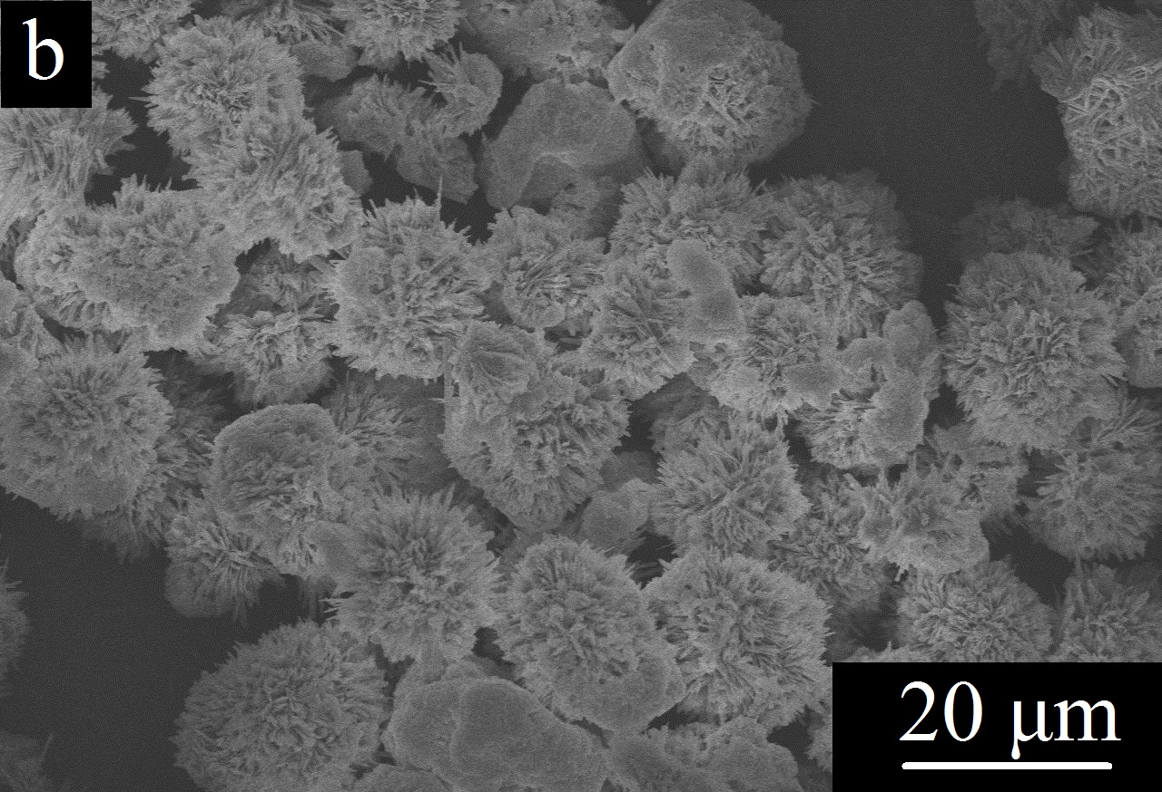
FIG. S1. SEM images of 4ZnO·B₂O₃·H₂O (a) and Zn_{3.64}:Eu_{0.24}[B₂O₇]·H₂O (b).
FIG. S1a shows the SEM images of the 4ZnO·B₂O₃·H₂O sample. It can be seen that 4ZnO·B₂O₃·H₂O exhibits rod-like morphology of different sizes. When Eu³⁺ is doped into 4ZnO·B₂O₃·H₂O lattice, because Eu³⁺ ions replace part of Zn² ⁺, the morphology of the sample changes greatly. When the molar ratio of Zn/Eu is 6.5%, the Zn_{3.64}:Eu_{0.24}[B₂O₇]·H₂O sample exhibits a flower-like morphology, as shown in FIG. S1b [1].

TABLE SI: Zn_{3.64}:Eu_{0.24}[B₂O₇]·H₂O/HTC_{x} samples with various glucose concentrations
samples | Eu/Zn (molar ratio%) | C₆H₁₂O₆ (mmol) | C₆H₁₂O₆ (mol%)
Zn_{3.64}:Eu_{0.24}[B₂O₇]·H₂O/HTC₀ | 6.5 | 0.00 | 0.00
Zn_{3.64}:Eu_{0.24}[B₂O₇]·H₂O/HTC_{5.97} | 6.5 | 0.55 | 5.97
Zn_{3.64}:Eu_{0.24}[B₂O₇]·H₂O/HTC_{11.27} | 6.5 | 1.10 | 11.27
Zn_{3.64}:Eu_{0.24}[B₂O₇]·H₂O/HTC_{16.01} | 6.5 | 1.65 | 16.01
Zn_{3.64}:Eu_{0.24}[B₂O₇]·H₂O/HTC_{20.26} | 6.5 | 2.20 | 20.26
Zn_{3.64}:Eu_{0.24}[B₂O₇]·H₂O/HTC_{24.10} | 6.5 | 2.75 | 24.10
Zn_{3.64}:Eu_{0.24}[B₂O₇]·H₂O/HTC_{27.59} | 6.5 | 3.30 | 27.59
Zn_{3.64}:Eu_{0.24}[B₂O₇]·H₂O/HTC_{30.78} | 6.5 | 3.85 | 30.78

TABLE SII: Zn_{3.55}:Tb_{0.3}[B₂O₇]·H₂O/HTC_{y} samples with various glucose concentrations
samples | Tb/Zn (molar ratio%) | C₆H₁₂O₆ (mmol) | C₆H₁₂O₆ (mol%)
Zn_{3.55}:Tb_{0.3}[B₂O₇]·H₂O/HTC₀ | 8.5 | 0.00 | 0.00
Zn_{3.55}:Tb_{0.3}[B₂O₇]·H₂O/HTC_{5.99} | 8.5 | 0.55 | 5.99
Zn_{3.55}:Tb_{0.3}[B₂O₇]·H₂O/HTC_{11.30} | 8.5 | 1.10 | 11.30
Zn_{3.55}:Tb_{0.3}[B₂O₇]·H₂O/HTC_{16.04} | 8.5 | 1.65 | 16.04
Zn_{3.55}:Tb_{0.3}[B₂O₇]·H₂O/HTC_{20.30} | 8.5 | 2.20 | 20.30
Zn_{3.55}:Tb_{0.3}[B₂O₇]·H₂O/HTC_{24.15} | 8.5 | 2.75 | 24.15
Zn_{3.55}:Tb_{0.3}[B₂O₇]·H₂O/HTC_{27.64} | 8.5 | 3.30 | 27.64
Zn_{3.55}:Tb_{0.3}[B₂O₇]·H₂O/HTC_{30.83} | 8.5 | 3.85 | 30.83
Zn_{3.55}:Tb_{0.3}[B₂O₇]·H₂O/HTC_{33.75} | 8.5 | 4.40 | 33.75

TABLE SIII: ICP analysis results of the Zn_{3.64}:Eu_{0.24}[B₂O₇]·H₂O/HTC_{x} samples.
samples | Cal (Eu/Zn) (molar ratio%) | Exp (Eu/Zn) (molar ratio%)
Zn_{3.64}:Eu_{0.24}[B₂O₇]·H₂O/HTC₀ | 6.5 | 6.30
Zn_{3.64}:Eu_{0.24}[B₂O₇]·H₂O/HTC_{5.97} | 6.5 | 6.32
Zn_{3.64}:Eu_{0.24}[B₂O₇]·H₂O/HTC_{11.27} | 6.5 | 6.28
Zn_{3.64}:Eu_{0.24}[B₂O₇]·H₂O/HTC_{16.01} | 6.5 | 6.31
Zn_{3.64}:Eu_{0.24}[B₂O₇]·H₂O/HTC_{20.26} | 6.5 | 6.34
Zn_{3.64}:Eu_{0.24}[B₂O₇]·H₂O/HTC_{24.10} | 6.5 | 6.30
Zn_{3.64}:Eu_{0.24}[B₂O₇]·H₂O/HTC_{27.59} | 6.5 | 6.29
Zn_{3.64}:Eu_{0.24}[B₂O₇]·H₂O/HTC_{30.78} | 6.5 | 6.31

TABLE SIV: ICP analysis results of the Zn_{3.55}:Tb_{0.3}[B₂O₇]·H₂O/HTC_{y} samples.
samples | Cal (Tb/Zn) (molar ratio%) | Exp (Tb/Zn) (molar ratio%)
Zn_{3.55}:Tb_{0.3}[B₂O₇]·H₂O/HTC₀ | 8.5 | 8.34
Zn_{3.55}:Tb_{0.3}[B₂O₇]·H₂O/HTC_{5.99} | 8.5 | 8.30
Zn_{3.55}:Tb_{0.3}[B₂O₇]·H₂O/HTC_{11.30} | 8.5 | 8.33
Zn_{3.55}:Tb_{0.3}[B₂O₇]·H₂O/HTC_{16.04} | 8.5 | 8.36
Zn_{3.55}:Tb_{0.3}[B₂O₇]·H₂O/HTC_{20.30} | 8.5 | 8.34
Zn_{3.55}:Tb_{0.3}[B₂O₇]·H₂O/HTC_{24.15} | 8.5 | 8.31
Zn_{3.55}:Tb_{0.3}[B₂O₇]·H₂O/HTC_{27.64} | 8.5 | 8.32
Zn_{3.55}:Tb_{0.3}[B₂O₇]·H₂O/HTC_{30.83} | 8.5 | 8.32
Zn_{3.55}:Tb_{0.3}[B₂O₇]·H₂O/HTC_{33.75} | 8.5 | 8.33

References
[1] S.W. Cao, Y. Jiao, W.F. Han, C.H. Ge, B. Song, J. Wang , and X.D. Zhang: Hydrothermal synthesis of 4ZnO·B₂O₃·H₂O:Ln³⁺ (Ln = Eu, Tb) phosphors: Morphology-tunable and luminescence properties. Spectrochim. Acta, Part A 190, 231 (2018).

