Supplementary Information
Modified triazine-based carbon nitride as a high efficiency fluorescence sensor for the label-free detection of Ag⁺

Liying Hao, ^{a, b} Hongjie Song,^{*a} Yi Lv, ^{c}
ª Key Laboratory of Green Chemistry & Technology, Ministry of Education, College of Chemistry, Sichuan University, Chengdu, 610064, China
^{b} State Key Laboratory of Oral Diseases, National Clinical Research Center for Oral Diseases, West China Hospital of Stomatology, Sichuan University, Chengdu 610041, China
^{c}Analytical & Testing Center, Sichuan University, Chengdu, Sichuan 610064, China

*Correspondence Author: Hongjie Song
E-mail: songhj@scu.edu.cn

FIG. S1. Schematic illustration of two kinds of structure of g-C₃N₄. The background color stands for the fluorescence emission color.
Characterization of the triazine-based g-C₃N₄
The morphologies of triazine-based g-C₃N₄ were characterized by SEM and AFM. As shown in Fig.S2a-c, the change of morphology of triazine-based g-C₃N₄ was obviously observed. After HNO₃treatment, tri-C₃N₄ displayed loose porous network (Fig. S2b) rather than the “stone-like” block structure of the primal tri-C₃N₄ (Fig. S2a). Interestingly, the porous network was peeled into nanoparticles (Fig. S2c). Therefore, AFM was used to observe the micro morphology of tri-HC₃N₄ nanoparticles. As shown in Fig. S2d, tri-HC₃N₄ was exfoliated to thin nanosheets about 50 nm with the height of 30 nm, which was helpful to enhance water solubility of triazine-based g-C₃N₄.
FIG. S2. SEM images of tri-C₃N₄ (a), tri-C₃N₄ treated with concentrated nitric acid (b), and SEM (c) and AFM (d) images of tri-HC₃N₄.
Meanwhile, FTIR was used to characterize the functional groups of tri-C₃N₄ before and after treatment. As shown in Fig. S3a, the characteristic peaks at 3140 and 3280 cm⁻¹, and 811cm⁻¹ of the triazine-based g-C₃N₄ were observed clearly, correspondingto stretching modes of N-H, and the bending vibration of triazine units, respectively, which was similar to the previous report^{1,2}. After the modification, the intensity of the peak at 1600 cm⁻¹ of tri-HC₃N₄ increased compared with that of tri-C₃N₄, indicated oxygen functional groups increased because of the modification³. Additionally, the increase in oxygen functional groups was further confirmed by XPS results. As shown in Fig. S3b, the oxygen content of tri-HC₃N₄ was clearly increased compared with that of tri-C₃N₄, which indicated the oxygen functional groups were successfully introduced.
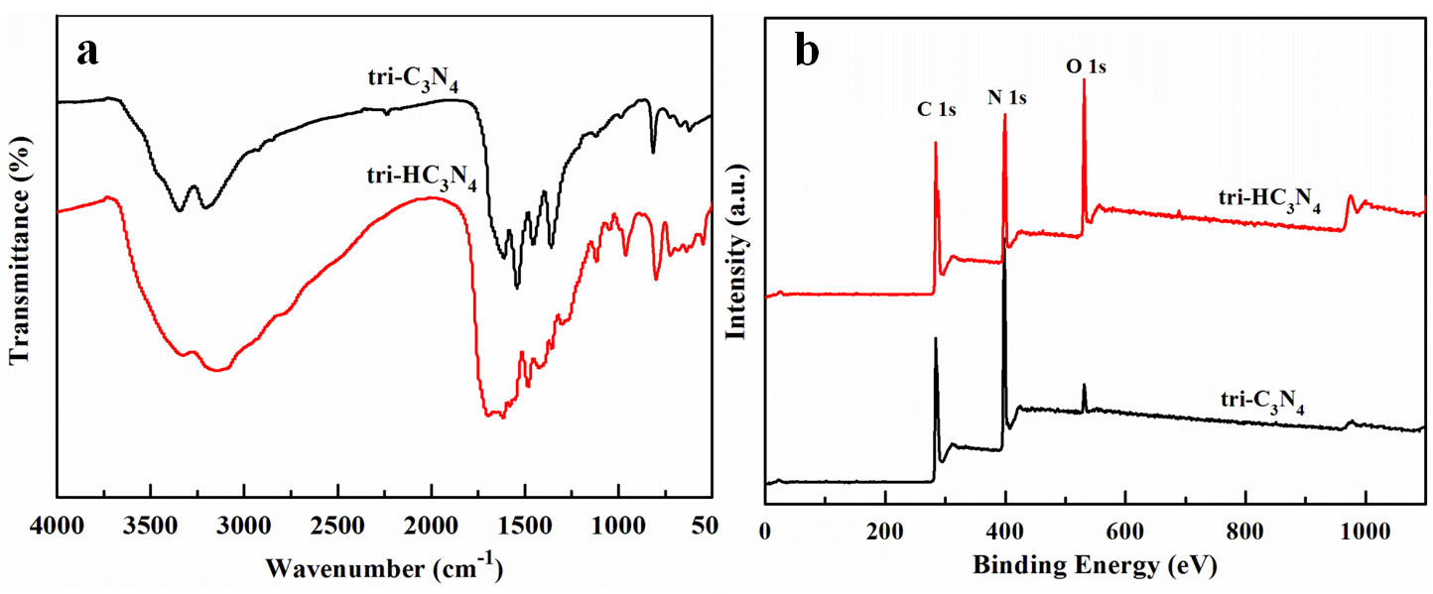
FIG. S3. FTIR spectra (a) and XPS survey spectra (b) of tri-C₃N₄ and tri-HC₃N₄.
FIG. S4. Time-dependent fluorescence intensity of tri-HC₃N₄ with the different excitation time.
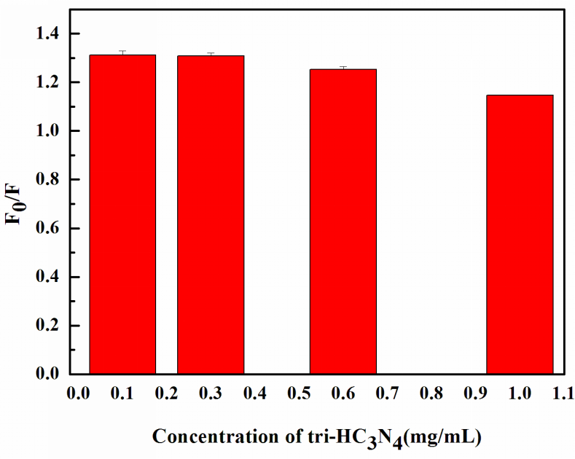
FIG. S5. Effect of the concentration of tri-HC₃N₄ on detection of Ag⁺ with 1.0 µM.
FIG. S6. The Lineweaver-Burk (a) and Stern-Volmer curves (b) of tri-HC₃N₄ and the concentrations of Ag⁺.
FIG. S7. UV-Vis spectra of tri-HC₃N₄ and tri-HC₃N₄ with 1.00 μM of Ag⁺.
FIG. S8. Cell viability of L929 cells with different concentrations of tri-HC₃N₄ for 24 h, 48 h and 72 h, respectively.

References
- L. Li, D. Deng, S. Huang, H. Song, K. Xu, L. Zhang, Y. Lv: UV-assisted cataluminescent sensor for carbon monoxide based on oxygen-functionalized g-C₃N₄ nanomaterials. Anal. Chem. 90, 9598 (2018).
- W. Zhu, H. Song, Y. Lv: Triazine-based graphitic carbon nitride: controllable synthesis and enhanced cataluminescent sensing for formic acid. Anal. Bioanal. Chem. 410, 17266 (2018).
- Q. Huang, L.Y. Hao, R. H. Zhou, B. F. Zhu, H. Zhao, X. X. Cai: Synthesis, Characterization, and Biological Study of Carboxyl- and Amino-Rich g-C3N4 Nanosheets by Different Processing Routes. J. Biomed. Nanotechnol. 14, 2114 (2018).

