Supporting information

From Prussian blue to iron carbides: High-temperature XRD monitoring of thermal transformation under inert gases

Claudia Aparicio, Jan Filip, and Libor Machala

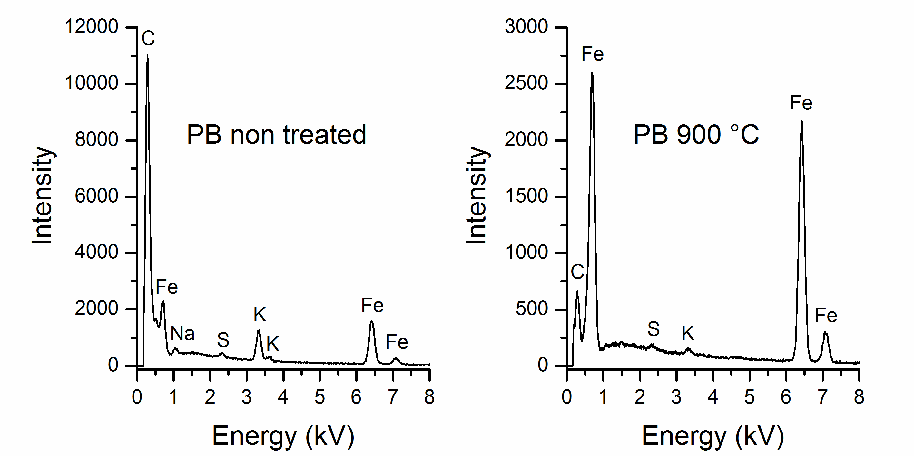

Figure S1. Elemental analysis by EDS of Prussian blue before thermal treatment (left), and after heating up to 900 °C in argon atmosphere (right). The data were collected using an electron beam voltage of 15 kV.

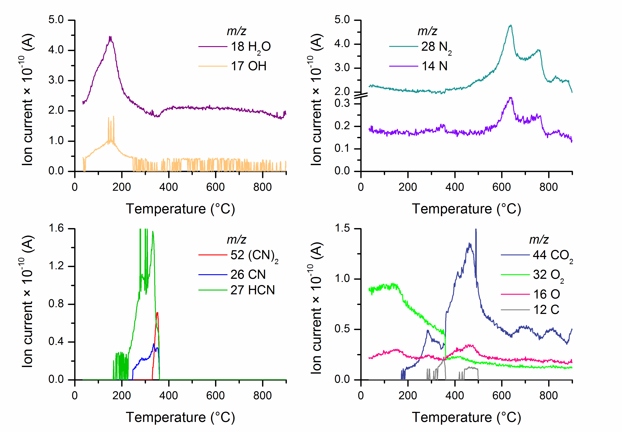

Figure S2. Gases evolved during the thermal decomposition of PB.

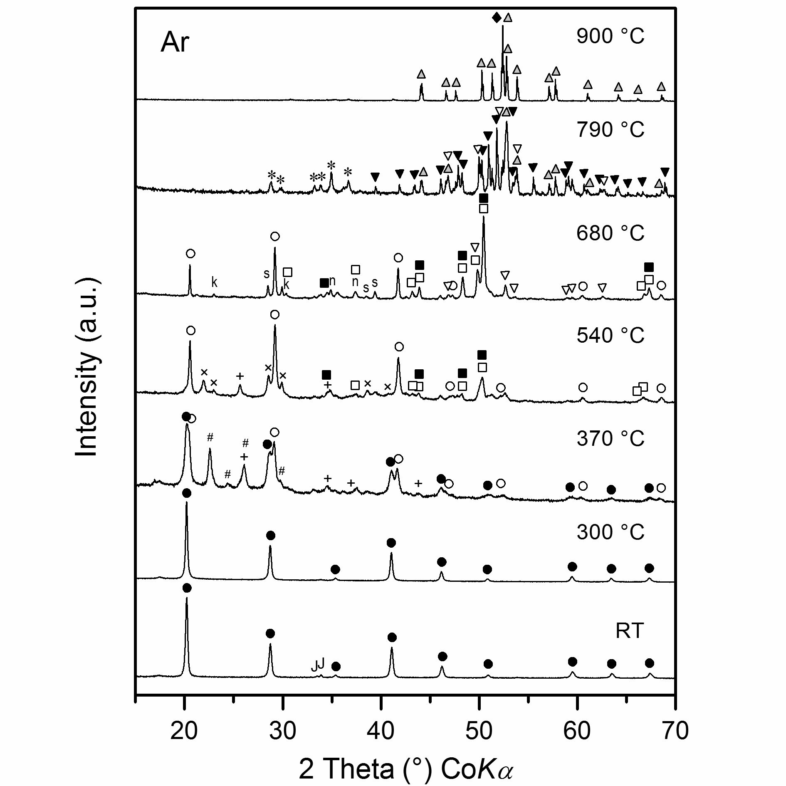

Figure S3. XRD patterns of samples heated up to selected temperatures under Ar. The symbols represent the identified phases: Jarosite (J), Fe₄[Fe(CN)₆]₃ (), Fe₂[Fe(CN)₆] (), Fe_{2+x}C (), Fe₂C (), Fe₇C₃ (), Fe₂C₅ (), Fe₃C (), α-Fe⁰ (), Urea (+), Malic acid (#), oxydiacetic acid (×), S₃N₂O₂ (s), K(HSO₄)(H₂SO₄) (k), Na(NaO₂) (n), K₄Fe(CN)₆ (*).

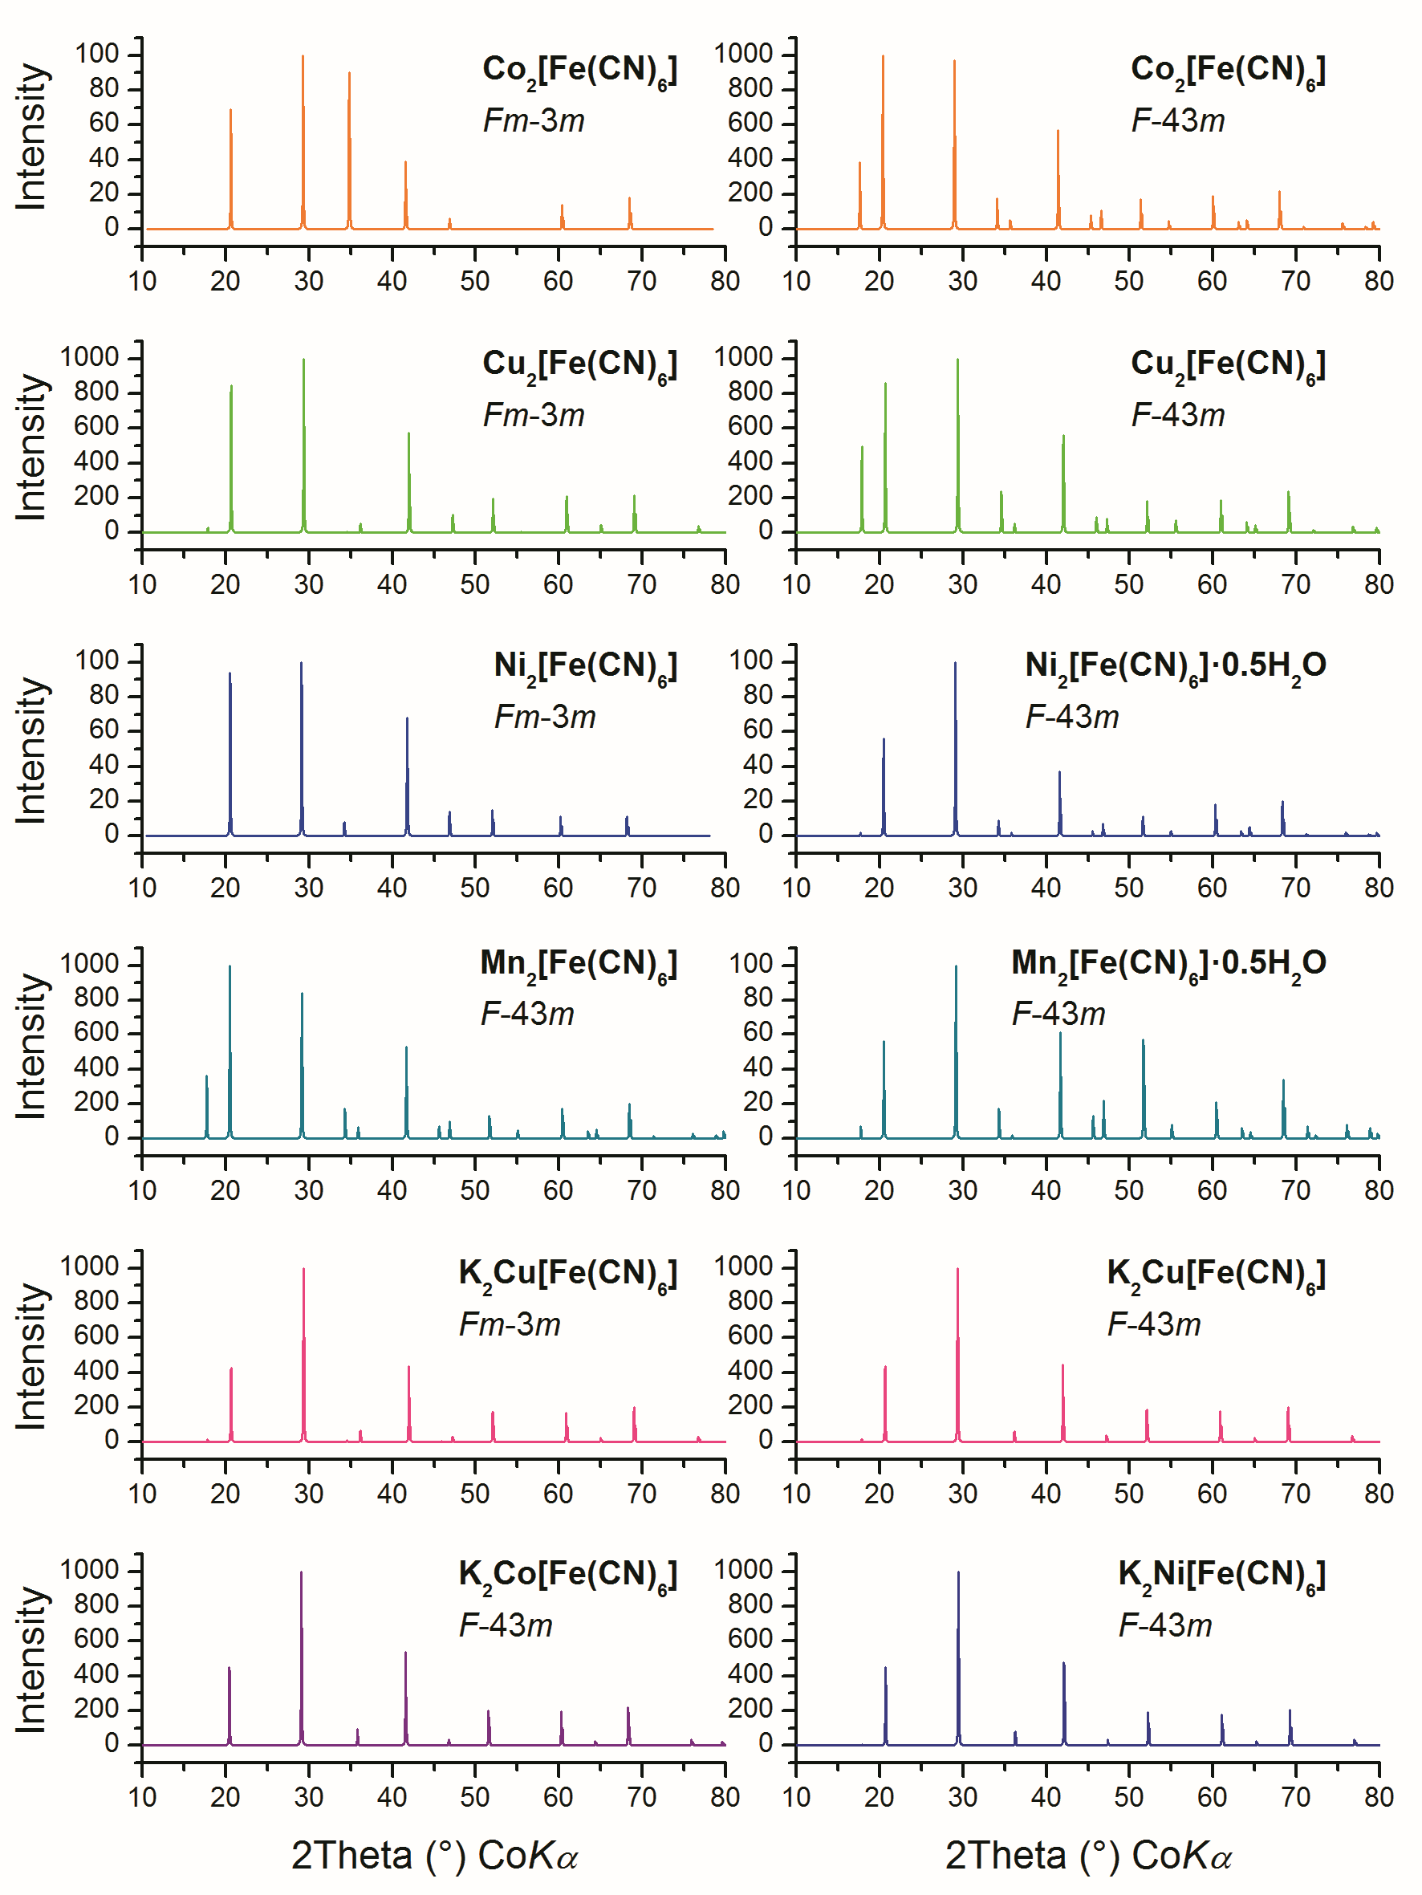

Figure S4. Diffraction patterns of selected ferrocyanide compounds, which crystallize in the cubic system. The diffraction patterns were simulated from the PDF cards listed in Table S1.

Table S1. Complementary information for the selected ferrocyanide compounds with cubic crystal structure shown in Fig. S4.

Ferrocyanide compound | Space group | Unit-cell parameter (Å) | PDF card | Reference
Co₂[Fe(CN)₆] |  | 10.05 | 00-057-0048 | 1
Co₂[Fe(CN)₆]* |  | 10.12(5) | 01-075-0039 | 2
Cu₂[Fe(CN)₆] |  | 10.014(3) | 01-070-2703 | 3
Cu₂[Fe(CN)₆] |  | 9.998(5) | 04-010-1961 | 4
Ni₂[Fe(CN)₆] |  | 10.05 | 00-057-0049 | 1
Ni₂[Fe(CN)₆]∙0.5H₂O |  | 10.077(5) | 00-046-0908 | 5
Mn₂[Fe(CN)₆] |  | 10.061(4) | 04-008-9478 | 6
Mn₂[Fe(CN)₆]∙0.5H₂O |  | 10.061(4) | 00-046-0910 | 5
K₂Cu[Fe(CN)₆]* |  | 9.99(5) | 04-010-1963 | 4
K₂Cu[Fe(CN)₆]* |  | 9.99(5) | 01-075-0023 | 4
K₂Co[Fe(CN)₆]* |  | 10.08(5) | 01-075-0038 | 2
K₂Ni[Fe(CN)₆]* |  | 9.96(5) | 01-075-0036 | 2
Note: The unit-cell parameters of the compounds marked with asterisk (*) were calculated from single crystals.
- Tatarintseva, T.B., Mikhailov, O.V., Naumkina, N.I., and Lygina, T.Z., (2003). “Electrophilic Substitution Co(II)→M(II) (M = Mn, Ni, Cu, Zn, Cd) in Co₂[Fe(CN)₆] Gelatin-Immobilized Matrices,” Russ. J. Coord. Chem., 29(2), 115–122.
- Rigamonti, R., (1938). “Struttura e costituzione chimica di alcuni ferrocianuri,” R. Gazz. Chim. Ital., 68, 803–809.
- Ayrault, S., Jimenez, B., Garnier, E., Fedoroff, M., Jones, D.J., and Loos-Neskovic, C. J., (1998). “Sorption Mechanisms of Cesium on Cu^{II}₂Fe^{II}(CN)₆ and Cu^{II}₃[Fe^{III}(CN)₆]₂ Hexacyanoferrates and Their Relation to the Crystalline Structure,” J. Solid State Chem., 141, 475–485.
- Rigamonti, R., (1937), “Struttura dei cupriferrocianuri: Note I. Ferrocianuro di rame e ferrocianuri di rame e potassio,” R. Gazz. Chim. Ital., 67, 137–146.
- Ratuszna, A., Juszczyk, S., and Małecki, G., (1995). “Crystal structure of the three-dimensional magnetic networkof type Me_{k}[Fe(CN)₆]_{l}. mH₂O, where Me=Cu, Ni, Co,” Powder Diff., 10(4), 300–305.
- Juszczyk, S., Johansson, C., Hanson, M., Ratuszna, A., and Małecki, G., (1994). “Structural and magnetic properties of Me₂[Fe(CN)₆] compounds, where Me are 3d transition metals,” J. Magn, Magn. Mater., 138, 281–286.

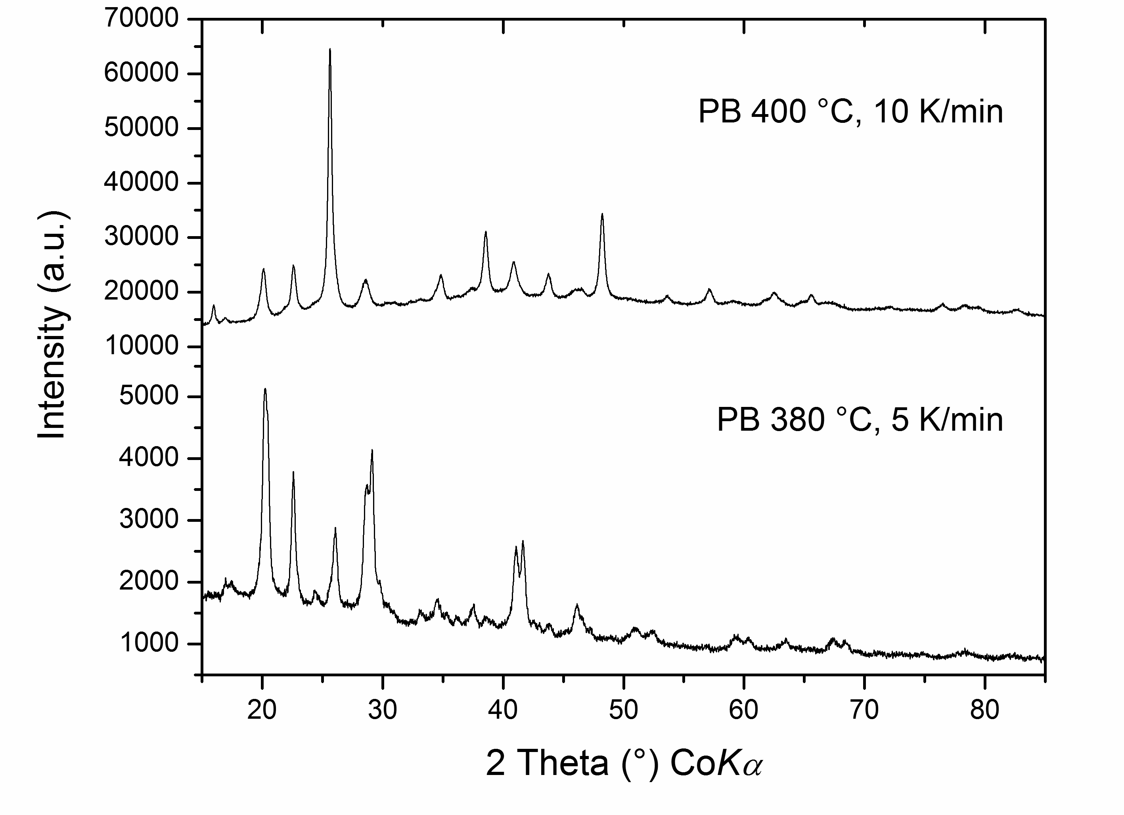

Figure S5. XRD patterns of PB heated up under argon with different heating rates.

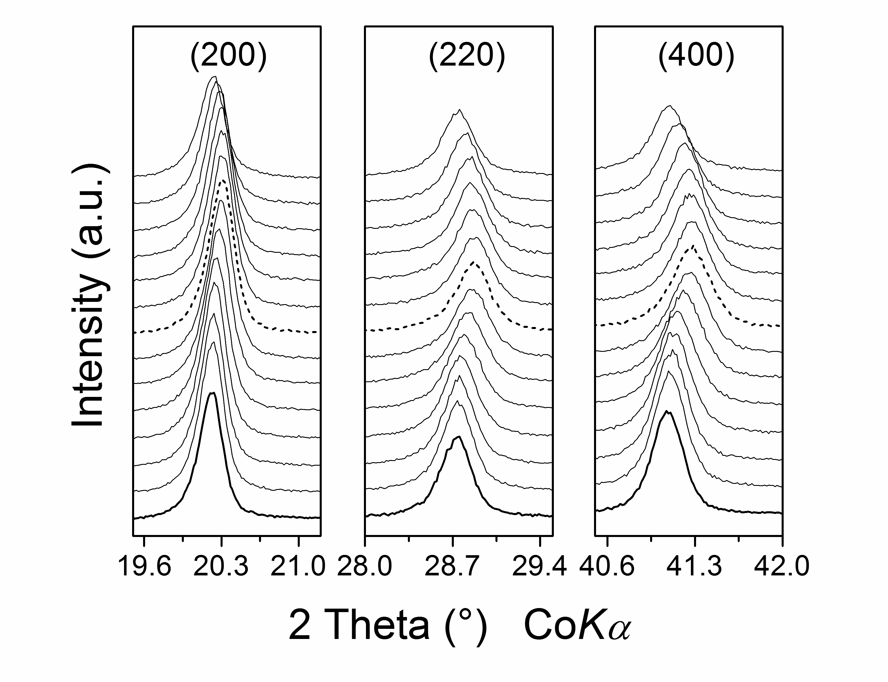
Figure S6. Shifting of the main reflections (200), (220), and (400) of PB with the increase in temperature. Notes: Diffraction data were collected every 20 °C, from room temperature up to 300 °C; non-treated PB (thick line), PB heated up to 180 °C (dashed line).

