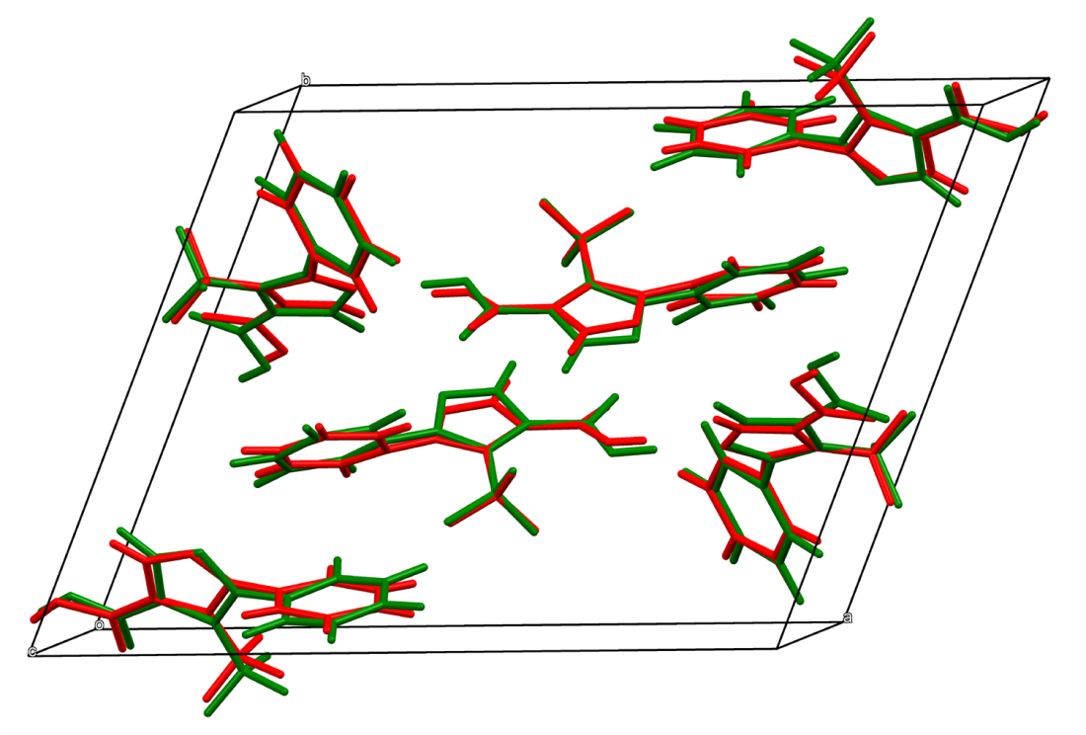
Figure S1: Superposition of molecular conformations as obtained from X-ray structure analysis (red) and solid state DFT calculation (green) of C₁₁H₇F₃N₂O₂ (1).
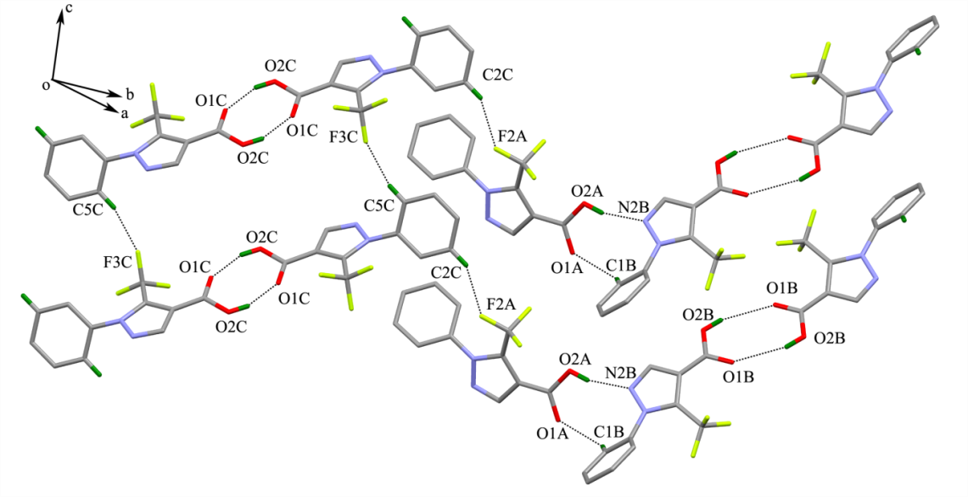
Figure S2: 1D molecular structure formed by O-H...O, C-H...F and O-H...N hydrogen bonds.

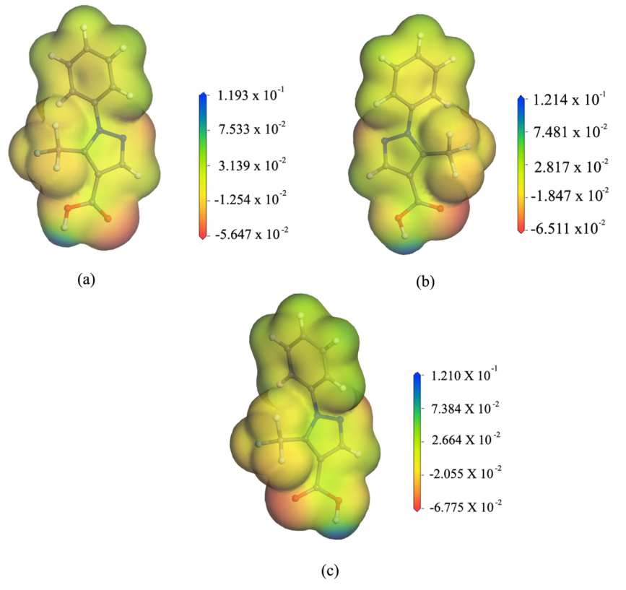
Figure S3: MEP surfaces of C₁₁H₇F₃N₂O₂ (1)

Table S1. Selected Torsion angles in compound 1(C₁₁H₇F₃N₂O₂)

Angle name | Molecule A | Molecule B | Molecule C
C6 N1 N2 C7 | -172.8(7) | -178.7(7) | 167.7(7)
C2 C1 C6 N1 | 169.9(6) | -162.5(6) | -179.4(6)
C2 C3 C4 C5 | 0.7(8) | 0.3(8) | 1.0(8)
C4 C5 C6 C1 | -0.1(9) | 0.4(9) | 1.3(9)
C9 N1 N2 C7 | -0.4(9) | 0.4(9) | -0.9(10)
C2 C1 C6 C5 | 0.3(9) | -0.3(9) | -1.0(9)
C3 C4 C5 C6 | -0.3(8) | -0.5(8) | -1.3(8)
C1 C6 N1 N2 | -42.8(11) | 34.2(11) | 123.5(9)
C6 C1 C2 C3 | 0.1(8) | 0.2(9) | 0.8(8)
C1 C2 C3 C4 | -0.5(8) | -0.2(8) | -0.8(8)
C4 C5 C6 N1 | -169.7(6) | 162.5(6) | 179.7(6)
C1 C6 N1 C9 | 146.0(7) | -144.7(7) | -70.2(6)
C5 C6 N1 N2 | 126.9(8) | -127.9(8) | -55.0(11)
N2 C7 C8 C9 | -0.2(8) | 3.3(8) | 0.2(9)
C7 C8 C9 C11 | -159.7(8) | 167.0(8) | -172.9(8)
C7 C8 C10 O1 | -2.0(1) | 174.7(9) | -167.5(9)
C9 C8 C10 O2 | 1.2(13) | 164.2(7) | -171.5(8)
C11 C9 N1 N2 | 161.3(8) | -168.9(8) | 173.4(8)
N1 C9 C11 F2 | -7.9(13) | 19.8(15) | -134.7(12)
C8 C9 C11 F2 | 148.4(10) | -148.4(13) | 36.2(15)
C5 C6 N1 C9 | -44.3(11) | 53.2(10) | 111.4(9)
N2 C7 C8 C10 | 179.2(7) | 177.3(7) | 179.6(8)
C10 C8 C9 N1 | -179.3(8) | -176.4(7) | 179.9(8)
C7 C8 C10 O2 | -177.9(7) | -8.1(10) | 9.3(13)
C8 C9 N1 N2 | 0.3(9) | 1.7(9) | 1.0(9)
C11 C9 N1 C6 | -26.3(12) | 10.2(12) | 5.2(13)
N1 C9 C11 F3 | -127.5(11) | -99.6(13) | 104.1(13)
C8 C9 C11 F3 | 28.9(14) | 92.3(13) | -85.1(14)
C8 C7 N2 N1 | 0.3(8) | -2.4(9) | 0.4(10)
C7 C8 C9 N1 | -0.1(8) | -3.0(8) | -0.7(8)
C10 C8 C9 C11 | 21.0(13) | -6.5(14) | 7.7(14)
C9 C8 C10 O1 | 177.2(9) | -12.9(13) | 11.8(15)
C8 C9 N1 C6 | 172.7(7) | -179.2(7) | -167.2(7)
N1 C9 C11 F1 | 110.6(14) | 138.3(12) | -17.0(14)
C8 C9 C11 F1 | -93.0(15) | -29.9(15) | 153.8(10)

