Supplementary material
Supplementary Figure S1. Daily average temperature (°C) from preemergence application to soil sampling for herbicide concentration in the soil at 25 days after treatment in 2020, 2021, and 2022.

Supplementary Figure S2. Daily (bars) and cumulative (lines) precipitation (mm) from 0 to 120 days after soybean planting in 2020, 2021, and 2022.

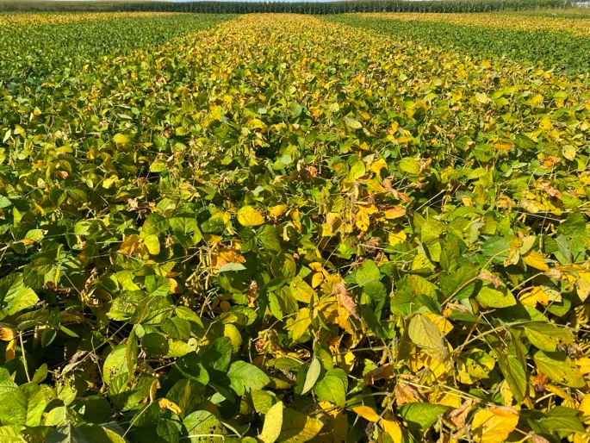
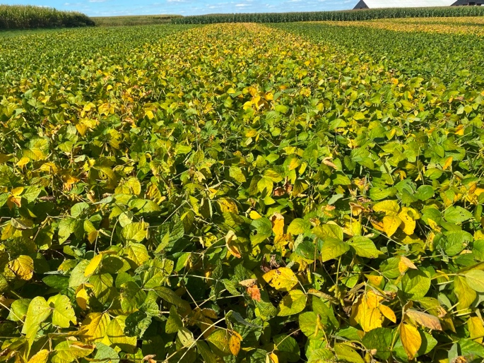
B
A

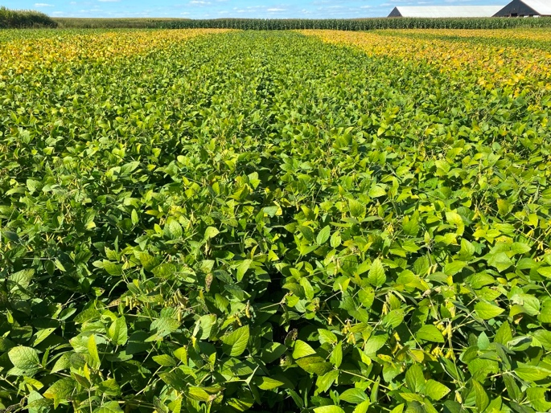
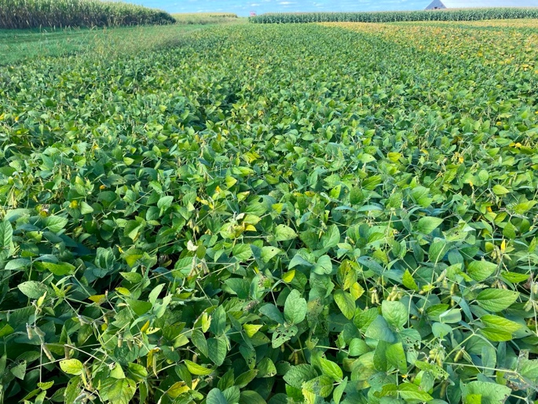
D
C

Supplementary Figure S3. Field plots showcasing the differences in soybean maturation between tillage (A, top-left corner), no-till (B, top-right corner), glyphosate (C, bottom-left corner), and no-till (D, bottom-right corner) at 113 days after planting on September 15, 2021.

Supplementary Figure S4. Density of droplets (droplets cm⁻²) at the preemergence application in 2020, 2021, and 2022. Error bars indicate the 95% confidence intervals. Treatments followed by the same letter within the facet of each year are not significantly different according to Fisher’s LSD test (α = 0.05).

Supplementary Figure S5. Spray coverage (%) at the preemergence application in 2020, 2021, and 2022. Error bars indicate the 95% confidence intervals. Treatments followed by the same letter within the facet of each year are not significantly different according to Fisher’s LSD test (α = 0.05).

Supplementary Figure S6. Sulfentrazone concentration (ng g⁻¹ soil) in the soil (0-7.6 cm) at 25 days after treatment in 2020, 2021, and 2022. Error bars indicate the 95% confidence intervals. Treatments followed by the same letter within the facet of each year are not significantly different according to Fisher’s LSD test (α = 0.05).

Supplementary Figure S7. Metolachlor concentration (ng g⁻¹ soil) in the soil (0-7.6 cm) at 25 days after treatment in 2020, 2021, and 2022. Error bars indicate the 95% confidence intervals. Treatments followed by the same letter within the facet of each year are not significantly different according to Fisher’s LSD test (α = 0.05).

Supplementary Figure S8. Soybean yield (kg ha⁻¹) in 2020, 2021, and 2022. Error bars indicate the 95% confidence intervals. Treatments followed by the same letter within the facet of each year are not significantly different according to Fisher’s LSD test (α = 0.05).

