National Interest, Nationalism, and the Legitimacy of the International Criminal Court

Supplementary Material

**Contents**

1 Question Wording 3

1.1 Perceptions of National Interest 3

1.2 Nationalism 3

1.2.1 Nationalism as British Exceptionalism 3

1.2.2 Nationalism as British Pride 3

1.3 Judicial Legitimacy 3

1.3.1 Diffuse Support 3

1.3.2 Compliance Attitudes 4

2 Experiment Information 5

2.1 Sample Descriptives 5

2.2 Sample Attentiveness 6

3 Survey Weighing 7

3.1 Weighting for observational results 7

3.2 Experiment Balance Table 9

4 Analysis Tables and Graphs 10

4.1 Treatment Effects on Nationalism Measures 10

4.2 Model Outputs 12

4.3 Extended Analyses 23

4.4 Verifying Treatment Validity (Pretest Results) 25

# Question Wording

## Perceptions of National Interest

Respondents were asked to indicate the extent to which they agreed with the statement, *“The International Criminal Court does work that is in the national interest of the United Kingdom.”* Response options are a four-point Likert scale ranging from “Strongly Agree” to “Strongly Disagree.”

## Nationalism

### Nationalism as British Exceptionalism

Respondents were asked, “Which of the following is closest to your view of the UK’s standing in the world?” with the options being, “The UK stands above all other countries,” “The UK is one of the greatest countries, along with others,” and “There are other countries that are better than the UK.”

### Nationalism as British Pride

Respondents were asked, “How proud of you of being British?” with the response options being, “Very proud,” “Somewhat proud,” “Not proud at all,” and finally, “I am not British.”

## Judicial Legitimacy

All response options are a four-point Likert Scale ranging from “Strongly Agree” to “Strongly Disagree.”

### Diffuse Support

1. If the [International Criminal Court/UK Supreme Court] started making decisions that most people disagree with, it might be better to do away with the [International Criminal Court/Supreme Court] altogether.
2. The right of the [International Criminal Court/UK Supreme Court] to decide certain types of controversial issues should be reduced.
3. The decisions of the [International Criminal Court/UK Supreme Court] favor some groups more than others.
4. The International Criminal Court should have the right to overrule national governments, even when a majority of people within that country disagree with the Court’s decision.[1]
5. The [International Criminal Court/UK Supreme Court] gets too mixed up in politics.

### Compliance Attitudes

1. The United Kingdom should comply with an order from the International Criminal Court, even if a majority of UK citizens disagree with the Court’s order.
2. If the International Criminal Court brings charges against an individual, they should voluntarily turn themselves over to the Court for trial.
3. If necessary, people should pressure their national governments to comply with decisions by the International Criminal Court.

# Experiment Information

## Sample Descriptives

|  |  |  |
| --- | --- | --- |
| **Characteristic** | **Sample %** | **Population Benchmark[2]** |
| 18-24 Years Old 25-34 Years Old  35-44 Years Old  45-54 Years Old  55-64 Years Old  65 or Over | 12.49%  15.70%  17.79%  16.82%  21.00%  16.19% | 10.9%  17.2%  15.9%  17.56%  15.27%  23.16% |
| Female  Male | 50.4  49.6 | 51%  49% |
| White | 89.25 | 85.5% |
| Black | 3.56 | 3.5% |
| Asian  Other Race | 5.17  2.03 | 7.8%  3.2% |
| Located in England | 83.68 | 84.3% |
| Located in Scotland | 8.44 | 8.2% |
| Located in Wales | 5.23 | 4.7% |
| Located in Northern Ireland | 2.65 | 2.8% |
|  |  |  |

## Sample Attentiveness

Recent research highlights a concerning decrease in respondent attentiveness on the Lucid surveying platform. This highlights a serious potential concern for any research: if respondents are giving random or uninformed responses, it affects the quality of the data collected and has the potential to compromise any analyses with that data unless taken into account. However, we are confident that our data and analyses are not compromised in this way for a number of reasons

First, our experiment included an attention check. This tested user attention by asking them to select a particular (and counterintuitive) response to a question, and removed respondents who answered incorrectly. 79 of 1,515 respondents (5%) were removed as a result of failing the attention check. Importantly, those removed were randomly distributed across the treatment groups. Second, our study was fielded in early 2019 when attentiveness on Lucid was relatively high (Coppock and McClellan, 2019). Third, research underscores that, so long as inattentiveness is unrelated to treatment assignment, the error produced by inattentive respondents results in an attenuating of effect sizes (Peyton, Huber, and Coppock, N.D.). In other words, including inattentive respondents in our analyses makes it more challenging to obtain significant results biasing our results downward. Finally, to further assuage concerns about respondent quality, we include in the manuscript an analysis using only an embedded manipulation check. The goal of this is to overcome any remaining concerns brought about by inattentive respondents by including the independent variable in the model instead of treatment assignment.

The following question was used to test respondent attentiveness:

What is your favourite colour?

Please select “Blue” from the options below. This question serves as an attention check to make sure people are paying attention during the survey. If you select any other option you will be removed from the survey.

(Answer options were Green, Red, Blue, Other, Yellow, Orange, Purple.)

# Survey Weighing

## Weighting for observational results

In an effort to increase the representativeness of the data, we present here the means from our indices reported in the manuscript, weighted using an iterative proportional weighing algorithm (commonly referred to as raking). This was conducted using the ipfweight package on Stata, with the observational data being weighted to national benchmarks available on the UK Office for National Statistics website. Data were weighted on the following characteristics: age, gender, race, and location. The distribution of weights is presented below. Importantly, we do not weight the data for experimental analysis given current practices in survey experimental research, and the concern of introducing bias into the analysis (Sekhon, Theodoridis, and Campos (2018); Franco et al. 2017).

**Figure 1.** Distribution of survey weights

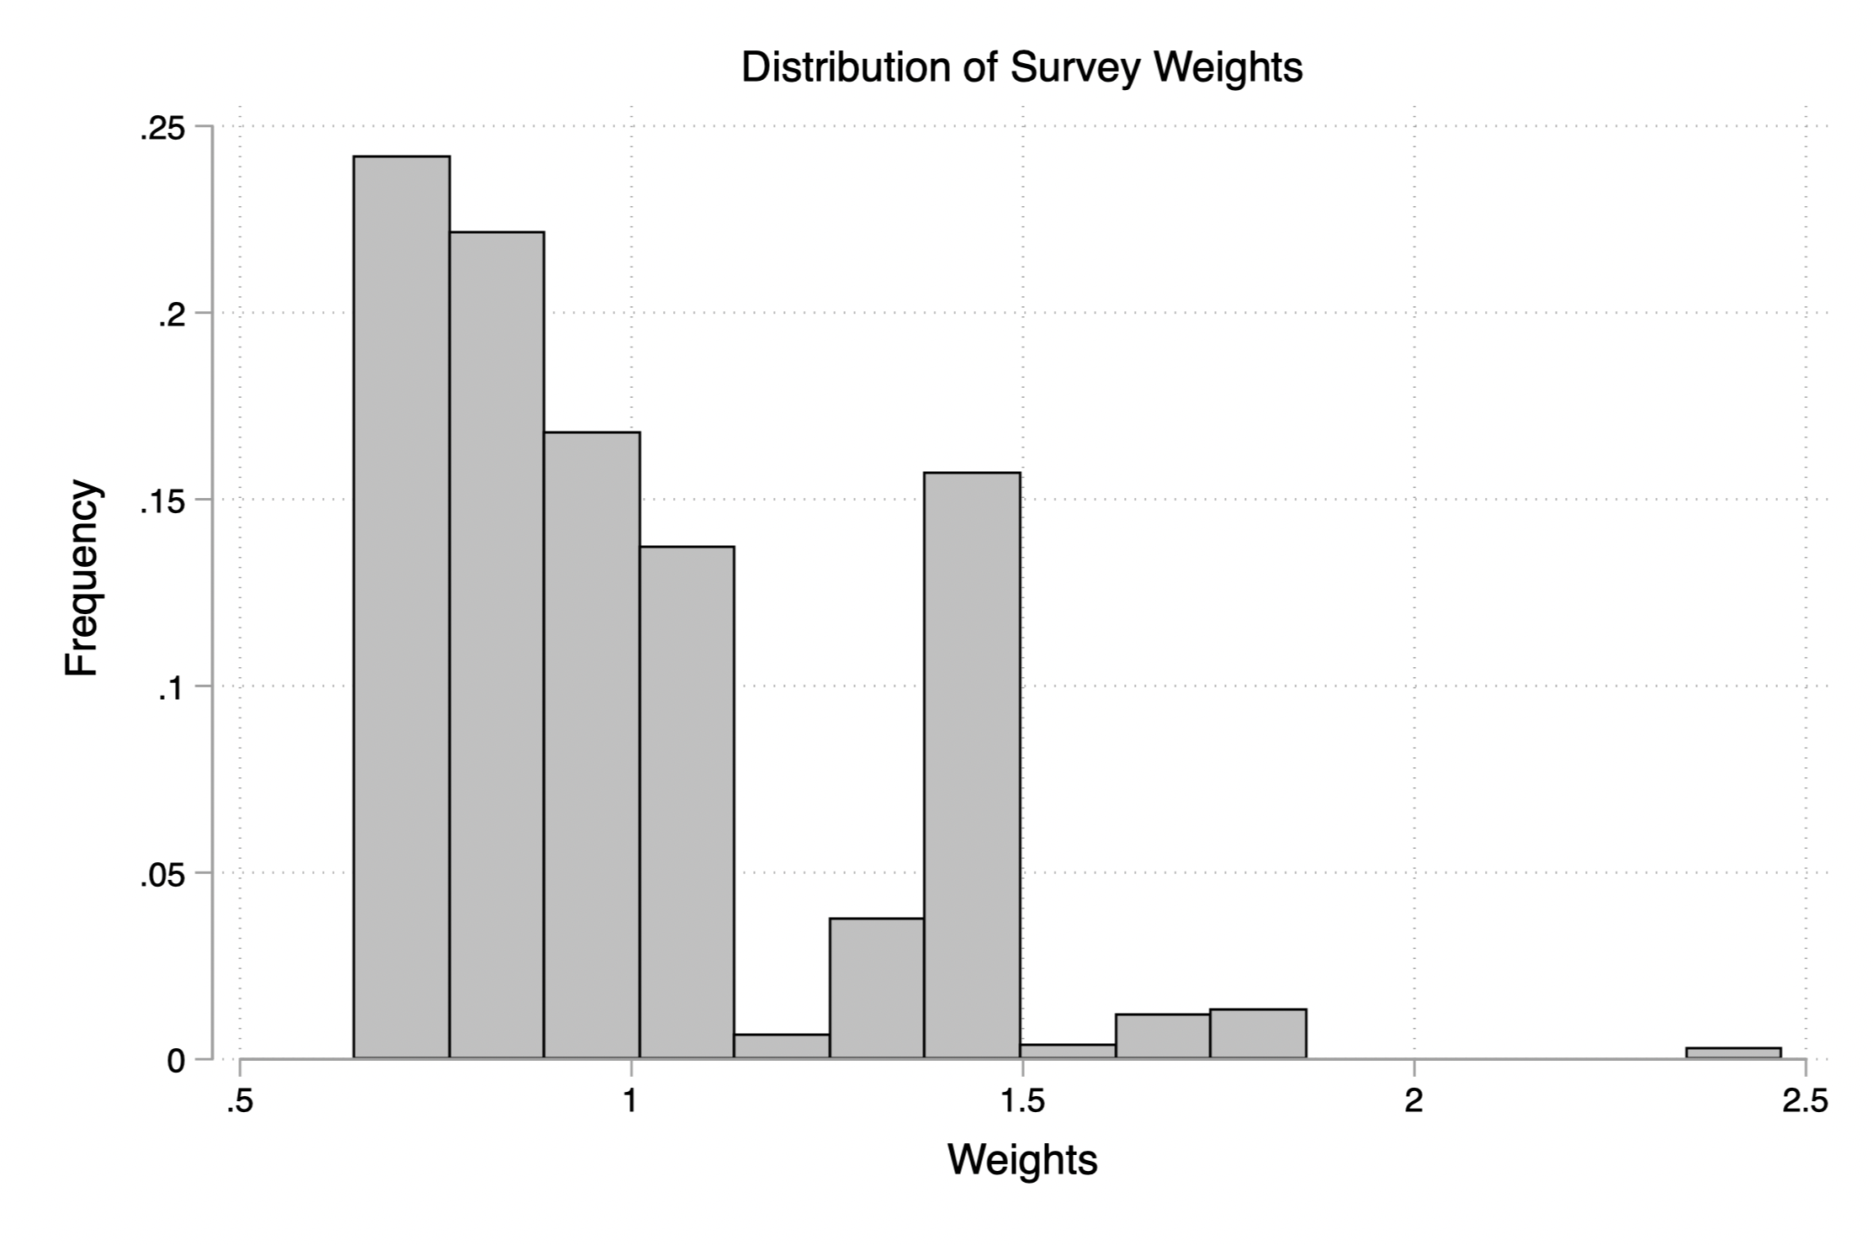

Table 1 shows the effect of weighting on key observational findings.

**Table 1.** Weighted Observational Analysis

|  |  |  |
| --- | --- | --- |
| **Characteristic** | **Unweighted Means**  **(In Manuscript)** | **Weighted Means** |
| ICC Institutional Support  (Control Group) | .41643 | .41691 |
| UKSC Institutional Support  (Control Group) | .51223 | .51562 |
| ICC Compliance Attitudes  (Control Group) | .61904 | .61658 |
| UKSC Compliance Attitudes  (Control Group) | .68970 | .69501 |
| Figure 4: % Agree or Strongly Agree that: | | |
| …to abolish the Court if it makes decisions the people disagree with. | ICC: 66.67 UKSC: 48.18 | ICC: 66.69 UKSC: 48.03 |
| …to reduce the right of the Court to decide certain types of controversial issues. | ICC: 63.87 UKSC: 46.77 | ICC: 63.87 UKSC: 45.37 |
| …that decisions of the Court favor some groups more than others. | ICC: 68.07 UKSC:53.99 | ICC: 67.85 UKSC: 53.27 |
| …the Court should have authority to overrule the government.* | ICC: 49.86 UKSC:64.71 | ICC: 49.63 UKSC: 64.96 |
| …the Court gets too mixed up in politics. | ICC: 71.76 UKSC: 57.71 | ICC: 72.02 UKSC: 57.43 |

## Experiment Balance Table

Table 2 presents the balance table comparing respondents assigned to each treatment group to those respondents randomized to the control group on the basis of several characteristics. As is clear, randomization was largely successful with the exception of income in the baseline condition. Because of this, any models we include that analyze the baseline condition have also been controlled for income.

**Table 2**. Experiment Balance Table

# Analysis Tables and Graphs

## Treatment Effects on Nationalism Measures

Even though our nationalism measures come well after the treatments in the survey (they were presented in the demographics module at the end of the study and after several questions for an unrelated project), there is still the potential for spillover effects of our treatments on these nationalism measures. To check for this, we regressed each nationalism measure on the treatment conditions. The results are presented below.

Beliefs in British exceptionalism are not significantly affected by the treatments. However, reported British pride is increased in each of our treatment conditions. While this might create cause for concern, we do not believe this strongly affects the results. First, the three (non-control) treatments are not statistically distinguishable from each other. Second, a SEM mediation analysis indicates the occurrence of very little mediation and, when slight mediation does occur, it is often in the reverse direction. Specifically, the proportion of total effects of a move from “control” to “negative” conditions being mediated through British pride is 0*.*04[3]. Similarly, only −0*.*05 of the total effects of the “positive” treatment are mediated through British pride[4]. Finally, the proportion of the baseline treatment mediated through British pride is −0*.*05[5].

**Figure 2.** Graph indicating that treatments do not affect belief in British exceptionalism

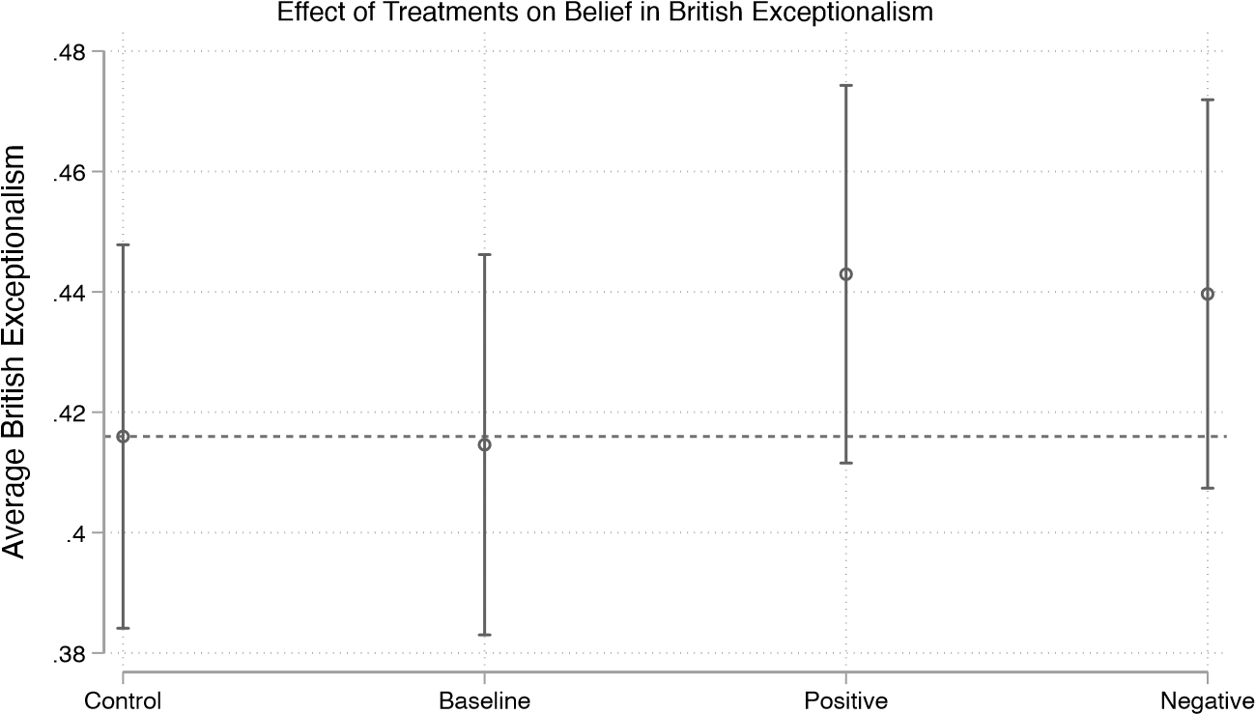

Experimental Group

Source: Lucid Study, April 29-May 7, 2019. N=1,432

**Figure 3.** Graph indicating that reported British pride is different from the control condition, but no significant difference is observed across the three treatment conditions.

Experimental Group

Source: Lucid Study, April 29-May 7, 2019. N=1,432

## Model Outputs

**Table 3.** Manipulation Check

(1)  
Perceived National Interest

Standard errors in parentheses

∗ *p <* 0*.*05, ∗∗ *p <* 0*.*01, ∗∗∗ *p <* 0*.*001

**Table 4.** Correlates of International Criminal Court Legitimacy

(1)

ICC Diffuse Support

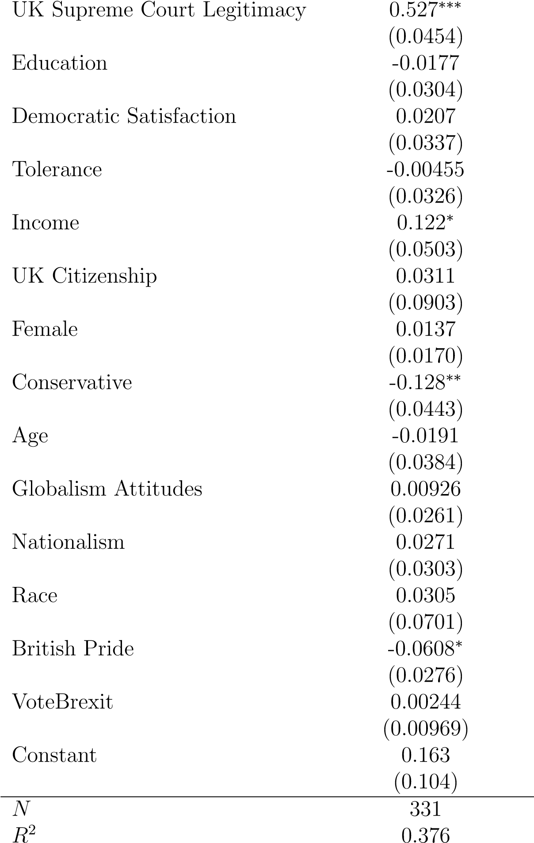

Standard errors in parentheses

∗ *p <* 0*.*05, ∗∗ *p <* 0*.*01, ∗∗∗ *p <* 0*.*001

**Figure 4.** Coefficient plot for correlates of Diffuse Support for the International Criminal Court

Correlates of ICC Legitimacy

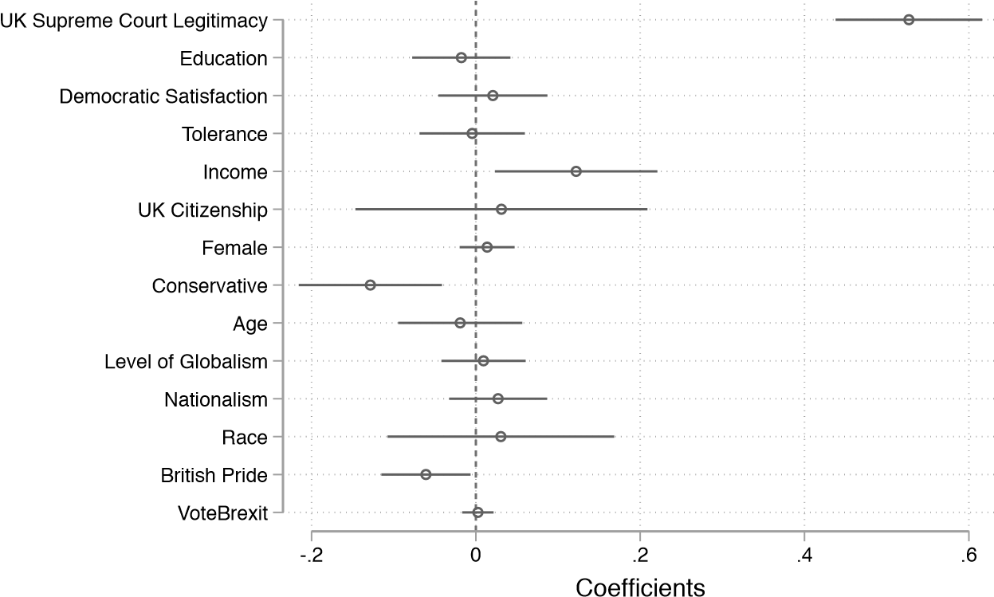

Source: Lucid Study, April 29-May 7, 2019. Coefficients are from an OLS regression. N=331

**Table 5.** Average Treatment Effects on International Criminal Court Legitimacy

(1)

ICC Diffuse Support

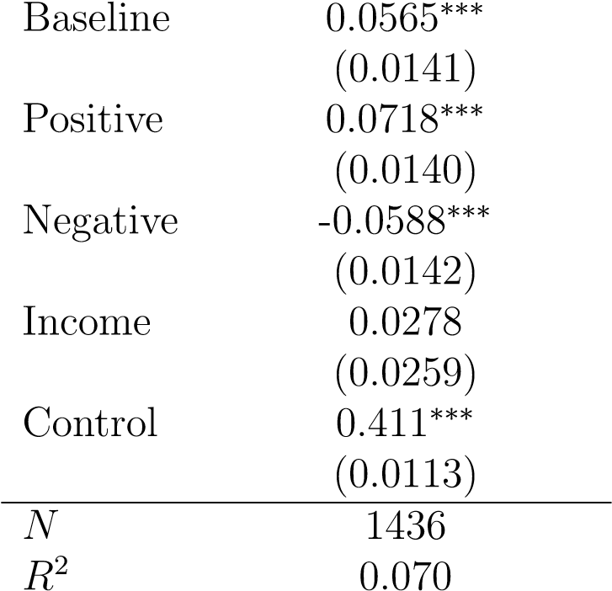

Standard errors in parentheses

∗ *p <* 0*.*05, ∗∗ *p <* 0*.*01, ∗∗∗ *p <* 0*.*001

**Table 6**. Heterogeneous Treatment Effects by British Exceptionalism

(1)  
ICC Diffuse Support

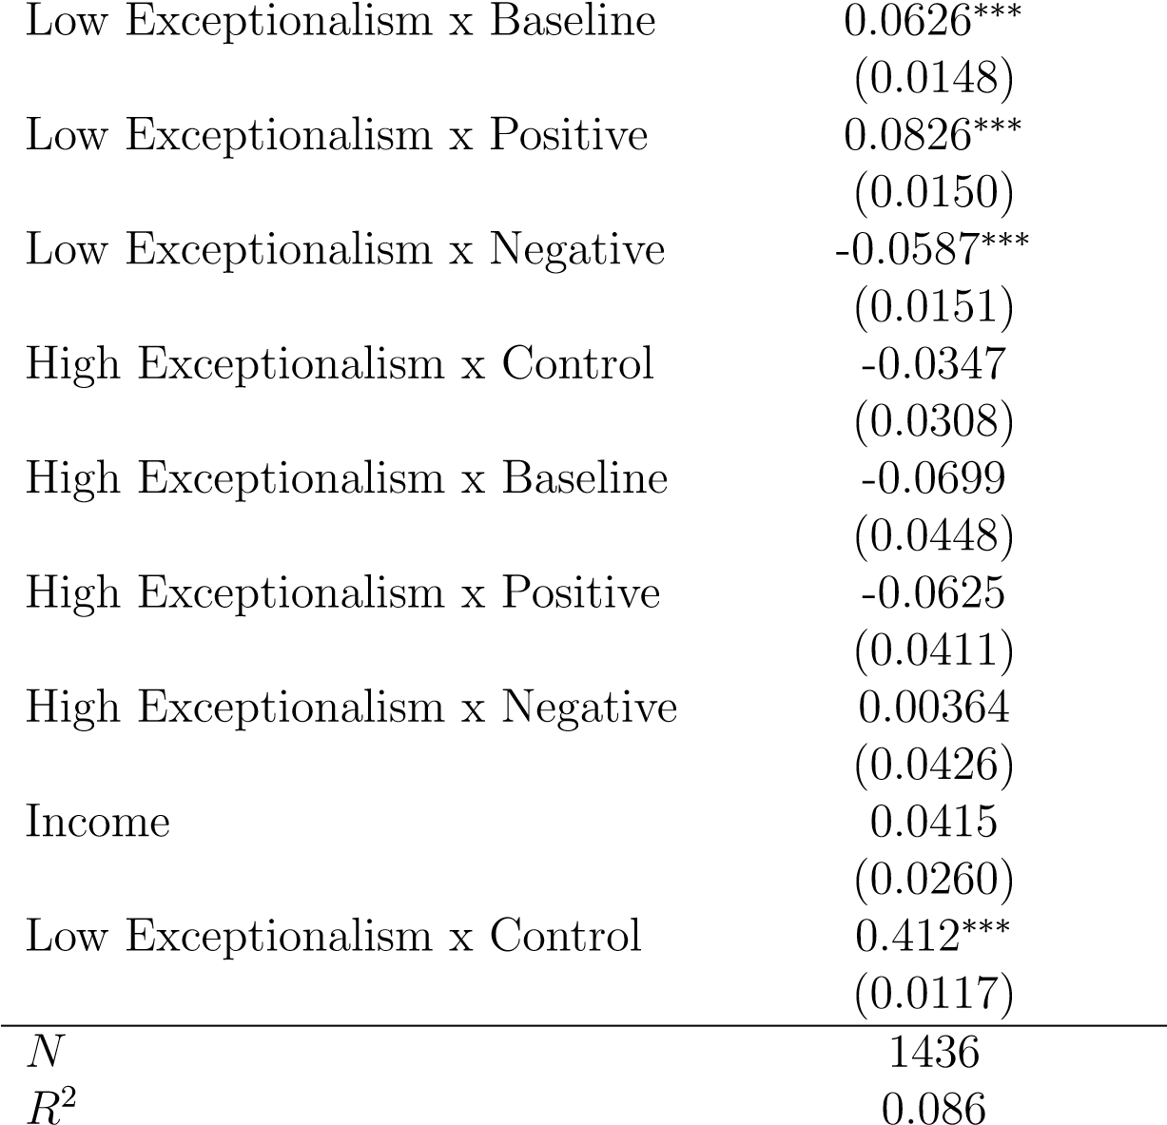

Standard errors in parentheses

∗ *p <* 0*.*05, ∗∗ *p <* 0*.*01, ∗∗∗ *p <* 0*.*001

**Table 7.** Heterogeneous Treatment Effects by British Pride

(1)  
ICC Diffuse Support

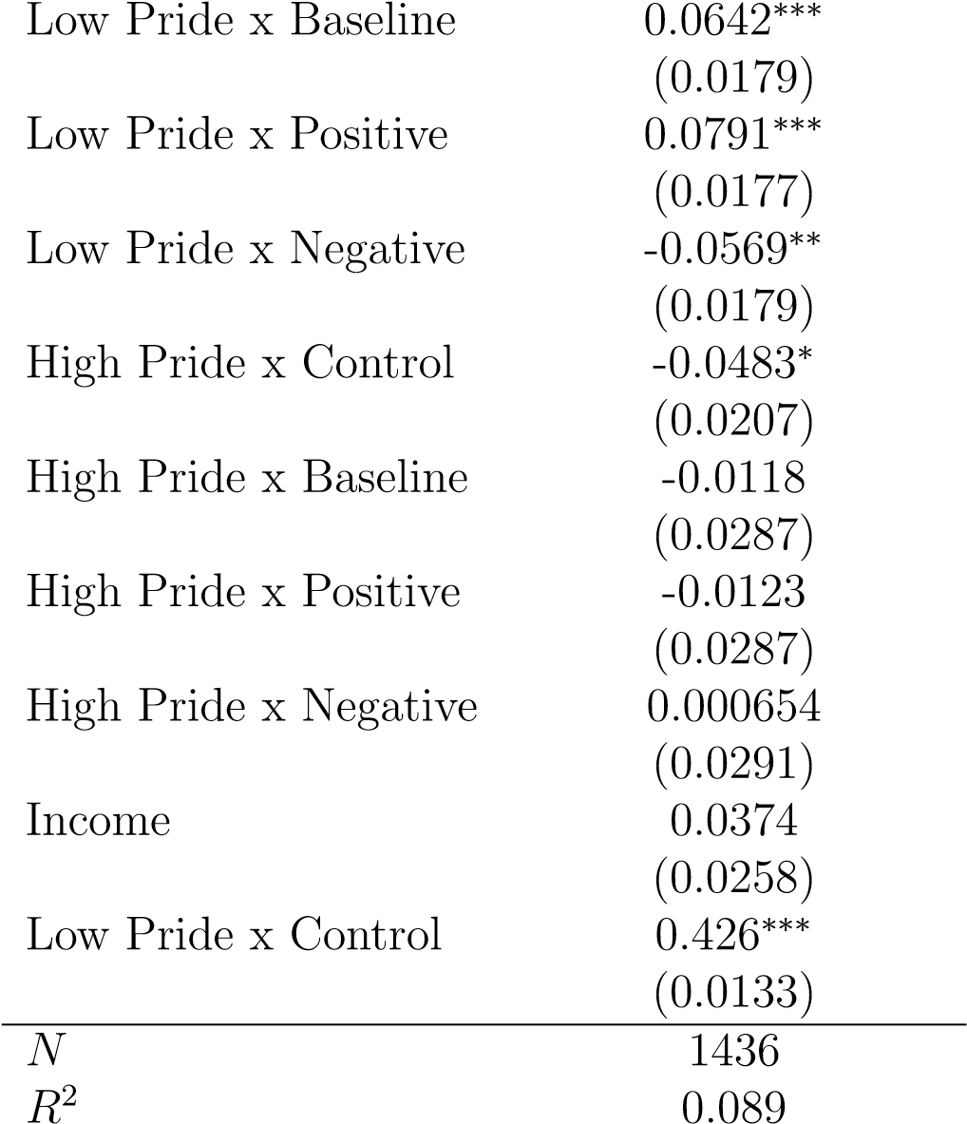

Standard errors in parentheses

∗ *p <* 0*.*05, ∗∗ *p <* 0*.*01, ∗∗∗ *p <* 0*.*001

**Table 8.** Treatment Effects on Compliance Attitudes Towards ICC

(1)

ICC Compliance Attitudes

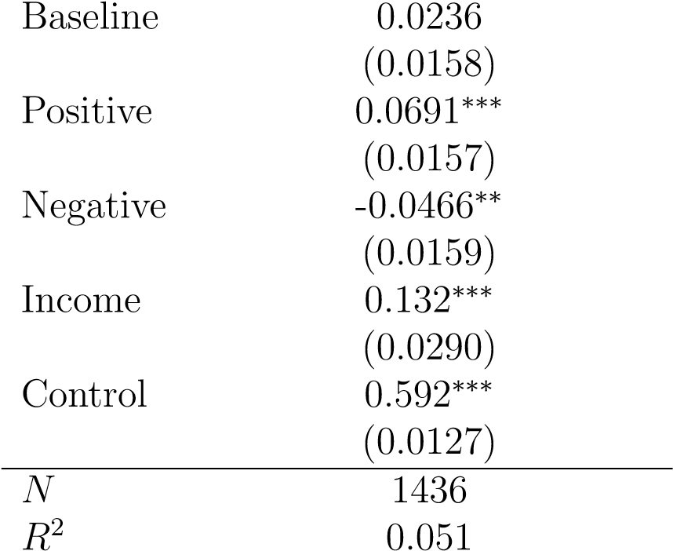

Standard errors in parentheses

∗ *p <* 0*.*05, ∗∗ *p <* 0*.*01, ∗∗∗ *p <* 0*.*001

**Table 9**. Heterogeneous Treatment Effects by British Exceptionalism

|  |  |
| --- | --- |
|  | (1) |
|  | ICC Compliance Attitudes |
| Low Exceptionalism x Baseline | 0.0238 |
|  | (0.0165) |
| Low Exceptionalism x Positive | 0.0764*** |
|  | (0.0167) |
| Low Exceptionalism x Negative | -0.0502** |
|  | (0.0168) |
| High Exceptionalism x Control | 0.114*** |
|  | (0.0344) |
| High Exceptionalism x Baseline | 0.0250 |
|  | (0.0499) |
| High Exceptionalism x Positive | -0.0757 |
|  | (0.0458) |
| High Exceptionalism x Negative | 0.0110 |
|  | (0.0474) |
| Income | 0.109*** |
|  | (0.0289) |
| Low Exceptionalism x Control | 0.583*** |
|  | (0.0131) |
| $$N$$ | 1436 |
| $$R^{2}$$ | 0.078 |
| Standard errors in parentheses |  |
| $p<0.05$* , $p<0.01$** , $p<0.001$*** |  |

**Table 10.** Heterogeneous Treatment Effects by British Pride

|  |  |
| --- | --- |
|  | (1) |
|  | ICC Compliance Attitudes |
| Low Pride x Baseline | 0.0304 |
|  | (0.0203) |
| Low Pride x Positive | 0.0749*** |
|  | (0.0200) |
| Low Pride x Negative | -0.0447* |
|  | (0.0203) |
| High Pride x Control | 0.0158 |
|  | (0.0234) |
| High Pride x Baseline | -0.0182 |
|  | (0.0324) |
| High Pride x Positive | -0.0162 |
|  | (0.0324) |
| High Pride x Negative | -0.00648 |
|  | (0.0329) |
| Income | 0.131*** |
|  | (0.0291) |
| Low Pride x Control | 0.586*** |
|  | (0.0151) |
| $$N$$ | 1436 |
| $$R^{2}$$ | 0.051 |
| Standard errors in parentheses |  |
| $p<0.05$* , $p<0.01$** , $p<0.001$*** |  |

**Figure 5** Sensitivity Analysis for the Negative Treatment Condition

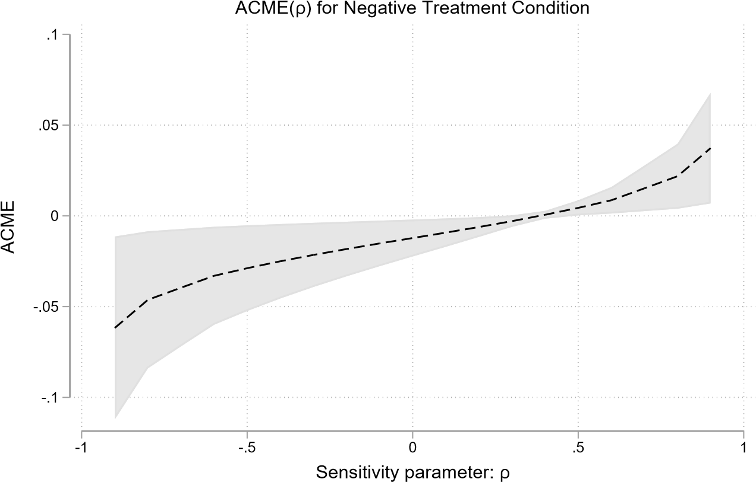

**Figure 6.** Sensitivity Analysis for Positive Treatment Condition

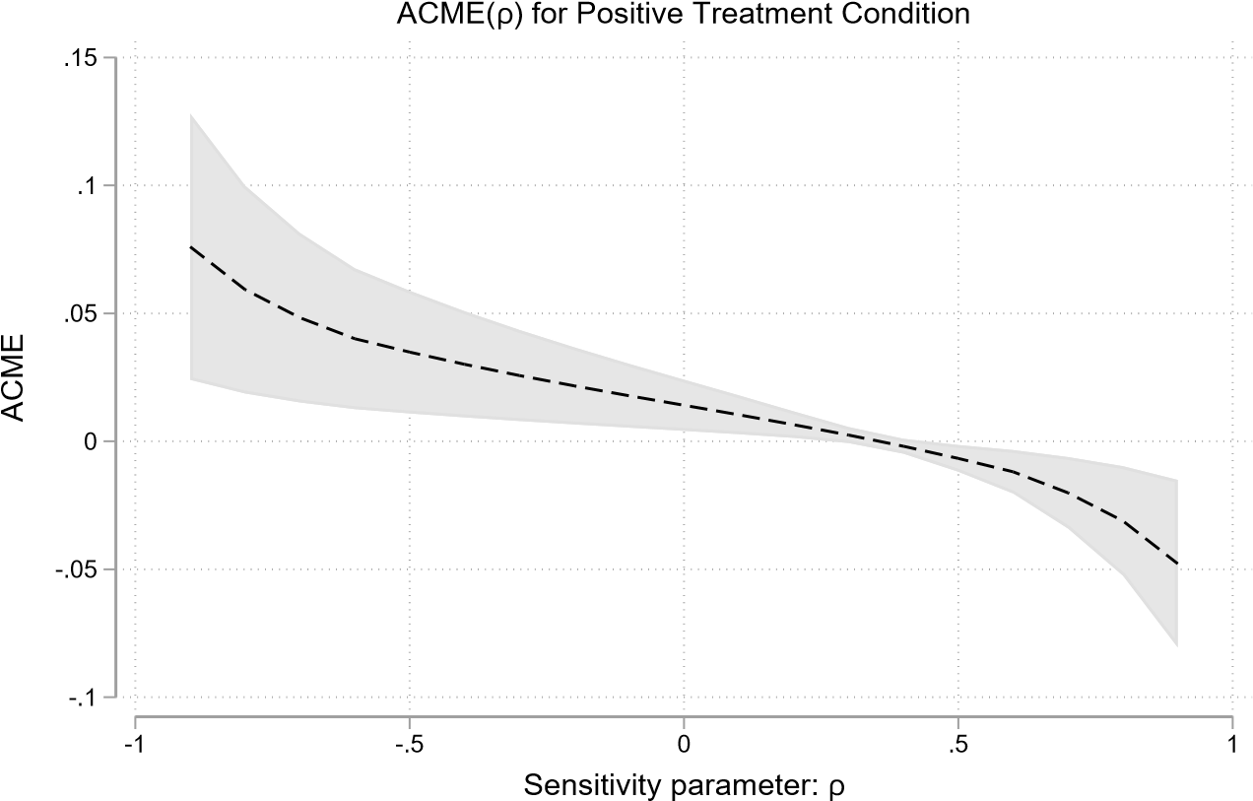

**Figure 7.** Sensitivity Analysis for the Baseline Treatment Condition

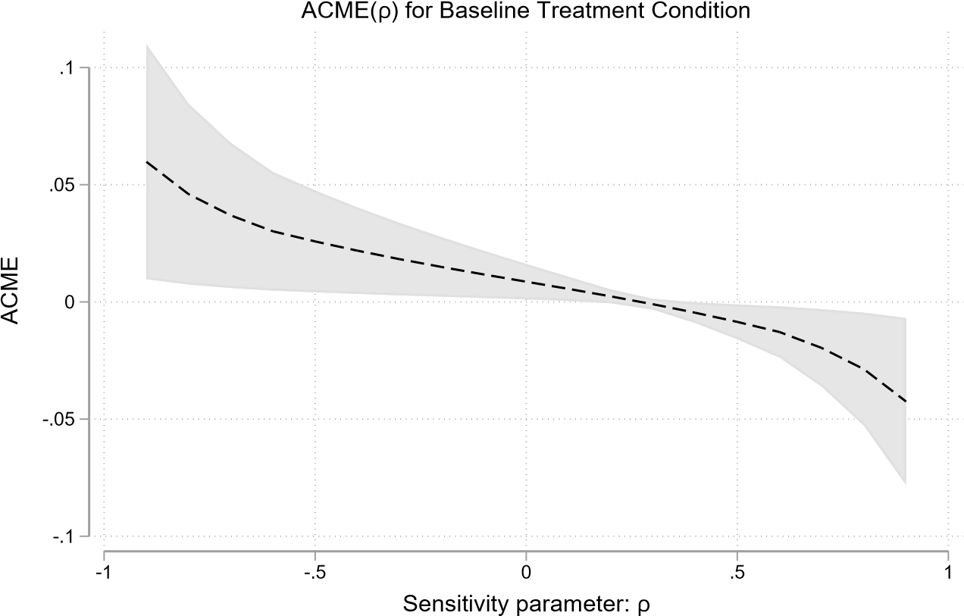

## Extended Analyses

This section provides further evidence regarding the effectiveness of our treatments, which was excluded from the main article due to space constraints.

As we acknowledge in the Data and Methods section of the manuscript, our treatment design includes references by our notional elites (parliamentarians) to other values that they associate with the national interest, and then frame ICC activity in relation to those values and interests. One potential objection to our findings is that these additional considerations—not national interest—are mechanisms through which our treatments influence ICC legitimacy. For example, do our treatments manipulate generic affect felt toward the ICC, and if so, is it that affect rather than perceived national interest, affecting the legitimacy afforded to the Court? If affect is driving this mechanism, our findings would not be about perceptions that the ICC is “pro-” or “anti-” national interest but rather perceptions of “good ICC” vs “bad ICC”. While this is an important question, we believe there are both theoretical and empirical reasons to be confident that the average treatment effects of our study are being driven, in large part, by perceived national interest.

First, we acknowledge that, in manipulating perceived national interest, we probably also manipulated respondents’ general feelings towards the ICC. Indeed, it would be very difficult—if not impossible—to alter the extent to which the public perceives an international institution as being in the national interest without also manipulating how people generally feel towards the institution. Importantly, however, while some accounts of the relationship between diffuse and specific support lead us to expect general affect towards a new court like the ICC to influence legitimacy, the evidence for that link is far from clear. Our theory is based on the expectation that appeals to national interest are particularly promising strategies for those engaged in legitimation or delegitimizing practices around international courts.

Empirically, we are confident that our treatments alter perceived national interest and that this mechanism is substantially responsible for the treatment effects we see. Our confidence derives from two sources: a pretest done on the treatments, and statistical analyses. During the pretest (discussed further in the following section), respondents answered a series of questions related to the ICC and national interest. If respondents were reacting based on general affect felt toward the ICC, we would expect all questions in which the ICC is mentioned to be influenced by the treatments. What we find, however, is the opposite: respondents only significantly respond to questions that specifically mention “national interest.” For example, questions asking about the ICC more generally (for example, “Oversight by the ICC threatens the UK’s ability to govern its own people”) were unaffected by the treatments, whereas questions that specifically asked about the ICC and national interest were significantly affected. This finding suggests that respondents are discriminating among questions in such a way that we would not expect were they simply responding based on their overall affect toward the ICC.

Finally, we ran tests to statistically identify the extent to which perceived national interest influences legitimacy. First, we re-ran the OLS model replacing the explanatory variable (previously the experimental treatment group) with the manipulation check. This question asked respondents the extent to which they agree with the statement: “The [ICC] does work that is in the national interest of the United Kingdom.” Second, mediation and sensitivity analyses were run to see how much of the variation in the dependent variable (legitimacy) was explained by variation in the mechanism (national interest).

When substituting treatment group assignment with the manipulation check, we find that a move from “Strongly Disagree” to “Strongly Agree” results in a 30 percent increase in diffuse support afforded the ICC and a 51 percent change in compliance attitudes. For the mediation and sensitivity analyses, we find that 22 percent of the variation in the dependent variable among those assigned to the negative treatment is routed through perceived national interest,[6] as is 29 percent of the variation from the positive treatment,[7] and 21 percent of those in the baseline group.[8] Taken together with the theoretical expectations, we can be confident that experimental changes in perceived national interest are resulting in changes in legitimacy afforded to the ICC.

## Verifying Treatment Validity (Pretest Results)

In the course of designing our study, we conducted a pretest to assess the validity and effectiveness of our treatments. This was fielded to 439 adult respondents in the United Kingdom, using the same Lucid platform that was used for the final study. Following treatment, we asked a series of questions intended to elicit perceptions of the ICC relative to national interests.

Our results are shown below and indicate that our treatments successfully manipulate perceptions that the ICC is in the national interest of the United Kingdom. This is evident in particular for the negative treatment, where the 4 questions that specifically refer to “national interest”, including 3 and 4, which we specifically intended to capture negative effects, all show statistically significant changes. For the positive treatment, the first two questions show statistically significant effects. Question 1 below was the most sensitive question when the battery was analyzed using exploratory factor analysis and was included in the final study as the manipulation check.

Our pretest results also offer reassurance that treatment effects are not driven by simply manipulating overall affect felt to the Court (given the treatments’ references to broad values such as fairness and justice). If this were the case, we would expect all questions which prime the Court to be significantly influenced by the treatments. Instead, we find that only questions which specifically mention “national interest” are affected to a significant degree.

After being randomized into either a pure control condition or one of the tested treatments, respondents were asked the following questions. Response options were a 4-point Likert Scale ranging from “strongly agree” to “strongly disagree.”

1. The International Criminal Court does work that is in the national interest of the United Kingdom.
2. The International Criminal Court helps defend the national interests of the United Kingdom.
3. Membership in the International Criminal Court advances other countries’ interests without benefitting the UK.
4. Any investigation or prosecution of UK nationals by the International Criminal Court (no matter the circumstances) would be harmful to UK national interests.
5. Participation in the International Criminal Court increases the UK’s international influence and ability to pursue its foreign policy objectives.
6. Oversight by the International Criminal Court threatens the UK’s ability to govern its own people.

The results presented below compare the treatments we include in our study to the pure control condition.

**Figure 9.** Results from treatment pre-test showing the effects of each treatment on questions measuring perceptions of the ICC.

1. For the UKSC, this question read, “The UK Supreme Court should have the right to overrule the government, even when the majority of people disagree with the Court’s decision.”
2. This column reflects the benchmarks that our data are weighted to, drawn from the UK Office of National Statistics: www.ons.gov.uk. Data are benchmarked to 2018 data unless not available (in which case it is benchmarked to the closest available year).
3. Indirect Effects: -0.0025444; Total Effects: -0.0606407
4. Indirect Effects: -0.0035487; Total Effects: 0.0747688
5. Indirect Effects: -0.0030881; Total Effects: 0.0572683
6. Direct Effect=-0.044; Total Effect-0.056
7. Direct Effect=0.057; Total Effect=0.071
8. Direct Effect=0.049; Total Effect=0.058