Appendix:

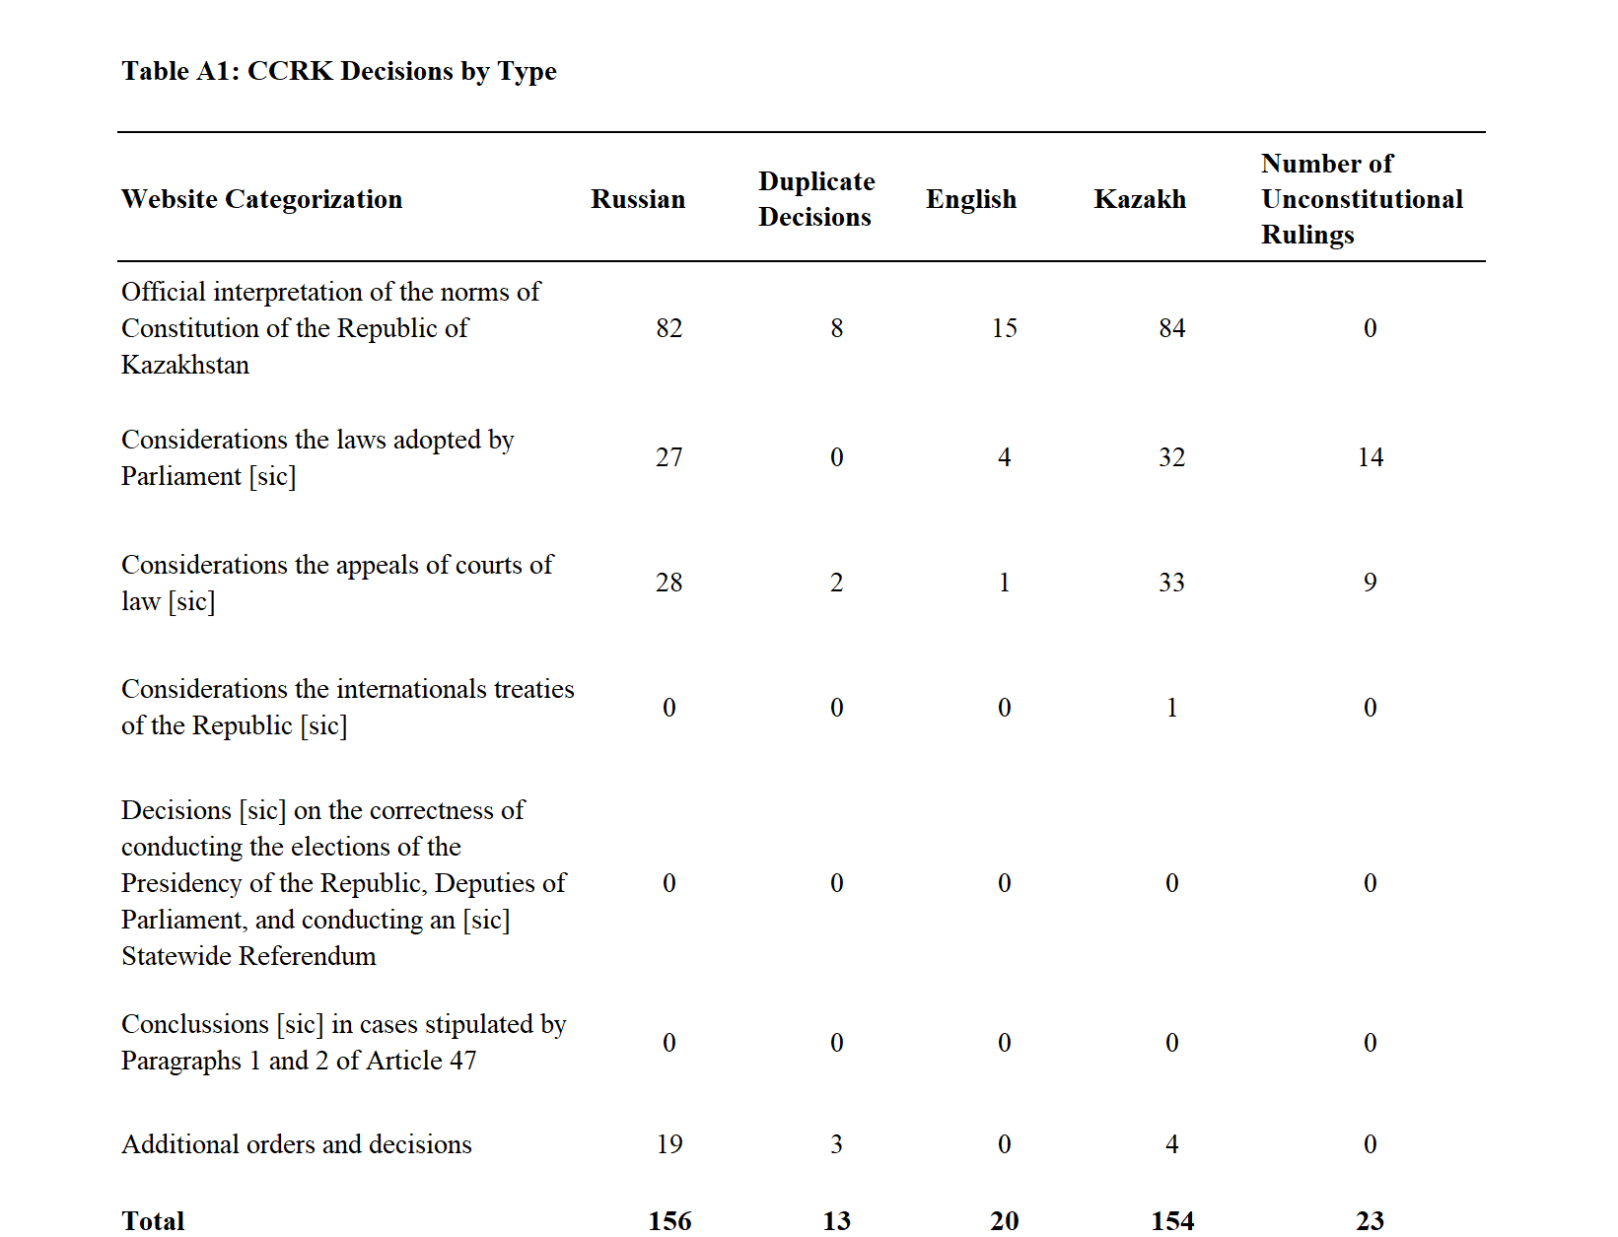

Sample Opening of a CCRK decision
Normative resolution of the Constitutional Council of the Republic dated February 24, 2014, no. 2: “On the official interpretation of paragraph 3.1, article 41 of the Constitution of the Republic of Kazakhstan.”
The Constitutional Council of the Republic of Kazakhstan consisting of Chair I.I. Rogov, Council members I.Z. Bahtybaev, N.V. Belorukov, A.N. Zhailganova, V.A. Malinovskiy, A.M. Nurmagambetov, U.M. Stamkulov with the participation of:
The petition representative: G.V. Kim, Republic of Kazakhstan’s Senate deputy,
the Republic of Kazakhstan’s Mazhilis representative: R.K. Sarpekov, Republic of Kazakhstan’s Mazhilis deputy,
the Government of the Republic of Kazakhstan representative: Z.H. Baimoldina, vice-minister of Justice in the Republic of Kazakhstan,
the Supreme Court of the Republic of Kazakhstan representative: A.A. Kasimov, representative of the Republic of Kazakhstan’s Supreme Court supervisory judicial board for criminal cases,
the Republic of Kazakhstan’s General Prosecutor representative: A.N. Kravchenko, Republic of Kazakhstan’s General Prosecutor deputy,
the Republic of Kazakhstan’s Central Election Commission representative: M.A. Sarsembaev, Republic of Kazakhstan’s Central Election Commission member,
the Republic of Kazakhstan’s Human Rights Commissioner representative: V.A. Kalyuzhnogo, National Center for Human Rights director,
the Republican Public Association “Lawyers for Fair Elections” president: O.K. Kopabaev
considered in an open meeting the appeal of the Republic of Kazakhstan’s Senate Representative K.K. Tokaev on the official interpretation of paragraph 3.1, article 41 of the Constitution of the Republic of Kazakhstan.
Having listened to the presentation of the speaker, N.V. Belorukov, member of the Constitutional Council of the Republic of Kazakhstan, and the presentations of the meeting participants; having analyzed expert opinions from: E.M Abaidel’dinov (Doctor of Law, professor in the International Law subfield in the Department of Law at the L.N. Gumilev Eurasian National University), K.K. Aithozhin (Doctor of Law, professor in the Constitutional and International Law subfield at the D.A. Kunaev Humanities University of Transport and Law), Z.D. Busurmanov (Doctor of Law, professor in the Theory and History of the State and Law subfield in the Department of Law at the L.N. Gumilev Eurasian National University), S.F. Udartsev (Director of the Legal Policy and Constitutional Legislation Research Institute at the Kazakh Humanities and Legal University, Doctor of Law, professor); being acquainted with other materials on constitutional production; and having studied the laws and practices of several foreign countries, the Constitutional Council of the Republic of Kazakhstan
established: …..

Author’s translation. Note that the year here is a typo, the current version of this decision posted online has the correct year, 2015, listed.

