Supplemental Material for
An outbreak of Streptococcus pyogenes in a mental health facility: Advantage of well-timed Whole Genome Sequencing over emm typing.
Authors
Authorship: Sarah M. Bergin, FRCPath;^{1*}, Balamurugan Periaswamy, Ph.D;^{2*} Timothy Barkham, FRCPath;^{1, 3} Choon Chua Hong, M Med (Psych);⁴ Yee Ming Mok, M Med (Psych);⁴ Daniel Shuen Sheng Fung, M Med (Psych);⁴ Alex Hsin Chuan Su, M Med (Psych); ⁴ Yen Ling Lee, BSc;² Ming Lai Ivan Chua, BSc;² Poh Yong Ng, MSc;², Wei Jia Wendy Soon, Ph.D;² Collins Wenhan Chu, MSc;² Siyun Lucinda Tan, MRCP; ⁵, Mary Meehan, Ph.D;⁶ Brenda Sze Peng Ang, MPH;^{7, 8} Yee Sin Leo, MPH, FAMS, FRCP;^{7, 8, 9, 10} Matthew T. G. Holden, Ph.D;¹¹ Partha De, MSc, FRCPath;^{1, 8}, Li Yang Hsu, MPH;^{7, 9} Swaine L. Chen, M.D.,Ph.D;^{2, 10 #}, Paola Florez de Sessions, Ph.D;^{2 #}, Kalisvar Marimuthu, FAMS, MRCP;^{7, 10 #}
Affiliations:
- Department of Laboratory Medicine, Tan Tock Seng Hospital, Singapore
- Genome Institute of Singapore, Singapore
- Yong Loo Lin School of Medicine, National University of Singapore, Singapore
- Institute of Mental Health, Singapore
- National Skin Centre, Singapore
- Irish Meningitis and Sepsis Reference Laboratory, Temple Street Children’s University Hospital, Dublin, Ireland
- Department of Infectious Diseases, Institute of Infectious Diseases and Epidemiology, Tan Tock Seng Hospital, Singapore
- Lee Kong Chien School of Medicine, Nanyang Technological University, Singapore
- Saw Swee Hock School of Public Health, National University of Singapore
- Yong loo Lin School of Medicine, National University of Singapore, Singapore
- University of St Andrews, Scotland
*Contributed equally to the manuscript; #Contributed equally to the manuscript
Contents
1. Supplementary methods 3
1.1 Microbiology Methods 3
1.2 Whole Genome Sequencing methods 3
1.3 Infection prevention and control methods 4
2. Supplementary results 15
2.1 Microbiology results 15
2.2 Whole genome sequencing results 18
3. Epidemiological investigation of staff members with S. pyogenes 21
4. Dermatological intervention 21

1. Supplementary methods

1.1 Microbiology Methods
Wound swabs were inoculated on blood agar and MacConkey Agar (Thermo Fischer). The blood agar was incubated at 37°C in 5% CO₂ and MacConkey agar incubated at 37°C in air. Plates were read at 24 and 48 hours. Organisms grown were identified as described in main text. Oropharyngeal swabs were inoculated on a blood agar plate (Thermo Fischer). The agar plates were incubated in anaerobic conditions and read at ≥ 18 hours. Organisms grown were identified as described in main text.

1.2 Whole Genome Sequencing methods
DNA was extracted using the QIAamp DNA Mini Kit (Qiagen Inc., Hilden, Germany). Indexed sequencing libraries were prepared using the New England Biolabs (NEB), NEBNext Ultra DNA Library Prep Kit. (NEB Inc., Massachusetts, USA E7370) following the manufacturer’s recommended protocol. Sequencing was done on an Illumina NextSeq 500 using paired-end 2×151 bp reads. On average, 900x sequencing coverage was obtained for each isolate.
Fastq files were mapped to the MGAS10750 genome (Genbank accession NC_008024.1) using bwa (version 0.7.10) with default parameters ¹. Single nucleotide polymorphisms (SNPs) were called using LoFreq* (version 2.1.2) ² using default parameters. SNP calls from LoFreq were further filtered to exclude those occurring within mobile genetic elements reported previously in the literature for the reference strain (MGAS10750), which included Prophages ³, Integrated conjugative elements ⁴, S. pyogenes phage-like chromosomal islands (SpyCI) ⁵ and other mobile genetic elements derived from RefSeq annotations from NCBI ⁶. The filtered SNPs were then used to construct isolate genomes by SNP imputation into the reference genome. The derived multiple alignment of genomic sequences were used to construct an approximately maximum likelihood based phylogenetic tree using FastTree (version 2.1.9 with Double precision) under a generalized time reversible model of nucleotide evolution with CAT approximation (20 rate categories) ⁷. Streptococcus dysgalactiae (NC_017567) was used as an out-group. Individual clusters of relevance were identified by manual inspection of the entire phylogenetic tree and clinical meta data. Isolates that belong to such clusters were further refined for topology and branch length by removing the genomic regions that were acquired by these isolates because of recombination as predicted by the Gubbins software ⁸ and the phylogeny was reconstructed and rooted (distance to root was scaled) as mentioned above. Graphical visualization of the genome phylogenetic tree and the sub trees (clusters) were done using Figtree 1.4.3 (http://tree.bio.ed.ac.uk/software/figtree/) and ggtree ⁹. Antibiotic resistance genes were called from the de-novo assembled genomes (Velvet 1.2.10) using blast based custom perl scripts and the modified ARG-Annot database ¹⁰ included in the SRST2 (version 0.1.8) distribution. MLST types were called using SRST2 (version 0.1.8) ¹¹ using MLST definitions downloaded from pubmlst.net ¹². Initial major emm types were called using the emm pipeline software ¹³. emm subtypes were then called using the emm typing tool ¹⁴, which had 100% concordance with emm pipeline major type calls. Therefore only the final results with subtitles from the emm typing tool are shown.

1.3 Infection prevention and control methods
The outbreak control team inspected the affected wards to identify the potential sources and transmission pathways of S. pyogenes. Compliance with hand hygiene was reinforced. The hospital’s environmental cleaning protocol was reviewed and enhanced. All patients with S. pyogenes were cared for in single rooms in a cohort ward with dedicated staffing until they screened negative for S. pyogenes. Staphylococcus aureus had also been isolated from some of the initial wound swabs and patients with infected skin lesions were therefore decolonised with chlorhexidine body wipes and treated with either oral cloxacillin or clindamycin. All other patients from the affected wards were screened for oropharyngeal carriage of S. pyogenes and given prophylactic treatment with penicillin V. All staff members from affected wards were prophylactically given penicillin V pending culture results during the early phase of the outbreak. One month into the outbreak (July 2016 onwards), only colonized staff members were treated and those positive for S. pyogenes completed ten days of penicillin V or clindamycin and were removed from active patient care until they screened negative for throat carriage at the end of treatment.
Tailored infection control measures were implemented in each ward based on number of cases identified, patient characteristics, and presence of clonal transmission as suggested by WGS. These measures are summarized in Supplementary Table 1 and Supplementary Figure 1.
Supplementary Table 1. Ward characteristics and infection control interventions
Ward | Ward  capacity | Ward  characteristics | Infection prevention and control actions
Ward | Ward  capacity | Ward  characteristics | Patients* | Staff | Environment | Ward | Visitors and volunteers
A | 50 | Male residential ward housing patients with chronic mental health and medical conditions. | June 2016:  Treatment of S. pyogenes infected patients as clinically indicated.  Throat swab to identify asymptomatic carriage.  Prophylaxis for other patients regardless of throat carriage status.  July-Aug 2016:  Active surveillance to identify skin lesions.  Treatment of S. pyogenes infected patients as clinically indicated.  Five days decolonization with chlorhexidine body wipes for all patients.  October 2016:  Treatment of S. pyogenes infected patients as clinically indicated.  Throat swab to identify asymptomatic carriage.  In-house dermatology consultation was arranged for patients. | June 2016:  Throat swab to identify asymptomatic carriage.  Empiric Penicillin V treatment.  Reinforcement of hand hygiene compliance.  Staff education on S. pyogenes.  July-August 2016 and October 2016:  Reinforcement of hand hygiene compliance.  Staff education on S. pyogenes. | June 2016  Reinforcement of routine environmental cleaning of all wards with S. pyogenes positive patients  July-Aug 2016:  Enhanced environmental cleaning for 5 days coinciding with decolonization of patients. | Jun/Jul/Aug 2016  Restricted movement for one month from last positive S. pyogenes culture including:  - No intra-ward movements of patients or staff  - No visitors were allowed to the affected ward. | June 2016  Visitors and volunteers who entered the ward during the preceding one month were screened for asymptomatic throat carriage of S. pyogenes.
B | 25 | Acute male ward housing intellectually disabled patients with severe emotional or behavioural problems. | July 2016  Active surveillance to identify skin lesions.  Throat swabs to identify asymptomatic carriage. | July 2016  Throat swab to identify asymptomatic carriage.  Reinforcement of hand hygiene compliance.  Staff education on S. pyogenes. | July 2016  Reinforcement of routine environmental cleaning of all wards with S. pyogenes positive patients. | July 2016  Restricted movement for one month from last positive S. pyogenes culture including:  No intra-ward movements of patients or staff. No visitors were allowed to the  affected ward. | Nil
C | 50 | Male residential ward housing patients with chronic mental health and medical conditions. | June 2016:  Treatment of S. pyogenes infected patients as clinically indicated.  Prophylaxis for other patients regardless of throat carriage status.  Throat swab to identify asymptomatic carriage  October 2016:  Treatment of S. pyogenes infected patients as clinically indicated.  Throat swab to identify asymptomatic carriage. | June 2016:  Throat swab to identify asymptomatic carriage.  Reinforcement of hand hygiene compliance.  Staff education on S. pyogenes.  October 2016:  Reinforcement of hand hygiene compliance.  Staff education on S. pyogenes. | June & October 2016  Enhanced environmental cleaning of all wards with S. pyogenes positive patients. | June & October 2016  Restricted movement for one month from last positive S. pyogenes culture including:  No intra-ward movements of patients or staff  No visitors were allowed to the affected ward. | June 2016  Visitors and volunteers who entered the ward during the preceding one month were screened for asymptomatic throat carriage of S. pyogenes.
D | 50 | Male slow-stream rehabilitation ward  - Patient from this ward may visit other wards as part of their rehabilitation training. | August 2016  Active surveillance to identify skin lesions.  Throat swabs to identify asymptomatic carriage. | August 2016  Throat swab to identify asymptomatic carriage.  Reinforcement of hand hygiene compliance.  Staff education on S. pyogenes. | August 2016  Enhanced environmental cleaning of all wards with S. pyogenes positive patients. | August 2016  Restricted movement for one month from last positive S. pyogenes including  No intra-ward movements of patients or staff  No visitors were allowed to the affected ward. | Nil.
E | 43 | Acute male ward | August 2016  Active surveillance to identify skin lesions.  Throat swabs to identify asymptomatic carriage. | August 2016  Reinforcement of hand hygiene compliance.  Staff education on S. pyogenes. | August 2016  Enhanced environmental cleaning of all wards with S. pyogenes positive patients. | August 2016  Restricted movement for one month from last positive S. pyogenes including:  No intra-ward movements of patients or staff  No visitors were allowed to the affected ward. | Nil.
F | 43 | Acute female ward | August 2016  Active surveillance to identify skin lesions. | August 2016  Reinforcement of hand hygiene compliance.  Staff education on S. pyogenes. | August 2016  Enhanced environmental cleaning of all wards with S. pyogenes positive patients. | August 2016  Restricted movement from last positive S. pyogenes including:  No intra-ward movements of patients or staff  No visitors were allowed to the affected ward. | Nil.
G | 39 | Acute female ward | September 2016  Active surveillance to identify skin lesions. | September 2016  Reinforcement of hand hygiene compliance.  Staff education on S. pyogenes. | September 2016  Enhanced environmental cleaning of all wards with S. pyogenes positive patients. | September 2016  Restricted movement for from last positive S. pyogenes including:  No intra-ward movements of patients or staff No visitors were allowed to the affected ward. | Nil.
H | 50 | Long stay male ward | September 2016  Active surveillance to identify skin lesions. | September 2016  Reinforcement of hand hygiene compliance.  Staff education on S. pyogenes. | September 2016  Enhanced environmental cleaning of all wards with S. pyogenes positive patients. | September 2016  Restricted movement for from last positive S. pyogenes including:  - No intra-ward movements of patients or staff  - No visitors were allowed to the affected ward. | Nil.
* all S. pyogenes positive patients were isolated in single rooms in a cohort ward
** We could not ascertain if the two patients from ward C transmitted the S. pyogenes strains to each other or acquired it from patients in ward A

Supplementary Figure 1. Enhanced environmental cleaning and decolonisation of patients
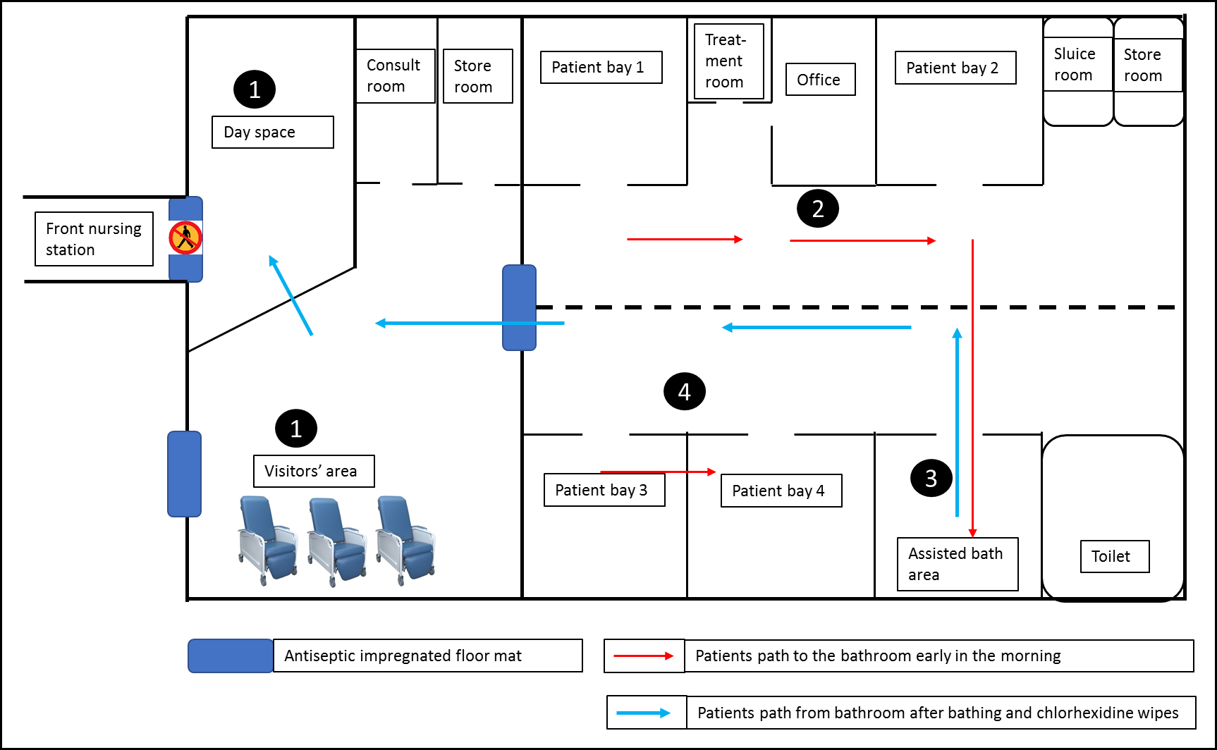
Enhanced environmental cleaning and decolonization of patients were implemented in August 2016. Figure 1 represents steps involved in the daily cleaning procedure. Step 1: Day space and visitor area (floor, wall, windows, grills, and furniture) were steam cleaned before patients woke up. Step 2: Patients were showered in batches. Step 3: Chlorhexidine body wipes were applied for all patients after showers. Step 4: Patients were then sent to the day space area following the “clean” route to join daily activities. Antisepsis impregnated floor mats were placed at strategic locations.

2. Supplementary results

2.1 Microbiology results
Supplementary Table 2. Susceptibility patterns of S. aureus isolated from patient samples
Strain  No* | Source | Sample  site | CLOX | ERY | CLIN | CIP | GENT | SXT | FA
GAS025 | Cluster 1 | Skin | S | R | R | S | S | S | S
GAS028 | Cluster 1 | Skin | S | S | S | S | S | S | S
GAS029 | Cluster 1 | Skin | S | S | S | S | S | S | S
GAS030 | Cluster 1 | Skin | S | S | S | R | R | S | S
GAS032 | Cluster 1 | Skin | S | S | S | R | R | S | S
GAS033 | Cluster 1 | Skin | S | S | S | S | S | S | S
GAS034 | Cluster 1 | Skin | S | S | S | S | S | S | S
GAS035 | Cluster 1 | Skin | S | S | S | S | S | S | R
GAS036 | Cluster 1 | Skin | R | S | S | R | I | S | S
GAS042 | Cluster 1 | Skin | S | S | S | S | S | S | S
GAS046 | Cluster 1 | Skin | S | R | R | S | S | S | R
GAS052 | Cluster 1 | Skin | S | S | S | S | S | S | S
GAS053 | Cluster 1 | Skin | S | R | R | R | S | S | S
GAS054 | Cluster 1 | Skin | S | S | S | S | S | S | R
GAS057 | Cluster 1 | Skin | S | S | S | S | S | S | S
GAS062 | Cluster 1 | Skin | S | S | S | S | S | S | R
GAS063 | Cluster 1 | Skin | S | R | R | S | S | S | S
GAS064 | Cluster 1 | Skin | S | S | S | S | S | S | S
GAS065 | Cluster 1 | Skin | S | S | S | S | S | S | S
GAS066 | Cluster 1 | Skin | R | S | S | S | S | S | S
GAS067 | Cluster 1 | Skin | S | S | S | S | S | S | R
GAS039 | Cluster2 | Skin | R | R | R | R | S | S | S
GAS041 | Cluster 2 | Skin | S | S | S | S | S | S | S
GAS060 | Cluster 2 | Skin | S | S | S | S | S | S | S
GAS061 | Cluster2 | Skin | S | S | S | R | S | R | R
GAS050 | Cluster 3 | Skin | S | S | S | S | S | R | S
GAS051 | Cluster 3 | Skin | S | S | S | S | S | S | S
GAS055 | Sporadic | Skin | S | S | S | S | S | S | S
GAS058 | Sporadic | Skin | S | S | S | S | S | S | S

Note: All S. aureus isolates above were penicillin resistant.
*Strain number refers to the S. pyogenes identity. S. aureus was isolated together with the corresponding S. pyogenes strain.
CLOX, Cloxacillin; ERY, Erythromycin; CLIN, Clindamycin; CIP, Ciprofloxacin; GENT, Gentamicin; SXT, Cotrimoxazole; FA, Fusidic Acid; Skin, superficial wound on the skin. There were eight different antibiograms identified using Vitek®2 (bioMerieux) from samples in Cluster 1 and three different antibiograms from the samples in Cluster 2

Supplementary Table 3. Source and sample site of S. pyogenes isolates sent for WGS
Strain  number | Source | Date  isolated | Sample  site | Strain  number | Source | Date  isolated | Sample  site
GAS001 | Community | 08/11/15 | Wound | GAS035 | Cluster 1 | 10/06/16 | Skin
GAS002 | Community | 09/12/15 | Pus | GAS036 | Cluster 1 | 10/06/16 | Skin
GAS003 | Community | 17/12/15 | Tissue | GAS038 | Cluster 2 | 28/07/16 | Throat
GAS004 | Community | 18/12/15 | Wound | GAS039 | Cluster 2 | 29/07/16 | Skin
GAS005 | Community | 17/12/15 | Throat | GAS040 | Cluster 2 | 29/07/16 | Skin
GAS006 | Community | 04/01/16 | Tissue | GAS041 | Cluster 2 | 29/07/16 | Skin
GAS007 | Community | 15/01/16 | Tissue | GAS042 | Cluster 1 | 29/07/16 | Skin
GAS008 | Community | 15/01/16 | Tissue | GAS043 | Cluster 2 | 27/07/16 | Blood
GAS009 | Community | 18/01/16 | Wound | GAS044 | Staff 1 | 28/07/16 | Throat
GAS010 | Community | 17/01/16 | Wound | GAS045 | Staff 2 | 02/08/16 | Throat
GAS011 | Community | 19/01/16 | Wound | GAS046 | Cluster 1 | 04/08/16 | Skin
GAS012 | Community | 20/01/16 | Wound | GAS047 | Cluster 3 | 08/08/16 | Throat
GAS013 | Community | 23/01/16 | Tissue | GAS050 | Cluster 3 | 10/08/16 | Skin
GAS014 | Community | 28/01/16 | Wound | GAS051 | Cluster 3 | 12/08/16 | Skin
GAS015 | Community | 31/01/16 | Pus | GAS052 | Cluster 1 | 12/08/16 | Skin
GAS016 | Community | 01/02/16 | Tissue | GAS053 P3 | Cluster 1 | 15/08/16 | Skin
GAS017 | Community | 05/02/16 | Wound | GAS054 P2 | Cluster 1 | 16/0816 | Skin
GAS018 | Community | 28/01/16 | Blood | GAS055 | Ward F | 16/08/16 | Skin
GAS019 | Community | 30/01/16 | Blood | GAS056 P5 | Cluster 1 | 22/08/16 | Skin
GAS020 | Community | 12/02/16 | Blood | GAS057 | Cluster 1 | 25/08/16 | Skin
GAS021 | Community | 16/02/16 | Wound | GAS058 | Ward F | 29/08/16 | Skin
GAS022 | Community | 15/03/16 | Blood | GAS059 | Cluster 3 | 31/08/16 | Skin
GAS023 | Community | 15/04/16 | Blood | GAS060 | Cluster 2 | 05/09/16 | Skin
GAS024 | Community | 30/04/16 | Blood | GAS061 | Cluster 2 | 22/09/16 | Skin
GAS025 P3 | Cluster 1 | 02/06/16 | Skin | GAS062 P4 | Cluster1 | 04/10/16 | Skin
GAS026 P1 | Cluster 1 | 07/06/16 | Blood | GAS063 | Cluster 1 | 06/10/16 | Skin
GAS027 P1 | Cluster 1 | 08/06/16 | Tissue | GAS064 P2 | Cluster 1 | 07/10/16 | Skin
GAS028 | Cluster 1 | 06/06/16 | Skin | GAS065 | Cluster 1 | 07/10/16 | Skin
GAS029 | Cluster 1 | 06/06/16 | Skin | GAS066 P5 | Cluster 1 | 07/10/16 | Skin
GAS030 P4 | Cluster 1 | 09/06/16 | Skin | GAS067 | Cluster 1 | 07/10/16 | Skin
GAS031 | Cluster1 | 11/06/16 | Tissue | GAS068 | Ward F | 18/10/16 | Skin
GAS032 | Cluster1 | 10/06/16 | Skin | GAS069 | Cluster 1 | 19/11/16 | Skin
GAS033 | Cluster 1 | 10/06/16 | Skin | GAS070 | Cluster 1 | 11/11/16 | Skin
GAS034 P2 | Cluster 1 | 10/06/16 | Skin
Note: P1-P5 denote 5 different patients who had S. pyogenes isolated from more than one sample.

2.2 Whole genome sequencing results
Supplementary Table 4. Comparison of results of emm typing by Sanger Sequencing and WGS
Strain number | Date samples  collected | Sanger Sequencing  emm types | emm pipeline  results | emm-cluster
GAS001 | 8-Nov-15 | emm120.0 | emm120.0 | D4
GAS002 | 9-Dec-15 | emm120.0 | emm120.0 | D4
GAS003 | 17-Dec-15 | emm12.0 | emm12.0 | A-C4
GAS004 | 18-Dec-16 | emm169.3 | emm169.3 | E4
GAS005 | 17-Dec-16 | emm12.7 | emm12.7 | A-C4
GAS006 | 4-Jan-16 | emm4.0 | emm4.0 | E1
GAS007 | 15-Jan-16 | emm12.8 | emm12.8 | A-C4
GAS008 | 15-Jan-16 | emm4.0 | emm4.0 | E1
GAS009 | 18-Jan-16 | emm101.0 | emm101.0 | D4
GAS010 | 17-Jan-16 | emm44.0 | emm44.0 | E3
GAS011 | 19-Jan-16 | emm109.1 | emm109.1 | E4
GAS012 | 20-Jan-16 | emm12.0 | emm12.0 | A-C4
GAS013 | 23-Jan-16 | emm81.0 | emm81.0 | E6
GAS014 | 28-Jan-16 | emm120.0 | emm120.0 | D4
GAS015 | 31-Jan-16 | emm91.0 | emm91.0 | D4
GAS016 | 1-Feb-16 | emm91.0 | emm91.0 | D4
GAS017 | 5-Feb-16 | emm80.0 | emm80.0 | D4
GAS018 | 28-Jan-16 | emm81.0 | emm81.0 | E6
GAS019 | 30-Jan-16 | emm113.0 | emm113.0 | E3
GAS020 | 12-Feb-16 | emm89.0 | emm89.0 | E4
GAS021 | 16-Feb-16 | emm91.0 | emm91.0 | D4
GAS022 | 15-Mar-16 | emm11.0 | emm11.0 | E6
GAS023 | 15-Apr-16 | emm12.0 | emm12.0 | A-C4
GAS024 | 30-Apr-16 | emm28.0 | emm28.0 | E4
GAS025 | 2-Jun-16 | emm4.0 | emm4.0 | E1
GAS026 | 7-Jun-16 | emm4.0 | emm4.0 | E1
GAS027 | 8-Jun-16 | emm4.0 | emm4.0 | E1
GAS028 | 6-Jun-16 | emm4.0 | emm4.0 | E1
GAS029 | 6-Jun-16 | emm4.0 | emm4.0 | E1
GAS030 | 9-Jun-16 | emm4.0 | emm4.0 | E1
GAS031 | 11-Jun-16 | emm4.0 | emm4.0 | E1
GAS032 | 10-Jun-16 | emm4.0 | emm4.0 | E1
GAS033 | 10-Jun-16 | emm4.0 | emm4.0 | E1
GAS034 | 10-Jun-16 | emm4.0 | emm4.0 | E1
GAS035 | 10-Jun-16 | emm4.0 | emm4.0 | E1
GAS036 | 10-Jun-16 | emm4.0 | emm4.0 | E1
GAS038 | 28-Jul-16 | emm11.0 | emm11.0 | E6
GAS039 | 29-Jul-16 | emm11.0 | emm11.0 | E6
GAS040 | 29-Jul-16 | emm11.0 | emm11.0 | E6
GAS041 | 29-Jul-16 | emm11.0 | emm11.0 | E6
GAS042 | 29-Jul-16 | emm4.0 | emm4.0 | E1
GAS043 | 27-Jul-16 | emm11.0 | emm11.0 | E6
GAS044 | 28-Jul-16 | emm12.0 | emm12.0 | A-C4
GAS045 | 2-Aug-16 | emm12.0 | emm12.0 | A-C4
GAS046 | 4-Aug-16 | emm4.0 | emm4.0 | E1
GAS047 | 8-Aug-16 | emm205.0 | emm205.0 | E5
GAS050 | 10-Aug-16 | emm120.0 | emm120.0 | D4
GAS051 | 12-Aug-16 | emm120.0 | emm120.0 | D4
GAS052 | 15-Aug-16 | emm4.0 | emm4.0 | E1
GAS053 | 15-Aug-16 | emm4.0 | emm4.0 | E1
GAS054 | 16-Aug-16 | emm4.0 | emm4.0 | E1
GAS055 | 16-Aug-16 | emm88.3 | emm88.3 | E4
GAS056 | 22-Aug-16 | emm4.0 | emm4.0 | E1
GAS057 | 25-Aug-15 | emm4.0 | emm4.0 | E1
GAS058 | 29-Aug-16 | emm88.3 | emm88.3 | E4
GAS059 | 31-Aug-16 | emm120.0 | emm120.0 | D4
GAS060 | 7-Sep-16 | emm11.0 | emm11.0 | E6
GAS061 | 22-Sep-16 | emm11.0 | emm11.0 | E6
GAS062 | 4-Oct-16 | emm4.0 | emm4.0 | E1
GAS063 | 6-Oct-16 | emm4.0 | emm4.0 | E1
GAS064 | 7-Oct-16 | emm4.0 | emm4.0 | E1
GAS065 | 7-Oct-16 | emm4.0 | emm4.0 | E1
GAS066 | 7-Oct-16 | emm4.0 | emm4.0 | E1
GAS067 | 10-Oct-16 | emm4.0 | emm4.0 | E1
GAS068 | 18-Oct-16 | Not done | Emm88.3 | E4
GAS069 | 19-Nov-16 | Not done | emm4.0 | E1
GAS070 | 11-Nov-16 | Not done | emm4.0 | E1

Supplementary Figure 2. Antibiotic resistance heatmap of S. pyogenes isolates
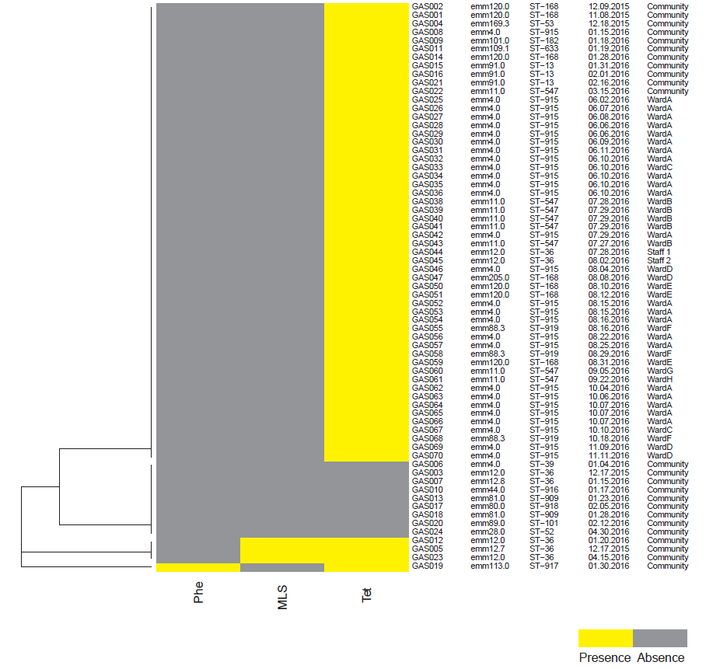
Phe, phenicol; MLS, macrolides, lincosamides, streptogramines; Tet, tetracycline
The tetM gene, which confers tetracycline resistance, was detected by WGS in all institutional S. pyogenes isolates. This matched laboratory-based antibiotic susceptibility results based on disc diffusion testing.

3. Epidemiological investigation of staff members with S. pyogenes
S. pyogenes was isolated from the oropharyngeal swab of one staff member from Ward B (GAS044- STAFF 1). This isolate was distinct from Ward B isolates by whole-genome phylogeny (Figure 1) and also had a distinct emm type (emm12) and sequence type (ST36). We initiated screening for oropharyngeal carriage for contacts of STAFF 1 and found S. pyogenes throat carriage in a household contact (GAS045- STAFF 2) who was also employed in the institution but did not work on Ward B. This isolate was also emm type12 and MLST type ST36. The pairwise SNP difference between the two staff member isolates was 38. We believe these strains are likely part of the circulating S. pyogenes strains in Singapore. S. pyogenes was not detected from any patients on the ward STAFF 2 worked. Therefore, these staff members were not considered to be the source of infection in Cluster 2.

4. Dermatological interventions
Dermatologist advised for regular gentle antiseptic baths and use of gentle soaps. Patients were supervised in their daily baths to ensure cleanliness. Patients have individualized moisturizer tubs to allow for frequent application of moisturizers and to reduce the risk of contamination. Nurses were advised to aid with moisturizer application if the patients were unable or unwilling to comply. Regular dermatological inspections were carried out and scabies or fungal infections were promptly treated. This helped to reduce the number of skin infections and improved the overall skin condition of patients.

References

1. Li H, Durbin R. Fast and accurate short read alignment with Burrows-Wheeler transform. Bioinformatics 2009;25:1754-1760.
2. Wilm A, Aw PP, Bertrand D, et al. LoFreq: a sequence-quality aware, ultra-sensitive variant caller for uncovering cell-population heterogeneity from high-throughput sequencing datasets. Nucleic Acids Res 2012;40:11189-11201.
3. Beres SB, Richter EW, Nagiec MJ, et al. Molecular genetic anatomy of inter- and intraserotype variation in the human bacterial pathogen group A Streptococcus. Proc Natl Acad Sci U S A 2006;103:7059-7064.
4. Beres SB, Musser JM. Contribution of exogenous genetic elements to the group A Streptococcus metagenome. PloS one 2007;2:e800.
5. Nguyen SV, McShan WM. Chromosomal islands of Streptococcus pyogenes and related streptococci: molecular switches for survival and virulence. Front Cell Infect Microbiol 2014;4:109.
6. Tatusova T, DiCuccio M, Badretdin A, et al. NCBI prokaryotic genome annotation pipeline. Nucleic Acids Res 2016;44:6614-6624.
7. Price MN, Dehal PS, Arkin AP. FastTree 2--approximately maximum-likelihood trees for large alignments. PloS one 2010;5:e9490.
8. Croucher NJ, Page AJ, Connor TR, et al. Rapid phylogenetic analysis of large samples of recombinant bacterial whole genome sequences using Gubbins. Nucleic Acids Res 2015;43:e15.
9. Yu G, Smith DK, Zhu H, Guan Y, Lam TTY. ggtree: an R package for visualization and annotation of phylogenetic trees with their covariates and other associated data. Methods in Ecology and Evolution 2017;8:28-36.
10. Gupta SK, Padmanabhan BR, Diene SM, et al. ARG-ANNOT, a new bioinformatic tool to discover antibiotic resistance genes in bacterial genomes. Antimicrobial agents and chemotherapy 2014;58:212-220.
11. Inouye M, Dashnow H, Raven LA, et al. SRST2: Rapid genomic surveillance for public health and hospital microbiology labs. Genome medicine 2014;6:90.
12. Jolley KA, Maiden MC. BIGSdb: Scalable analysis of bacterial genome variation at the population level. BMC Bioinformatics 2010;11:595.
13. Athey TB, Teatero S, Li A, Marchand-Austin A, Beall BW, Fittipaldi N. Deriving group A Streptococcus typing information from short-read whole-genome sequencing data. Journal of clinical microbiology 2014;52:1871-1876.
14. Kapatai G, Coelho J, Platt S, Chalker VJ. Whole genome sequencing of group A Streptococcus: development and evaluation of an automated pipeline for emmgene typing. PeerJ 2017;5:e3226.

