Increasing burden of Escherichia coli, Klebsiella pneumoniae and Enterococcus faecium in hospital-acquired bloodstream infections (2000–2014): a national dynamic cohort study
Supplementary appendix
Appendix 1. HABSI definition criteria

Appendix 1.1. Surveillance of Bloodstream Infection in Hospitals programme: bloodstream infection case definition
Bloodstream infection criteria
Recognized pathogen isolated from ≥1 blood culture
Common skin commensal* cultured from ≥2 blood cultures drawn on separate occasions (within 3 days of each other) and clinical symptoms within 24 hours of the positive culture:
* Organisms that constitute normal skin flora include diphteroids, Bacillus sp., Propionibacterium sp., coagulase-negative staphylococci (CNS), or micrococci.

Appendix 1.2. Surveillance of Bloodstream Infection in Hospitals programme: central line-associated bloodstream infection case definition
Central line-associated bloodstream infection (CLABSI) definition criteria
To be classified as CLABSI, the BSI must fulfil at least one of the following criteria:
Definite: Catheter-related bloodstream infections are defined as a bloodstream infection with a positive culture of the catheter, using one of the following semi-quantitative methods:
1. ≥15 colonies (CFU) in a semi-quantitative culture (24h incubation) on a catheter segment (5–7cm) rolled over a blood agar (roll-plate Maki method)
2. >10³ colonies (CFU) per intradermal catheter segment (1cm), washed with a liquid blood agar by ‘flushing’ or ‘vortex’ after semi-quantitative culturing of the flushing medium
3. ‘Paired samples’: The same microorganisms (species and antibiogram) are cultured from a peripheral vein sample and catheter with, in a quantitative culture, the number of CFUs in catheter / number of CFUs peripheral blood >5
Probable: However, if one of the three previous criteria are not satisfied but the bloodstream infection is still considered to be related to the central venous catheter, it can be noted as a probable central line-associated bloodstream infection.
CDC Surveillance definition: A central line-associated bloodstream infection is a BSI where a central line was in place during the 2 calendar days before the onset of infection and no other cause of infection can be identified

Appendix 2. Statistical methodology
A Poisson-type distribution model was chosen above linear regression because the dependant variable, HABSI per patient days, was not normally distributed. A negative binomial distribution was applied in place of a Poisson distribution because the number of quarterly infections was overdispersed: i.e. the variance (the square of the standard deviation) of quarterly HABSI per hospital was greater than the mean.
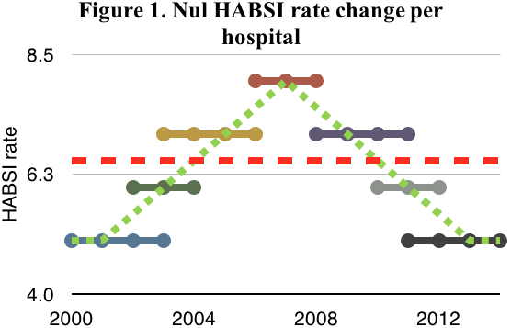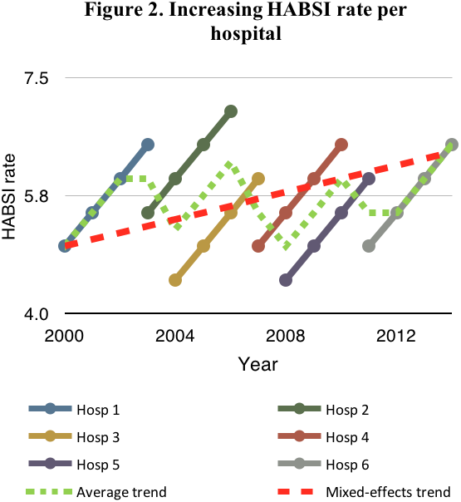The mixed-effects negative binomial distribution regression model estimated the adjusted incidence rate ratio (IRR) with 95% confidence intervals (CI) to identify the annual change in HABSI rates. The model adjusts for confounding factors by applying fixed effects: university hospital status, trimester, and chronic care facilities. Monthly number of patient days was included as an exposure variable to adjust for the fact that with increased exposure, there is an increased risk of HABSI development. Varying hospital participation and characteristics that could not be further quantified were accounted for by applying the individual hospitals as random effects. This allows the mixed-effects model to correctly identify a stable (figure 1) or globally increasing trend (figure 2) in the presence of varying hospital participation with different baseline infection rates over the duration of the study period. Other non-significant factors such as number of admissions and hospital bed size were excluded through backwards elimination.
The mixed-effects negative binomial regression analysis was calculated with the menbreg function. To create figures based on the estimated adjusted IRR, the statistical post-estimation function predict calculated the estimated average infections per hospital month (with respect to the results of the fixed and random effects).
Fixed and random effects were tested using the Wald and likelihood-ratio test. Model goodness-of-fit was visually assessed by graphing the deviance residuals of the predicted values and identifying the severe outliers above or below 75th and 25th percentile ±3(IQR).

Appendix 3. Total, gram-positive, and gram-negative incidence trends over 2000–2014
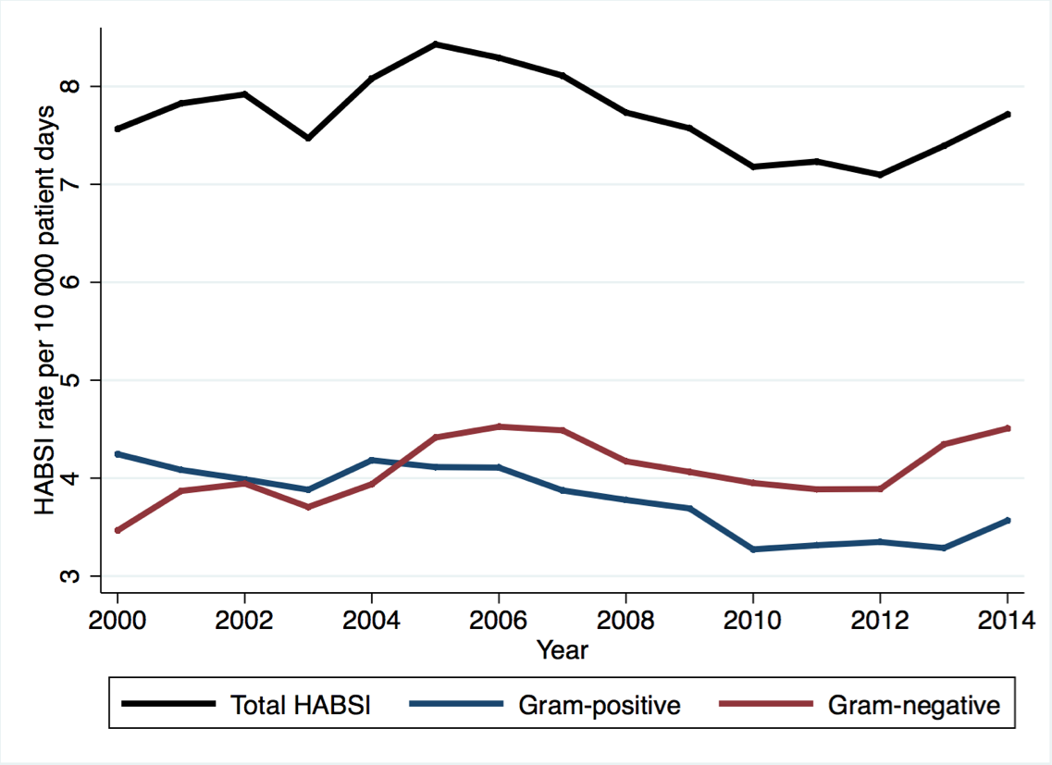

Appendix 4. Annual adjusted incidence rate ratio, trends of HABSI incidence per microorganism (2000–2014)
 | Hospital-wide |  |  | Intensive care
 | IRR (%) | 95% CI | p-value | IRR (%) | 95% CI | p-value
Gram-positive | -1.8 | (-2.2–-1.3) | <0.001 | -2.0 | (-2.9–-1.1) | 0.002
CNS | -4.5 | (-5.2–-3.8) | <0.001 | -4.5 | (-5.2–-3.8) | <0.001
S. aureus | -0.8 | (-1.5–-0.2) | 0.02 | -1.5 | (-3.0–0.1) | 0.07
E. faecalis | +1.5 | (0.4–2.6) | 0.007 | -1.5 | (-3.5–0.5) | 0.13
E. faecium | +10.9 | (9.0–12.8) | <0.001 | +13.3 | (9.7–16.9) | <0.001
Gram-negative | +1.0 | (0.6–1.4) | <0.001 | -0.1 | (-0.9–0.8) | 0.90
E. coli | +2.8 | (2.2–3.3) | <0.001 | +2.1 | (0.7–3.5) | 0.004
K. pneumoniae | +4.4 | (3.4–5.4) | <0.001 | +3.1 | (0.7–5.5) | 0.01
K. oxytoca | -0.3 | (-1.7–1.1) | 0.64 | -2.5 | (-5.4–0.6) | 0.11
E. aerogenes | -6.1 | (-7.4–-4.7) | <0.001 | -7.0 | (-9.6–-4.4) | <0.001
E. cloacae | +1.1 | (-0.1–2.3) | 0.07 | +2.6 | (0.3–5.0) | 0.03
P. aeruginosa | -0.8 | (-1.7–0.1) | 0.07 | -2.9 | (-4.5–-1.3) | <0.001
Bacteroides spp. | +0.8 | (-0.7–2.5) | 0.29 | -1.1 | (-4.4–2.2) | 0.51
Candida spp. | -1.3 | (-2.2–-0.4) | 0.004 | +0.3 | (-1.5–2.2) | 0.74
Candida glabrata | +0.3 | (-1.5–2.0) | 0.76 | +0.4 | (-2.8–3.8) | 0.81
Mixed-effects regression analysis adjusting for trimester, number of patient-days, hospital type, and participation. IRR: incidence rate ratio; HABSI: hospital-acquired bloodstream infection; CNS: coagulase-negative staphylococci.

Appendix 5. Plotted deviance residuals for visual assessment of model goodness-of-fit
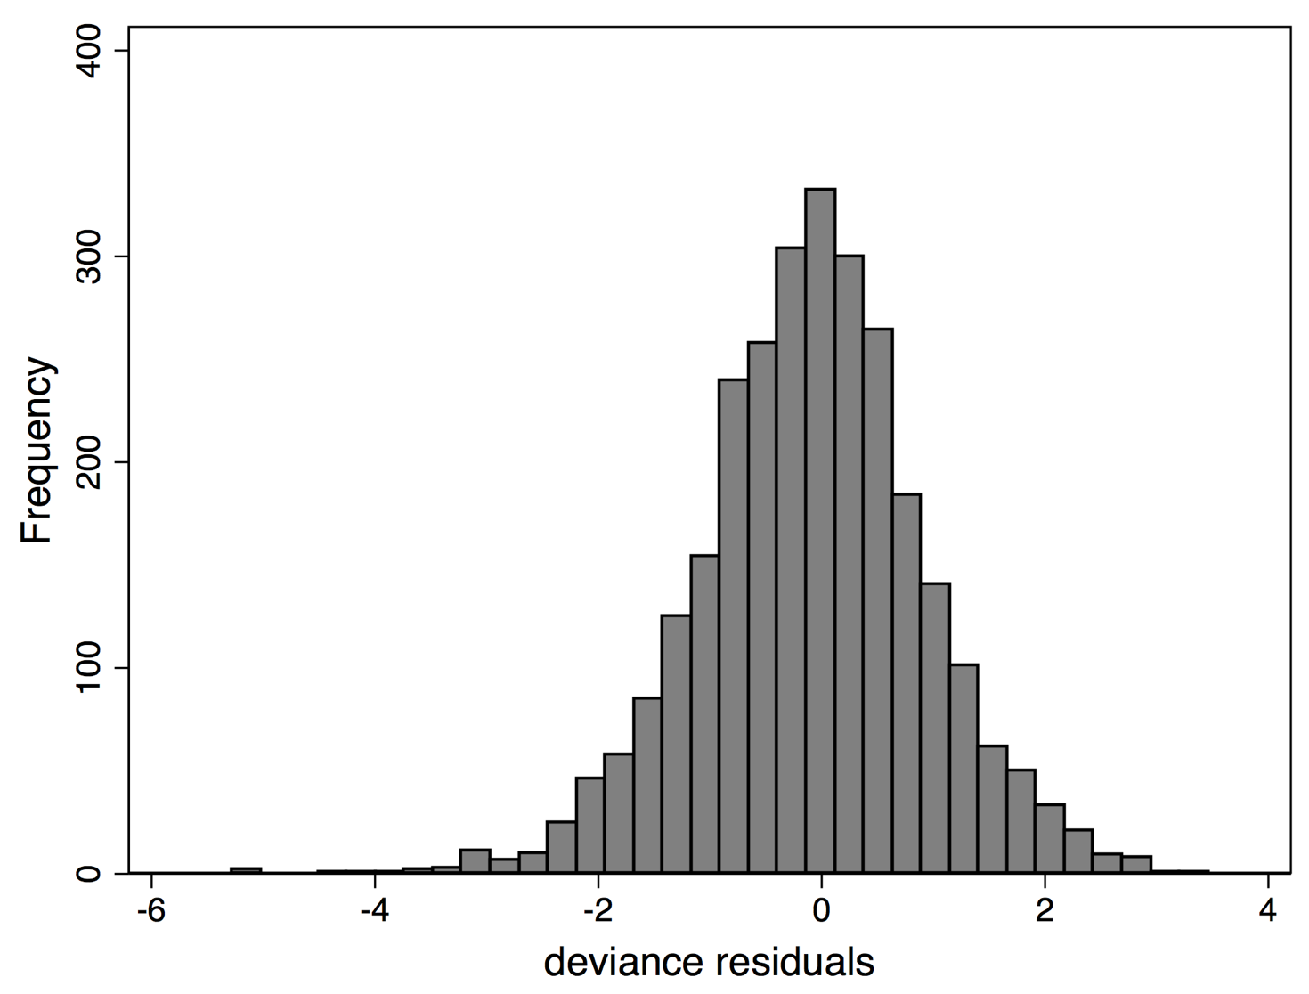
This histogram plots the deviance residuals (differences between observed and fitted values) of the model based on the mixed-effects negative binomial regression analysis for hospital-wide total HABSI rates. Analysis identified 2 severe outliers in the low end of the spectrum. This could theoretically bias the model by predicting lower infection rates than should be expected. However, removal of these severe outliers did not influence or change the results of the mixed-effects regression model (IRR -0.4% [95% CI, -0.7–-0.1], p=0.02 versus IRR -0.5% [95% CI, -0.8–-0.1], p=0.006).
Rate regression models for Gram-negative, Gram-positive, and fungal HABSI demonstrated optimal model goodness of fit.

Appendix 6. Sensitivity analysis: HABSI rate trends per hospital participation cohorts
 | Reporting ≥3 years |  |  | Reporting ≥5 years |  |  | Reporting ≥10 years |  |  | Reporting ≥3 full years
HABSI rates | IRR (%) | (95% CI) | p-value | IRR (%) | (95% CI) | p-value | IRR (%) | (95% CI) | p-value | IRR (%) | (95% CI) | p-value
Hospital-wide
Total | -0.5 | (-0.8; -0.2) | 0.002 | -0.5 | (-0.8; -0.1) | 0.006 | -0.9 | (-1.2; -0.5) | <0.001 | -0.1 | (-0.5; 0.3) | 0.61
Gram-negative | +1.1 | (0.7; 1.4) | <0.001 | +1.0 | (0.6; 1.4) | <0.001 | +0.6 | (0.1; 1.0) | 0.01 | +1.0 | (0.6; 1.5) | <0.001
Gram-positive | -1.9 | (-2.4; -1.5) | <0.001 | -1.8 | (-2.2; -1.3) | <0.001 | -2.2 | (-2.7; -1.7) | <0.001 | -1.0 | (-1.6; -0.5) | <0.001
Fungal | -1.6 | (-2.4; -0.7) | <0.001 | -1.3 | (-2.2; -0.4) | 0.004 | -2.0 | (-2.9; -1.0) | <0.001 | -1.6 | (-2.4; -0.7) | <0.001
Intensive care
Total | -0.8 | (-1.4; -0.1) | 0.02 | -0.8 | (-1.5; -0.2) | 0.01 | -1.1 | (-1.8; -0.3) | 0.004 | +0.3 | (-0.5; 1.2) | 0.46
Gram-negative | +0.1 | (-0.8; 0.9) | 0.87 | -0.1 | (-0.9; 0.8) | 0.90 | -0.6 | (-1.5; 0.4) | 0.26 | +0.6 | (-0.5; 1.8) | 0.26
Gram-positive | -1.9 | (-2.8; -1.1) | <0.001 | -2.0 | (-2.9; -1.1) | 0.002 | -2.1 | (-3.1; -1.1) | <0.001 | -0.4 | (-1.6; 0.8) | 0.48
Fungal | +0.4 | (-1.4; 2.3) | 0.64 | +0.3 | (-1.5; 2.2) | 0.74 | +0.6 | (-1.4; 2.7) | 0.56 | +0.4 | (-1.4; 2.3) | 0.64
HABSI: hospital-acquired bloodstream infection. IRR: adjusted incidence rate ratio

Sensitivity analysis was performed to assess the impact of varying hospital selection criteria, based on their level of participation, on the total, gram-negative, gram-positive, and fungal rate trends both hospital-wide and in intensive care.

