**Supplemental Data File**

**Supplemental Figure 1. Interaction Plot of ICU and Patient Factors**

Each dot represents an individual ICU. As the percentage of patients on room air in each ICU (Percentage of RA) on the x-axis increases, the antibiotic use (Antibiotic DOT / 1000 PD) on the y-axis decreases. The minimally crossed lines in this graph suggest that there is a minimal interaction effect among the ICU and patient factors. RA, room air. DOT, days of therapy. PD, patient-days.

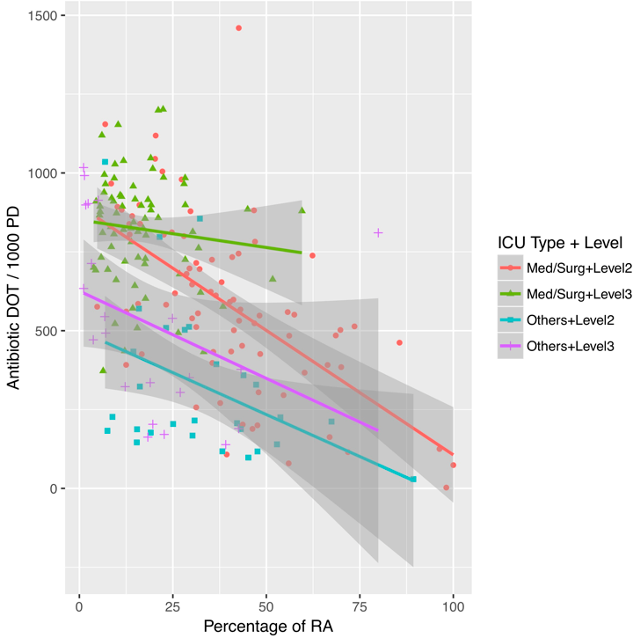

**SUPPLEMENTAL TABLE 1. Antibiotic Use in “Others” ICUs**

|  |  |  |  |
| --- | --- | --- | --- |
| **Types of “Others” ICUs** | **No. (%)**  **(Total = 51)** | **Mean DOT ± SD** | **CV** |
| CCUs | 16 | 292 ± 193 | 0.66 |
| CVICUs | 32 | 439 ± 299 | 0.68 |
| Burn Units | 2 | 675 ± 192 | 0.28 |
| Transplant Units | 1 | 855 | N/A |

Abbreviations: No., number of ICUs. SD, standard deviation. CV, coefficient of variation. CCUs, Coronary Care Units. CVICUs, Cardiovascular ICUs.

**SUPPLEMENTAL TABLE 2. Univariable Linear Regression of Antibiotic Use by combined ICU Factors**

|  |  |  |  |
| --- | --- | --- | --- |
| **Combined ICU Factors** | **Coefficient (95%CI)** | **p-value** | **Adj R2** |
| **Med/Surg + Level 2** | 582 (528, 636) | <0.0001 | 0.32 |
| **Med/Surg + Level 3** | -256 (-360, -151) | <0.0001 |
| **Others + Level 2** | -60 (-176, 56) | <0.0001 |
| **Others + Level 3** | 240 (161, 318) | 0.495 |

Abbreviations: CI, confidence interval. Adj R2, adjusted R2. Med/Surg, medical/surgical.

**SUPPLEMENTAL TABLE 3. Univariable Linear Regression of Antibiotic Use by Individual Patient Factors**

|  |  |  |  |
| --- | --- | --- | --- |
| **Patient factors** | **Coefficient (95% CI)** | **p-value** | **Adj R2** |
| Mean of MODS | 103 (77, 130) | <0.0001 | 0.23 |
| Percentage of RA | -7 (-9, -6) | <0.0001 | 0.25 |
| Percentage of no CVC | -5 (-6, -3) | <0.0001 | 0.15 |

Abbreviations: CI, confidence interval. Adj R2, adjusted R2. MODS, Multiple Organ Dysfunction Score. RA, room air. CVC, central venous catheter.